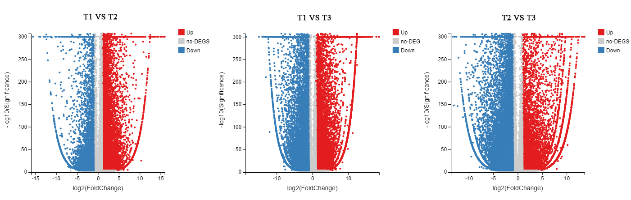
Fig. S1 Intergroup differential Volcano Plot. The X-axis represents the difference multiple value.

