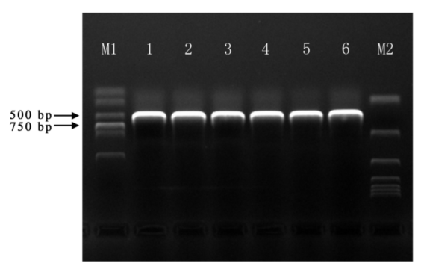
Fig. S5 PCR amplification of target genes. M1. DL 2000 Maker; M2. DL 15000 Maker; 1-6. PCR amplification of PlFT.

