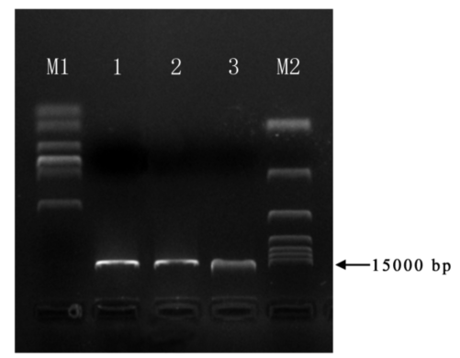
Fig. S4 pCAMBIA1301 vector and its control after double enzyme digestion. M1. DL 2000 Maker; M2. DL 15000 Maker; 1-2. Linearized vector; 3. Circular vector.

