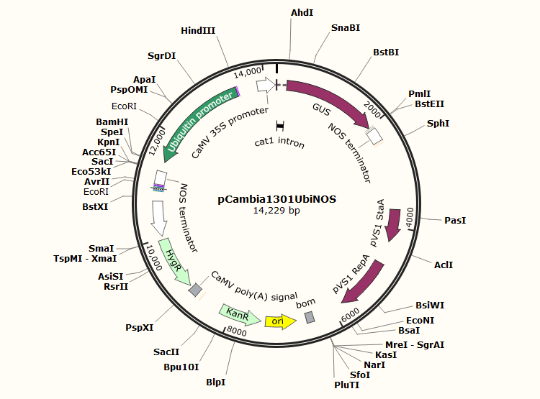
Fig. S3 The plasmid vector of pCAMBIA1301 UbiNOS.

