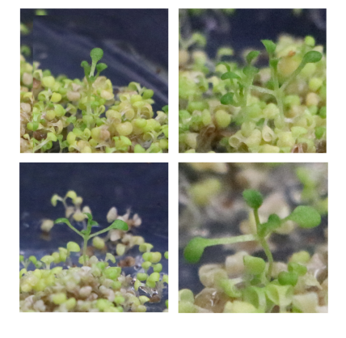
Fig.S2 Screening of transgenic Arabidopsis.

