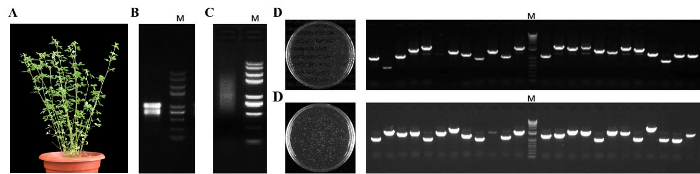

Supplemental Figure 1 Expression library procedure of alfalfa. (A) Alfalfa “No.2 gongnong”; (B) Analysis and detection of total RNA extracted from alfalfa mixed sample (roots, stems and leaves) by 1% Agarose gel electrophoresis; (C) Analysis and detection of mRNA purified from total RNA of alfalfa by 1% Agarose gel electrophoresis; (D) titer and inserted fragment detection of entry cDNA library; (E) titer and inserted fragment detection of pDEST52 expression cDNA library.