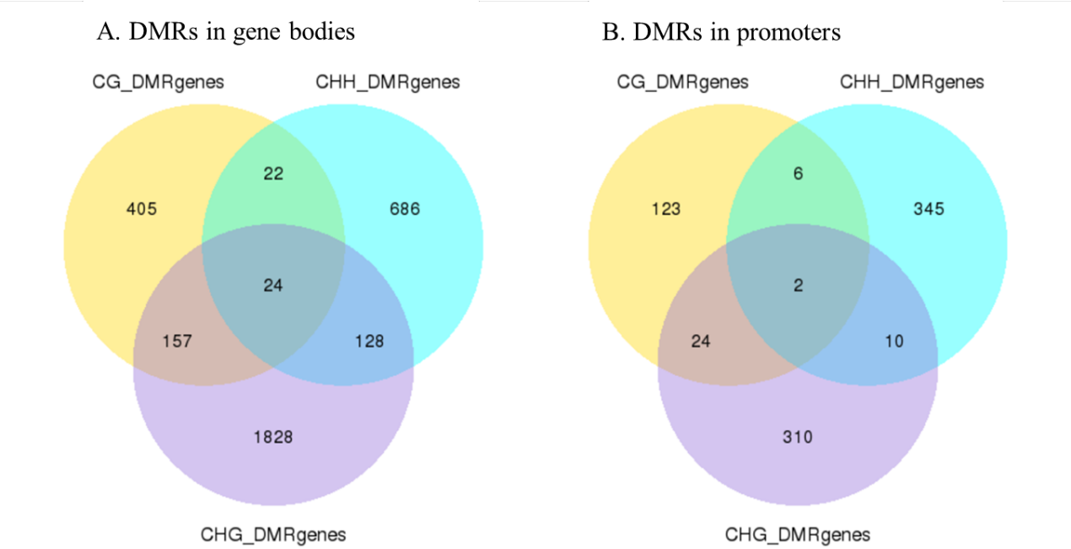
Fig. S2 Venn diagrams of DMR genes

