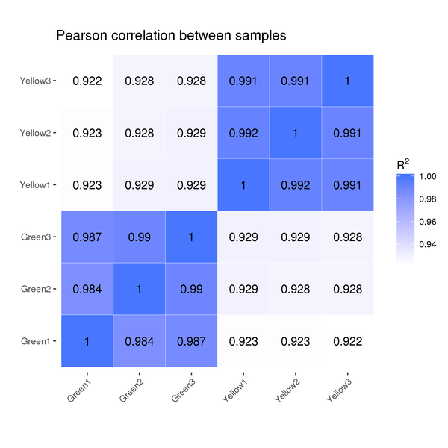
Fig. S1 Correlation analysis of the RNA-Seq results.

