Metabolomics of leafy vegetables: A systematic review of leafy vegetables with bioactive effects and factors influencing metabolic variation

Seam Choon Law^{a,b}, Pei-Wen Ong^{a,b}, Fook Tim Chew^{a,b,c*}

ª Department of Biological Sciences, National University of Singapore, 14 Science Drive 4, Singapore 117543, Republic of Singapore
^{b} Research Centre on Sustainable Urban Farming (SUrF), Department of Biological Sciences, National University of Singapore, Block S3, #05-01, 16 Science Drive 4, Singapore 117558, Republic of Singapore
^{c} Lee Hiok Kwee Functional Genomics Laboratories, Department of Biological Sciences, Block S2, Level 5, 14 Science Drive 4, Lower Kent Ridge Road, Singapore 117543, Republic of Singapore.
* Corresponding author. Fook Tim Chew; dbscft@nus.edu.sg; ORCID: 0000-0003-1337-5146

Acknowledgments
The authors would like to acknowledge the help of Ting Xiang Neik, Adrian Ming Jern Lee, and Ethan Tze Cherng Lim from the Department of Biological Sciences, National University of Singapore for their assistance in the reviewing of the article.
Figures
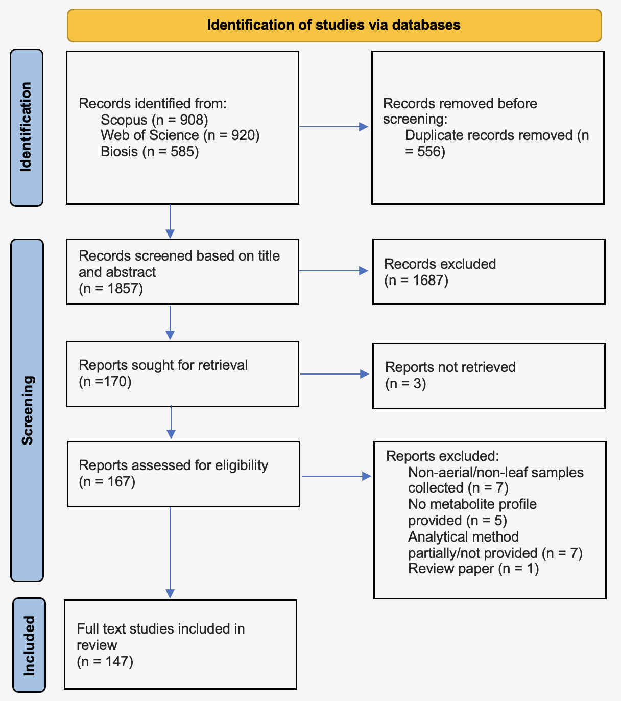
Figure S1. PRISMA flow diagram illustrating the process used to identify and shortlist articles for systematic review
Tables
Table S1. Full search terms applied to the Scopus, Web of Science, and BIOSIS databases for the literature search. All three databases were limited to only English-language, research articles
Database | Full search term
Scopus | ( TITLE-ABS-KEY ( leafy* AND vegetable* AND metabol* ) AND NOT TITLE-ABS-KEY ( *soil* OR drug* OR animal* OR arabidopsis* OR bacter* OR root* OR egg* OR obesity* OR fruit* OR expression* OR enzymology* OR diet* OR protein* OR gene* ) ) AND ( LIMIT-TO ( DOCTYPE , "ar" ) ) AND ( LIMIT-TO ( LANGUAGE , "English" ) )
Web of Science / BIOSIS | ( TITLE-ABS-KEY ( leafy* AND vegetable* AND metabol* ) NOT TITLE-ABS-KEY ( *soil* OR drug* OR animal* OR arabidopsis* OR bacter* OR root* OR egg* OR obesity* OR fruit* OR expression* OR enzymology* OR diet* OR protein* OR gene* ) ) AND ( LIMIT-TO ( DOCTYPE , "ar" ) ) AND ( LIMIT-TO ( LANGUAGE , "English" ) )

Table S2. Investigated leafy vegetables with their subgroup name derived from 147 qualified articles
No. | Common name of leafy vegetable | Scientific name of leafy vegetable | Subgroup name | Reference
1 | Abyssinian cabbage | Brassica carinata A. Braun | Brassica leafy vegetables/baby leaves | ^{[43,44]}
2 | African nightshade | Solanum villosum Mill. | Leafy greens | ^{[44]}
3 | Amaranth leaves | Amaranthus spp. | Leafy greens | ^{[45-53]}
4 | Bitter leaf | Vernonia hybrids | Leafy greens | ^{[54]}
5 | Blackjack | Bidens pilosa L. | Leafy greens | ^{[55]}
6 | Broccoli raab | Brassica ruvo L.H. Bailey | Brassica leafy vegetables | ^{[56]}
7 | Cat’s whiskers | Cleome gynandra L. | Leafy greens | ^{[44]}
8 | Chard | Beta vulgaris L. subsp. vulgaris var. vulgaris | Leafy greens | ^{[47]}
9 | Chicory leaves | Cichorium intybus L., var. foliosum Hegi | Leafy greens | ^{[47,57-59]}
10 | Chili pepper leaves | Capsicum annuum L. | Leafy greens | ^{[60]}
11 | Chinese broccoli | Brassica oleracea var. alboglabra (L.H. Bailey) Musil | Brassica leafy vegetables | ^{[61-64]}
12 | Curly kale | Brassica oleracea L., convar. acephala (D. C.) Alef., var. sabellica L. | Brassica leafy vegetables/baby leaves | ^{[5,6,44,47,65-73]}
13 | Kohlrabi leaves | Brassica oleracea L var. gongylodes L. | Brassica leafy vegetables/baby leaves | ^{[71,74]}
14 | Ssam cabbage | Brassica rapa L. subsp. pekinensis (Lour.) Hanelt (non-head type) | Brassica leafy vegetables | ^{[62-64,75-86]}
15 | Chinese flat cabbage | Brassica rapa subsp. narinosa (L.H. Bailey) Hanelt | Brassica leafy vegetables | ^{[47]}
16 | Choi sum | Brassica rapa L. subsp. chinensis (L.) Hanelt var. Parachinensis (L.H. Bailey) Hanelt. | Brassica leafy vegetables/baby leaves | ^{[62-64,87,88]}
17 | Komatsuna | Brassica rapa L. var. perviridis L.H. Bailey | Brassica leafy vegetables | ^{[86]}
18 | Mizuna | Brassica rapa L. subsp. nipposinica (L.H. Bailey) Hanelt | Brassica leafy vegetables/baby leaves | ^{[74,82,86,89,90]}
19 | Pak-choi | Brassica rapa subsp. chinensis (L.) Hanelt | Brassica leafy vegetables/baby leaves | ^{[52,62-64,68,83,86,89,91-105]}
20 | Rape greens | Brassica napus L. subsp. trilocularis (Roxb.) Hanelt; Brassica napus L. subsp. dichotoma (Roxb.) Hanelt; Brassica napus L. subsp. oleifera Metzg. | Brassica leafy vegetables | ^{[52,86]}
21 | Turnip greens | Brassica rapa L. subsp. rapa | Brassica leafy vegetables | ^{[82,83,106-109]}
22 | Cosmos | Cosmos caudatus Kunth | Leafy greens | ^{[110,111]}
23 | Cowpea leaves | Vigna unguiculata (L.) Walp. | Leafy greens | ^{[44,112,113]}
24 | Ebolo | Crassocephalum crepidioides (Benth.) S. Moore | Leafy greens | ^{[114]}
25 | Endive | Cichorium endivia L. | Leafy greens | ^{[22,52,115]}
26 | Fennel | Foeniculum vulgare Mill. subsp. vulgare var. azoricum (Mill.) Thell- | Leafy greens | ^{[116]}
27 | Garland chrysanthemum | Glebionis coronaria (L.) Cass. ex-Spach | Leafy greens | ^{[52]}
28 | Glasswort | Salicornia L. | Leafy greens | ^{[117]}
29 | Goosefoot leaves | Chenopodium spp. | Leafy greens | ^{[118,119]}
30 | Jew mallow | Corchorus olitorius L. | Leafy greens | ^{[54,120]}
31 | Kangkung | Ipomoea aquatica Forssk. | Leafy aquatic vegetables | ^{[121,122]}
32 | Lambs lettuce | Valerianella locusta L. | Leafy greens | ^{[123-125]}
33 | Lettuce | Lactuca sativa L., var. crispa L. | Leafy greens | ^{[7-9,47,52,76,123-147]}
34 | Red lettuce | Lactuca sativa L., var. capitata | Leafy greens | ^{[7,8,52,134,135,140,148-153]}
35 | Maca leaves | Lepidium meyenii Walp. | Brassica leafy vegetables | ^{[154,155]}
36 | Mustard greens | Brassica juncea (L.) Czern | Brassica leafy vegetables/baby leaves | ^{[47,68,70,74,82,86,89,156-158]}
37 | Radish leaves | Raphanus sativus L. | Brassica leafy vegetables/baby leaves | ^{[62-64,76,83,89,106,159,160]}
38 | Perilla leaves | Perilla frutescens (L.) Britton var. frutescens | Leafy greens | ^{[161-165]}
39 | Purslane | Portulaca oleracea L., ssp. sativa ^{[18]} Celak. | Leafy greens | ^{[166]}
40 | Rocket salad | Eruca sativa Mill. | Brassica leafy vegetables/baby leaves | ^{[62-64,68,124,159,167-171]}
41 | Spinach | Spinacia oleracea L. | Leafy greens | ^{[52,55,76,172-178]}
42 | Water mimosa | Neptunia oleracea Lour. | Leafy aquatic vegetables | ^{[179]}
43 | Watercress | Nasturtium officinale W.T Aiton | Leafy aquatic vegetables/baby leaves | ^{[62-64,180-184]}

Table S3. Summary of light-related abiotic stresses influencing metabolite composition in leafy vegetables
Treatment period | Factor | Sub-factor | Treatment | Leafy vegetable | Outcome
Cultivation | Abiotic stress | Light source | Mild/high LED light intensity | Lettuce, red lettuce | Increased phenolic compounds
 |  |  |  | Spinach | Increased growth and quality
 |  |  |  | Chinese cabbage, pakchoi, mustard green, mizuna, and radish leaves | Increased glucosinolates
 |  |  |  | Chilli pepper leaves | Increases in anthocyanin, chlorophyll, carotenoids, phenolic compounds
 |  |  |  | Mizuna, mustard green, kohlrabi | Increases in anthocyanin, chlorophyll, carotenoids, phenolic compounds
 |  |  |  | Choisum | Increases in glucosinolates, chlorophyll, carotenoids, phenolic compounds
 |  |  |  | Rocket salad, lamb’s lettuce | Increases in chlorophyll, carotenoids, carbohydrates, organic acids, amino acids
Cultivation | Abiotic stress | Light source | UV-A | Lettuce | Increased chlorophyll
Cultivation | Abiotic stress | Light source | UV-B | Lettuce | Increased phenolic compounds
 |  |  |  | Curly kale | Increased phenolic compounds
Cultivation | Abiotic stress | Light source | Fluorescence | Lettuce | Increased phenolic compounds
Cultivation | Abiotic stress | Light source | Red light | Abyssinian cabbage | Increases in phenolic compounds, glucosinolates
Cultivation | Abiotic stress | Light source | Blue light | Amaranth | Increases in lipids, amino acids, organic acids
 |  |  |  | Red lettuce | Increased phenolic compounds
 |  |  |  | Pakchoi | Increased glucosinolates

Table S4. Summary of nutrient-related abiotic stresses influencing metabolite composition in leafy vegetables
Treatment period | Factor | Sub-factor | Treatment | Leafy vegetable | Outcome
Cultivation | Abiotic stress | Nutrient supply | Ascorbic acid | Spinach | Increased phenolic compounds
Cultivation | Abiotic stress | Nutrient supply | Mineral and organic fertilizer | Chicory leaves | Decreased phenolic compounds
Cultivation | Abiotic stress | Nutrient supply | Salicylic acid | Spinach | Increased phenolic compounds, osmolytes
Cultivation | Abiotic stress | Macro-elements adjustment | Increased nitrogen | Watercress | Increases in carotenoids, glucosinolates
 |  |  |  | Pakchoi | Increases in sugars, amino acids, organic acids
 |  |  |  | Lettuce | Increases in sugars and decreased in glucosinolates
Cultivation | Abiotic stress | Macro-elements adjustment | Increased sulfur | Lettuce | Promote growth and primary metabolites
Cultivation | Abiotic stress | Macro-elements adjustment | Decreased nitrogen | Lettuce | Increases in phenolic compounds
 |  |  |  | Mustard greens | Increased glucosinolates
 |  |  |  | Spinach | Increases in carbohydrates, amino acids
Cultivation | Abiotic stress | Macro-elements adjustment | Decreased potassium | Lettuce | Decreased amino acids
Cultivation | Abiotic stress | Macro-elements adjustment | Short term phosphorus deficiency | Pakchoi | Increased phenolic compounds

Table S5. Summary of temperature, salinity, and water-related abiotic stresses influencing metabolite composition in leafy vegetables
Treatment period | Factor | Sub-factor | Treatment | Leafy vegetable | Outcome
Cultivation | Abiotic stress | Temperature | Heat | Chinese broccoli | Decreased glucosinolates
 |  |  |  | Lettuce | Increased phenolic compounds
 |  |  |  | Rocket salad | Increased glucosinolates
Cultivation | Abiotic stress | Temperature | Cold | Curly kale | Increased glucosinolates/Increased aliphatic glucosinolates
 |  |  |  | Lettuce | Increased fatty compounds, phenolic compounds
 |  |  |  | Curly kale, spinach | Increased phenolic compounds
 |  |  |  | Chinese cabbage | Increases in carbohydrates and decreases in glucosinolates
Cultivation | Abiotic stress | Salinity | Increased NaCl | Abyssinian cabbage | Increases in phenolic compounds, glucosinolates
 |  |  |  | Lamb’s lettuce | Increased carotenoids and vitamin C
 |  |  |  | Lettuce | Decreased amino acids
 |  |  |  | Amaranth | Increased phenolic compounds
 |  |  |  | Purslane | Increased fatty acids and vitamin C
Cultivation | Abiotic stress | Waterlog/drought | Water saturation | Endive | Decreases in total carbohydrates, organic acids, phenylpropanoids
Cultivation | Abiotic stress | Waterlog/drought | Waterlog | Cowpea leaves | Increases in primary metabolites
 |  |  |  | Lettuce | Promote growth and phenolic compounds accumulation
 |  |  |  | Lettuce | Increased phenolic compounds, amino acids, and vitamins

Table S6. Summary of different cultivation conditions and harvesting periods influencing metabolite composition in leafy vegetables
Treatment period | Factor | Sub-factor | Treatment | Leafy vegetable | Outcome
Cultivation | Cultivation conditions | Environment comparison | Origin | Watercress | Watercress grown in US has higher glucosinolates comparing with China
 |  |  |  | Rocket salad | Rocket salad grown in Italy has higher glucosinolates comparing with UK
 |  |  |  | Chinese cabbage | Chinese cabbage found in Korea is sweeter due to higher sugar content compared to Chinese cabbage with high phenolic compounds found in China
Cultivation | Cultivation conditions | Environment comparison | Outdoor | Spinach | Open-field cultivation yielded more bioactive compounds with antibacterial properties
 |  |  |  | Curly Kale | Increased total phenolics under direct sunlight
Cultivation | Cultivation conditions | Environment comparison | Indoor | Lettuce | Higher nitrogen supply under indoor farming conditions yielded more sweetness-related metabolites
Cultivation | Harvesting periods | Growth stage | Microgreens, seedlings, adult stage | Choisum | Increased phenolic compounds in microgreens and seedlings; Increased sugars and glucosinolates in adult
 |  |  |  | Curly kale | Increased phenolic compounds in seedlings, Increased glucosinolates in microgreens
Cultivation | Harvesting periods | Growth stage | Bolting stage | Lettuce | Bolting has higher phenolic compounds than mature stage

Table S7. Summary of different post-harvest conditions influencing metabolite composition in leafy vegetables
Treatment period | Factor | Sub-factor | Treatment | Leafy vegetable | Outcome
Post-harvest | Processing and packaging methods | Light | High LED light intensity | Pakchoi | Increases in vitamins, organic acids, glucosinolates, carotenoids, and chlorophyll
Post-harvest | Processing and packaging methods | Light | White LED | Pakchoi | Increases in glucosinolates and chlorophyll
Post-harvest | Processing and packaging methods | Cook | Steaming | Pakchoi | Retain more secondary metabolites except glucosinolates and chlorophyll
Post-harvest | Processing and packaging methods | Cook | Boiling | Blackjack, spinach | Increased phenolic compounds
Post-harvest | Processing and packaging methods | Product preparation | Fermentation | Goosefoot leaves | Increased phenolic compounds, decreases in toxic alkaloids
Post-harvest | Processing and packaging methods | Product preparation | Cutting | Lettuce | Increased phenolic compounds
Post-harvest | Processing and packaging methods | Product preparation | Drying | Kangkung | Oven drying retain more bioactive compounds
 |  |  |  | Chinese cabbage | Shorter drying time retain more bioactive compounds
Post-harvest | Processing and packaging methods | Packaging method | MAP packaging | Lettuce | Retain more bioactive compounds
Post-harvest | Storage condition | Storage temperature | Cold | Lettuce | Decreased anthocyanin
 |  |  |  | Lettuce | Increased phenolic compounds, decreases in amino acids, fatty acids, terpenes
 |  |  |  | Lambs’ lettuce | Increased phenolic compounds such as ferulic acid methyl ester and caffeoylquinic acid in fridge 5 days after harvesting
Post-harvest | Storage condition | Storage temperature | Room temperature | Cosmos | Twelve hours storage has higher alpha-glucosidase inhibitory activity

