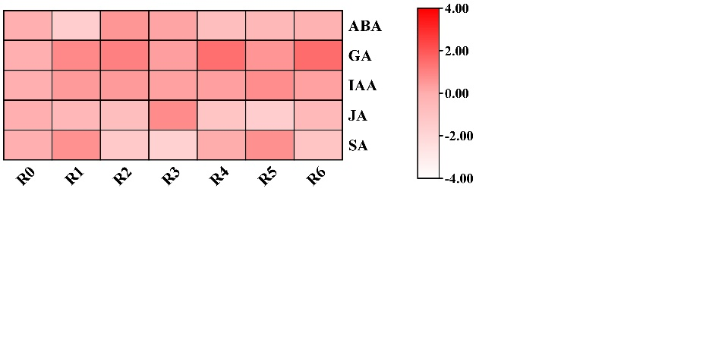
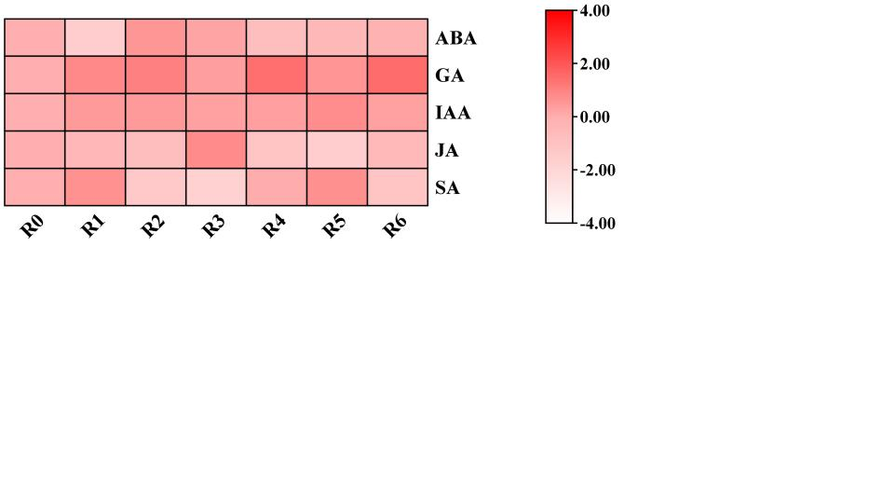
Supplementary Fig. S2: Heatmap showing the expression levels of the previously documented pepper internal reference genes under various hormonal treatments in the Pepper Hub dataset.
Actin
GAPDH

