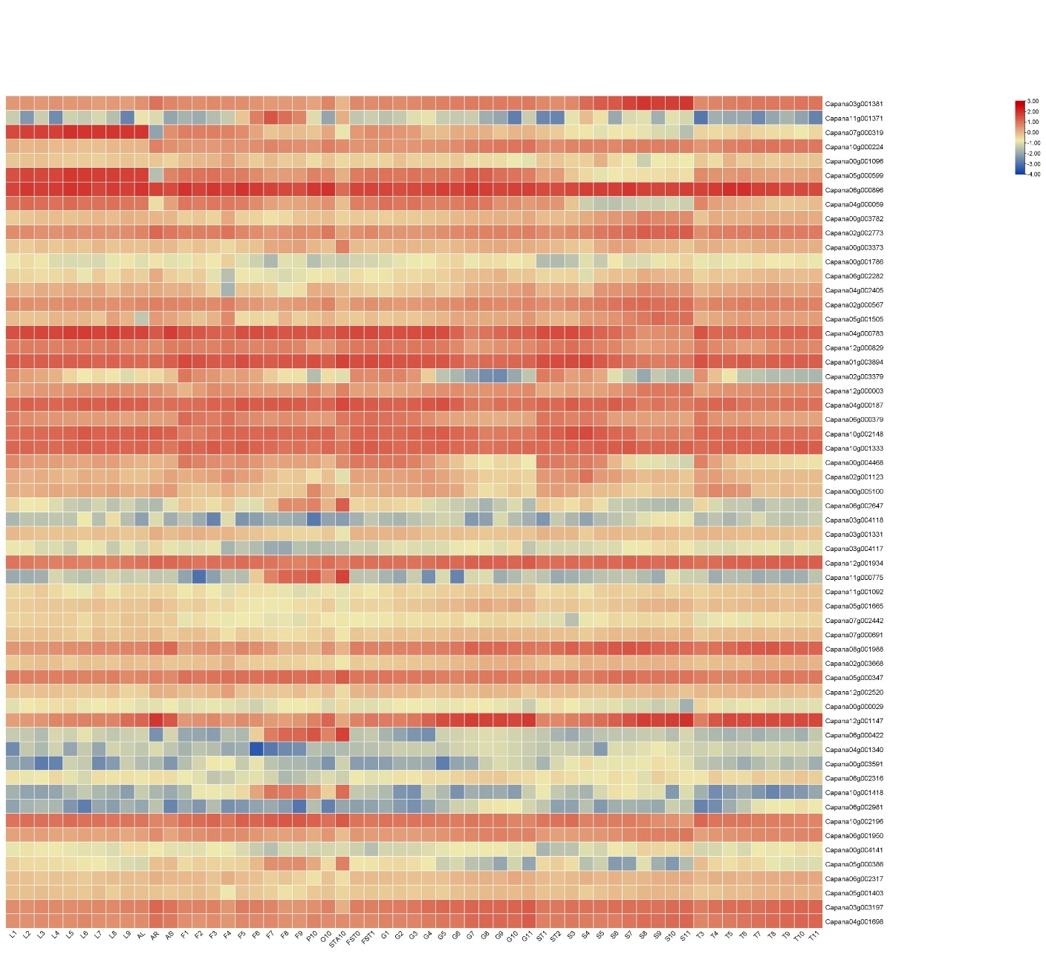
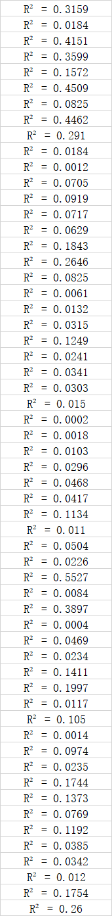
Supplementary Fig. S1: Expression heat maps and R² of four gene families. (The date is from Pepper Hub and some genes with absent expression levels are removed.)

