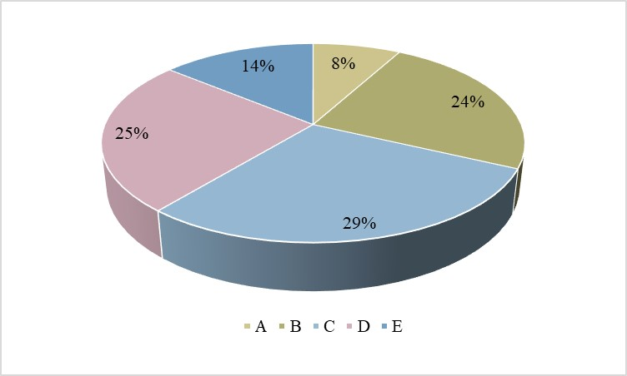
Supplementary Figure 3. The proportion of leaf color types in ‘F₂-449’ population.

