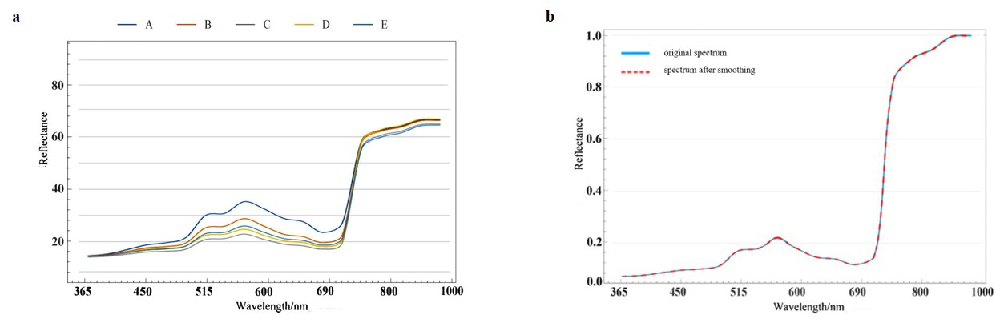
Supplementary Figure 1. (a) Multispectral K-means clustering center spectrogram of leaf color samples. (b) Comparison between the original spectrum after SNV processing and the spectrum after SG smoothing.

