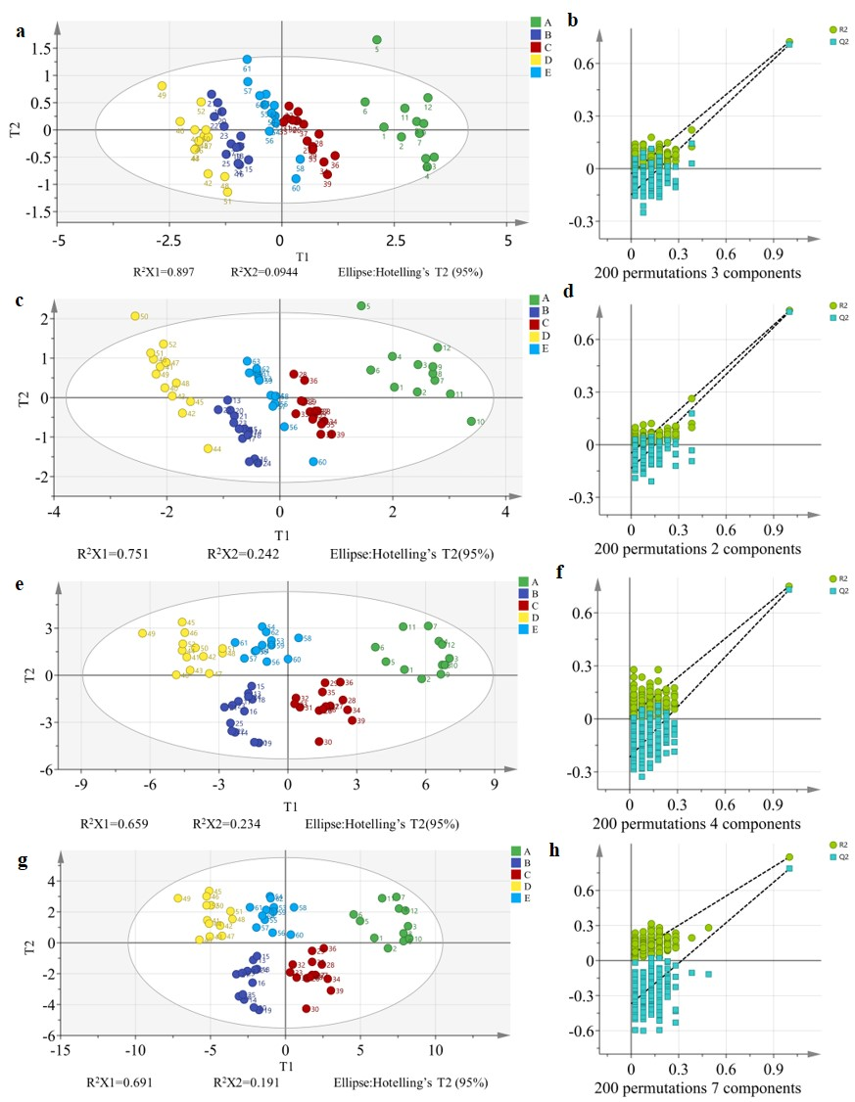
Supplementary Figure 2. PLS-DA model based on image RGB (a, b) and HSL (c, d) color, multispectral data (e, f) and data fusion (g, h).

