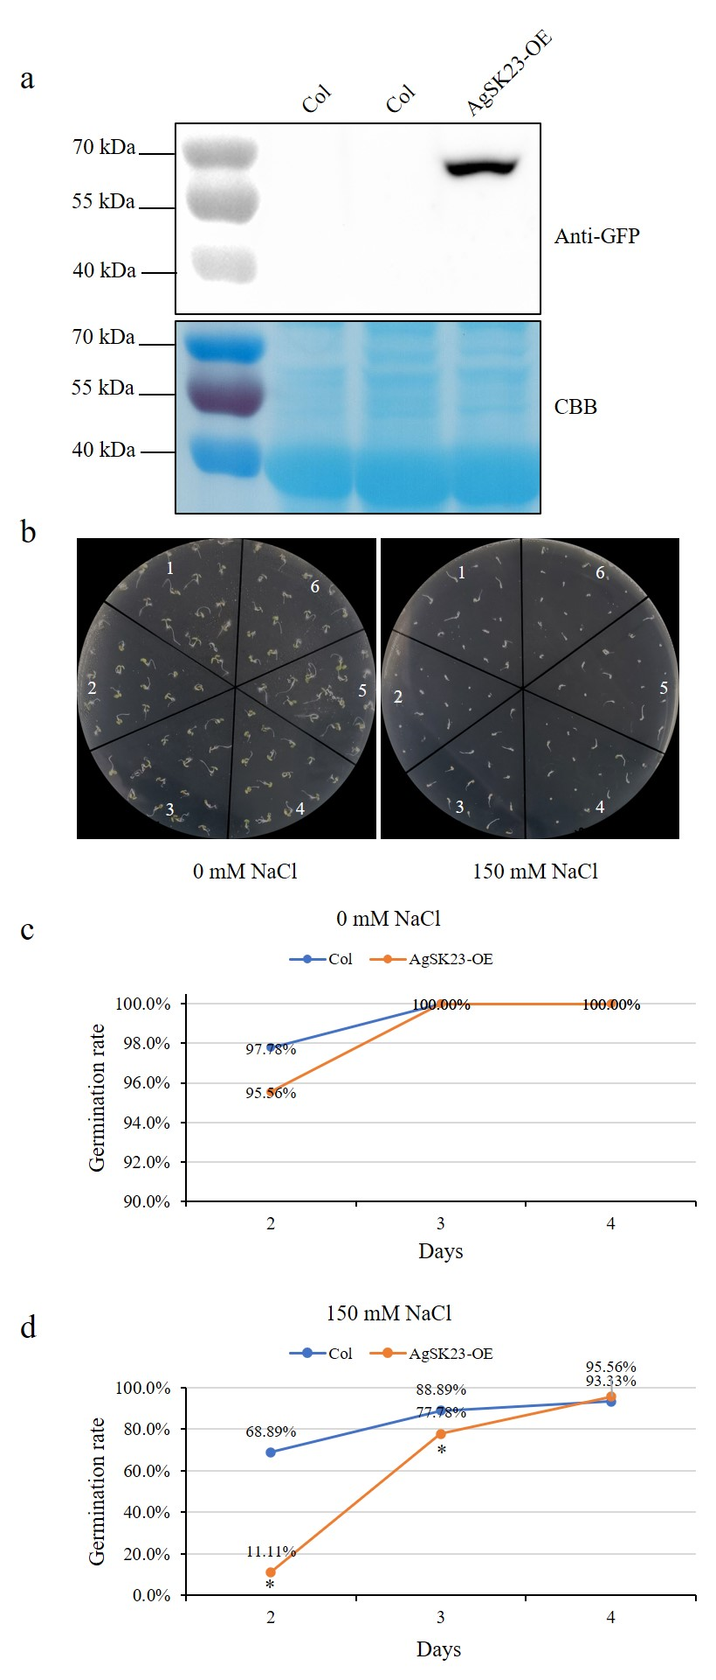
Figure S2. Responses of AgSK23 overexpression transgenic Arabidopsis plants to NaCl. (a) AgSK23 protein was detected using an anti-GFP antibody. (b) AgSK23 overexpression transgenic lines showed more sensitive phenotypes when germinated on 1/2 MS media with 0 or 150 mM NaCl for 3 days. 1, 3, 5: Col; 2, 4, 6: AgSK23-OE. (c) and (d) Germination rate of Col-0 and AgSK23-OE overexpression transgenic lines at 2-, 3-, and 4-day on 1/2 MS media containing 0 or 150 mM NaCl. Asterisk (*) denotes P < 0.05, as determined by a Student’s t-test.

