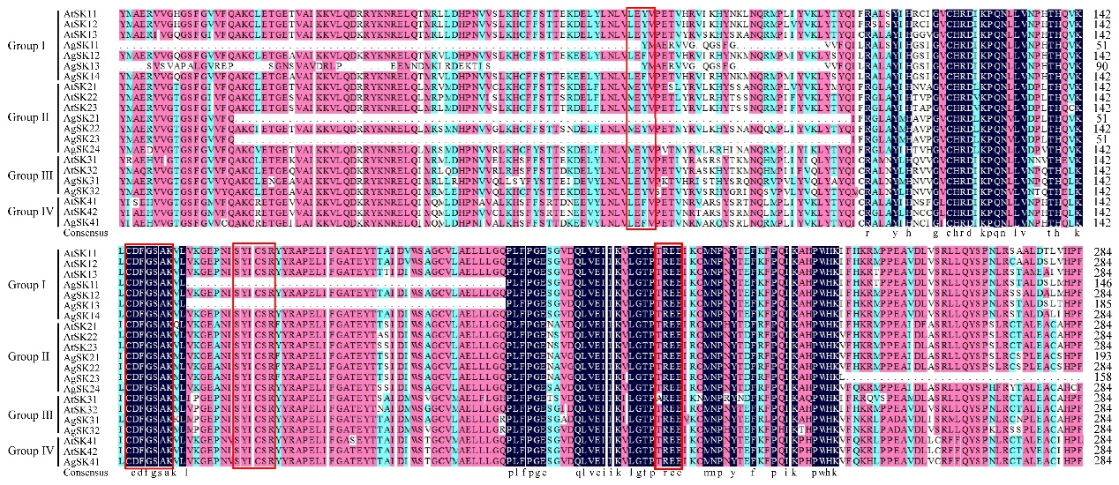
Figure S1. Sequence alignment of STKs_GSK3 domain of AgSKs and AtSKs. Motifs CDFGSAK, SYICSR, TREE and M/LEYV were indicated by red color boxes.

