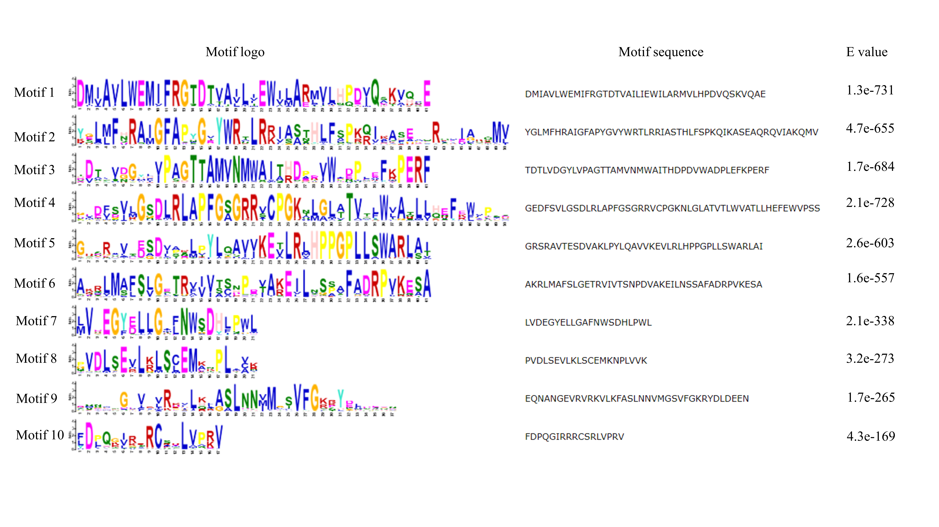
Supplemental Figure S1. Motif sequences identified in CYP78A proteins from eggplant, Arabidopsis, rice and tomato by MEME.

