Supplementary Table 1 Flow cytometry results

Sample name | Reference selection | Reference fluorescence intensity | Test sample fluorescence intensity | Ratio | Genome(Gb)
Ficus altissima | Solanum lycopersicum | 28.07 | 13.56 | 0.48 | 0.43
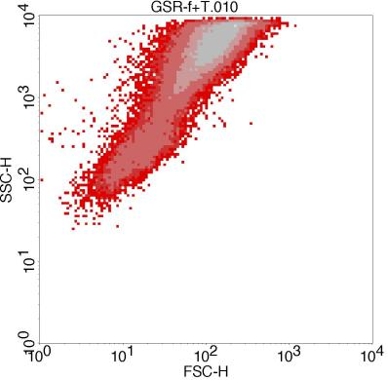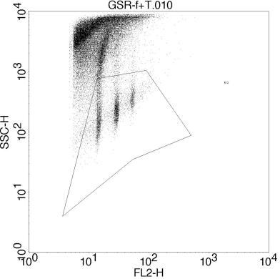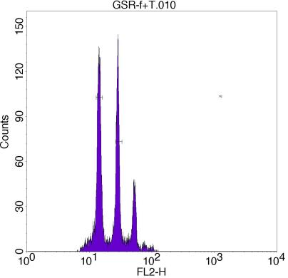

Sample name | Reference selection | Reference fluorescence intensity | Test sample fluorescence intensity | Ratio | Genome(Gb)
Ficus hirta | Zea mays | 54.87 | 7.17 | 0.13 | 0.30
