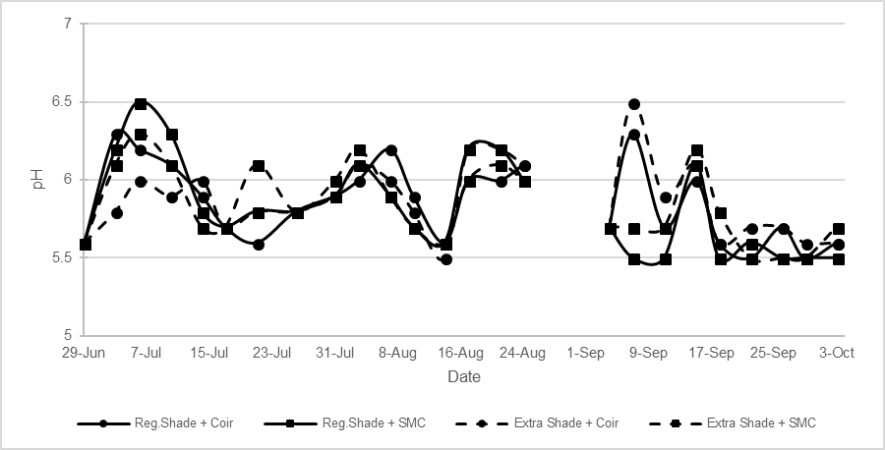
Figure S2. Fluctuation of pH in recirculation system. Discontinuity in the graph indicates missing data.

