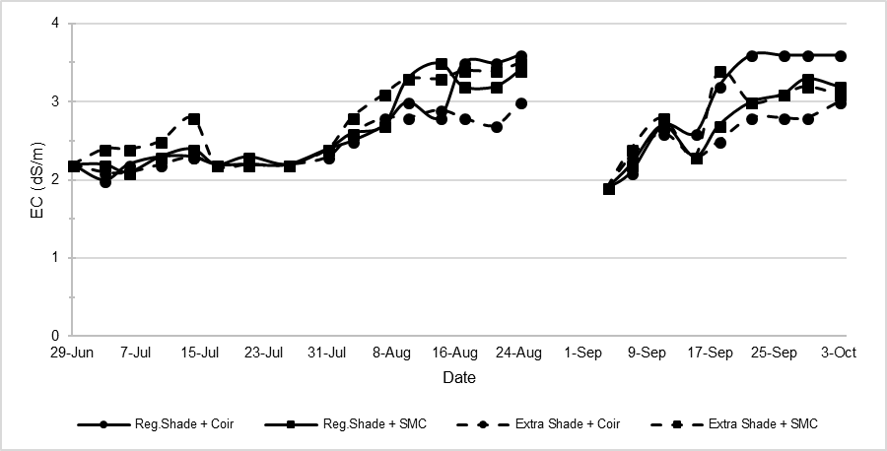
Figure S1. Fluctuation of electrical conductivity (EC) in recirculating system. Discontinuity in the graph indicates missing data.

