Supplemental figure 1. Photos of the seven genotypes that were treated for 8 weeks: control (left), EC5 (middle), and EC10 (right). The genotype arrangement in each treatment was randomized. Photos were taken right after trimming.
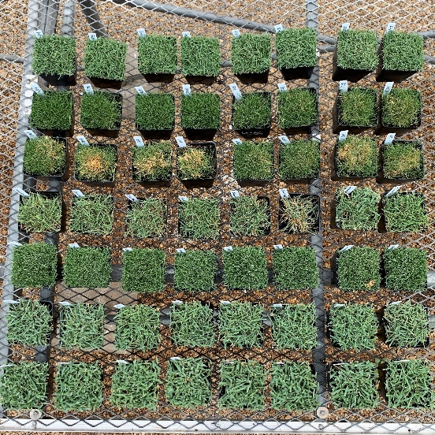
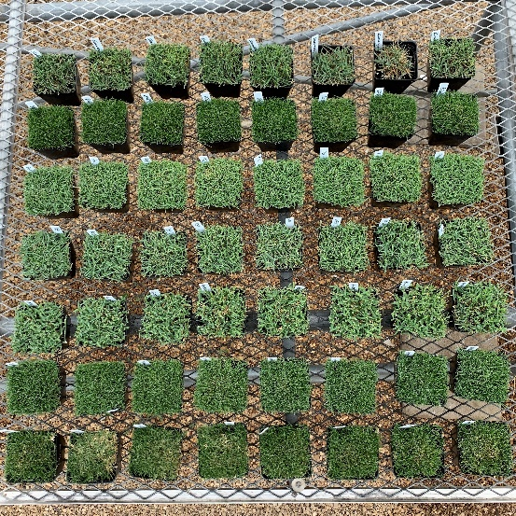
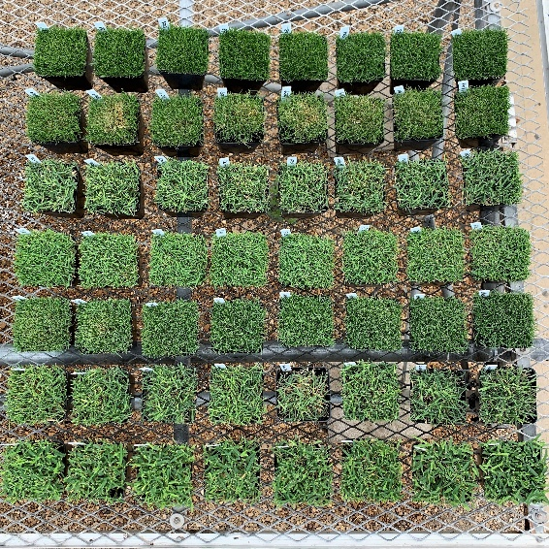
From top to bottom:
Lazer, DALZ 1309, DALZ 1701, DALZ 1713, Innovation, Diamond, Palisade
From top to bottom:
Innovation, Lazer, DALZ 1309, DALZ 1713, DALZ 1701, Palisade, Diamond, 1309
From top to bottom:
DALZ 1713, Lazer, DALZ 1309, Innovation, Diamond, DALZ 1701, Palisade

