Supplementary File 1: Supporting materials to this study.

WG4GEE: A GEE-Integrated Regional Winter Wheat Growth Model for Efficient Agronomic Process and Yield Simulation
Qin Han^{a,b,1},Wenjun Zuo^{a,c,1}, Runjia Xue ^{a,d}, Jingyan Shi^{b,c}, Zhaowen Zheng^{a,c}, Hao Xu^{e}, Xiaolei Qiu^{a,b}, Liang Tang^{a,b}, Yan Zhu^{b,c}, Weixing Cao^{c,d}, Xiaohu Zhang^{a,b*}
ª National Engineering and Technology Center for Information Agriculture, Nanjing Agricultural University, Nanjing 210095, China
^{b} Key Laboratory for Crop System Analysis and Decision Making, Ministry of Agriculture and Rural Affairs, Nanjing 210095, China
^{c} Jiangsu Key Laboratory for Information Agriculture, Nanjing 210095, China
^{d} Jiangsu Collaborative Innovation Center for Modern Crop Production, Nanjing 210095, China
^{e} Institute of Agricultural Information and Economics, Shandong Academy of Agricultural Sciences, Jinan 250000, China
¹ Qin Han and Wenjun Zuo have contributed to the work equally
* Corresponding author at: National Engineering and Technology Center for Information Agriculture, Nanjing Agricultural University, Nanjing 210095, China
E-mail address: zhangxiaohu@njau.edu.cn

The specific procedure for the dual-window planting date simulation rule proposed in this study is outlined as follows (Figure S1):
(1) Determine the overwintering day: set the overwintering temperature $T_{threshold}$ to 0 °C for regions where the coldest monthly mean temperature $T_{coldest_mean}$ is less than or equal to 0°C, and set $T_{threshold}=T_{coldest_mean}$ for regions where $T_{coldest_mean}$ is greater than 0 °C. The first day of seven consecutive days on which the mean temperature $aT$ is below $T_{threshold}$ is defined as the overwintering day for winter wheat in that year.
(2) Determine the winter-springiness ability of regionally suitable cultivars: Based on the coldest monthly mean temperature $T_{coldest_mean}$, determine the winter-springiness of winter wheat suitable for planting in different regions. This categorization includes strong winter hardiness, winter hardiness, semi-winter hardiness, and spring habit. These four types of winter wheat can correspond to different pre-winter suitable cumulative temperatures $T_{ac}$ and optimal sowing temperatures $T_{sow}$.
(3) Determine the planting date: Accumulate the daily cumulative temperature $T_{ac_daily}$ from the overwintering date forward to the total cumulative temperature equal to $T_{ac}$. Define this date as the potential planting date. Project the potential sowing date forward and backward three days each, and set the sowing date to the date in the week in which the potential sowing date falls that has the temperature closest to $T_{sow}$.

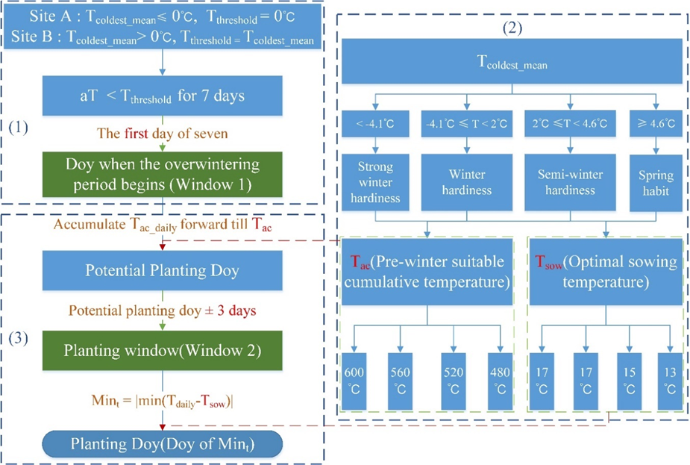
Figure S1 Winter wheat planting date simulation based on dual-window rule.
Simulations based on different rules (Table S1) produced the distribution of 2010-2018 sowing date means within the winter wheat region (Fig. S2). Generally, the planting date of winter wheat showed a trend of gradually advancing from south to north and from low to high altitude with spatial location. Validating the results with observed planting dates from 129 agricultural stations within the winter wheat region (Fig. S3), simulations using the rule based solely on temperature window (Table S1a, Fig. S3a) and the rule incorporating soil moisture (Table S1b, Fig. S3b) generally indicated later planting dates in the winter wheat region of China. Moreover, the discrete planting dates obtained from simulations using these two rules may contribute to increased model error.
The dual-window rule proposed in this study, based on agronomic prior knowledge, performed well overall while maintaining the mechanistic nature of the planting date simulation process (Fig. S3c). However, when results were analyzed for different sub-regions, the performance of the dual-window rule varied significantly. It performs well in the plains (Huanghuai winter wheat sub-region) but poorly in the southwest winter wheat region. This discrepancy arises from the dual-window rule being solely temperature-based, and the Southwest winter wheat sub-region, characterized by complex topography, noticeable terrain changes, and diverse microclimates, exhibits high actual spatial variability in temperature. The coarse resolution of the meteorological data used in this study makes capturing temperature variability at a small spatial scale challenging, resulting in better performance in areas with smaller temperature variability and poorer performance in areas with larger variability.

Table S1 Different rules for simulating winter wheat planting dates.
ID | Rules | Reference
a) | $doy$when $aT$<12 ℃ for 7 days | (Dobor et al., 2016)
b) | $doy$when $aT$<14 ℃ for 7 days and 20%<$NWC$<80% | (Dobor et al., 2016)
c) | dual-window model | /
$doy$: Day of year. $aT$: Average daily air temperature at 2m. $NWC$: Normalized water content of the top soil.

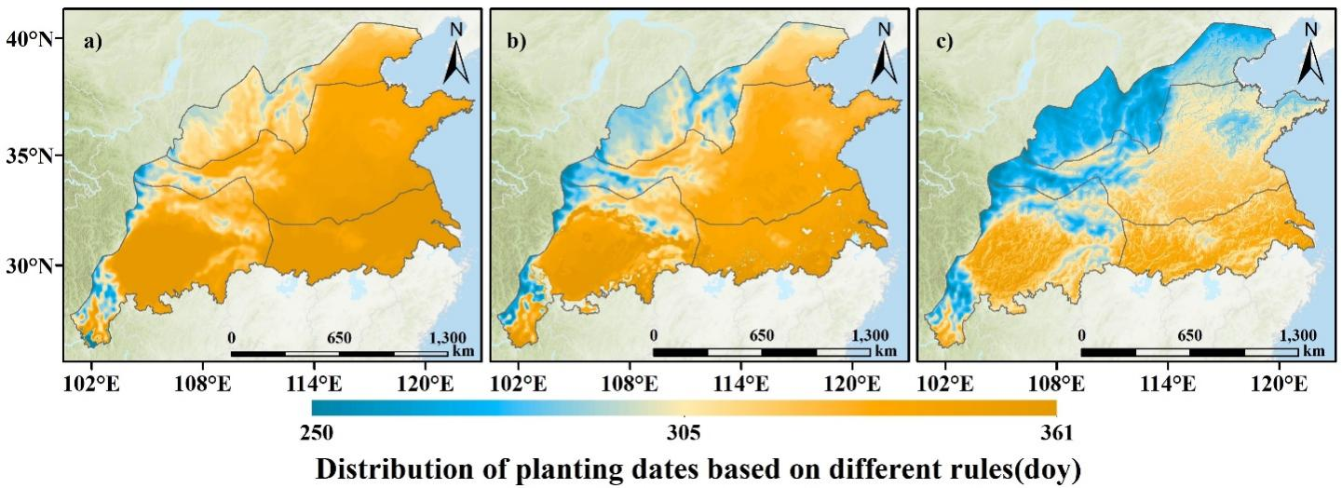
Figure S2 Spatial distribution of winter wheat planting date based on three rules. a)-c) represent different rules, with specific details outlined in Table 5.
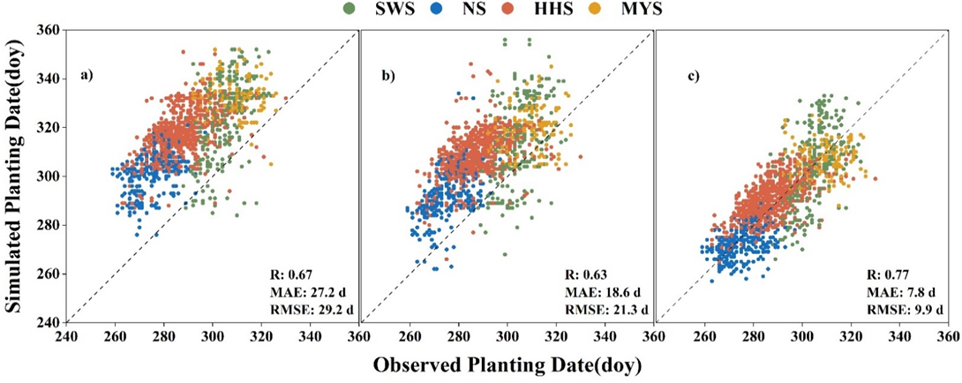
Figure S3 Observed winter wheat planting date versus simulated planting date by three rules. a)-c) represent different rules, with specific details outlined in Table 5.

Reference
L. Dobor, Z. Barcza, T. Hlásny, T. árendás, T. Spitkó, N. Fodor. Crop planting date matters: Estimation methods and effect on future yields[J]. Agricultural & Forest Meteorology, 2016, 223: 103-115.

