Transfer learning algorithm assisted in the discovery of novel gp130 inhibitors and their application in colorectal cancer treatment
Jie Guan^{1,#}, Lecheng Xiao^{1,#}, Jian Hong^{2,#}, Jin Wang¹, Guiping Cai¹, Des R Richardson³, Yixian Liao^{1,*}, Wenying Yu^{1,*}
¹State Key Laboratory of Natural Medicines, China Pharmaceutical University, Nanjing 211198, China
²Department of Geriatric Medicine, The First Affiliated Hospital of Nanjing Medical University, Nanjing 210029, China
³Centre for Cancer Cell Biology and Drug Discovery, Institute for Biomedicine and Glycomics, Griffith University, Gold Coast, Queensland 4215, Australia; Department of Pathology and Biological Responses, Nagoya University Graduate School of Medicine, Nagoya 466-8550, Japan

#These authors contributed equally: Jie Guan, Lecheng Xiao, Jian Hong
*Correspondence: yixian_liao@163.com (Yixian Liao); ywy@cpu.edu.cn (Wenying Yu)

Table of Contents
1. Figures and Tables 3
Figure S1 Study on the interaction between evodiamine, rutecarpine and bazedoxifene and gp130 protein 3
Table S1 Hyperparameter search space and optimized values selected by Bayesian optimization for the STAT3 pretraining model 4
Table S2 ADMET-based screening criteria and corresponding molecular property descriptors used for compound pre-selection 4
Table S3 Performance comparison between baseline and transfer learning models 4
Table S4 Anti-proliferative activity of the compounds 4a-9d in HT-29 cells. 4
Table S5 Antiproliferative effects of the preferred compound 8a and bazedoxifene on normal cells. 5
2.Chemistry 6
General Information for Chemistry. 6
General procedures for the preparation of 2a-2d. 6
General procedures for the preparation of 3a-3d. 7
General procedures for the preparation of 2e-2g. 7
General procedures for the preparation of 3e-3g. 8
General procedures for the preparation of 4a-8g. 8
3. Characterization spectra of all compounds 15

1. Figures and Tables

Figure S1 Study on the interaction between evodiamine, rutecarpine and bazedoxifene and gp130 protein. (a) The heat effect of evodiamine binding with gp130 protein (left), fitting curve (middle), and binding thermodynamic parameters (right). (b) The heat effect of rutecarpine binding with gp130 protein (left), fitting curve (middle), and binding thermodynamic parameters (right). (c) The heat effect of bazedoxifene binding with gp130 protein (left), fitting curve (middle), and binding thermodynamic parameters (right)

Table S1 Hyperparameter search space and optimized values selected by Bayesian optimization for the STAT3 pretraining model
Hyperparameters | Search range | Optimized value
Message-passing hidden dimension | 300-2400 | 1800
Feed-forward network hidden dimension | 300-2400 | 1500
Network depth | 2-6 | 3
Dropout rate | 0-0.4 | 0
Number of feed-forward layers | 1-3 | 2

Table S2 ADMET-based screening criteria and corresponding molecular property descriptors used for compound pre-selection
Descriptor | Property and Criterion
Quantitative Estimate of Drug-likeness | QED>0.67
Lipinski’s Rule of Five | Lipinski (optimal)
Caco-2 Cell Permeability | Caco2≥-4.7
Molecular Weight | 100≤MW≤600
Octanol-Water Partition Coefficient | logP<5.0
Number of Hydrogen Bond Acceptors | nHA≤12
Number of Hydrogen Bond Donors | nHD≤7
Number of Rotatable Bonds | nRot≤11
Number of Rings | nRing≤6
Number of Heteroatoms | 1≤nHet≤15
Topological Polar Surface Area | TPSA≤140

Table S3 Performance comparison between baseline and transfer learning models
Model | AUROC | AUPRC | Recall@3
Baseline | 0.7436 ± 0.2793 | 0.9322 ± 0.0888 | 0.3814 ± 0.0687
Transfer learning | 0.8260 ± 0.1960 | 0.9620 ± 0.0499 | 0.3980 ± 0.0455

Table S4 Anti-proliferative activity of the compounds 4a-9d in HT-29 cells.
Compound | IC₅₀ ª (μmol∙L⁻¹)
Compound | HT-29 | SW480 | HCT116 | HIEC-6
6a | 6.18 ± 0.83 | 36.83 ± 1.48 | 9.382 ± 0.94 | 12.00 ± 0.85
6b | 5.77 ± 0.79 | 30.48 ± 1.38 | 11.63 ± 1.01 | 11.43 ± 0.56
6d | 7.55 ± 0.92 | 17.57 ± 0.86 | 11.61 ± 1.35 | 12.61 ± 0.87
8a | 4.57 ± 0.16 | 15.24 ± 0.47 | 15.04 ± 0.56 | 18.53 ± 0.53
8b | 6.57 ± 0.91 | 21.77 ± 1.27 | 12.53 ± 1.04 | 13.67 ± 0.91
8d | 6.58 ± 1.21 | 20.06 ± 1.23 | 11.76 ± 1.01 | 11.37 ± 1.10
Bazedoxifene^{b} | 10.03 ± 1.02 | 5.28 ± 0.03 | 5.93 ± 0.21 | 11.3 ± 0.50
ªIC₅₀: 50% inhibitory concentration (means ± SD of three experiments).
^{b}Used as positive control.

Table S5 Antiproliferative effects of the preferred compound 8a and bazedoxifene on normal cells.
Compound | IC₅₀ª (μmol∙L⁻¹)
Compound | MCF-10A | Beas-2B | 293T | L-02 | HIEC-6
8a | 28.30 ± 0.99 | 14.78 ± 0.28 | 9.26 ± 0.13 | 17.01 ± 0.29 | 18.53 ± 0.53
bazedoxifene^{b} | 12.88 ± 0.19 | 5.533 ± 0.23 | 6.69 ± 0.98 | 13.7 ± 0.64 | 11.3 ± 0.50
ªIC50: 50% inhibitory concentration (means ± SD of three experiments).
^{b}Used as positive control.
.

2.Chemistry

General Information for Chemistry.
All chemicals were obtained from commercial suppliers and used without further purification. The reaction progress was monitored via analytical thin layer chromatography (TLC) on precoated silica gel GF254 plates (Qingdao Haiyang Chemical Plant, Qingdao, China), and the spots were detected under UV light (254 nm). The melting point was measured on an XT-4 micromelting point instrument. IR (KBr-disc) spectra were recorded with a Bruker Tensor 27 spectrometer. ¹H NMR and ¹³C NMR spectra were measured on a Bruker ACF-500 spectrometer at 25°C and referenced to TMS. Chemical shifts are reported in ppm (δ) using the residual solvent line as an internal standard. Splitting patterns were designed as s, singlet; br.s, broad single; d, doublet; t, triplet; and m, multiplet. The purities of all the compounds used for biological evaluation were confirmed to be greater than 95% through analytical HPLC performed with an Agilent 1100 HPLC System. Mass spectra were obtained on an MS Agilent 1100 Series LC/MSD Trap mass spectrometer (ESI-MS) and a Mariner ESI-TOF spectrometer (HRESI-MS), respectively.

General procedures for the preparation of 2a-2d.
To a solution of sodium hydroxide (2.4 equiv) in water (45 mL) was added p-hydroxy benzyl alcohol (1.0 equiv), and the mixture was stirred for 20 min. Toluene (30 mL), compounds 1a-1d (1.3 equiv) and tetra butyl ammonium bromide (0.02 equiv) were subsequently added. The mixture was subsequently heated to reflux (85-90°C) and stirred vigorously for 2 h. The organic layer was separated and washed with water and saltwater, after which the solvent was removed under reduced pressure. The residue was purified by silica gel column chromatography to yield target compounds 2a-2d.
1-(2-chloroethyl)pyrrolidine hydrochloride (2a). Following the above procedure, p-hydroxybenzyl alcohol (35.73 mg, 0.29 mmol) and 1-(2-chloroethyl) pyrrolidine (50.00 mg, 0.37 mmol) were used as starting materials. After purification, 2a was obtained as a white solid (63.70 mg, 75.0% yield); ¹H NMR (300 MHz, chloroform-d) δ 7.27-7.19 (m, 2H), 6.85-6.76 (m, 2H), 4.55 (s, 2H), 3.99 (t, J = 6.0 Hz, 2H), 3.90 (s, 1H), 2.84 (t, J = 6.0 Hz, 2H), 2.59 (td, J = 5.4, 4.7, 2.2 Hz, 4H), 1.78 (p, J = 3.1 Hz, 4H).
1-(2-chloroethyl)piperidine hydrochloride (2b). Following the above procedure, p-hydroxybenzyl alcohol (29.10 mg, 0.23 mmol) and 1-(2-chloroethyl) piperidine (55.17 mg, 0.30 mmol) were used as starting materials. After purification, 2b was obtained as a white solid (51.88 mg, 70.0% yield); ¹H NMR (400 MHz, chloroform-d) δ 7.28 (d, J = 8.8 Hz, 2H), 6.91-6.85 (m, 2H), 4.61 (s, 2H), 4.09 (t, J = 6.1 Hz, 2H), 2.77 (t, J = 6.1 Hz, 2H), 2.51 (t, J = 5.5 Hz, 4H), 1.62 (p, J = 5.6 Hz, 4H), 1.45 (q, J = 6.2 Hz, 2H).
4-(2-chloroethyl)morpholine hydrochloride (2c). Following the above procedure, p-hydroxybenzyl alcohol (28.72 mg, 0.23 mmol) and 1-(2-chloroethyl)-pyrrolidine (45.00 mg, 0.30 mmol) were used as starting materials. After purification, 2c was obtained as a white solid (54.90 mg, 77.0% yield); ¹H NMR (300 MHz, chloroform-d) δ 7.28 (d, J = 8.2 Hz, 1H), 6.89 (d, J = 7.6 Hz, 1H), 4.61 (s, 2H), 4.11 (t, J = 5.8 Hz, 2H), 3.85-3.65 (m, 4H), 2.81 (t, J = 5.5 Hz, 2H), 2.69-2.51 (m, 4H).
1-(2-chloroethyl)azepane hydrochloride (2d). Following the above procedure, p-hydroxybenzyl alcohol (31.42 mg, 0.25 mmol) and 1-(2-chloroethyl)-pyrrolidine (53.20 mg, 0.33 mmol) were used as starting materials. After purification, 2d was obtained as a white solid (63.12 mg, 70.0% yield); ¹H NMR (400 MHz, chloroform-d) δ 7.27 (d, J = 8.6 Hz, 2H), 6.87 (d, J = 8.6 Hz, 1H), 4.60 (s, 2H), 4.05 (t, J = 6.2 Hz, 2H), 2.94 (t, J = 6.2 Hz, 2H), 2.81-2.74 (m, 4H), 2.32 (s, 1H), 1.71-1.56 (m, 8H).

General procedures for the preparation of 3a-3d.
A solution of compounds 2a-2d (1.0 equiv) in tetrahydrofuran was cooled to 0°C, and sulfoxide chloride was then slowly added to the mixture. The resulting mixture was stirred at room temperature overnight. When TLC indicated that the reaction was complete, the solvent was removed under reduced pressure. To the reaction mixture, 1.2 mL of tetrahydrofuran and 0.6 mL of n-hexane were added, followed by stirring at room temperature for 1 hour. The mixture was filtered to obtain 3a-3d, which were used as such (without further purification) in the subsequent step.
1-(2-(4-(chloromethyl)phenoxy)ethyl)pyrrolidine (3a). Following the above procedure, 2a (60.00 mg, 0.27 mmol) and SOCl₂ were used as starting materials. After purification, 3a was obtained as a white solid (65.00 mg, 67.0% yield); ¹H NMR (300 MHz, DMSO-d₆) δ 11.05 (s, 1H), 7.40 (dd, J = 8.6, 2.0 Hz, 2H), 7.01 (d, J = 8.6, 2.1 Hz, 2H), 4.74 (s, 2H), 4.37 (t, J = 5.1 Hz, 2H), 3.56 (q, J = 5.0 Hz, 4H), 3.10 (d, J = 9.0 Hz, 2H), 2.04-1.82 (m, 4H).
1-(2-(4-(chloromethyl)phenoxy)ethyl)piperidine (3b). Following the above procedure, 2b (60.00 mg, 0.25 mmol) and SOCl₂ (0.03 mL, 0.23 mmol) were used as starting materials. After purification, 3b was obtained as a white solid (64.70 mg, 65.8% yield); ¹H NMR (300 MHz, chloroform-d) δ 12.49 (s, 1H), 7.33 (d, J= 8.0 Hz, 2H), 6.88 (d, J = 8.1 Hz, 2H), 4.57 (s, 4H), 3.64 (d, J = 12.0 Hz, 2H), 3.48-3.33 (m, 2H), 2.95-2.71 (m. 2H), 2.40-2.15 (m, 2H), 1.98-1.79 (m, 2H), 1.53-1.34 (m, 1H).
4-(2-(4-(chloromethyl)phenoxy)ethyl)morpholine (3c). Following the above procedure, 2c (60.00 mg, 0.25 mmol) and SOCl₂ were used as starting materials. After purification, 3c was obtained as a white solid (64.66 mg, 65.0% yield); ¹H NMR (300 MHz, DMSO-d₆) δ 12.01 (s, 1H), 7.40 (d, J = 7.7 Hz, 2H), 7.01 (d, J = 8.0 Hz, 2H), 4.74 (s, 2H), 4.49 (t, J = 5.1 Hz, 2H), 4.01-3.82 (m, 4H), 3.60-3.41 (m, 4H), 3.29-3.16 (m, 2H).
1-(2-(4-(chloromethyl)phenoxy)ethyl)azepane (3d). Following the above procedure, 2d (60.00 mg, 0.24 mmol) and SOCl₂ were used as starting materials. After purification, 3d was obtained as a white solid (64.44 mg, 61.0% yield); ¹H NMR (300 MHz, chloroform-d) δ 12.52 (s, 1H), 7.33 (d, J = 8.5 Hz, 2H), 6.89 (d, J = 8.6 Hz, 2H), 4.56 (s, 4H), 3.72-3.55 (m, 2H), 3.48 (s, 2H), 3.23-3.04 (m, 2H),2.28-2.09 (m, 2H), 1.95-1.82 (m, 4H), 1.73-1.60 (m, 2H).

General procedures for the preparation of 2e-2g.
1e-1g (500 mg, 4.09 mmol), 4-hydroxybenzaldehyde (499.82 mg, 4.09 mmol), and PPh₃ (1.29 g, 4.91 mmol) were added to dry tetrahydrofuran (20 mL). Stir under nitrogen protection and cool the mixture to 0°C using an ice bath. DIAD (993.12 mg, 4.91 mmol) was added dropwise to the mixture over approximately 5 minutes. The reaction was monitored by TLC; after approximately 1 h, the starting material was completely consumed. The solvent was subsequently removed via vacuum evaporation, and the product was purified via silica gel column chromatography with a petroleum ether:ethyl acetate ratio of 2:1 to obtain the intermediates. Next, the intermediate (883.88 mmol) was dissolved in 20 mL of ethanol, and 2 equivalents of sodium borohydride (100.32 mg, 2.65 mmol) were added. The reaction was allowed to proceed for 1 hour, and the progress was monitored by TLC. After the reaction was complete, the ethanol was removed via vacuum distillation. The organic layer was extracted with dichloromethane and dried over anhydrous sodium sulfate. The solvent was filtered and evaporated to obtain a colorless, transparent, oily substance.
4-phenethoxybenzaldehyde (2e). Following the above procedure, phenethyl alcohol (500.00 mg, 4.09 mmol) and PPh₃ were used as starting materials. After purification, 2e was obtained as a white solid (926.09 mg, 85.0% yield); ¹H NMR (300 MHz, DMSO-d6) δ 7.36-7.27 (m, 4H), 7.26-7.16 (m, 3H), 6.92-6.84 (m, 2H), 5.04 (t, J = 5.7 Hz, 1H), 4.40 (d, J = 5.7 Hz, 2H), 4.16 (t, J = 6.9 Hz, 2H), 3.02 (t, J = 6.9 Hz, 2H).
4-(3-(trifluoromethyl)phenethoxy)benzaldehyde (2f). Following the above procedure, 2-(2-hydroxyethyl)pyridine (500.00 mg, 2.63 mmol) and PPh₃ were used as starting materials. After purification, 2f was obtained as a white solid (773.73 mg, 75.0% yield); ¹H NMR (400 MHz, DMSO-d6) δ 7.72-7.68 (m, 1H), 7.67-7.63 (m, 1H), 7.61-7.51 (m, 2H), 7.25-7.16 (m, 2H), 6.91-6.83 (m, 2H), 5.03 (t, J = 5.7 Hz, 1H), 4.40 (d, J = 5.7 Hz, 2H), 4.21 (t, J = 6.7 Hz, 2H), 3.13 (t, J = 6.7 Hz, 2H).
4-(2-(pyridin-2-yl)ethoxy)benzaldehyde (2g). Following the above procedure, 2-(trifluoromethyl)phenethyl alcohol (500.00 mg, 4.06 mmol) and PPh₃ were used as starting materials. After purification, 2g was obtained as a white solid (922.67 mg, 76.0% yield); ¹H NMR (400 MHz, DMSO-d6) δ 8.51 (ddd, J = 4.9, 1.9, 0.9 Hz, 1H), 7.72 (td, J = 7.6, 1.9 Hz, 1H), 7.36 (dt, J = 7.9, 1.1 Hz, 1H), 7.27-7.16 (m, 3H), 6.92-6.82 (m, 2H), 5.03 (t, J = 5.7 Hz, 1H), 4.40 (d, J = 5.7 Hz, 2H), 4.33 (t, J = 6.7 Hz, 2H), 3.17 (t, J = 6.7 Hz, 2H).

General procedures for the preparation of 3e-3g.
2e-2g was dissolved in 20 mL of anhydrous dichloromethane, respectively, and at 0°C, 1.5 equivalents of thionyl chloride were added dropwise. After the reaction proceeded for 12 h, excess triethylamine was added to neutralize the hydrochloric acid generated during the reaction, resulting in the formation of intermediates 3e-3g. No purification was needed, and the reaction proceeded directly to the next reaction step.

General procedures for the preparation of 4a-8g.
To a solution of compounds 4-8 (1.0 equiv.) stirred under anhydrous dimethylformamide argon protection, sodium hydride (1.1 equiv.) was added. After the mixture was stirred at 0°C for 1 h, compounds 3a-3d and 3e-3g were added, and the mixture was stirred at room temperature for 4 h. When TLC indicated that the reaction was complete, the mixture was added to ice water and washed with ethyl acetate. The organic layer was separated and washed with water and saltwater, after which the solvent was removed under reduced pressure. The residue was purified by silica gel column chromatography to yield target compounds 4a-8g.
14-methyl-13-(4-(2-(pyrrolidin-1-yl)ethoxy)benzyl)-7,8,13b,14-tetrahydroindolo [2',3':3,4]pyrido[2,1-b]quinazolin-5(13H)-one (4a). Following the above procedure, 3a (40.30 mg, 0.17 mmol) and evodiamine (51.00 mg, 0.17 mmol) were used as starting materials. After purification, 4a was obtained as a white solid (85.17 mg, 77.0% yield); m.p. 70.4-71.5℃; ¹H NMR (300 MHz, chloroform-d) δ 8.09 (dd, J = 7.8, 1.6 Hz, 1H), 7.63 (dt, J = 7.6, 1.0 Hz, 1H), 7.48 (ddd, J = 8.0, 7.3, 1.6 Hz, 1H), 7.38 (dt, J = 8.2, 1.0 Hz, 1H), 7.28 (dd, J = 7.0, 1.3 Hz, 1H), 7.23-7.12 (m, 3H), 7.00-6.89 (m, 2H), 6.81-6.71 (m, 2H), 5.80 (d, J = 1.4 Hz, 1H), 5.59 (d, J = 16.3 Hz, 1H), 5.38 (d, J = 16.3 Hz, 1H), 4.90 (ddd, J = 12.7, 4.9, 1.8 Hz, 1H), 4.05 (t, J = 5.9 Hz, 2H), 3.17 (td, J = 12.2, 4.0 Hz, 1H), 3.05 (ddd, J = 15.5, 3.4, 1.9 Hz, 1H), 2.99 - 2.83 (m, 3H), 2.65 (dt, J = 6.3, 3.6 Hz, 4H), 2.38 (s, 3H), 1.80 (dq, J = 6.0, 3.0 Hz, 4H). ¹³C NMR (75 MHz, Chloroform-d) δ 164.60, 158.06, 150.82, 137.72, 132.91, 129.90, 128.91, 128.61, 127.68, 125.74, 124.20, 124.09, 123.06, 122.90, 119.79, 119.00, 114.74, 113.65, 110.01, 68.03, 66.72, 54.93, 54.68, 46.68, 39.36, 36.53, 23.44, 20.40. HR-ESI-MS m/z 507.2750 [M+H]⁺ (calcd. for 507.2755, C₃₂H₃₅N₄O₂).
14-methyl-13-(4-(2-(piperidin-1-yl)ethoxy)benzyl)-7,8,13b,14-tetrahydroindolo [2',3':3,4]pyrido[2,1-b]quinazolin-5(13H)-one(4b). Following the above procedure, 3b (42.06 mg, 0.16 mmol) and evodiamine (50.28 mg, 0.16 mmol) were used as starting materials. After purification, 4b was obtained as a white solid (86.30 mg, 73.0% yield); m.p. 71.3-72.1°C; ¹H NMR (300 MHz, chloroform-d) δ 8.09 (dd, J = 7.8, 1.6 Hz, 1H), 7.63 (dt, J = 7.6, 1.1 Hz, 1H), 7.48 (ddd, J = 8.0, 7.3, 1.7 Hz, 1H), 7.38 (dt, J = 8.3, 1.0 Hz, 1H), 7.30-7.21 (m, 2H), 7.17 (ddd, J = 8.0, 2.6, 1.1 Hz, 2H), 6.99-6.88 (m, 2H), 6.82-6.69 (m, 2H), 5.80 (d, J = 1.4 Hz, 1H), 5.59 (d, J = 16.3 Hz, 1H), 5.38 (d, J = 16.3 Hz, 1H), 4.90 (ddd, J = 12.7, 4.9, 1.8 Hz, 1H), 4.03 (t, J = 6.0 Hz, 2H), 3.17 (td, J = 12.2, 4.0 Hz, 1H), 3.10 - 2.85 (m, 2H), 2.74 (t, J = 6.0 Hz, 2H), 2.49 (t, J = 5.4 Hz, 4H), 2.38 (s, 3H), 1.59 (p, J = 5.6 Hz, 4H), 1.43 (q, J = 6.2 Hz, 2H). ¹³C NMR (75 MHz, Chloroform-d) δ 158.09, 150.82, 132.91, 129.83, 128.92, 128.61, 127.67, 125.75, 124.20, 124.09, 123.06, 122.90, 119.79, 119.00, 114.75, 113.65, 110.01, 65.78, 57.80, 54.99, 46.68, 39.36, 36.53, 25.77, 24.06, 20.39. HR-ESI-MS m/z 521.2909 [M+H]⁺ (calcd. for 521.2911, C₃₃H₃₆N₄O₂).
14-methyl-13-(4-(2-morpholinoethoxy)benzyl)-7,8,13b,14-tetrahydroindolo [2',3':3,4]pyrido[2,1-b]quinazolin-5(13H)-one(4c). Following the above procedure, 3c (42.15 mg, 0.16 mmol) and evodiamine (50.00 mg, 0.16 mmol) were used as starting materials. After purification, 4c was obtained as a white solid (86.14 mg, 72.1% yield); m.p. 59.7-60°C; ¹H NMR (300 MHz, chloroform-d) δ 8.10 (dd, J = 7.8, 1.6 Hz, 1H), 7.68-7.59 (m, 1H), 7.48 (td, J = 7.6, 1.6 Hz, 1H), 7.38 (d, J = 8.3 Hz, 1H), 7.35-7.12 (m, 5H), 6.98-6.89 (m, 2H), 6.80-6.69 (m, 2H), 5.80 (d, J = 1.4 Hz, 1H), 5.59 (d, J = 16.3 Hz, 1H), 5.39 (d, J = 16.3 Hz, 1H), 4.90 (ddd, J = 12.7, 4.9, 1.8 Hz, 1H), 4.04 (t, J = 5.6 Hz, 2H), 3.76-3.67 (m, 4H), 3.17 (td, J = 12.1, 4.0 Hz, 1H), 3.10 - 2.99 (m, 1H), 2.99 - 2.83 (m, 1H), 2.77 (t, J = 5.7 Hz, 2H), 2.56 (t, J = 4.6 Hz, 4H), 2.39 (s, 3H). ¹³C NMR (75 MHz, Chloroform-d) δ 164.60, 157.98, 150.82, 137.71, 132.92, 130.02, 128.92, 127.69, 125.75, 124.22, 124.08, 123.06, 122.91, 119.81, 119.02, 114.76, 113.69, 109.98, 68.03, 66.79, 65.63, 57.56, 54.02, 46.65, 39.36, 36.54, 20.39. HR-ESI-MS m/z 523.2708 [M+H]⁺ (calcd. for 523.2704, C₃₂H₃₅N₄O₃).
13-(4-(2-(azepan-1-yl)ethoxy)benzyl)-14-methyl-7,8,13b,14-tetrahydroindolo [2',3':3,4]pyrido[2,1-b]quinazolin-5(13H)-one(4d). Following the above procedure, 3d (48.55 mg, 0.18 mmol) and evodiamine (55.00 mg, 0.18 mmol) were used as starting materials. After purification, 4d was obtained as a white solid (96.94 mg, 74.0% yield); m.p. 72.4-74.1°C; ¹H NMR (300 MHz, chloroform-d) δ 8.09 (dd, J = 7.8, 1.6 Hz, 1H), 7.63 (dd, J = 7.4, 1.2 Hz, 1H), 7.48 (td, J = 7.7, 1.6 Hz, 1H), 7.41-7.35 (m, 1H), 7.29-7.21 (m, 2H), 7.21-7.15 (m, 2H), 6.98-6.89 (m, 2H), 6.80-6.69 (m, 2H), 5.80 (d, J = 1.4 Hz, 1H), 5.59 (d, J = 16.3 Hz, 1H), 5.38 (d, J = 16.3 Hz, 1H), 4.90 (ddd, J = 12.7, 4.9, 1.8 Hz, 1H), 4.01 (t, J = 6.1 Hz, 2H), 3.17 (td, J = 12.2, 4.0 Hz, 1H), 3.10-2.94 (m, 2H), 2.91 (d, J = 6.2 Hz, 2H), 2.80-2.74 (m, 4H), 2.38 (s, 3H), 1.69-1.55 (m, 8H). ¹³C NMR (75 MHz, Chloroform-d) δ 164.60, 158.13, 150.82, 137.72, 132.91, 129.82, 128.92, 128.61, 127.67, 125.74, 124.20, 124.08, 123.06, 122.90, 119.79, 119.00, 114.75, 113.65, 110.01, 77.26, 68.03, 66.21, 56.21, 55.78, 46.69, 39.36, 36.53, 27.56, 27.03, 20.40. HR-ESI-MS m/z 535.3067 [M+H]⁺ (calcd. for 535.3068, C₃₄H₃₉N₄O₃).
13-(4-(2-(pyrrolidin-1-yl)ethoxy)benzyl)-7,8-dihydroindolo[2',3':3,4]pyrido[2,1-b]quinazolin-5(13H)-one(5a). Following the above procedure, 3a (43.91 mg, 0.18 mmol) and routaecarpine (52.63 mg, 0.18 mmol) were used as starting materials. After purification, 5a was obtained as a white solid (89.87 mg, 82.0% yield); m.p. 115.6-116.5°C; ¹H NMR (300 MHz, chloroform-d) δ 8.29 (dd, J = 8.0, 1.5 Hz, 1H), 7.74-7.55 (m, 3H), 7.47-7.37 (m, 2H), 7.33 (ddd, J = 8.3, 6.9, 1.2 Hz, 1H), 7.24-7.12 (m, 3H), 6.84-6.74 (m, 2H), 6.12 (s, 2H), 4.54 (t, J = 6.7 Hz, 2H), 4.04 (t, J = 6.0 Hz, 2H), 3.19 (t, J = 6.7 Hz, 2H), 2.87 (t, J = 5.9 Hz, 2H), 2.61 (td, J = 5.0, 4.5, 2.0 Hz, 4H), 1.78 (dq, J = 6.0, 3.0 Hz, 4H). ¹³C NMR (75 MHz, Chloroform-d) δ 161.73, 157.87, 147.28, 140.37, 134.13, 131.03, 128.13, 127.22, 126.99, 126.59, 126.25, 125.47, 124.40, 120.90, 120.53, 120.08, 119.79, 114.54, 111.03, 66.74, 54.99, 54.66, 47.86, 40.85, 23.44, 19.87. HR-ESI-MS m/z 491.2443 [M+H]⁺ (calcd. For 491.2442, C₃₁H₃₀N₄O₂).
13-(4-(2-(piperidin-1-yl)ethoxy)benzyl)-7,8-dihydroindolo[2',3':3,4]pyrido[2,1-b]quinazolin-5(13H)-one(5b). Following the above procedure, 3b (40.61 mg, 0.16 mmol) and revutaecarpine (45.98 mg, 0.16 mmol) were used as starting materials. After purification, 5b was obtained as a white solid (80.76 mg, 71.0% yield); m.p. 114.2-115.3°C; ¹H NMR (300 MHz, chloroform-d) δ 8.29 (dt, J = 8.0, 1.0 Hz, 1H), 7.74-7.55 (m, 3H), 7.47-7.37 (m, 2H), 7.33 (ddd, J = 8.3, 6.9, 1.2 Hz, 1H), 7.23-7.10 (m, 3H), 6.85-6.72 (m, 2H), 6.12 (s, 2H), 4.54 (dd, J = 7.1, 6.3 Hz, 2H), 4.03 (t, J = 6.0 Hz, 2H), 3.19 (t, J = 6.7 Hz, 2H), 2.73 (t, J = 6.1 Hz, 2H), 2.48 (t, J = 5.4 Hz, 4H), 1.63-1.53 (m, 4H), 1.42 (q, J = 6.1 Hz, 2H). ¹³C NMR (75 MHz, Chloroform-d) δ 157.87, 140.37, 134.13, 130.98, 128.13, 127.21, 126.99, 126.58, 126.25, 125.46, 124.40, 120.90, 120.53, 120.08, 119.79, 114.54, 111.02, 65.73, 57.85, 54.98, 47.86, 40.85, 25.80, 24.09, 19.87. HR-ESI-MS m/z 505.2598 [M+H]⁺ (calcd. for 505.2598, C₃₂H₃₂N₄O₂).
13-(4-(2-morpholinoethoxy) benzyl)-7,8-dihydroindolo[2',3':3,4]pyrido[2,1-b] quinazolin-5(13H)-one(5c). Following the above procedure, 3c (44.77 mg, 0.17 mmol) and revutaecarpine (50.30 mg, 0.17 mmol) were used as starting materials. After purification, 5c was obtained as a white solid (88.69 mg, 75.0% yield); m.p. 152.3-153.1°C; ¹H NMR (300 MHz, chloroform-d) δ 8.29 (dd, J = 8.0, 1.5 Hz, 1H), 7.74-7.55 (m, 3H), 7.47-7.37 (m, 2H), 7.33 (ddd, J = 8.3, 6.9, 1.2 Hz, 1H), 7.21-7.10 (m, 3H), 6.83-6.72 (m, 2H), 6.12 (s, 2H), 4.53 (t, J = 6.7 Hz, 2H), 4.04 (t, J = 5.7 Hz, 2H), 3.80-3.66 (m, 4H), 3.19 (t, J = 6.7 Hz, 2H), 2.76 (t, J = 5.6 Hz, 2H), 2.55 (t, J = 4.7 Hz, 4H). ¹³C NMR (75 MHz, Chloroform-d) δ 157.74, 140.36, 134.13, 131.19, 128.16, 127.19, 127.00, 126.27, 125.47, 124.41, 120.90, 120.55, 120.10, 119.81, 114.54, 111.00, 66.79, 65.56, 57.59, 54.00, 47.84, 40.85, 19.87. HR-ESI-MS m/z 507.2390 [M+H]⁺ (calcd. for 507.2391, C₃₁H₃₀N₄O₃).
13-(4-(2-(azepan-1-yl)ethoxy)benzyl)-7,8-dihydroindolo[2',3':3,4]pyrido[2,1-b]quinazolin-5(13H)-one(5d). Following the above procedure, 3d (41.94 mg, 0.16 mmol) and revutaecarpine (45.00 mg, 0.16 mmol) were used as starting materials. After purification, 5d was obtained as a white solid (81.23 mg, 77.1% yield); m.p.105.6-107.1°C ¹H NMR (300 MHz, chloroform-d) δ 8.29 (dd, J = 7.9, 1.5 Hz, 1H), 7.74-7.55 (m, 3H), 7.47-7.29 (m, 3H), 7.21-7.10 (m, 3H), 6.83-6.72 (m, 2H), 6.12 (s, 2H), 4.59-4.48 (m, 2H), 3.99 (t, J = 6.2 Hz, 2H), 3.19 (t, J = 6.7 Hz, 2H), 2.90 (t, J = 6.2 Hz, 2H), 2.78-2.69 (m, 4H), 1.66-1.54 (m, 8H). ¹³C NMR (75 MHz, Chloroform-d) δ 157.98, 140.37, 134.13, 130.92, 128.13, 127.22, 126.99, 126.59, 126.25, 125.46, 124.40, 120.90, 120.53, 120.08, 119.80, 114.54, 111.03, 66.27, 56.29, 55.81, 47.86, 40.84, 27.76, 27.03, 19.87. HR-ESI-MS m/z 519.2757 [M+H]⁺ (calcd. for 519.2755, C₃₃H₃₄N₄O₂).
9-(4-(2-(pyrrolidin-1-yl)ethoxy)benzyl)-9H-pyrido[3,4-b]indolen-2-one (6a). Following the above procedure, 3a (65.41 mg, 0.27 mmol) and β-carboline (45.89 mg, 0.27 mmol) were used as starting materials. After purification, 6a was obtained as a yellow oil (110.43 mg, 83.0% yield); m.p. 65.8-66.8°C; ¹H NMR (300 MHz, chloroform-d) δ 8.86 (s, 1H), 8.51-8.43 (m, 1H), 8.17 (d, J = 7.8 Hz, 1H), 7.98 (d, J = 5.2 Hz, 1H), 7.57 (t, J = 7.8 Hz, 1H), 7.46 (d, J = 8.3 Hz, 1H), 7.32 (d, J = 7.6 Hz, 1H), 7.14-7.05 (m, 2H), 6.87-6.75 (m, 2H), 5.52 (s, 2H), 4.08 (t, J = 5.9 Hz, 2H), 3.00-2.86 (m, 2H), 2.68 (d, J = 5.9 Hz, 4H), 1.82 (t, J = 4.7 Hz, 4H). ¹³C NMR (75 MHz, Chloroform-d) δ 158.30, 139.21, 136.64, 132.39, 128.65, 128.57, 128.54, 127.86, 121.94, 121.26, 119.90, 114.97, 114.62, 109.78, 77.27, 66.61, 54.86, 54.64, 46.47, 23.43. HR-ESI-MS m/z 372.2072 [M+H]⁺ (calcd. for 372.2070, C₂₄H₂₆N₃O).
9-(4-(2-(piperidin-1-yl)ethoxy)benzyl)-9H-pyrido[3,4-b]indole (6b). Following the above procedure, 3b (67.89 mg, 0.27 mmol) and β-carboline (45.00 mg, 0.27 mmol) were used as starting materials. After purification, 6b was obtained as a yellow oil (119.18 mg, 81.0% yield); m.p. 82.7-83.9°C; ¹H NMR (300 MHz, chloroform-d) δ 8.86 (s, 1H), 8.48 (d, J = 5.2 Hz, 1H), 8.18 (d, J = 7.8 Hz, 1H), 7.99 (d, J = 5.2 Hz, 1H), 7.58 (t, J = 7.8 Hz, 1H), 7.47 (d, J = 8.3 Hz, 1H), 7.31 (t, J = 7.6 Hz, 1H), 7.10 (d, J = 8.1 Hz, 2H), 6.86-6.73 (m, 2H), 5.52 (s, 2H), 4.11 (d, J = 6.0 Hz, 2H), 2.82 (d, J = 6.2 Hz, 2H), 2.56 (s, 4H), 1.64 (t, J = 5.8 Hz, 4H), 1.46 (s, 2H). ¹³C NMR (75 MHz, Chloroform-d) δ 158.33, 141.35, 139.23, 136.64, 132.41, 128.59, 128.56, 128.53, 127.85, 121.94, 121.26, 119.89, 114.96, 114.62, 109.77, 65.68, 57.72, 54.94, 46.47, 25.65, 23.98. HR-ESI-MS m/z 386.2229 [M+H]⁺ (calcd. for 386.2227, C₂₅H₂₈N₃O).
4-(2-(4-((9H-pyrido[3,4-b]indol-9-yl)methyl)phenoxy)ethyl)morpholine (6c). Following the above procedure, 3c (68.42 mg, 0.26 mmol) and β-carboline (45.00 mg, 0.26 mmol) were used as starting materials. After purification, 6c was obtained as a yellow oil (115.19 mg, 83. % yield); m.p. 128.8-131.5°C; ¹H NMR (300 MHz, chloroform-d) δ 8.86 (s, 1H), 8.48 (d, J = 5.2 Hz, 1H), 8.18 (d, J = 7.8 Hz, 1H), 8.00 (d, J = 5.1 Hz, 1H), 7.58 (t, J = 7.7 Hz, 1H), 7.47 (d, J = 8.3 Hz, 1H), 7.31 (t, J = 7.8 Hz, 1H), 7.10 (d, J = 8.1 Hz, 2H), 6.85-6.74 (m, 2H), 5.52 (s, 2H), 4.09-4.04 (m, 2H), 3.75-3.70 (m, 4H), 2.78 (dt, J = 6.0, 3.4 Hz, 2H), 2.60-2.50 (m, 4H). ¹³C NMR (75 MHz, Chloroform-d) δ 158.30, 141.42, 139.01, 136.60, 132.21, 128.67, 128.63, 127.88, 121.99, 121.23, 119.97, 114.98, 114.67, 109.77, 66.81, 65.67, 57.54, 54.02, 46.48. HR-ESI-MS m/z 388.2020 [M+H]⁺ (calcd. for 388.2022, C₂₄H₂₆N₃O₂).
9-(4-(2-(azepan-1-yl)ethoxy)benzyl)-9H-pyrido[3,4-b]indole (6d). Following the above procedure, 3d (76.33 mg, 0.30 mmol) and β-carboline (50.20 mg, 0.30 mmol) were used as starting materials. After purification, 6d was obtained as a yellow oil (108.32 mg, 84.0% yield); m.p. 78.9-79.7°C; ¹H NMR (300 MHz, chloroform-d) δ 8.86 (s, 1H), 8.48 (d, J = 5.1 Hz, 1H), 8.17 (d, J = 7.8 Hz, 1H), 7.98 (d, J = 5.2 Hz, 1H), 7.57 (t, J = 7.8 Hz, 1H), 7.47 (d, J = 8.3 Hz, 1H), 7.29 (dd, J = 13.5, 6.2 Hz, 2H), 7.10 (d, J = 8.1 Hz, 2H), 6.85-6.75 (m, 2H), 5.52 (s, 2H), 4.05 (t, J = 6.0 Hz, 2H), 2.96 (t, J = 6.1 Hz, 2H), 2.81 (t, J = 5.2 Hz, 4H), 1.68 (s, 4H), 1.60 (d, J = 5.6 Hz, 4H). ¹³C NMR (75 MHz, Chloroform-d) δ 158.47, 141.36, 139.22, 136.64, 132.41, 128.56, 128.53, 128.49, 127.85, 121.94, 121.25, 119.89, 114.96, 114.61, 109.78, 66.27, 56.22, 55.79, 46.47, 27.63, 27.04. HR-ESI-MS m/z 400.2383 [M+H]⁺ (calcd. for 400.2383, C₂₆H₃₀N₃O).
10-(4-(2-(pyrrolidin-1-yl)ethoxy)benzyl)acridin-9(10H)-one (7a). Following the above procedure, 3a (65.51 mg, 0.27 mmol) and acridone (45.96 mg, 0.27 mmol) were used as starting materials. After purification, 7a was obtained as a white solid (56.10 mg, 43.0% yield); m.p. 138.2-138.9°C; ¹H NMR (300 MHz, chloroform-d) δ 8.58 (dd, J = 8.1, 1.7 Hz, 2H), 7.62 (ddd, J = 8.7, 7.0, 1.7 Hz, 2H), 7.36 (d, J = 8.6 Hz, 2H), 7.31-7.25 (m, 2H), 7.15-7.06 (m, 2H), 6.94-6.84 (m, 2H), 5.52 (s, 2H), 4.08 (t, J = 5.9 Hz, 2H), 2.89 (t, J = 5.9 Hz, 2H), 2.62 (td, J = 5.5, 4.2, 2.7 Hz, 4H), 1.80 (p, J = 3.1 Hz, 4H). ¹³C NMR (75 MHz, Chloroform-d) δ 178.26, 158.46, 142.54, 134.06, 127.72, 127.31, 126.83, 122.55, 121.59, 115.29, 115.27, 67.00, 55.00, 54.71, 50.32, 23.47. HR-ESI-MS m/z 399.2065 [M+H]⁺ (calcd. for 399.2067, C₂₆H₂₇N₂O₂).
10-(4-(2-(piperidin-1-yl)ethoxy)benzyl)acridin-9(10H)-one (7b). Following the above procedure, 3b (78.45 mg, 0.31 mmol) and acridone (52.00 mg, 0.31 mmol) were used as starting materials. After purification, 7b was obtained as a white solid (127.54 mg, 41.8% yield); m.p. 138.7-139.4°C; ¹H NMR (300 MHz, chloroform-d) δ 8.65-8.53 (m, 2H), 7.63 (ddt, J = 8.5, 7.0, 1.5 Hz, 2H), 7.37-7.27 (m, 4H), 7.12 (d, J = 8.3 Hz, 2H), 6.92-6.81 (m, 2H), 5.54 (s, 2H), 4.27 (t, J = 5.1 Hz, 2H), 3.14 (t, J = 5.1 Hz, 2H), 2.91 (s, 4H), 1.79 (p, J = 5.7 Hz, 4H), 1.55 (q, J = 6.1 Hz, 2H). ¹³C NMR (75 MHz, Chloroform-d) δ 178.26, 168.11, 157.59, 142.52, 134.10, 128.02, 127.76, 127.00, 122.56, 121.64, 115.26, 115.23, 64.17, 56.36, 53.87, 50.25, 23.86, 22.83. HR-ESI-MS m/z 413.2227 [M+H]⁺ (calcd. for 413.2224, C₂₇H₂₈N₂O₂).
10-(4-(2-morpholinoethoxy)benzyl)acridin-9(10H)-one (7c). Following the above procedure, 3c (88.19 mg, 0.34 mmol) and acridone (58.00 mg, 0.34 mmol) were used as starting materials. After purification, 7c was obtained as a white solid (142.93 mg, 38.0% yield); m.p. 153.9-154.5°C; ¹H NMR (300 MHz, chloroform-d) δ 8.59 (dd, J = 8.0, 1.7 Hz, 2H), 7.63 (ddd, J = 8.7, 6.9, 1.7 Hz, 2H), 7.36 (d, J = 8.6 Hz, 2H), 7.33-7.27 (m, 2H), 7.17-7.06 (m, 2H), 6.94-6.83 (m, 2H), 5.54 (s, 2H), 4.09 (t, J = 5.6 Hz, 2H), 3.80-3.69 (m, 4H), 2.80 (t, J = 5.7 Hz, 2H), 2.63-2.54 (m, 4H). ¹³C NMR (75 MHz, Chloroform-d) δ 158.30, 142.55, 134.07, 127.78, 127.51, 126.88, 122.59, 121.63, 115.28, 115.24, 66.82, 65.74, 57.57, 54.04, 50.30. HR-ESI-MS m/z 415.2014 [M+H]⁺ (calcd. for 415.2016, C₂₆H₂₆N₂O₃).
10-(4-(2-(azepan-1-yl)ethoxy)benzyl)acridin-9(10H)-one (7d). Following the above procedure, 3d (76.42 mg, 0.28 mmol) and acridone (48.00 mg, 0.28 mmol) were used as starting materials. After purification, 7d was obtained as a white solid (121.73 mg, 40.0% yield); m.p. 120.2-121.6°C; ¹H NMR (400 MHz, chloroform-d) δ 8.58 (dd, J = 8.0, 1.8 Hz, 2H), 7.62 (ddd, J = 8.8, 7.0, 1.7 Hz, 2H), 7.36 (d, J = 8.7 Hz, 2H), 7.30-7.25 (m, 2H), 7.13-7.07 (m, 2H), 6.92-6.84 (m, 2H), 5.52 (s, 2H), 4.03 (t, J = 6.2 Hz, 2H), 2.93 (t, J = 6.2 Hz, 2H), 2.80-2.72 (m, 4H), 1.62 (ddd, J = 23.2, 7.4, 4.4 Hz, 8H). ¹³C NMR (75 MHz, Chloroform-d) δ 178.27, 158.52, 142.55, 134.06, 127.73, 127.23, 126.83, 122.55, 121.59, 115.30, 115.28, 66.45, 56.25, 55.83, 50.32, 27.77, 27.05. HR-ESI-MS m/z 427.2587 [M+H]⁺ (calcd. for 427.2380, C₂₈H₃₀N₂O₂).
9-(4-(2-(pyrrolidin-1-yl)ethoxy)benzyl)-9H-pyrido[2,3-b]indole (8a). Following the above procedure, 3a (65.41 mg, 0.27 mmol) and 9H-pyrido[2,3-b] indole (45.89 mg, 0.27 mmol) were used as starting materials. After purification, 8a was obtained as a white solid (101.35 mg, 83.0% yield); m.p. 64.8-65.8°C; ¹H NMR (300 MHz, chloroform-d) δ 8.52 (dd, J = 4.9, 1.6 Hz, 1H), 8.34 (dd, J = 7.7, 1.6 Hz, 1H), 8.08 (dt, J = 7.8, 1.0 Hz, 1H), 7.51-7.35 (m, 2H), 7.27 (dd, J = 6.8, 1.1 Hz, 1H), 7.22-7.14 (m, 3H), 6.85-6.76 (m, 2H), 5.64 (s, 2H), 4.05 (t, J = 6.0 Hz, 2H), 2.87 (t, J = 6.0 Hz, 2H), 2.62 (ddt, J = 6.9, 4.6, 2.4 Hz, 4H), 1.87-1.72 (m, 4H). ¹³C NMR (75 MHz, Chloroform-d) δ 158.11, 151.68, 146.17, 139.52, 129.55, 128.32, 128.19, 126.74, 121.00, 120.61, 119.95, 115.87, 115.26, 114.70, 109.93, 66.84, 55.00, 54.69, 44.45, 23.46. HR-ESI-MS m/z 372.2067 [M+H]⁺ (calcd. for 372.2070, C₂₄H₂₅N₃O).
9-(4-(2-(piperidin-1-yl)ethoxy)benzyl)-9H-pyrido[2,3-b]indole (8b). Following the above procedure, 3b (67.89 mg, 0.27 mmol) and 9H-pyrido[2,3-b] indole (45.00 mg, 0.27 mmol) were used as starting materials. After purification, 8b was obtained as a white solid (103.14 mg, 77.9% yield); m.p. 83.0-84.6°C; ¹H NMR (300 MHz, chloroform-d) δ 8.52 (dd, J = 4.9, 1.6 Hz, 1H), 8.35 (dd, J = 7.7, 1.6 Hz, 1H), 8.08 (dt, J = 7.8, 1.0 Hz, 1H), 7.49-7.35 (m, 2H), 7.27 (s, 1H), 7.23-7.15 (m, 3H), 6.85-6.71 (m, 2H), 5.64 (s, 2H), 4.07 (t, J = 6.0 Hz, 2H), 2.77 (t, J = 6.1 Hz, 2H), 2.52 (s, 4H), 1.61 (d, J = 5.8 Hz, 4H), 1.44 (dd, J = 13.5, 8.3 Hz, 2H). ¹³C NMR (75 MHz, Chloroform-d) δ 158.08, 151.68, 146.17, 139.52, 129.54, 128.33, 128.19, 126.74, 121.01, 120.61, 119.95, 115.87, 115.26, 114.69, 109.93, 65.76, 57.84, 54.99, 44.45, 25.81, 24.10. HR-ESI-MS m/z 386.2230 [M+H]⁺ (calcd. for 386.2227, C₂₅H₂₈N₃O).
4-(2-(4-((9H-pyrido[2,3-b]indol-9-yl)methyl)phenoxy)ethyl)morpholine (8c). Following the above procedure, 3c (68.42 mg, 0.27 mmol)) and 9H-pyrido[2,3-b] indole (45.00 mg, 0.27 mmol) were used as starting materials. After purification, 8c was obtained as a white solid (103.67 mg, 79.1% yield); m.p. 129.0-130.2°C; ¹H NMR (300 MHz, chloroform-d) δ 8.52 (d, J = 4.8 Hz, 1H), 8.34 (d, J = 7.7 Hz, 1H), 8.08 (d, J = 7.8 Hz, 1H), 7.42 (dt, J = 16.9, 7.9 Hz, 2H), 7.27 (d, J = 8.1 Hz, 1H), 7.22-7.13 (m, 3H), 6.83-6.73 (m, 2H), 5.64 (s, 2H), 4.03 (t, J = 5.8 Hz, 2H), 3.71 (t, J = 4.2 Hz, 4H), 2.75 (t, J = 5.8 Hz, 2H), 2.58-2.50 (m, 4H). ¹³C NMR (75 MHz, Chloroform-d) δ 157.98, 151.67, 146.17, 139.51, 129.72, 128.36, 128.20, 126.74, 121.03, 120.62, 119.97, 115.87, 115.29, 114.70, 109.90, 66.87, 65.66, 57.60, 54.05, 44.43. HR-ESI-MS m/z 388.2019 [M+H]⁺ (calcd. for 388.2020, C₂₄H₂₆N₃O₂).
9-(4-(2-(azepan-1-yl)ethoxy)benzyl)-9H-pyrido[2,3-b]indole (8d). Following the above procedure, 3d (79.93 mg, 0.30 mmol) and 9H-pyrido[2,3-b] indole (50.20 mg, 0.30 mmol) were used as starting materials. After purification, 8d was obtained as a white solid (119.24 mg, 84.0% yield); m.p. 79.2-79.8°C; ¹H NMR (300 MHz, chloroform-d) δ 8.52 (dd, J = 4.9, 1.6 Hz, 1H), 8.34 (dd, J = 7.6, 1.6 Hz, 1H), 8.08 (dt, J = 7.7, 1.0 Hz, 1H), 7.49-7.35 (m, 2H), 7.25 (d, J = 6.8 Hz, 1H), 7.23-7.15 (m, 3H), 6.85-6.73 (m, 2H), 5.64 (s, 2H), 4.02 (t, J = 6.1 Hz, 2H), 2.93 (t, J = 6.1 Hz, 2H), 2.84-2.65 (m, 4H), 1.71-1.53 (m, 8H). ¹³C NMR (75 MHz, Chloroform-d) δ 158.13, 151.68, 146.17, 139.53, 129.52, 128.34, 128.19, 126.74, 121.01, 120.62, 119.95, 115.87, 115.26, 114.69, 109.93, 66.20, 56.28, 55.79, 44.45, 27.66, 27.04. HR-ESI-MS m/z 400.2381 [M+H]⁺ (calcd.for 400.2383, C₂₆H₃₀N₃O).
9-(4-(2-(azepan-1-yl)ethoxy)benzyl)-9H-pyrido[2,3-b]indole (8e). Following the above procedure, 3e (67.04 mg, 0.30 mmol) and 9H-pyrido[2,3-b] indole (49.83 mg, 0.30 mmol) were used as starting materials. After purification,8e was obtained as a white solid (112.13 mg, 62.0% yield); m.p. 106.5-107.7°C; ¹H NMR (300 MHz, DMSO-d₆) δ 8.61-8.47 (m, 2H), 8.21 (dd, J = 7.7, 1.2 Hz, 1H), 7.64 (d, J = 8.2 Hz, 1H), 7.48 (ddd, J = 8.3, 7.2, 1.2 Hz, 1H), 7.31-7.18 (m, 9H), 6.87-6.77 (m, 2H), 5.63 (s, 2H), 4.09 (t, J = 6.9 Hz, 2H), 2.96 (t, J = 6.8 Hz, 2H). ¹³C NMR (75 MHz, Chloroform-d) δ 158.13, 145.94, 139.54, 138.19, 129.46, 129.00, 128.49, 128.38, 126.82, 126.50, 121.03, 120.60, 120.03, 115.26, 114.68, 109.97, 68.64, 44.54, 35.75. HR-ESI-MS m/z 379.1809 [M+H]+ (calcd.for 379.1805, C₂₆H₃₀N₃O).
9-(4-(2-(azepan-1-yl)ethoxy)benzyl)-9H-pyrido[2,3-b]indole (8f). Following the above procedure, 3f (87.48 mg, 0.30 mmol) and 9H-pyrido[2,3-b] indole (50.00 mg, 0.30 mmol) were used as starting materials. After purification, 8f was obtained as a white solid (132.72 mg, 66.8% yield); m.p. 119.5-120.3°C; ¹H NMR (300 MHz, DMSO-d₆) δ 8.56 (dd, J = 7.6, 1.6 Hz, 1H), 8.50 (dd, J = 4.9, 1.6 Hz, 1H), 8.21 (dt, J = 7.8, 1.0 Hz, 1H), 7.65-7.44 (m, 6H), 7.30-7.19 (m, 4H), 6.86-6.78 (m, 2H), 5.62 (s, 2H), 4.13 (t, J = 6.6 Hz, 2H), 3.07 (t, J = 6.6 Hz, 2H). ¹³C NMR (75 MHz, Chloroform-d) δ 157.92, 139.52, 139.31, 132.41, 132.40, 129.70, 128.86, 128.41, 128.36, 126.82, 125.81, 125.76, 123.36, 121.04, 120.05, 116.02, 115.27, 114.67, 109.94, 68.05, 44.51, 35.51.6. HR-ESI-MS m/z 447.1682 [M+H]+ (calcd.for 447.1679, C₂₆H₃₀N₃O).
9-(4-(2-(azepan-1-yl)ethoxy)benzyl)-9H-pyrido[2,3-b]indole (8g). Following the above procedure, 3g (67.95 mg, 0.30 mmol) and 9H-pyrido[2,3-b] indole (50.29 mg, 0.30 mmol) were used as the starting material. After purification, 8g was obtained as a white solid (113.46 mg, 58.0% yield); m.p. 85.5-86.5°C; ¹H NMR (300 MHz, chloroform-d) δ 8.51 (dt, J = 4.9, 1.4 Hz, 2H), 8.33 (dd, J = 7.7, 1.6 Hz, 1H), 8.07 (dt, J = 7.8, 1.0 Hz, 1H), 7.57 (td, J = 7.7, 1.9 Hz, 1H), 7.43 (ddd, J = 8.2, 7.0, 1.3 Hz, 1H), 7.36 (dt, J = 8.2, 1.1 Hz, 1H), 7.30-7.14 (m, 5H), 7.11 (ddd, J = 7.6, 4.9, 1.2 Hz, 1H), 6.86-6.72 (m, 2H), 5.62 (s, 2H), 4.28 (t, J = 6.6 Hz, 2H), 3.20 (t, J = 6.6 Hz, 2H). ¹³C NMR (75 MHz, Chloroform-d) δ 158.45, 158.09, 149.27, 146.15, 139.51, 136.48, 129.54, 128.34, 128.19, 126.74, 123.79, 121.61, 121.01, 120.61, 119.95, 115.87, 115.26, 114.72, 109.92, 67.08, 44.45, 37.97. HR-ESI-MS m/z 380.1761 [M+H]+ (calcd.for 380.1757, C₂₆H₃₀N₃O).

3. Characterization spectra of all compounds
Compound 2a
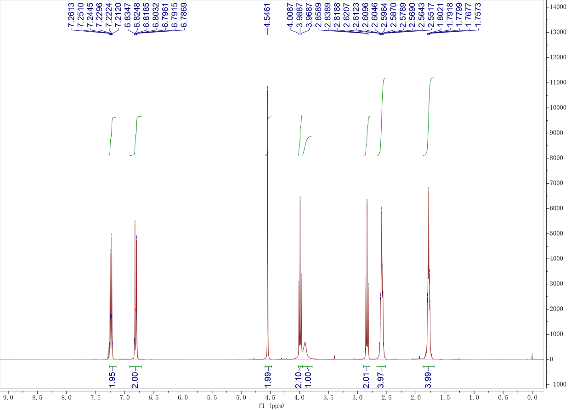
Compound 2b
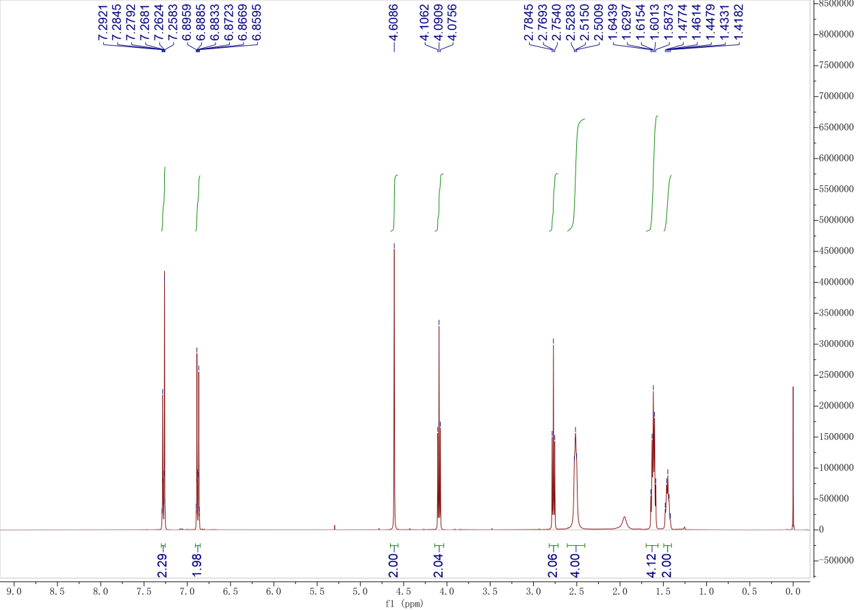

Compound 2c
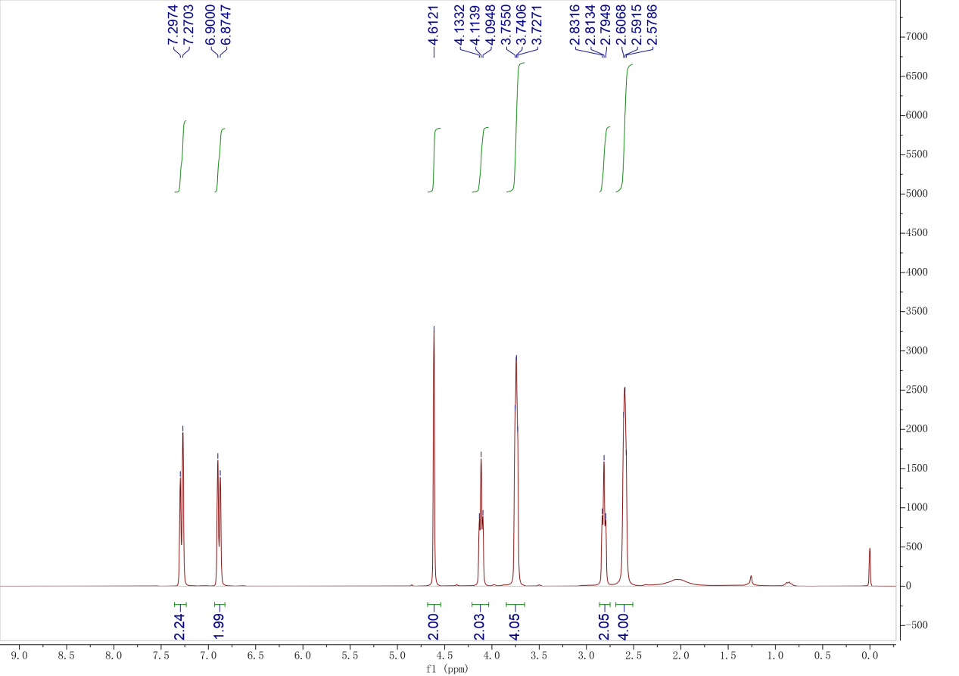

Compound 2d
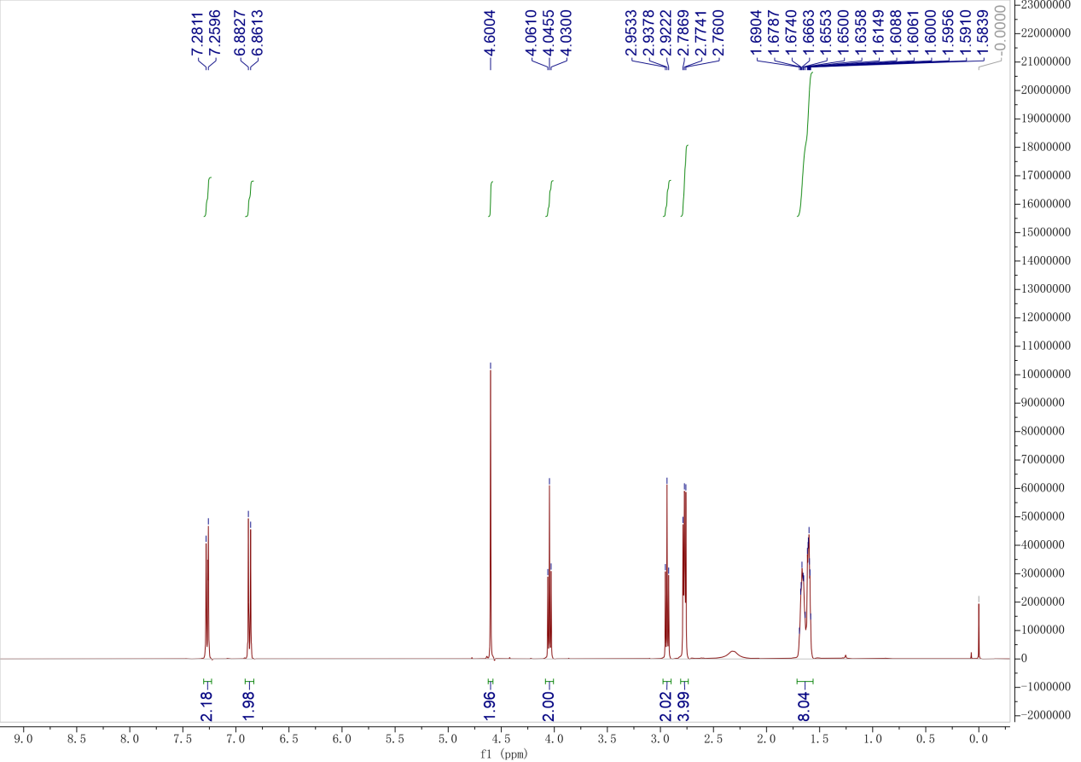

Compound 3a
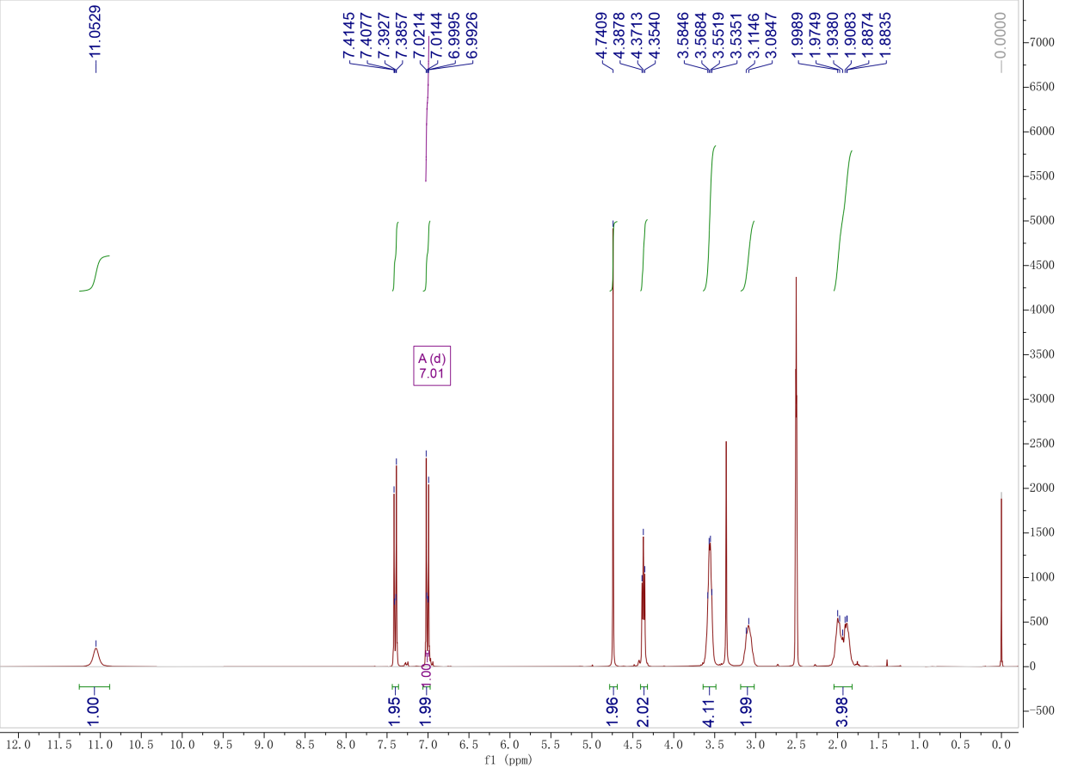
Compound 3b
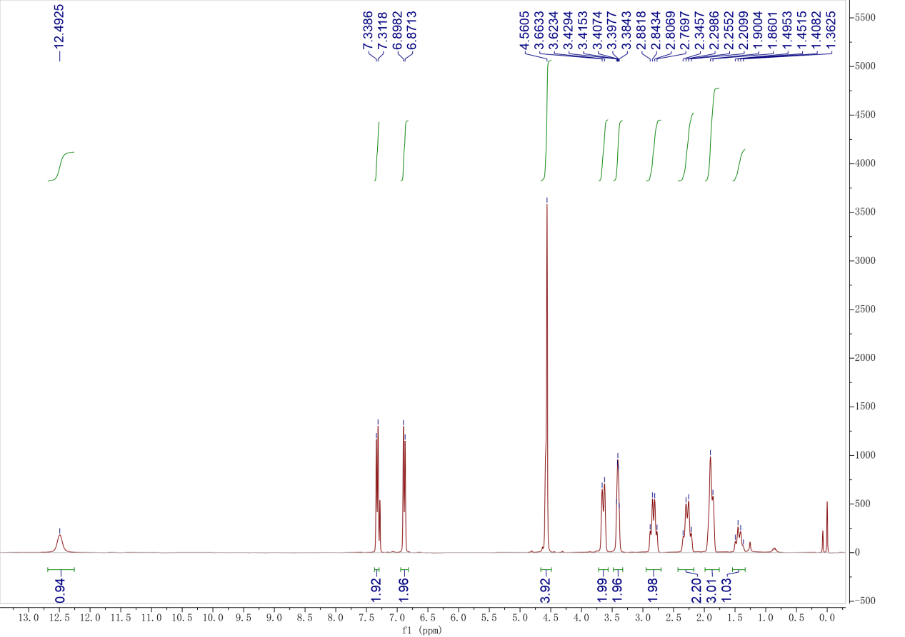

Compound 3c
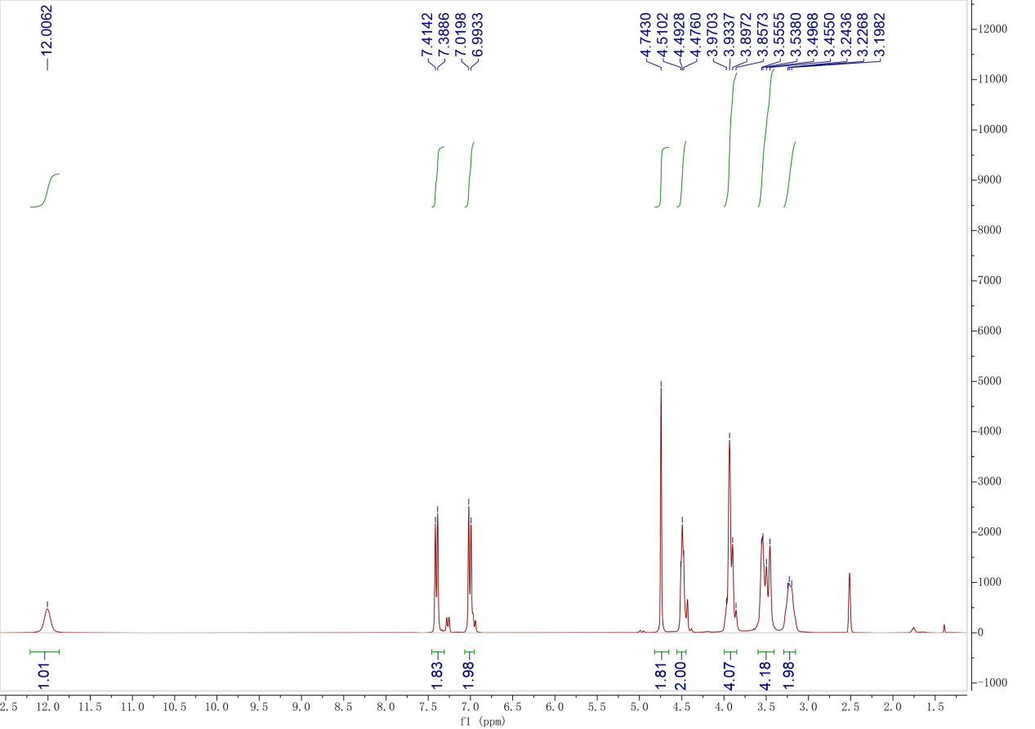
Compound 3d
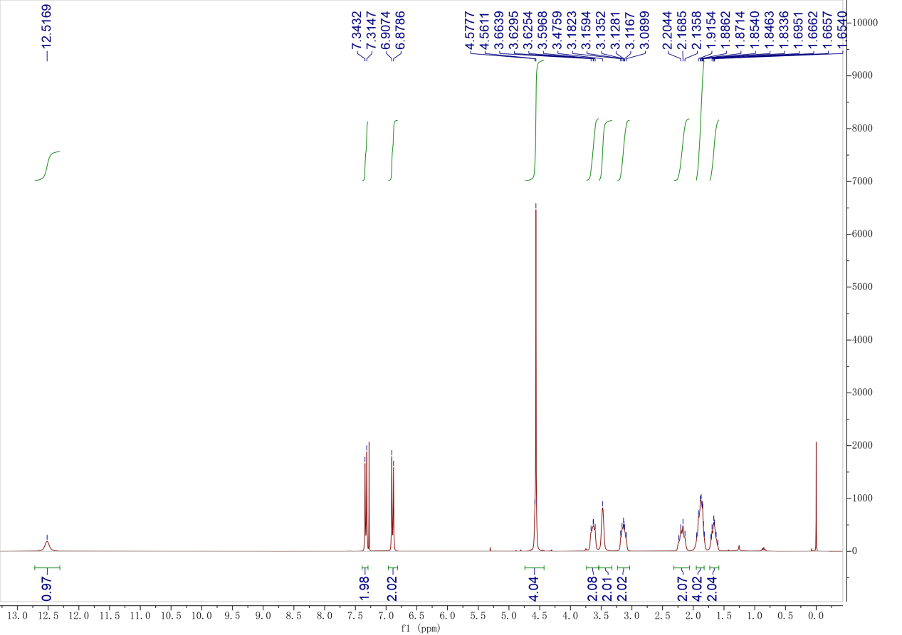

Compound 2e
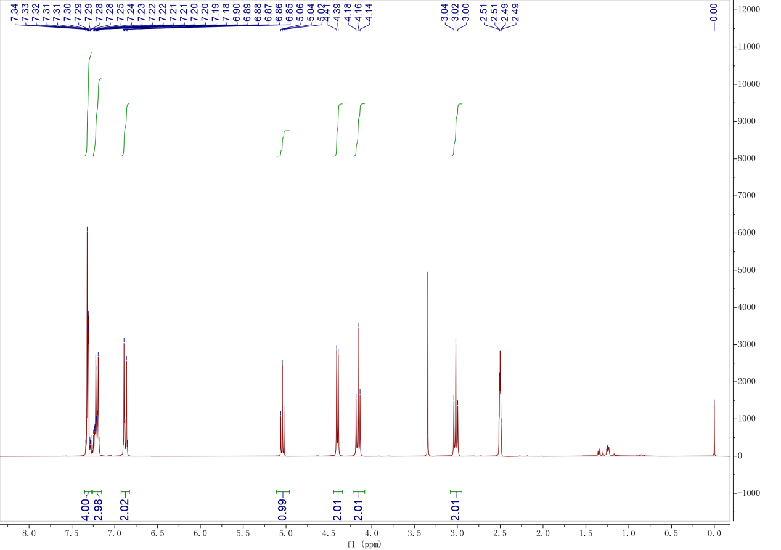
Compound 2f
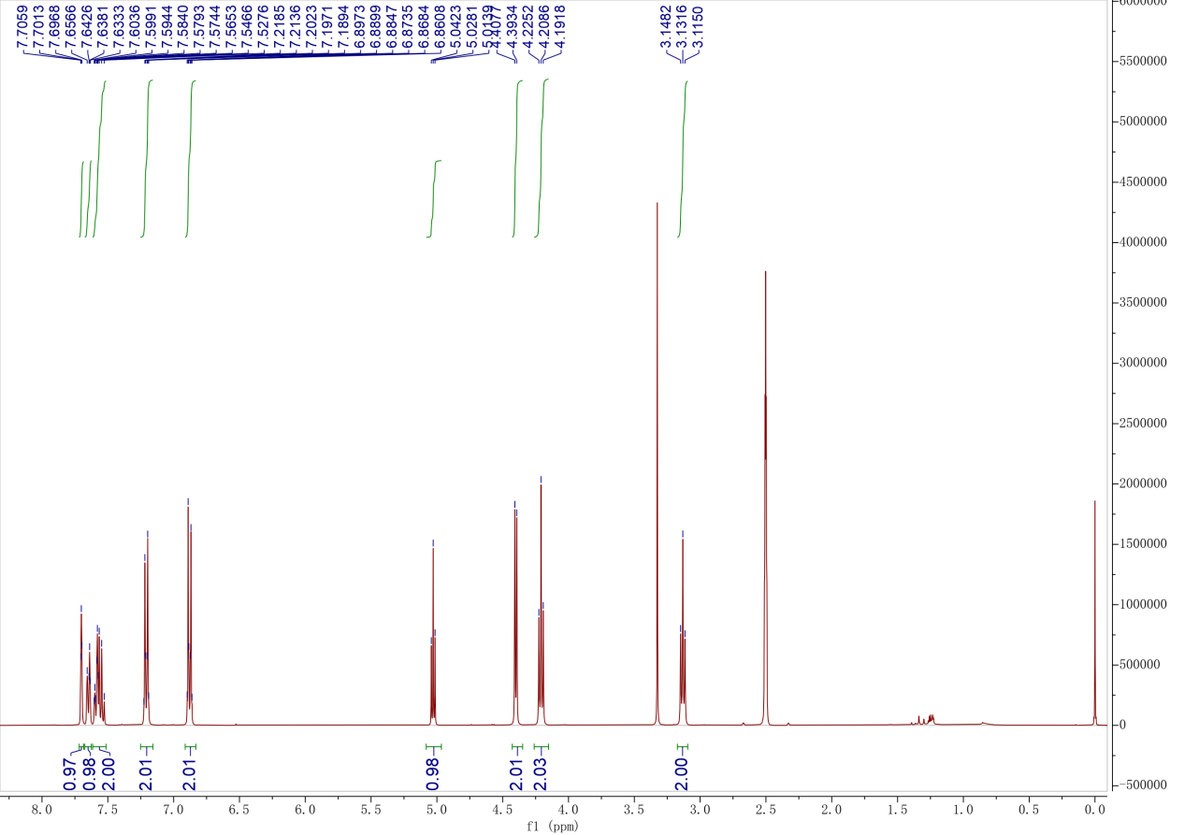

Compound 2g
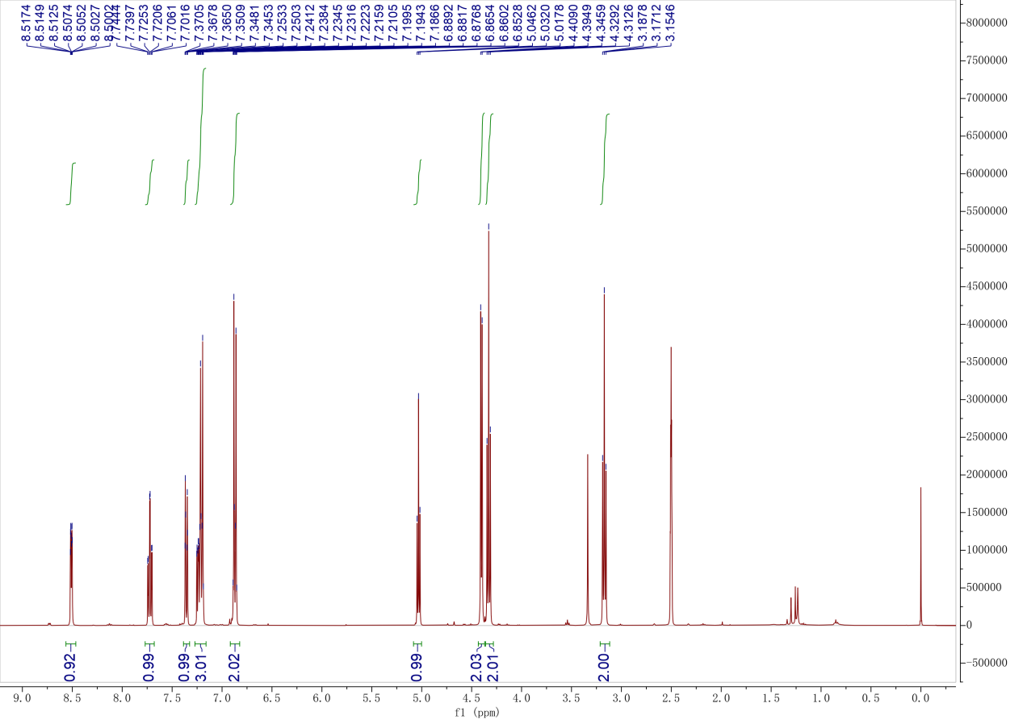
Compound 4a
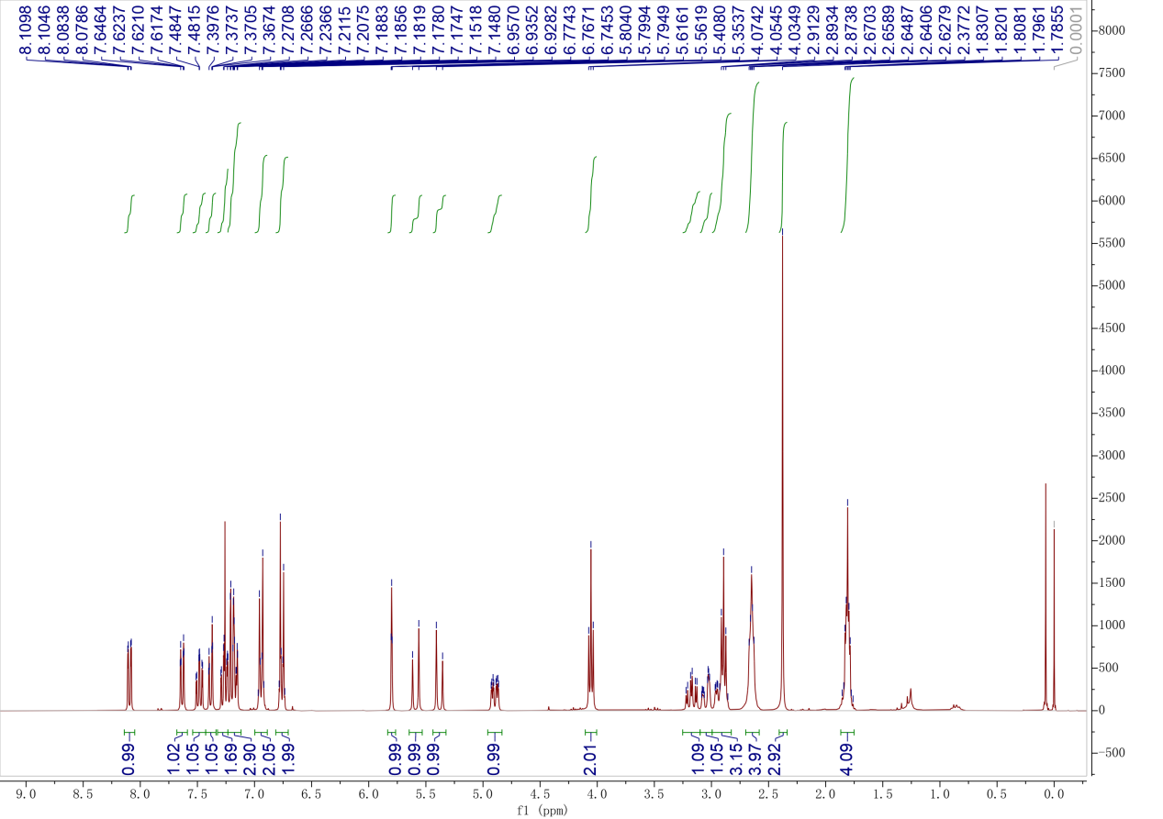

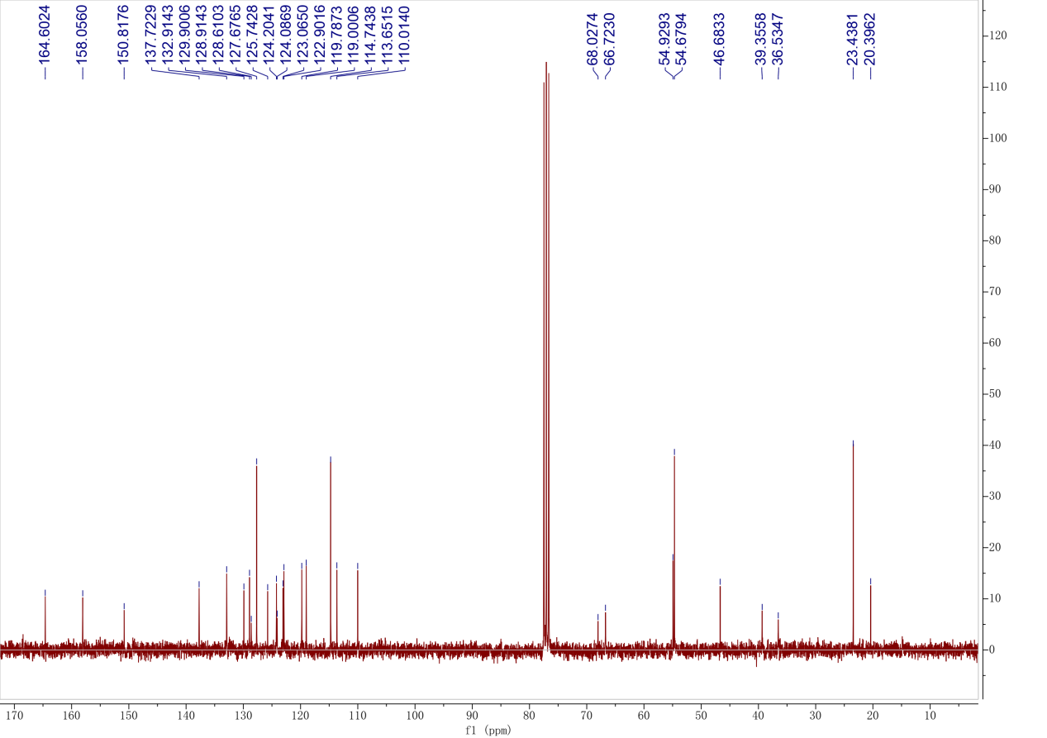

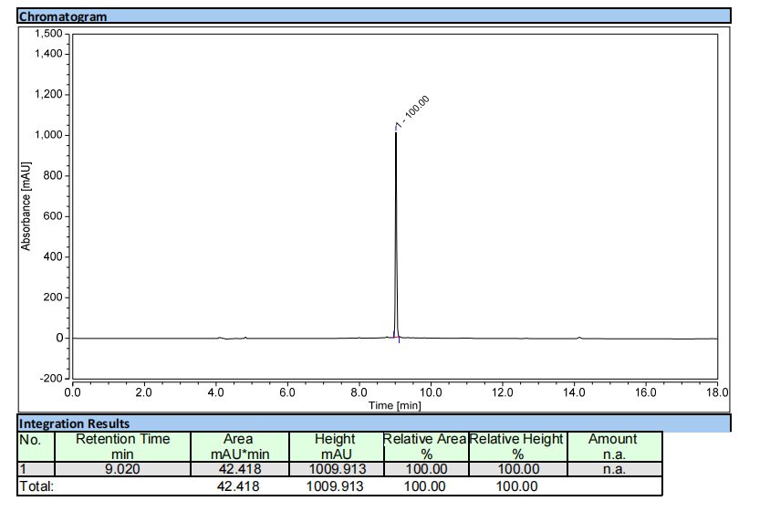
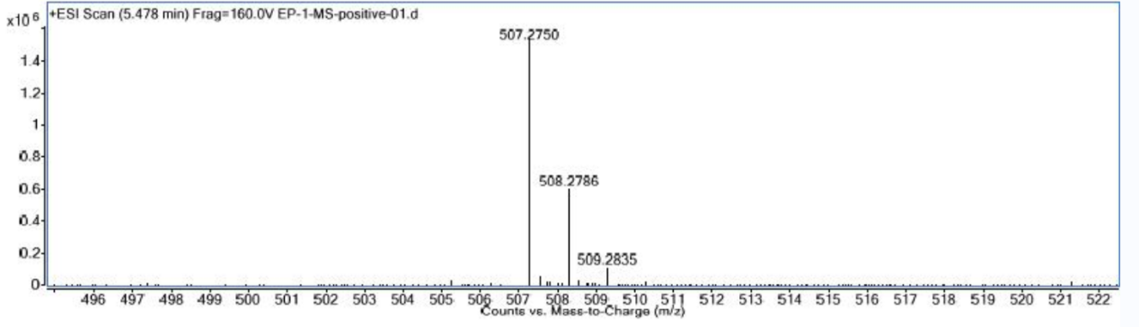

Compound 4b
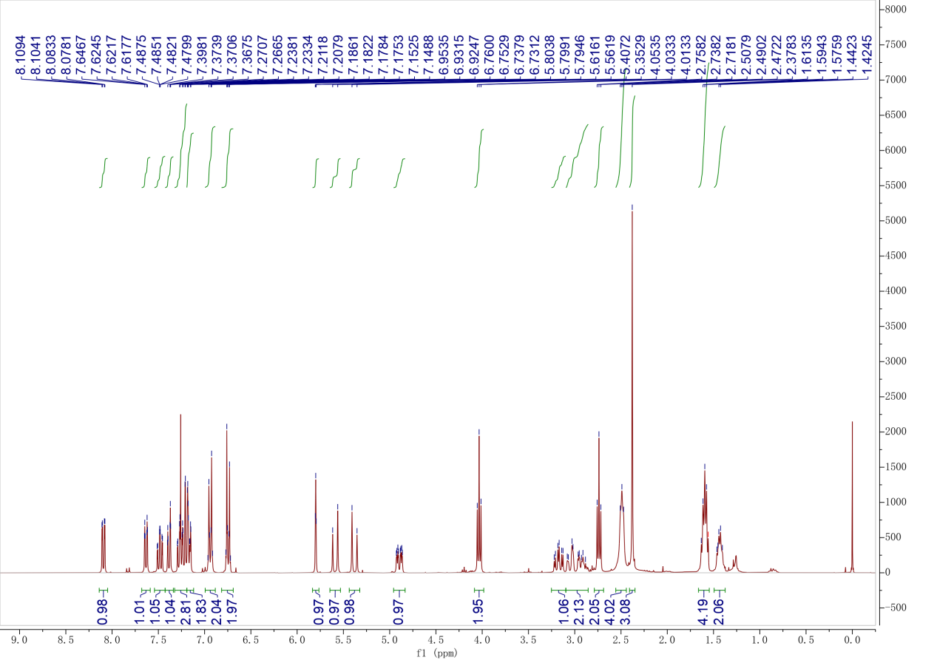

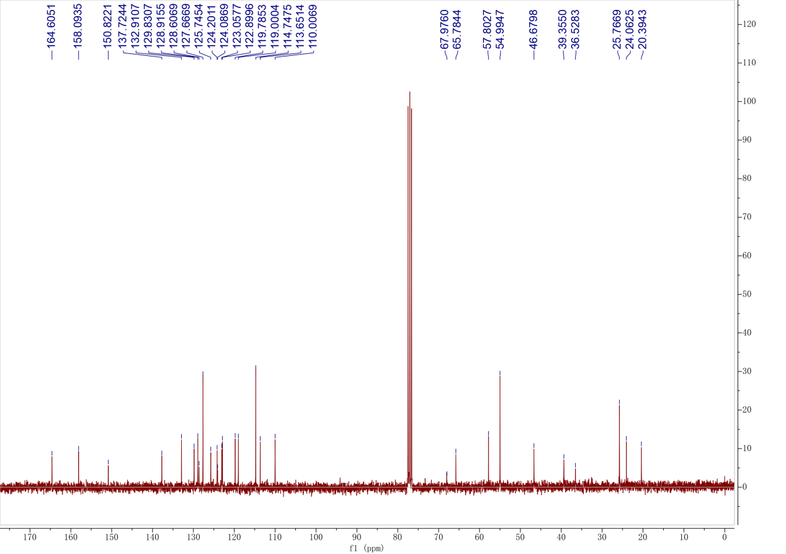

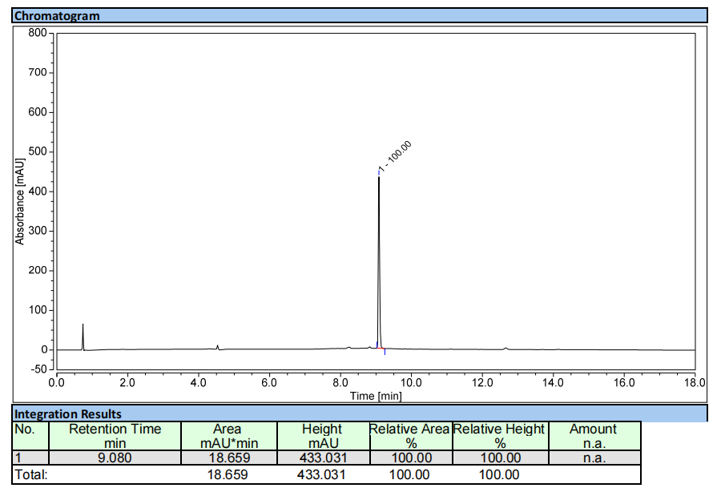
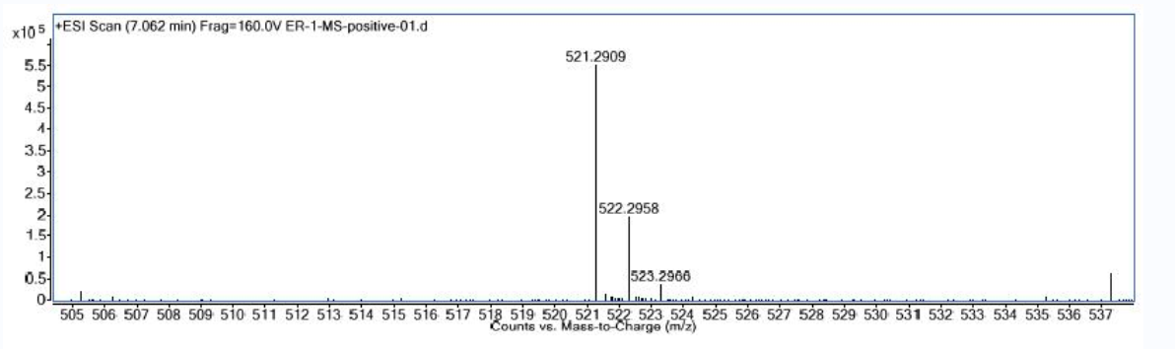

Compound 4c
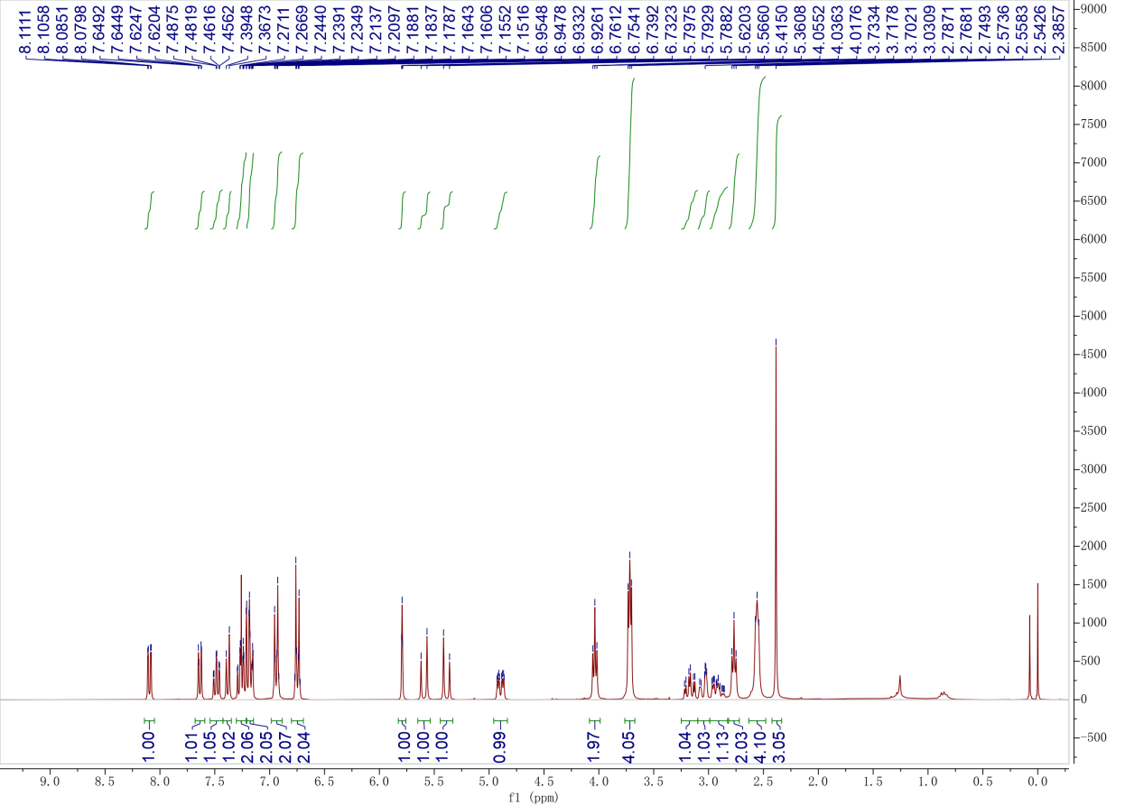
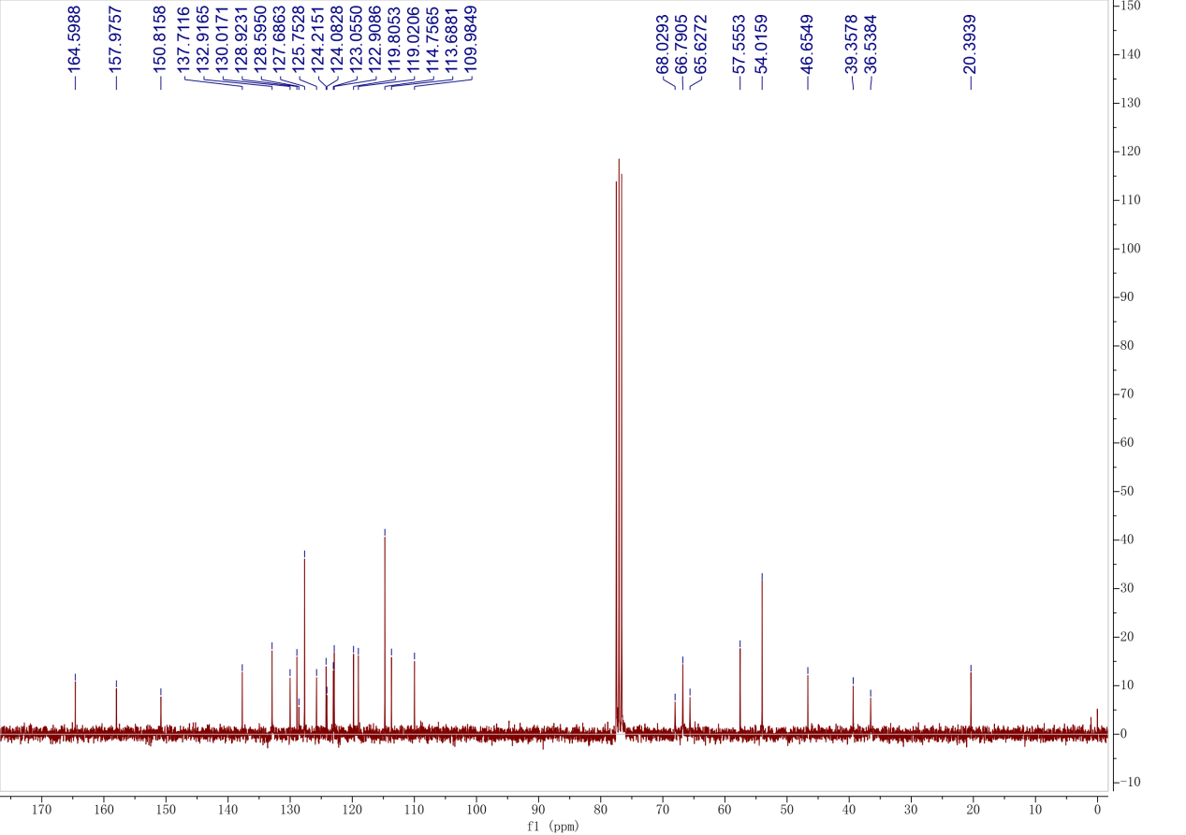
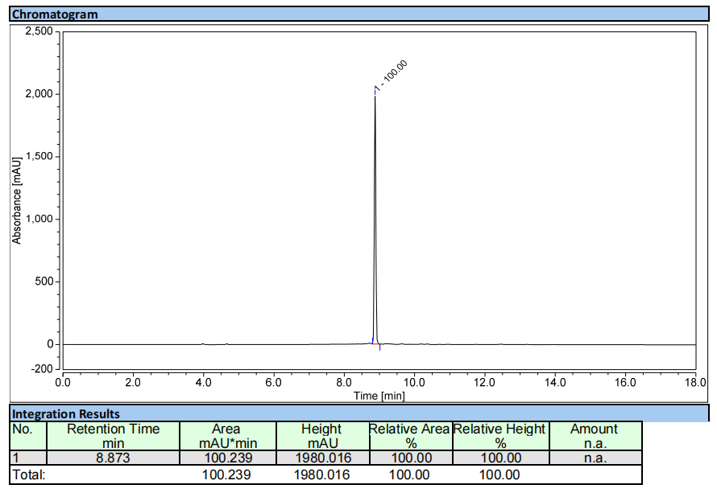
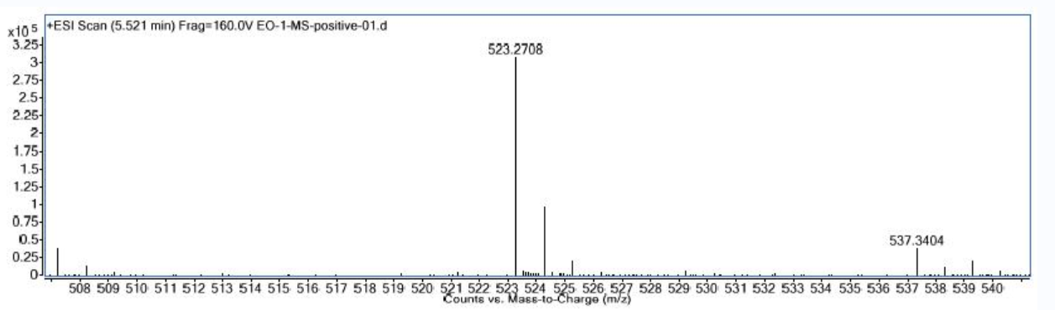

Compound 4d
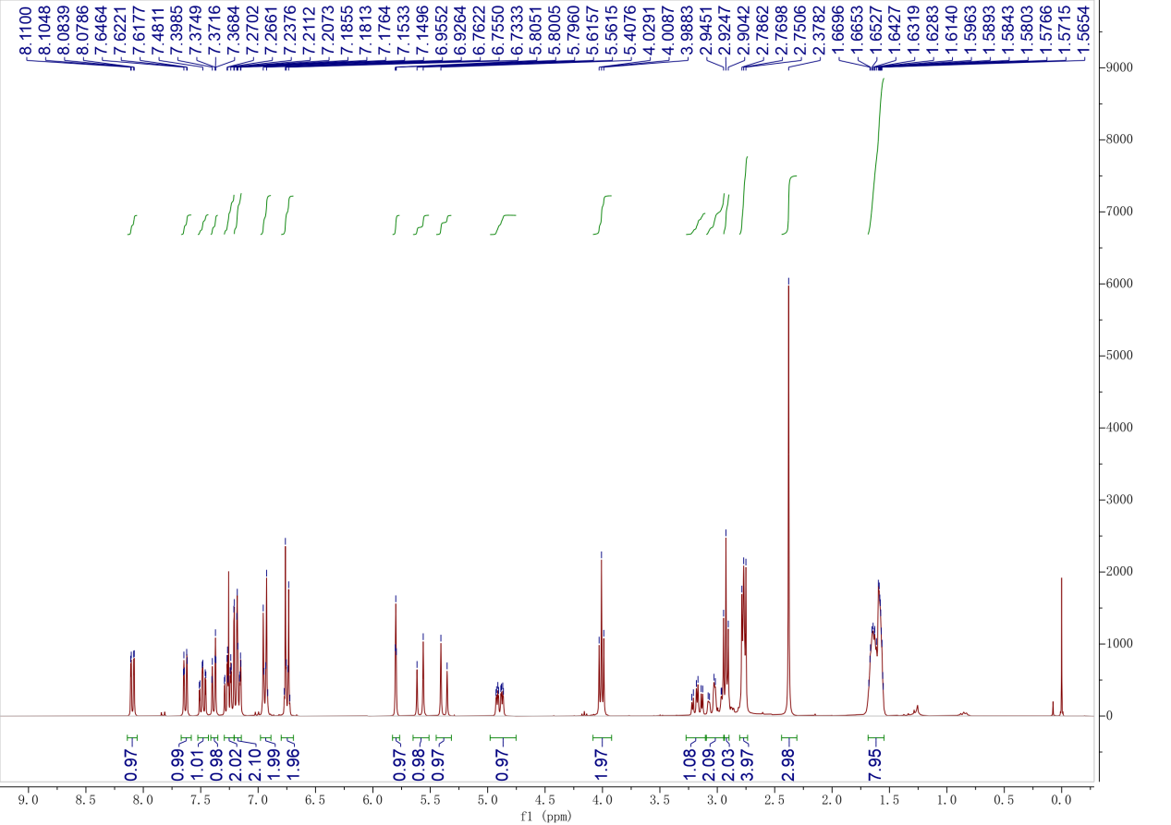

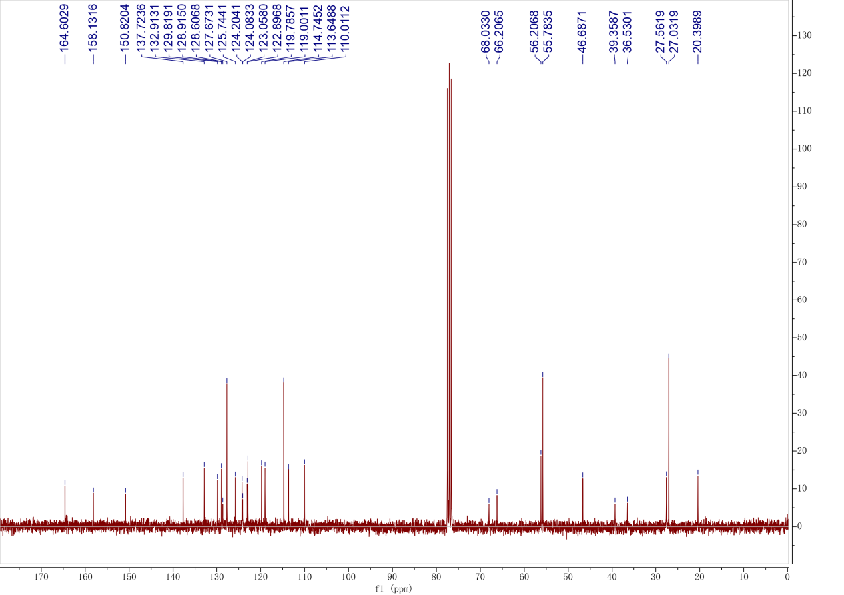

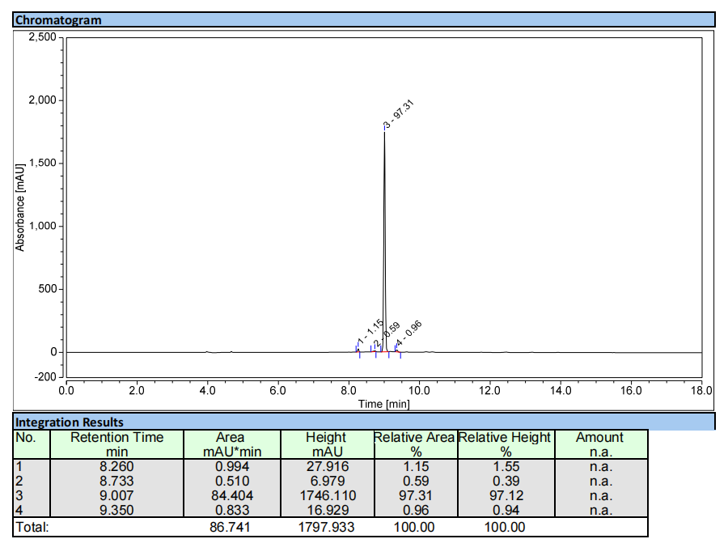
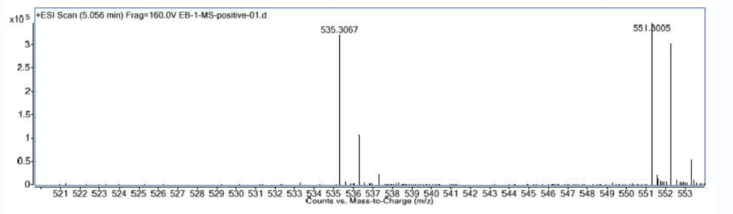

Compound 5a
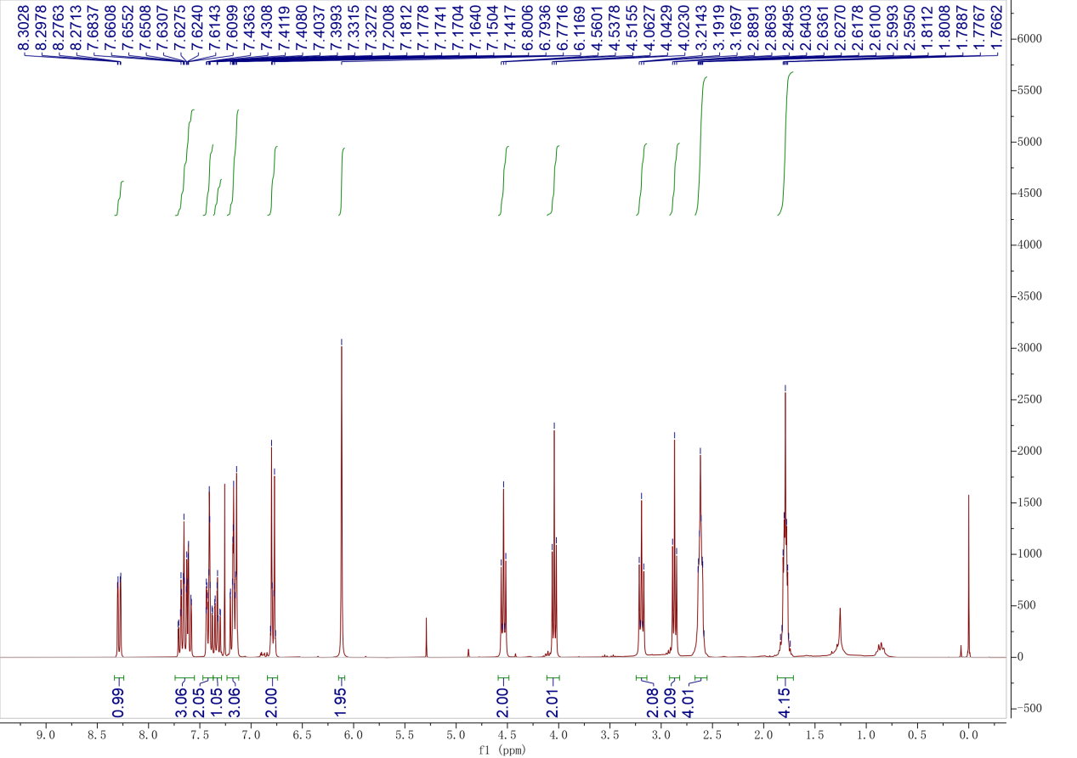
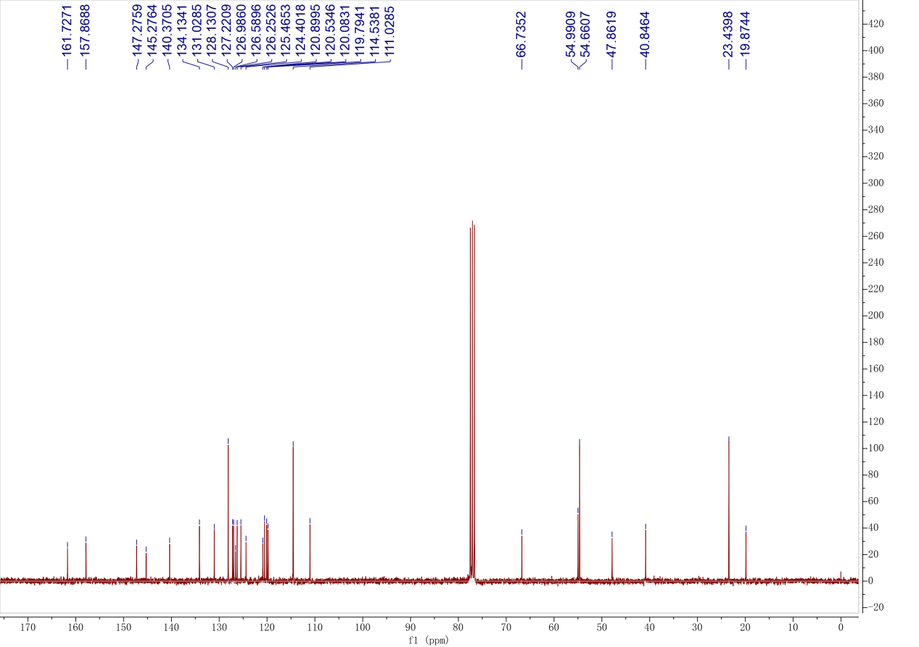

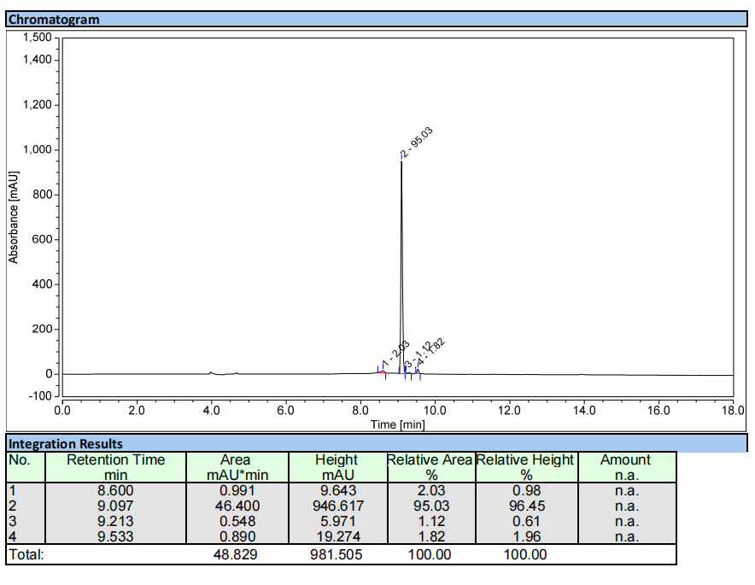
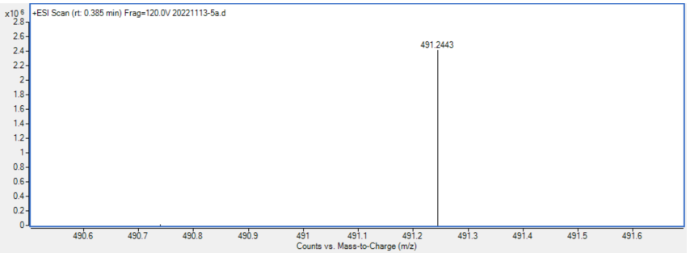

Compound 5b
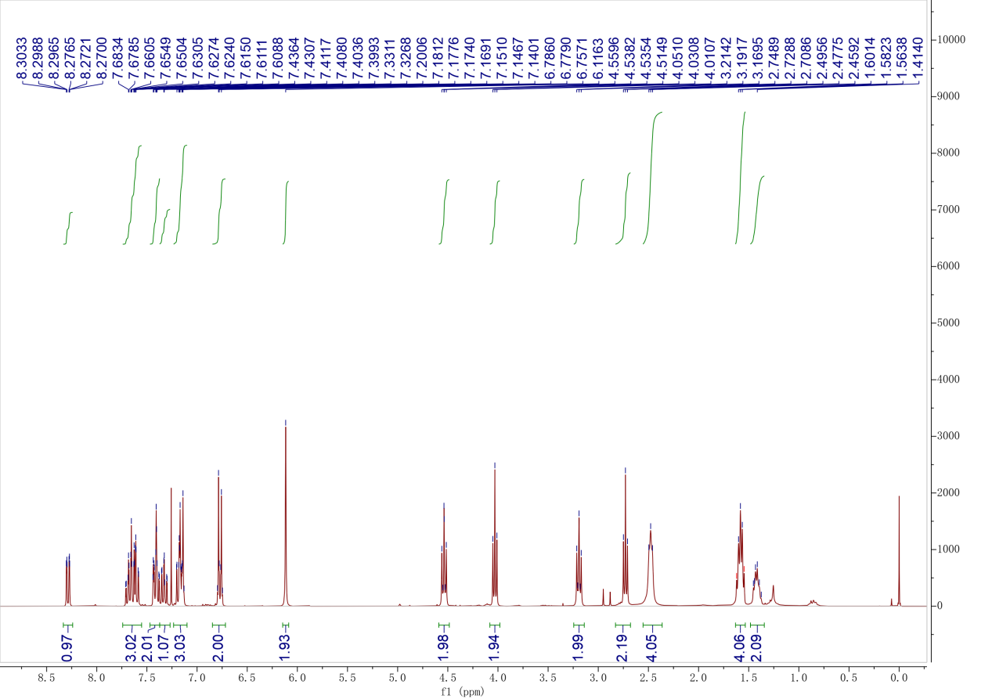

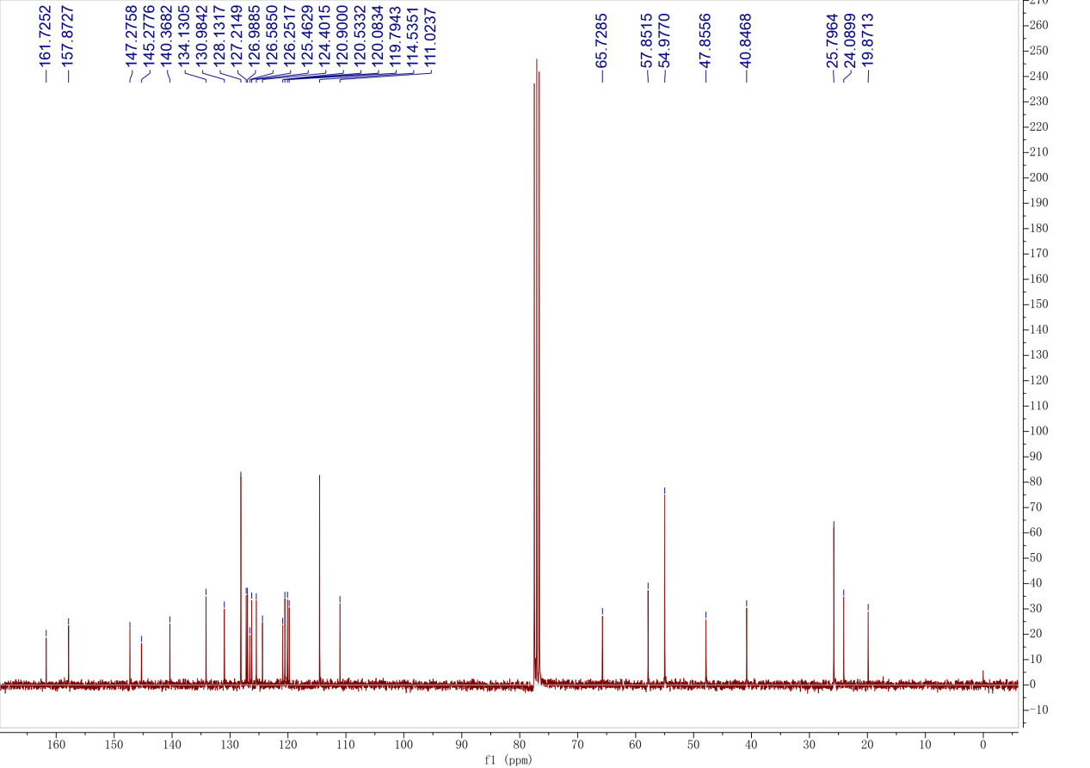
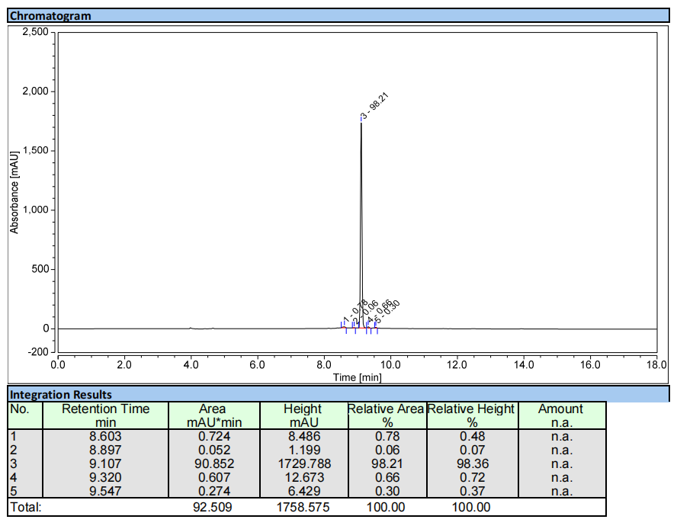
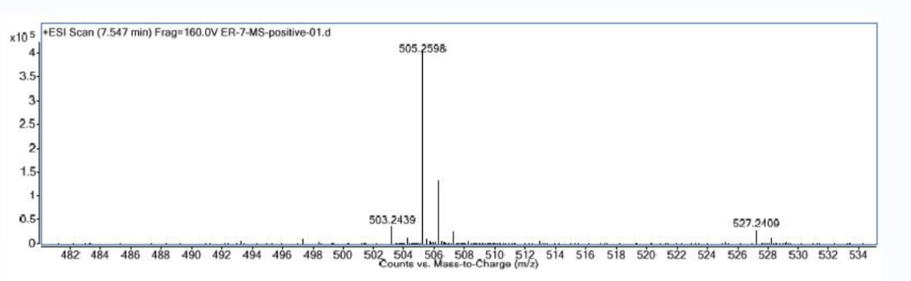

Compound 5c
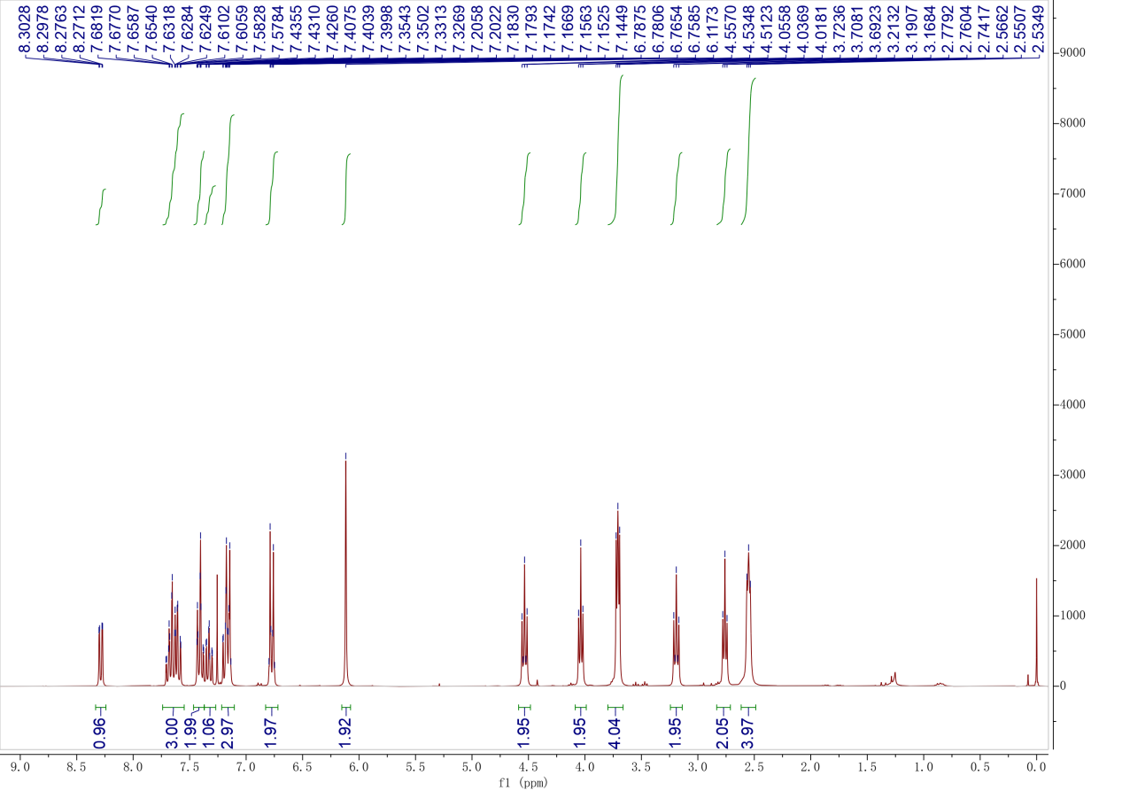

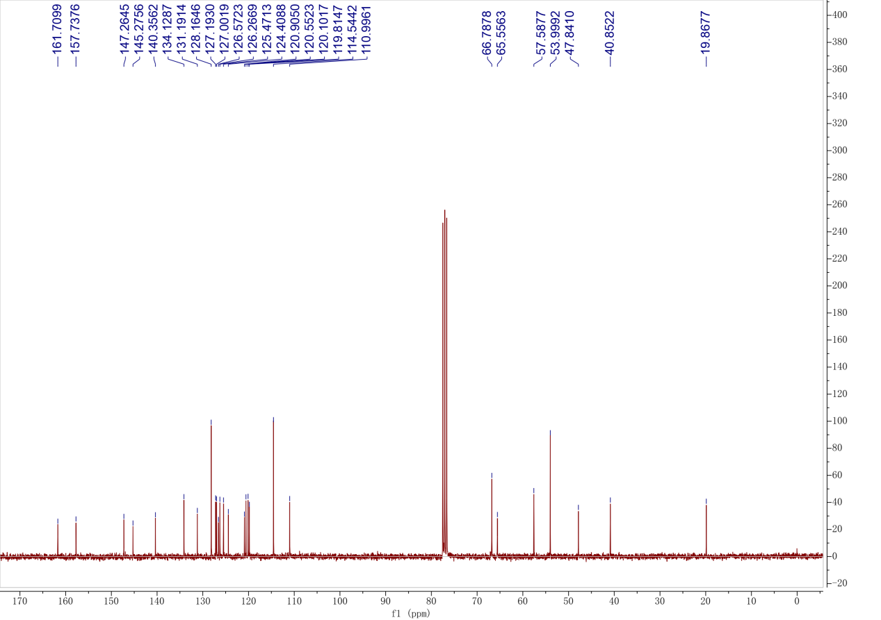
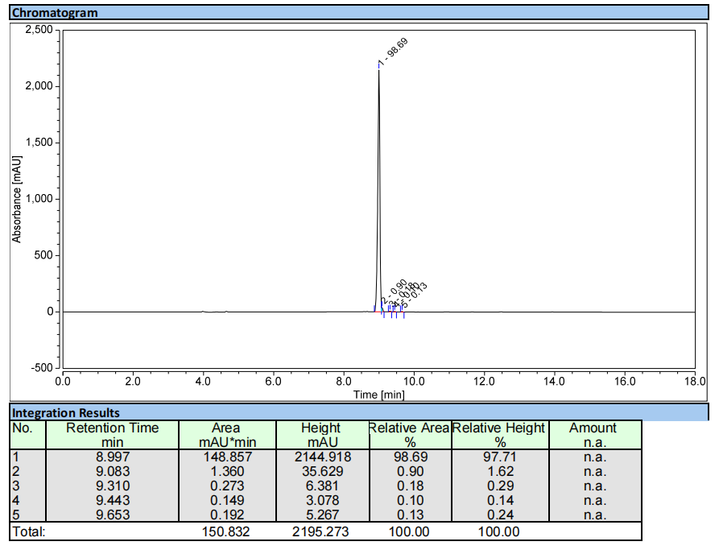
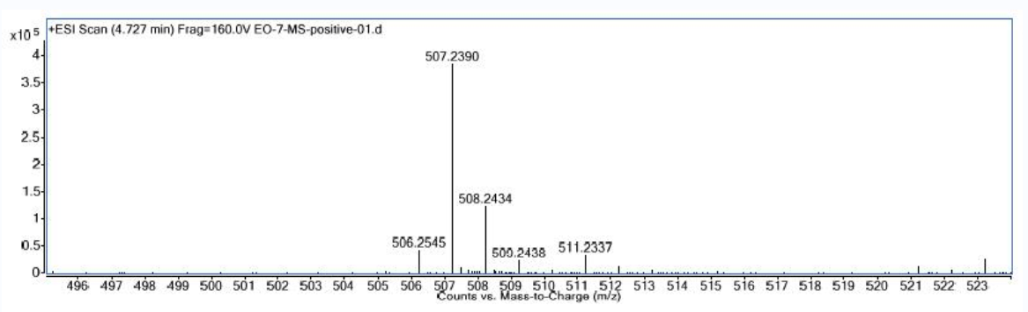

Compound 5d
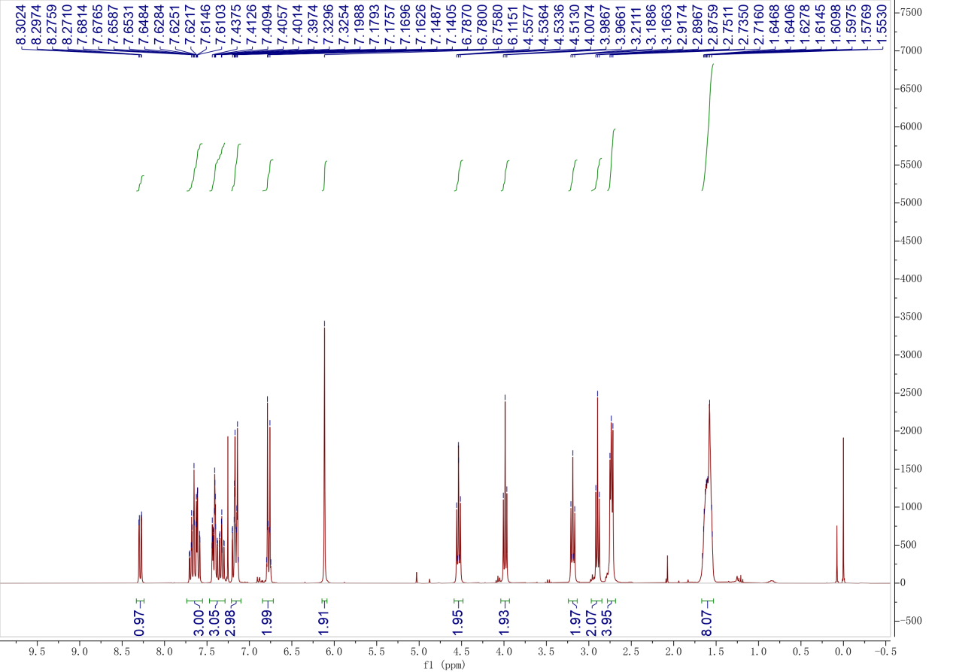

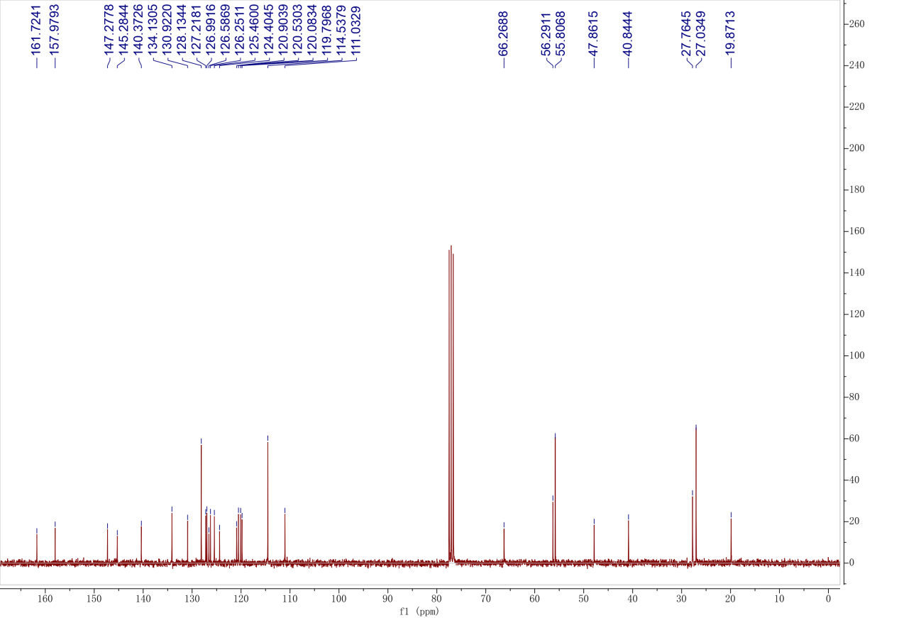

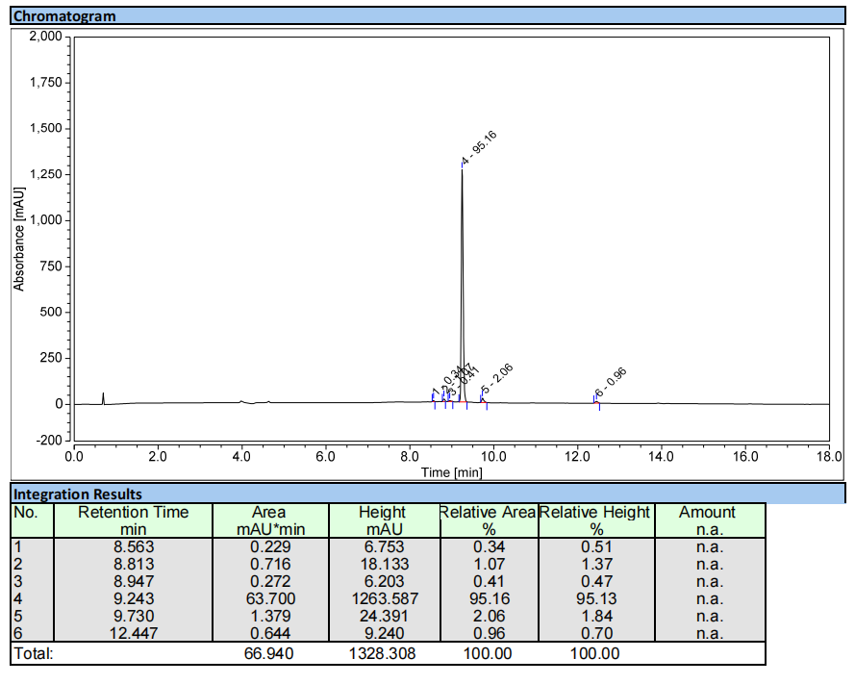
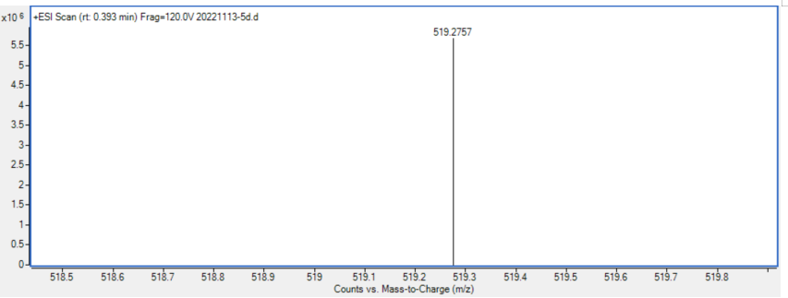

Compound 6a
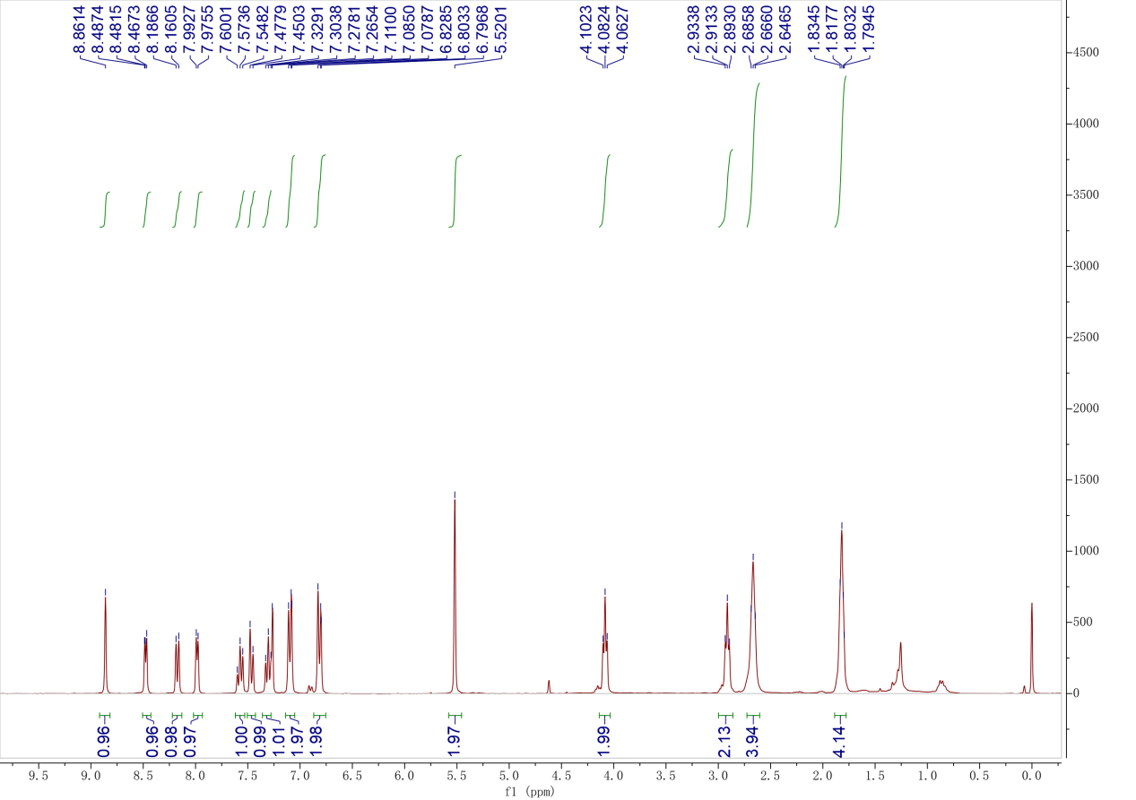

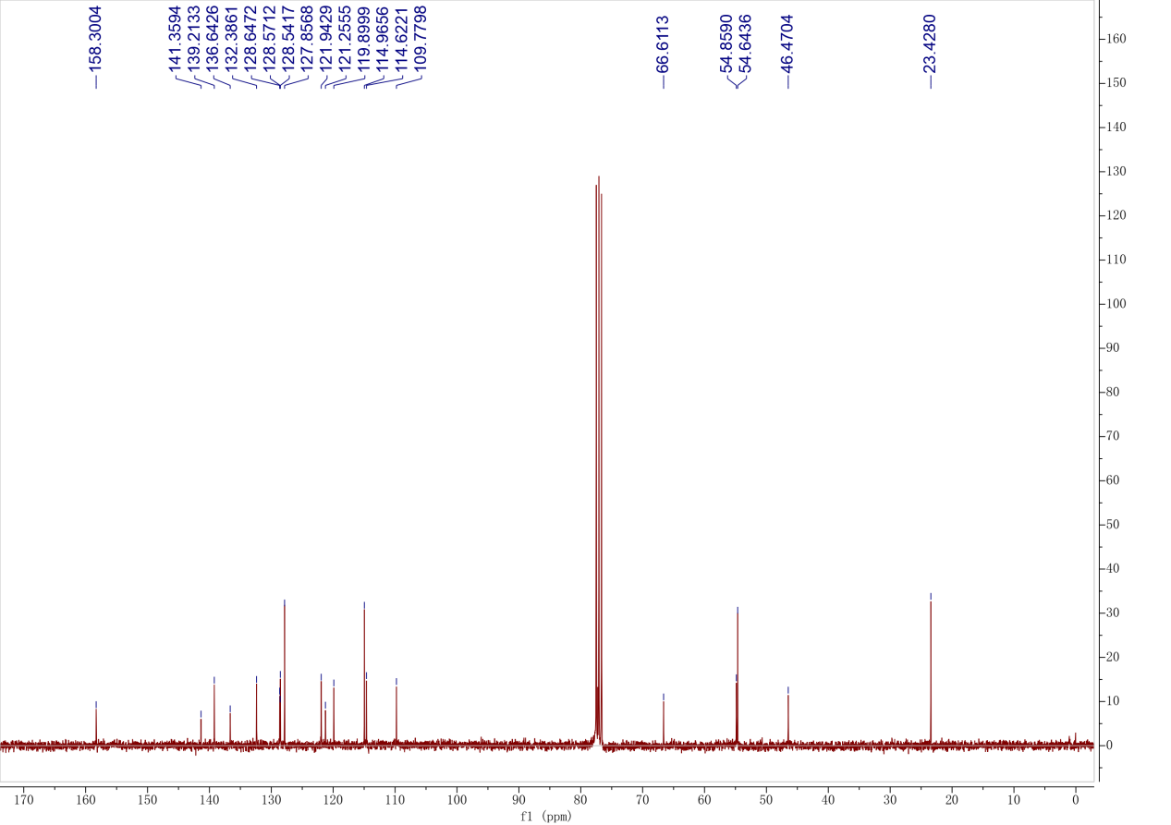

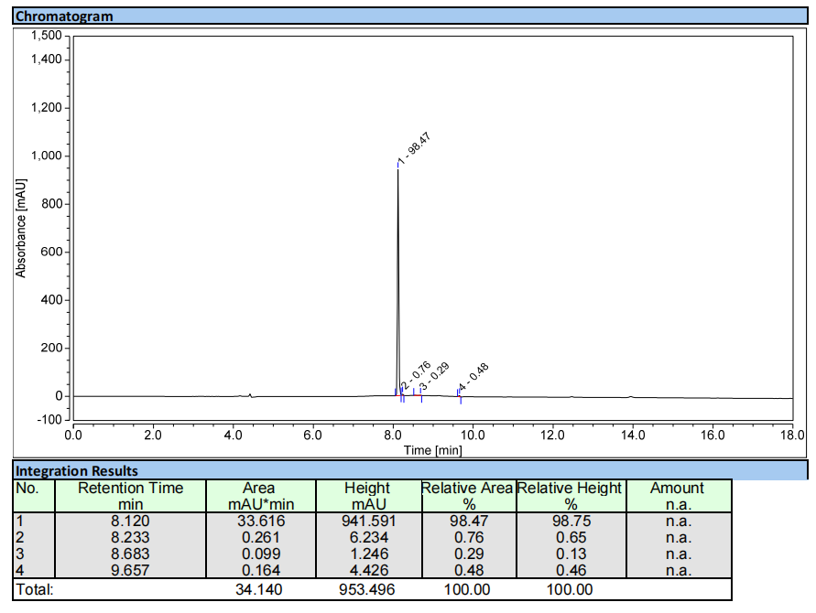
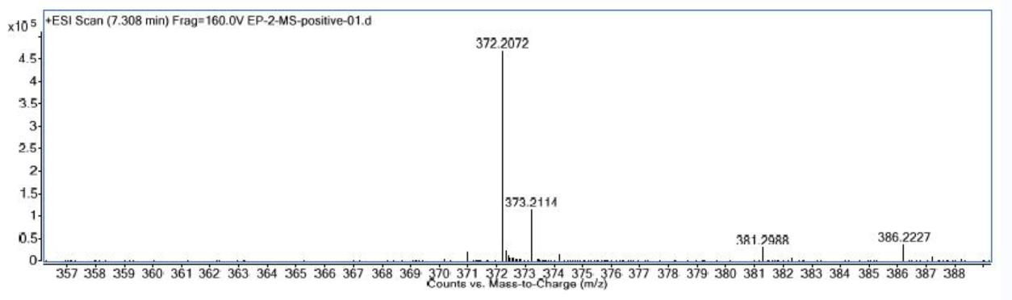

Compound 6b
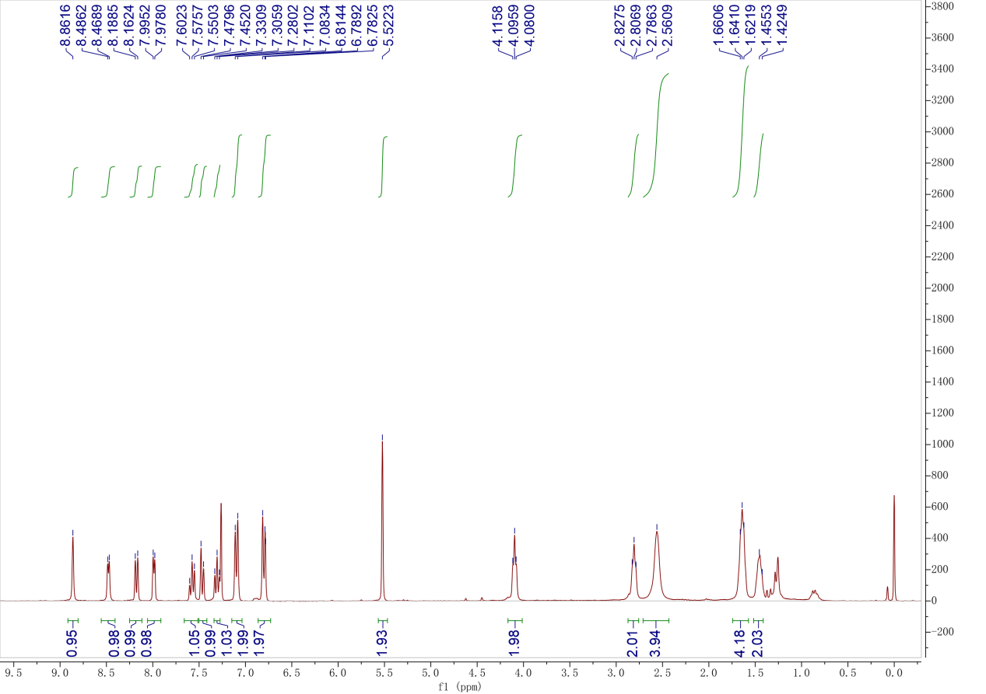
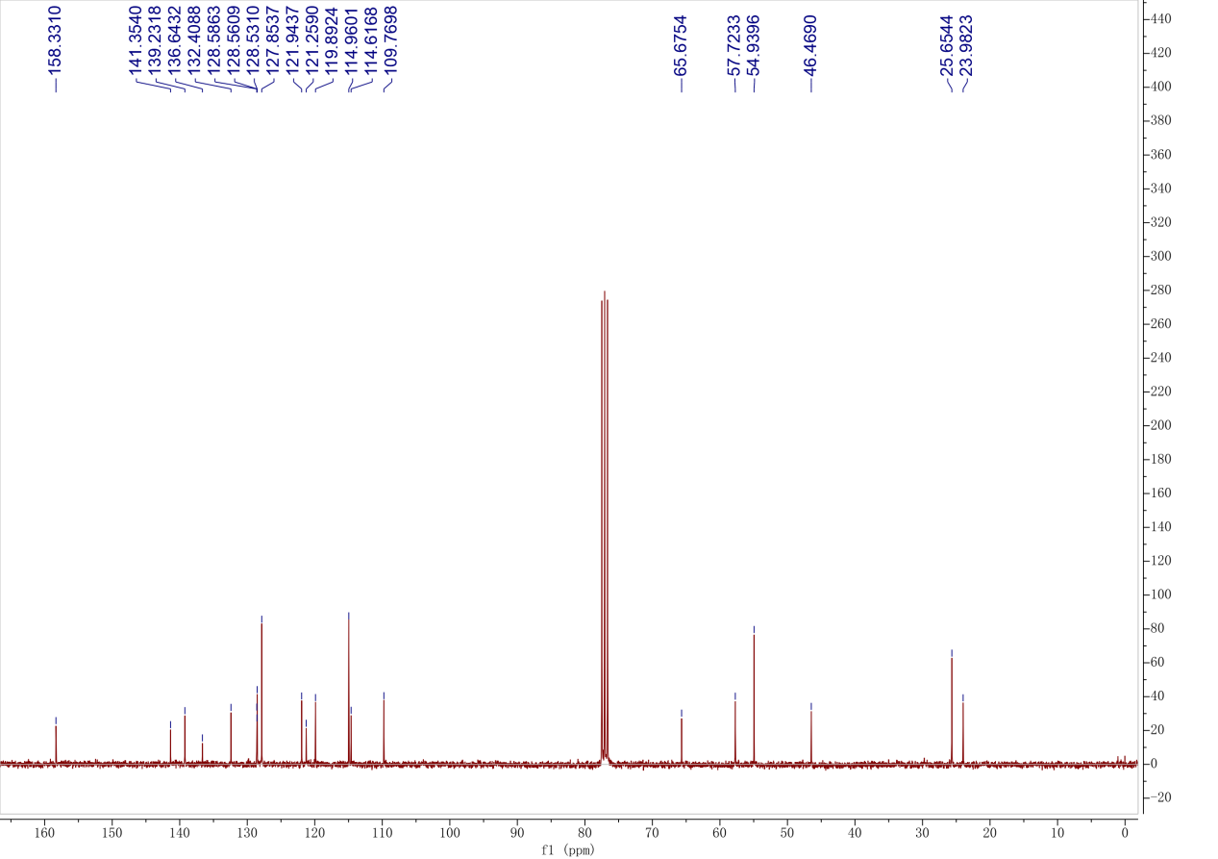

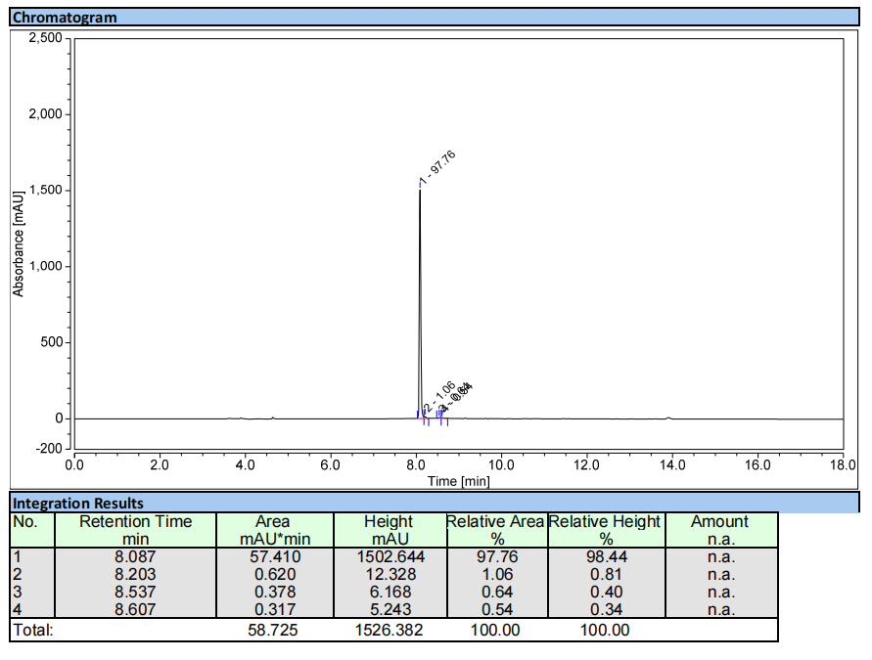
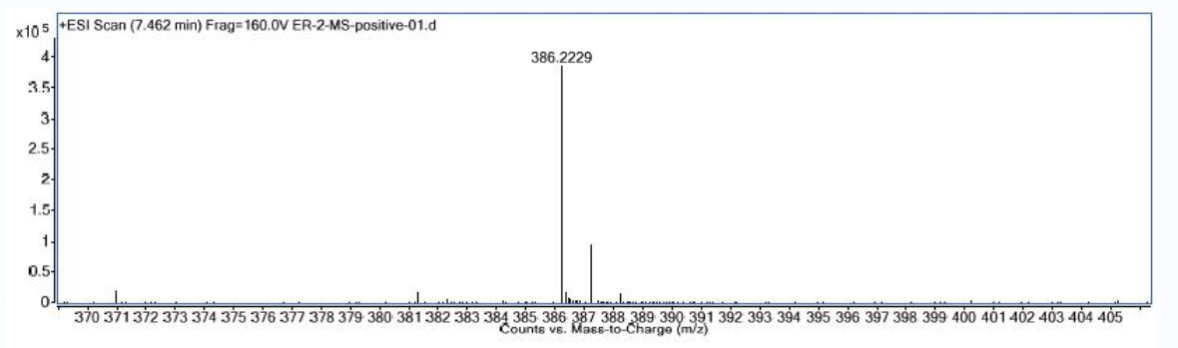

Compound 6c
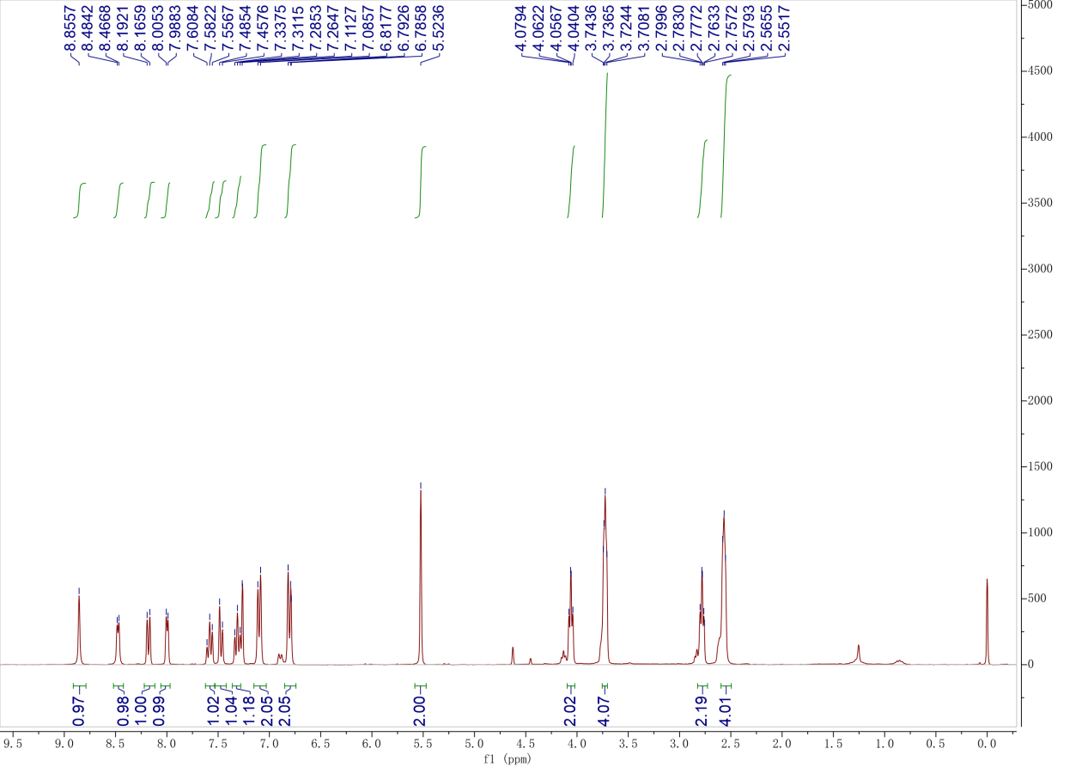
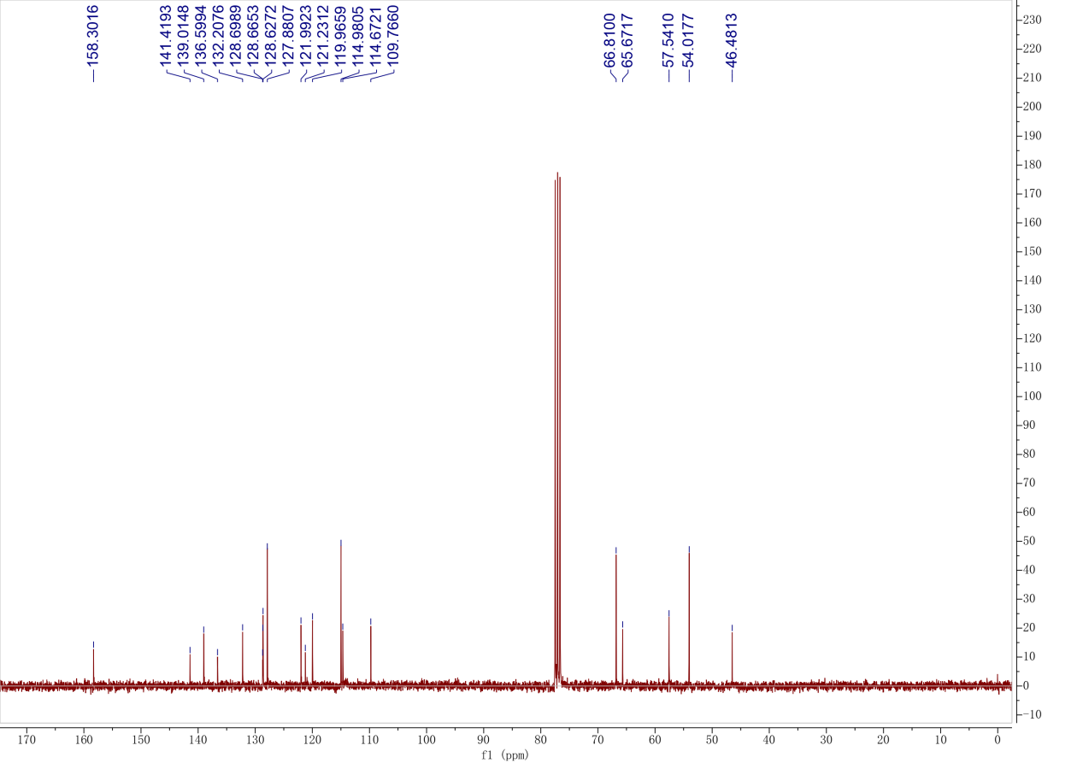

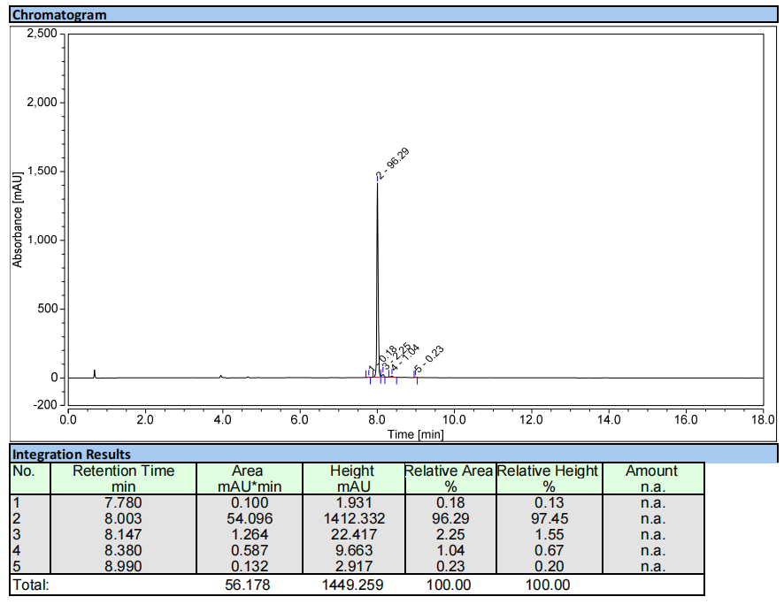
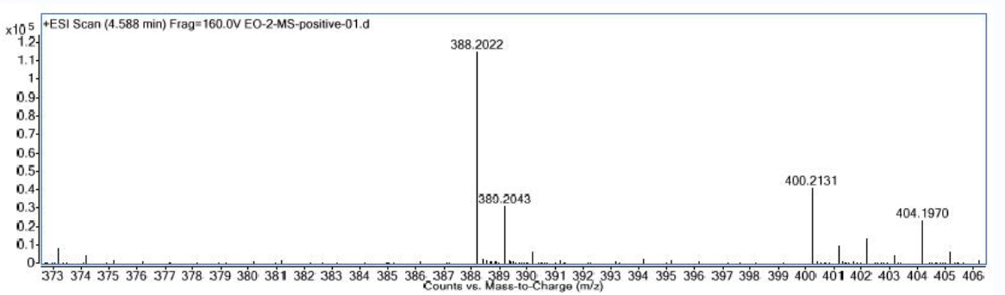

Compound 6d
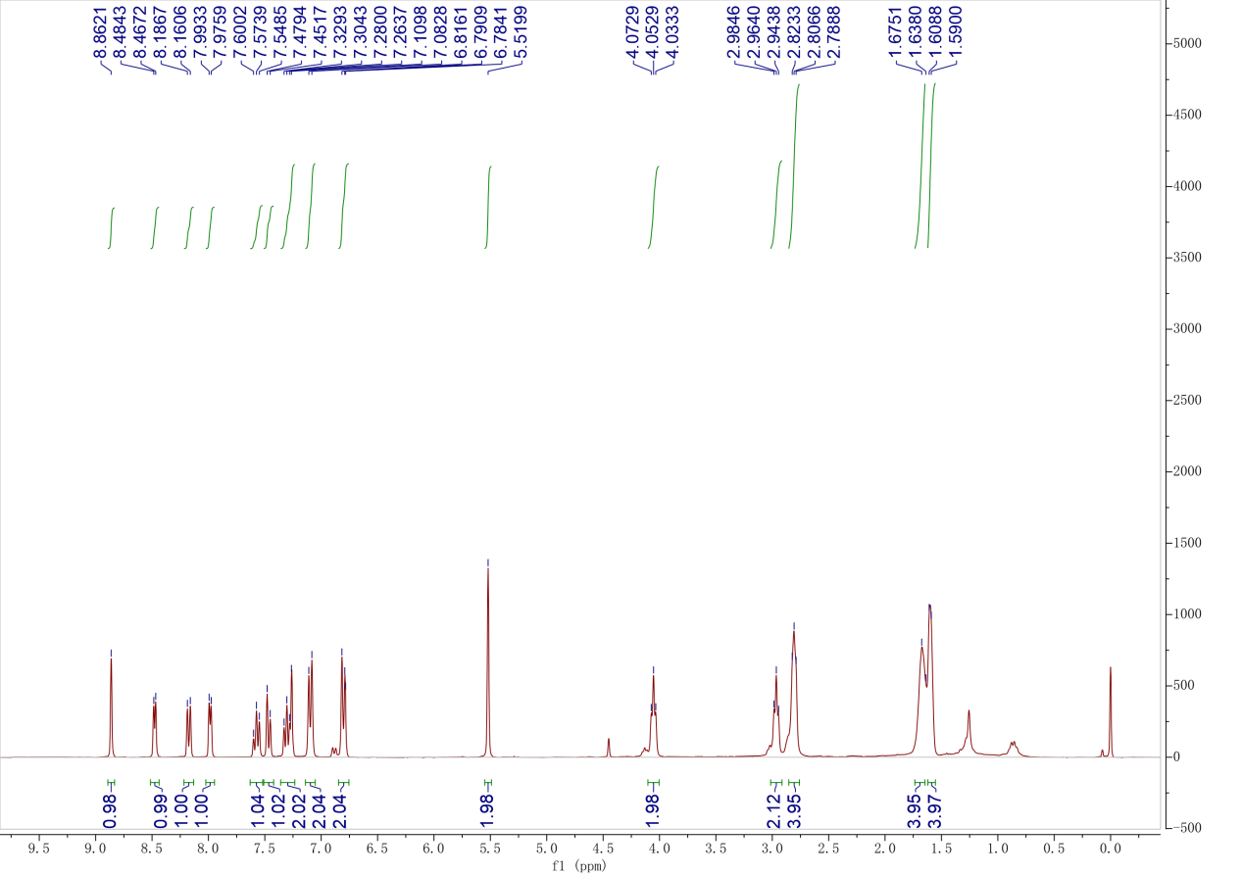
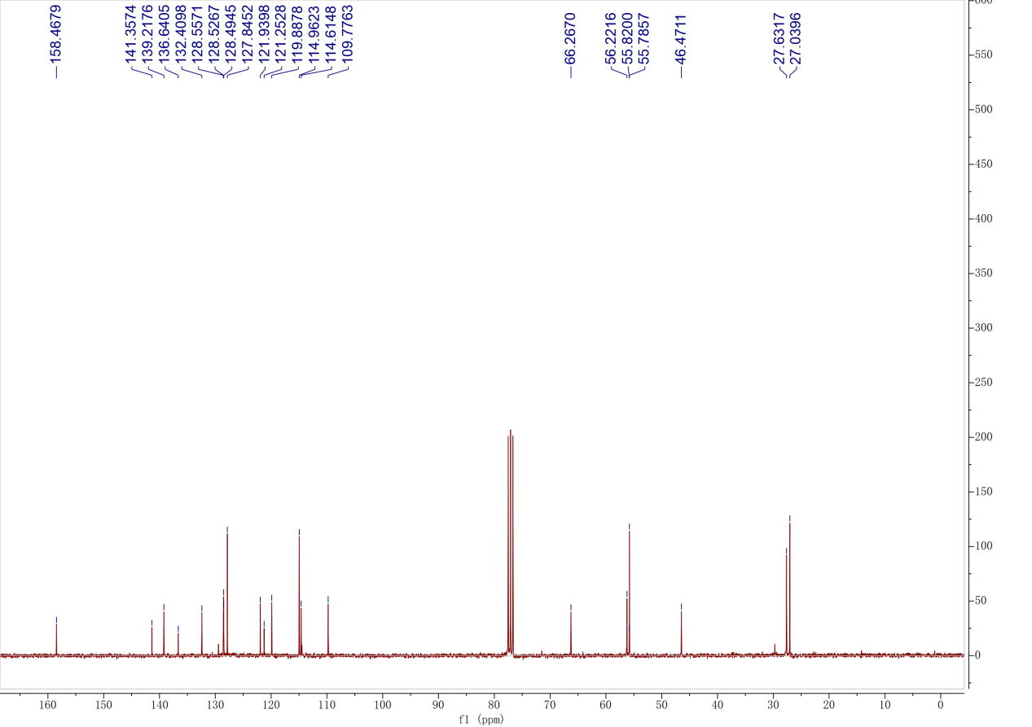

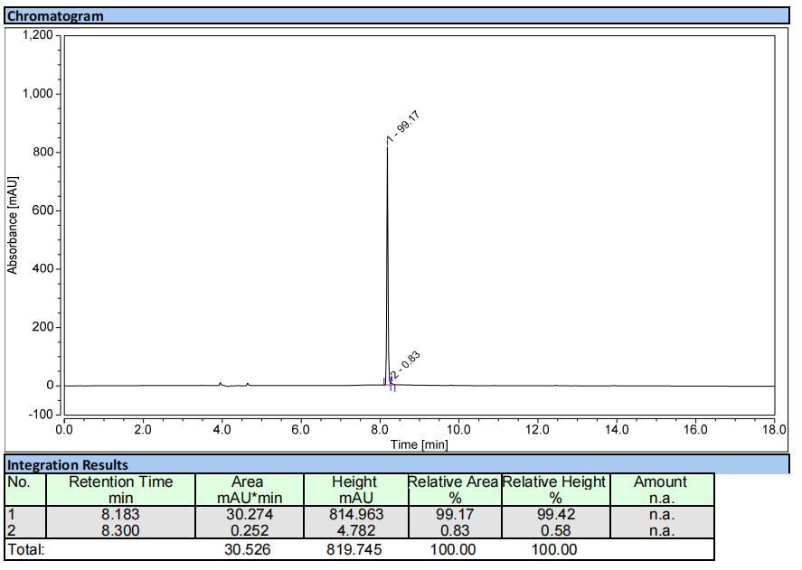
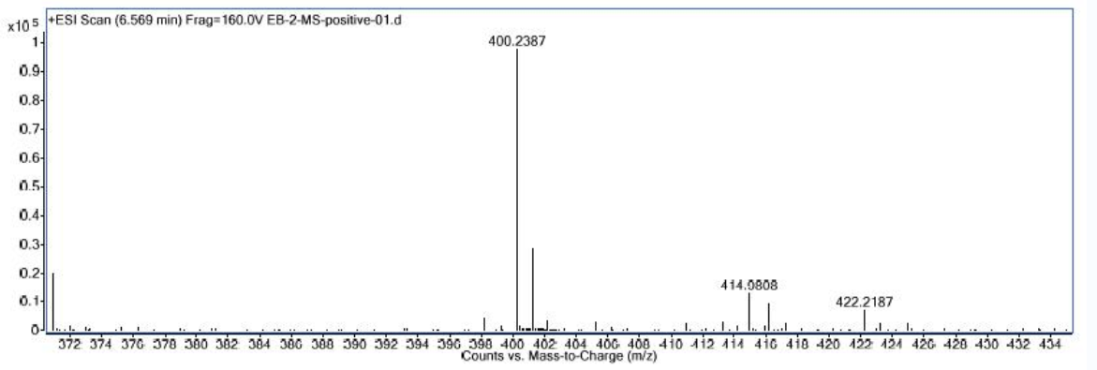

Compound 7a
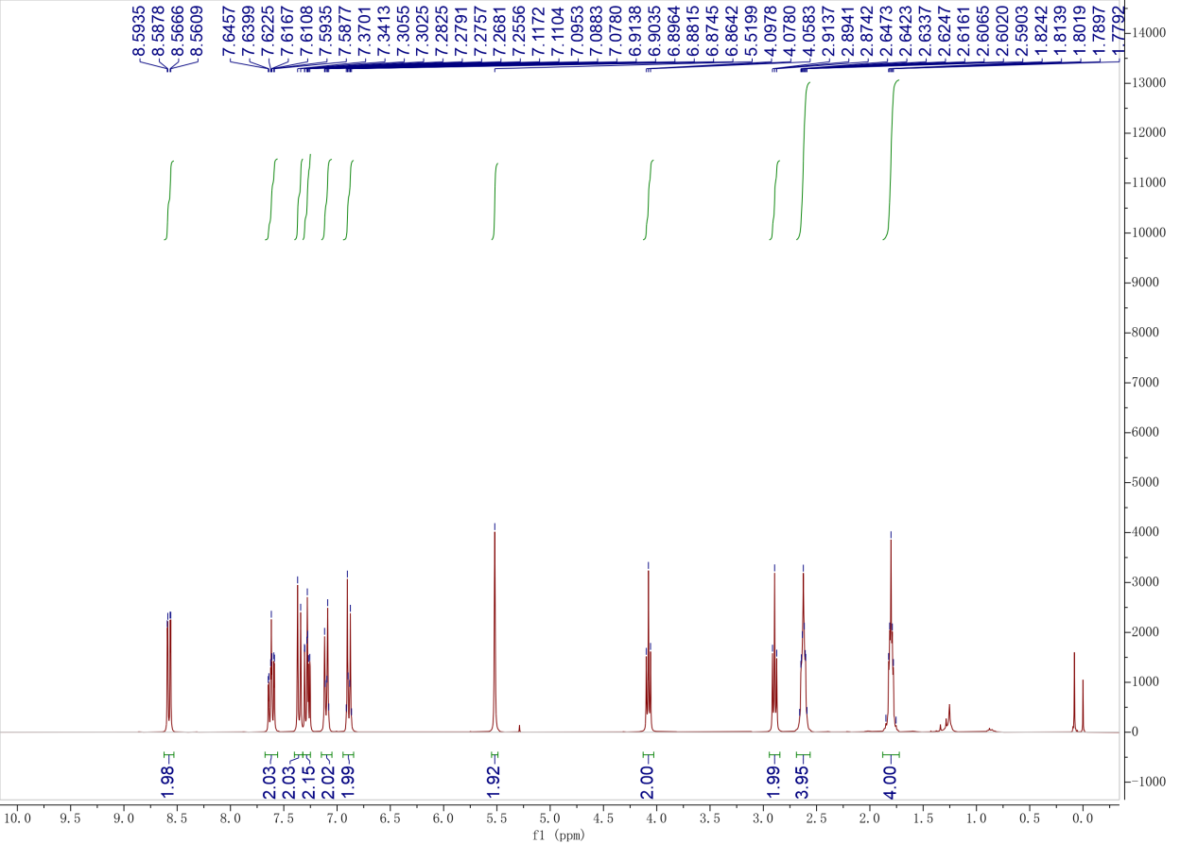
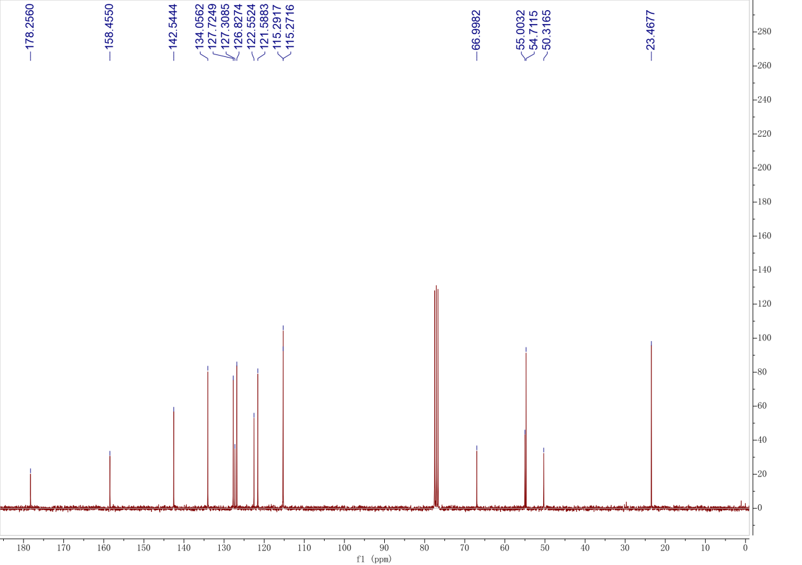

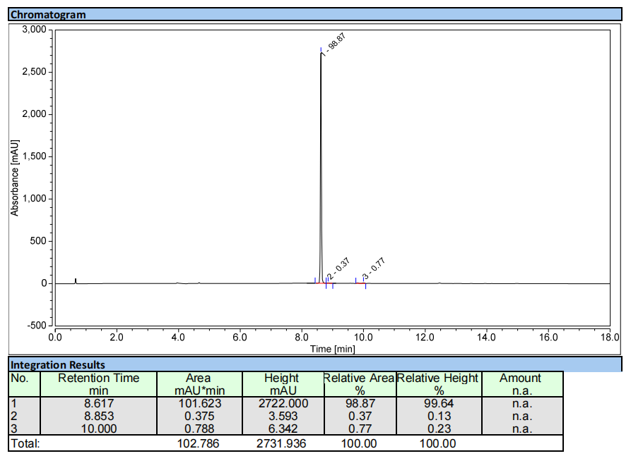
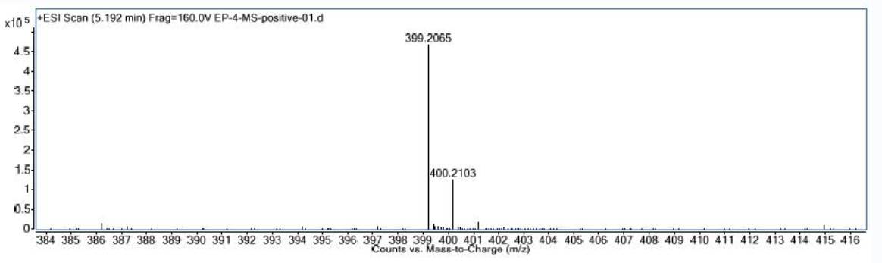

Compound 7b
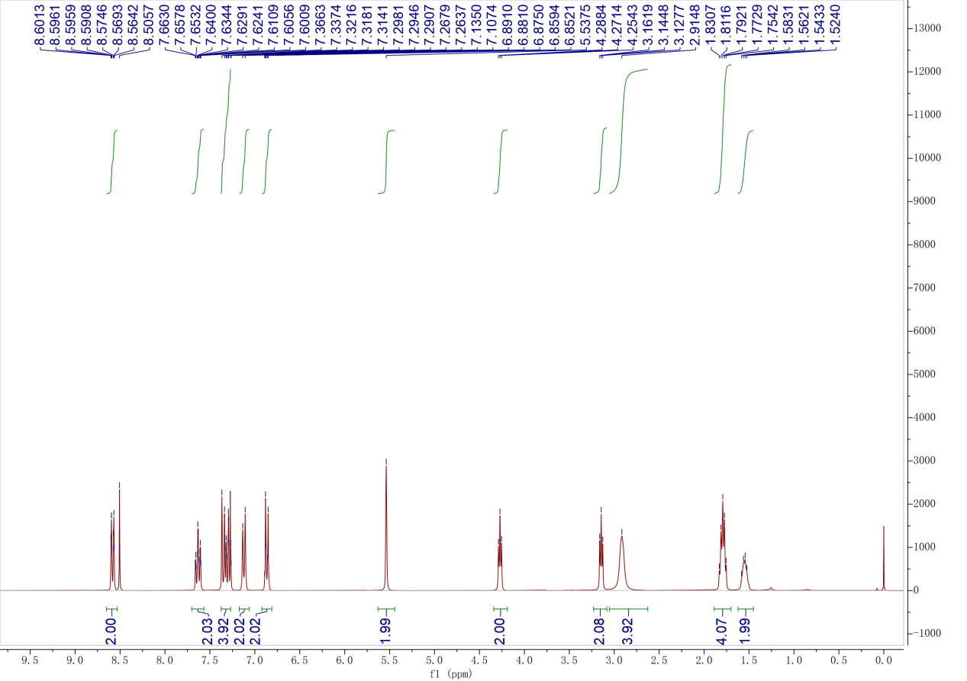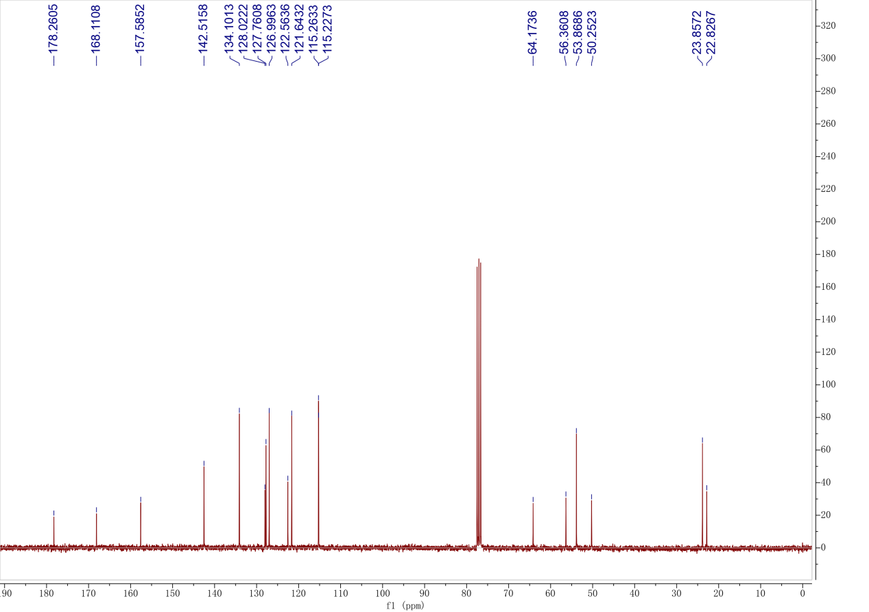

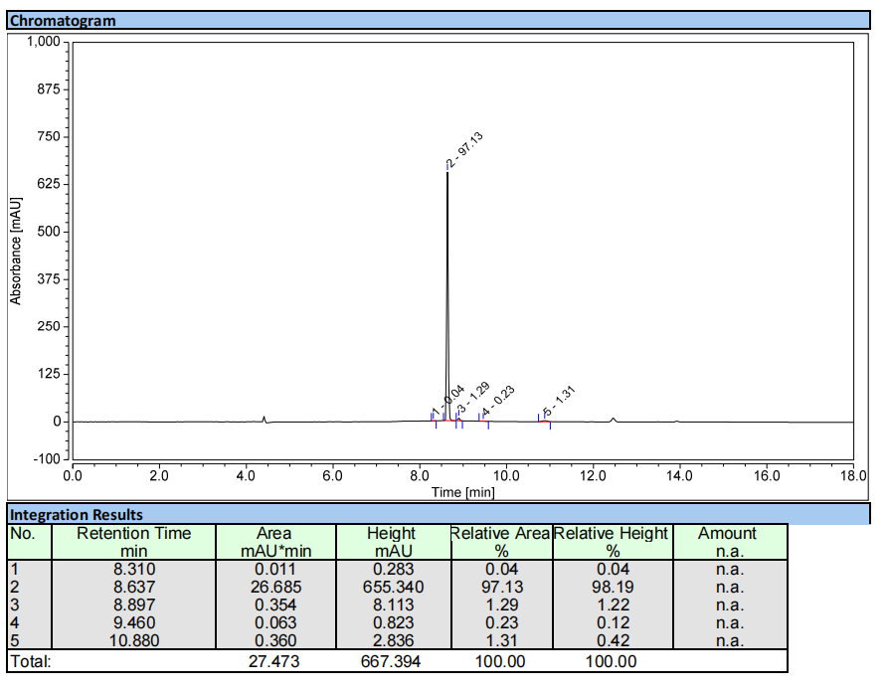
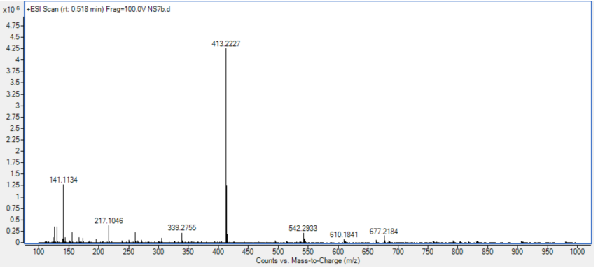

Compound 7c
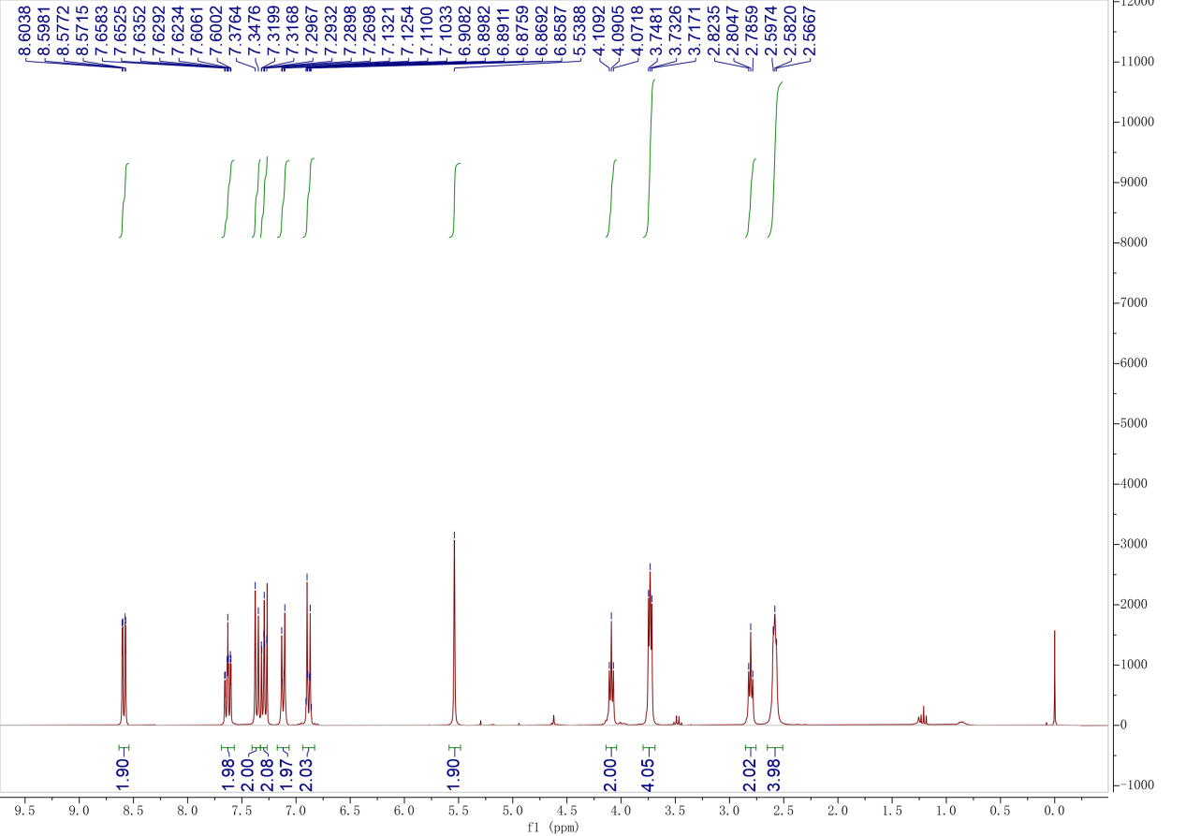
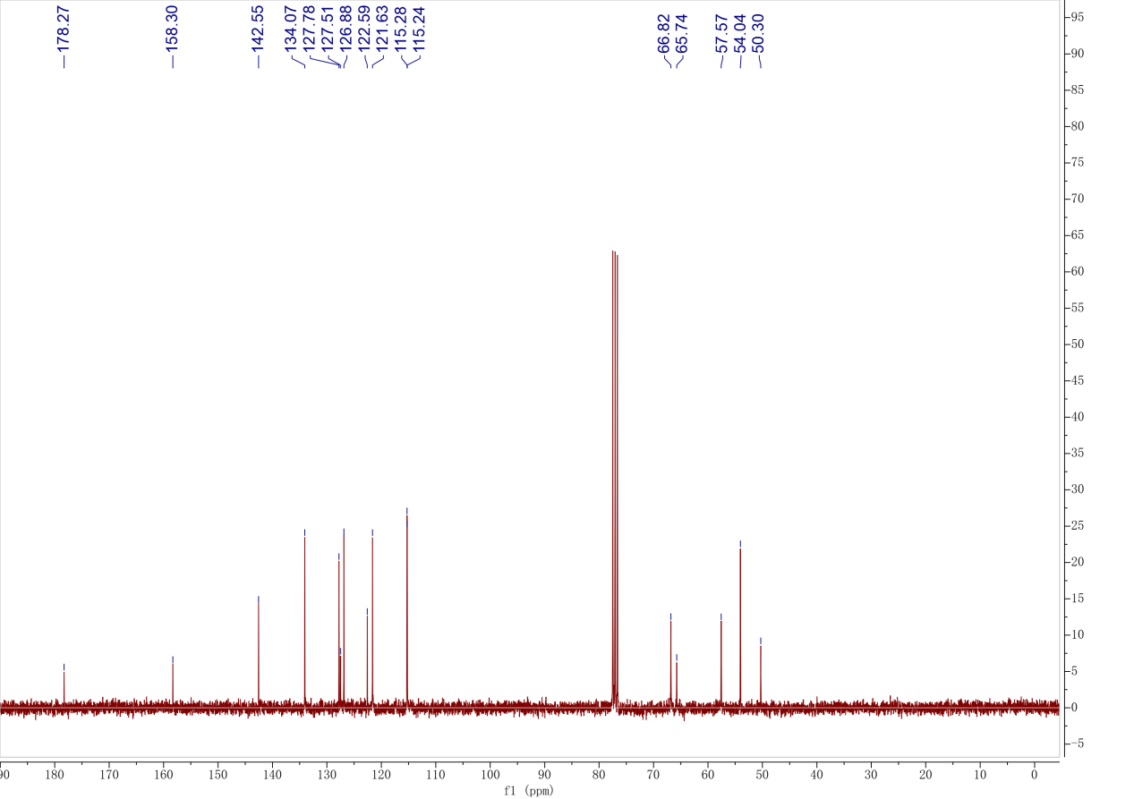

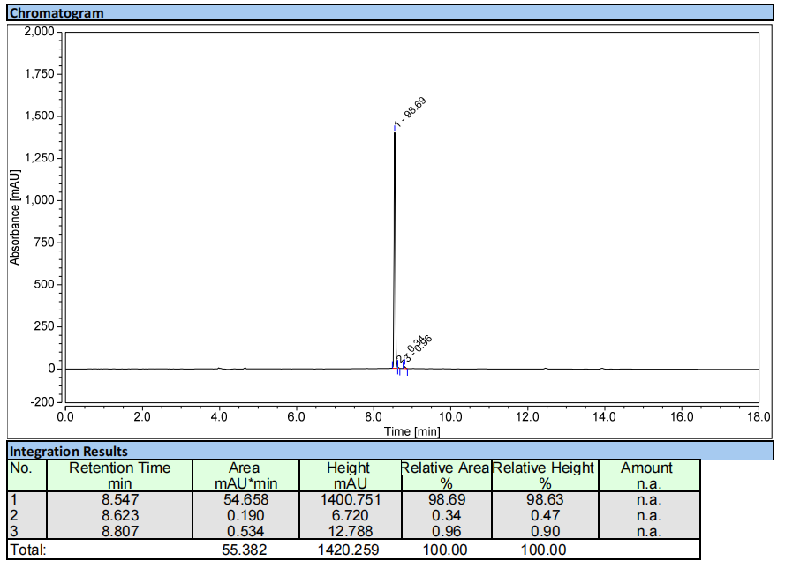
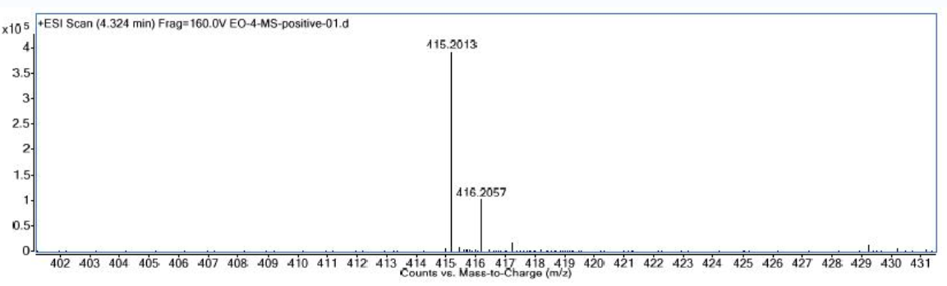

Compound 7d
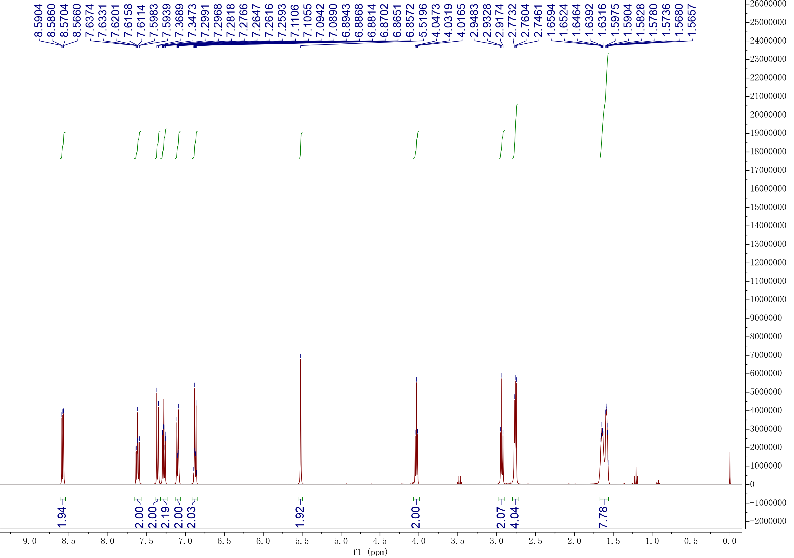
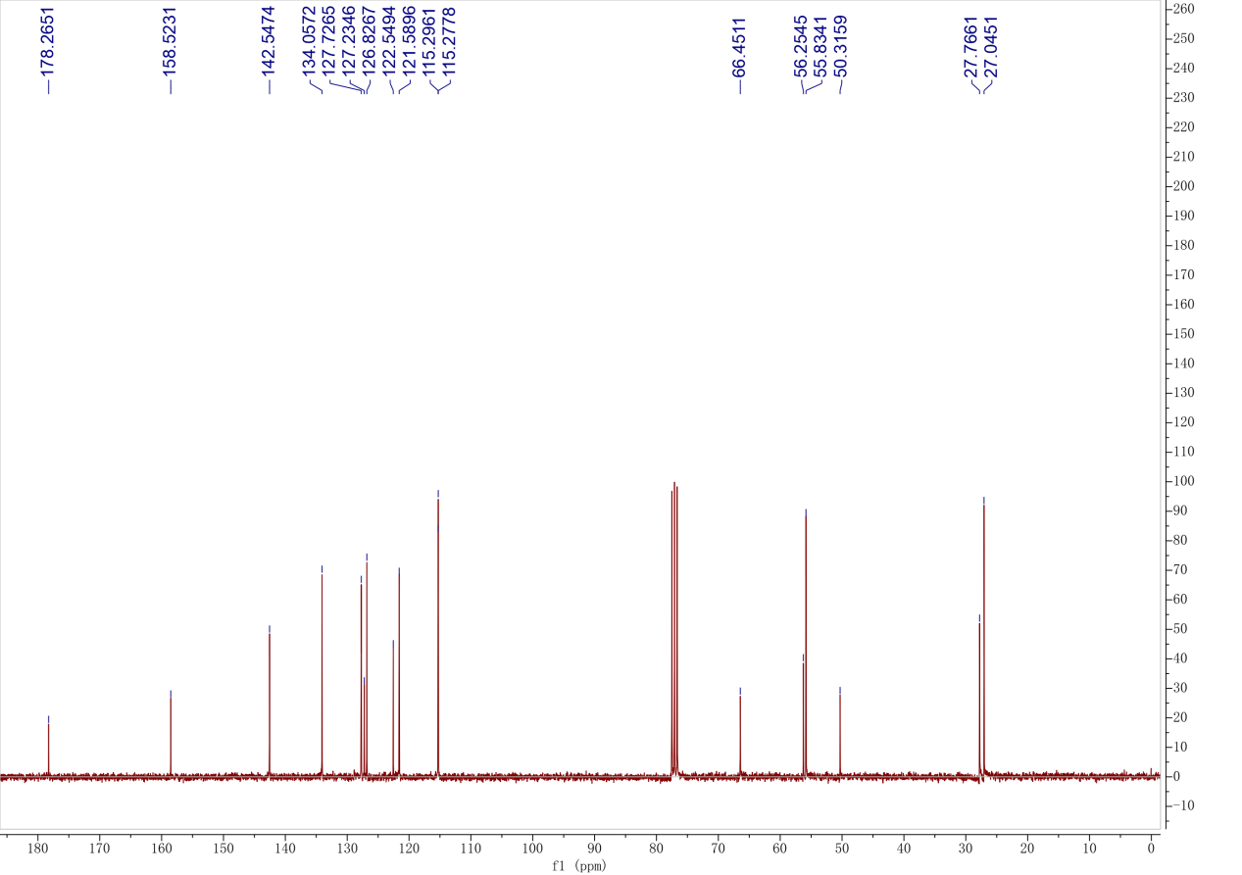

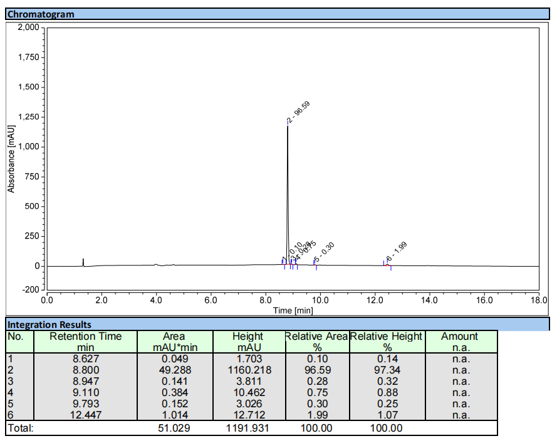
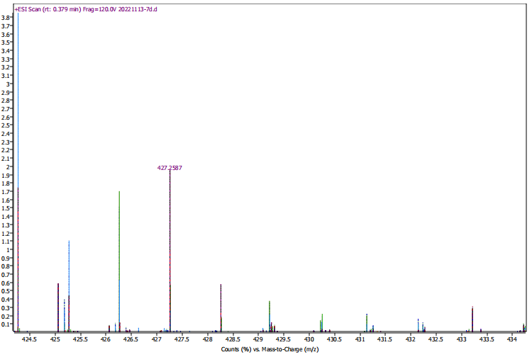

Compound 8a
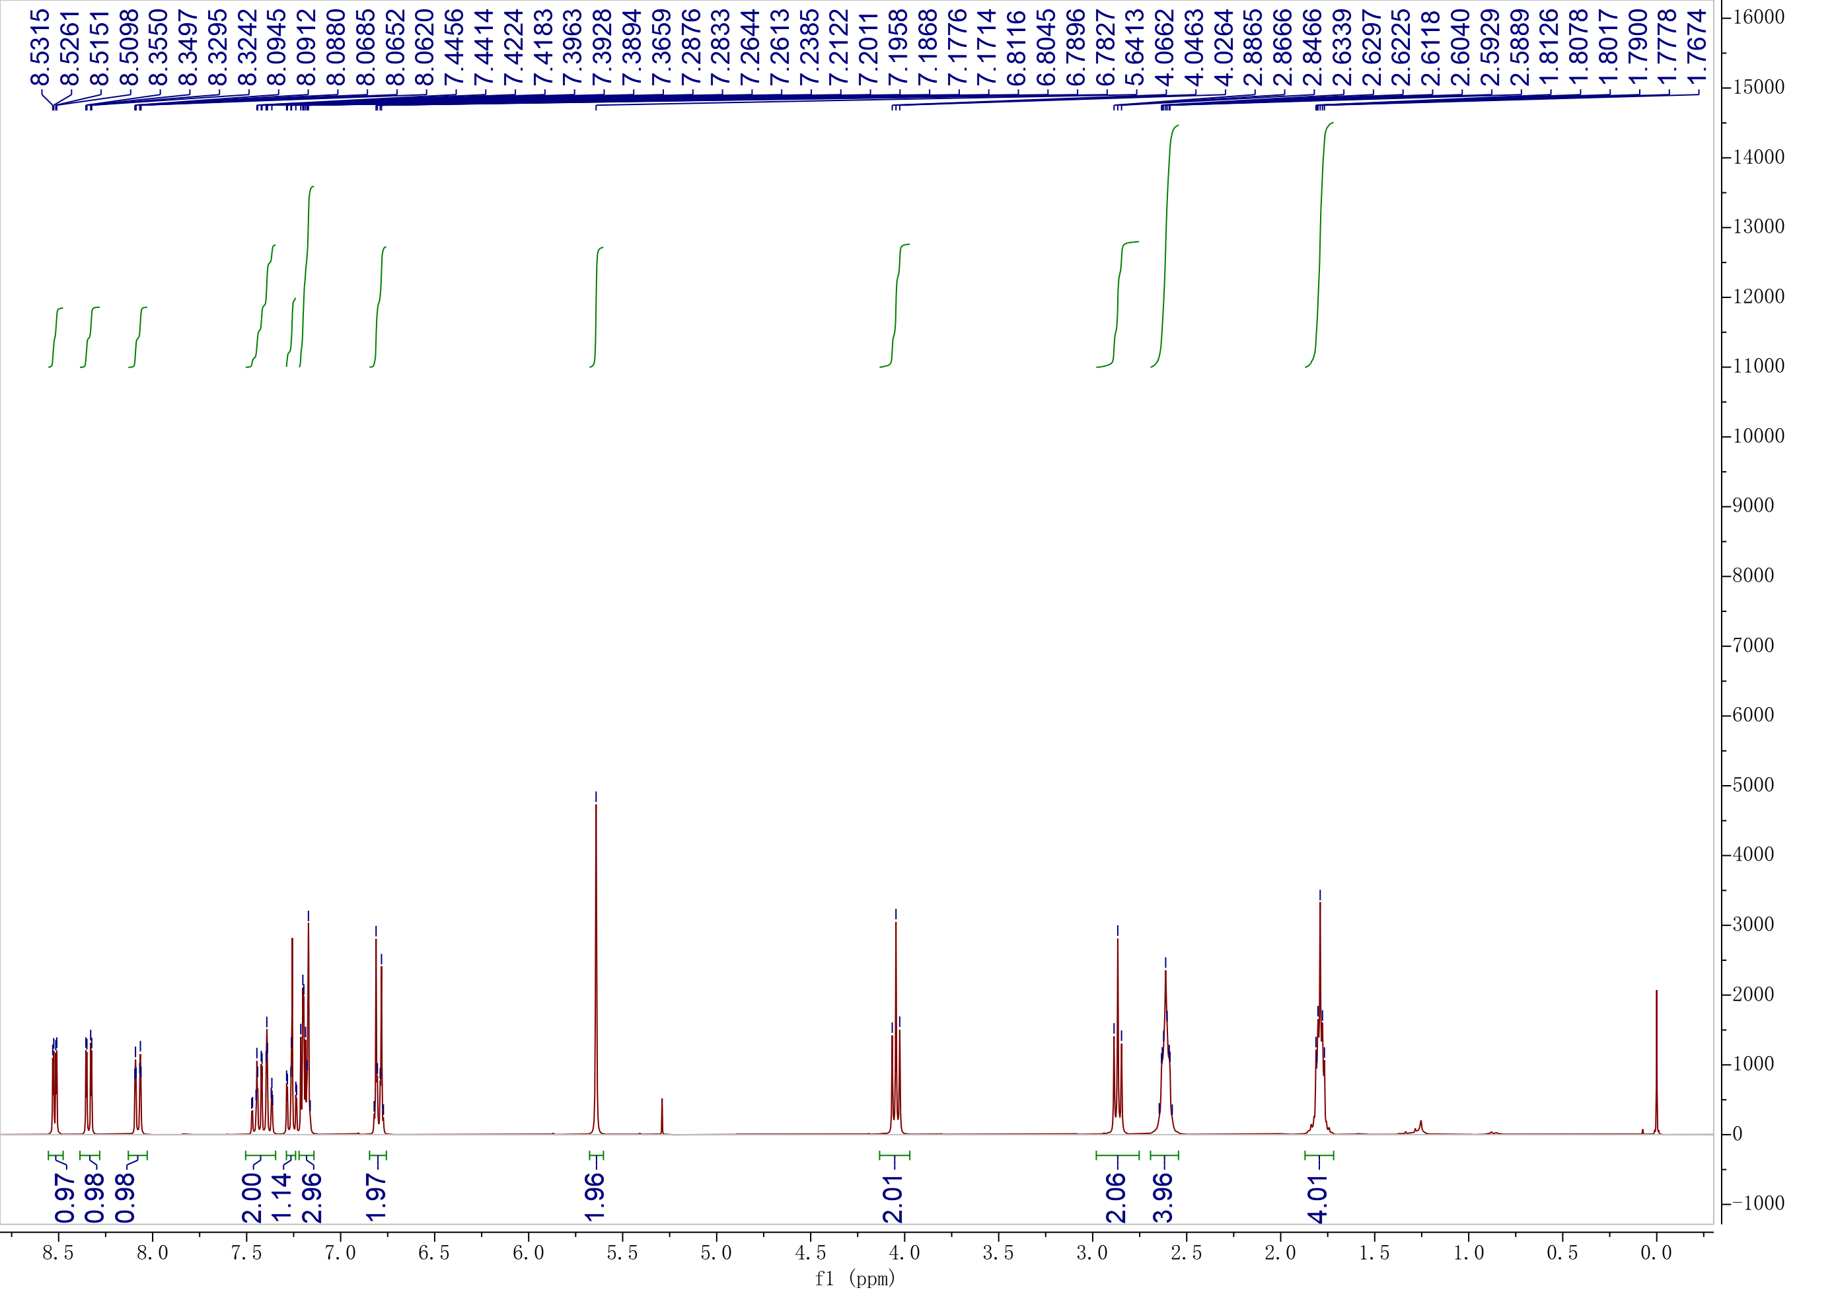
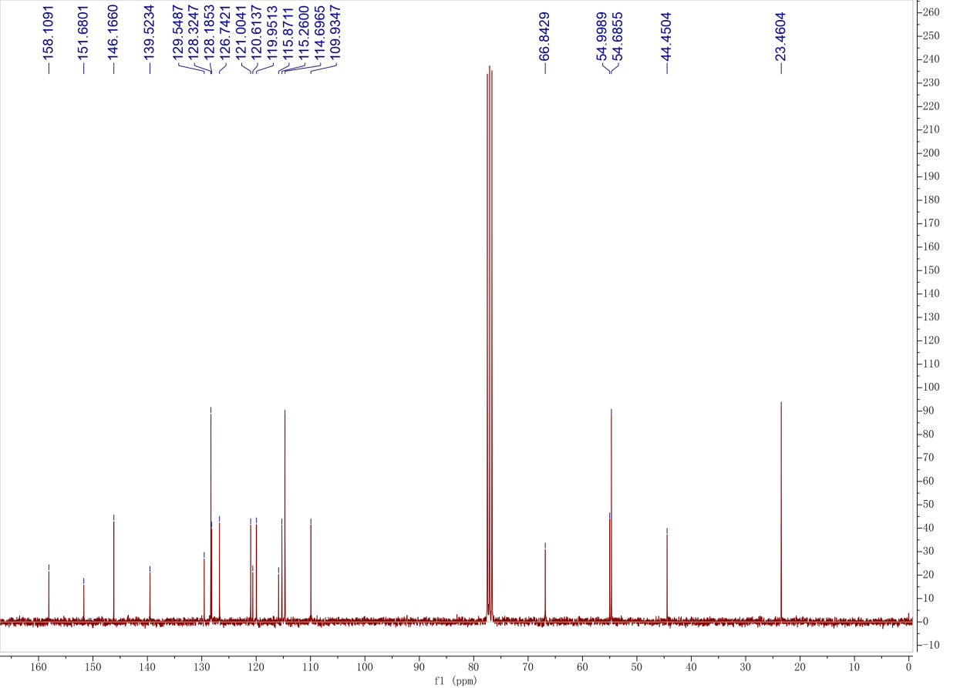

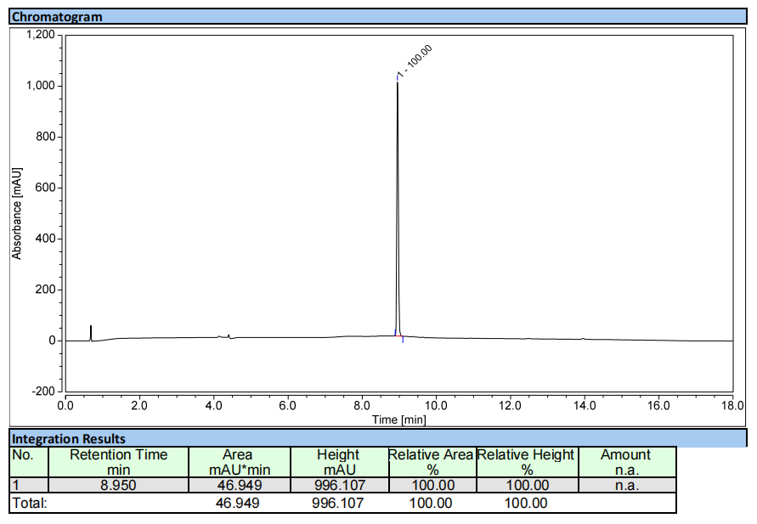
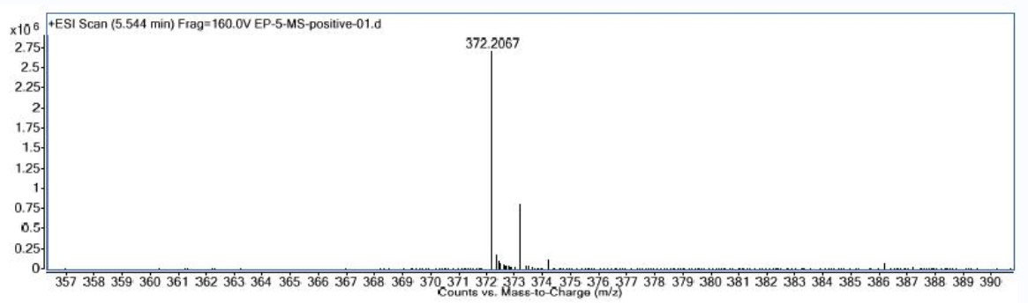

Compound 8b
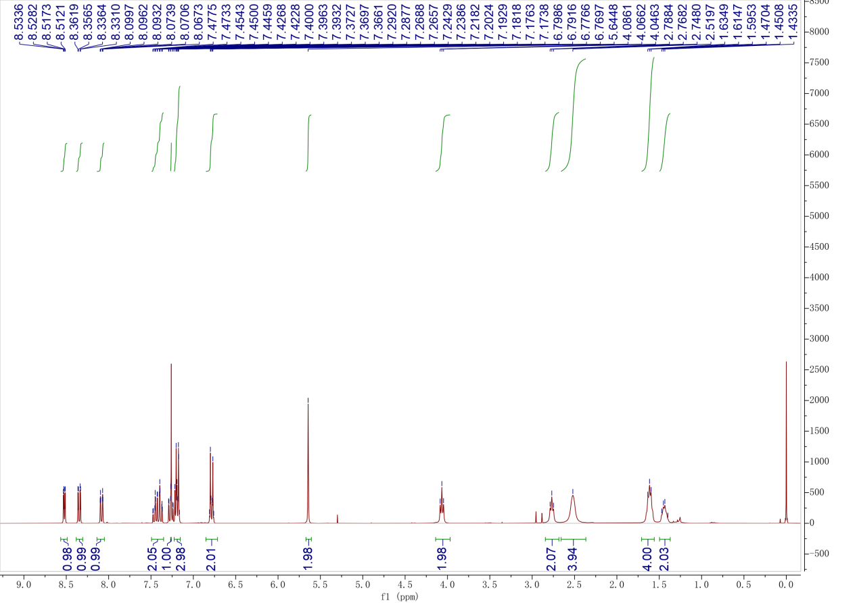
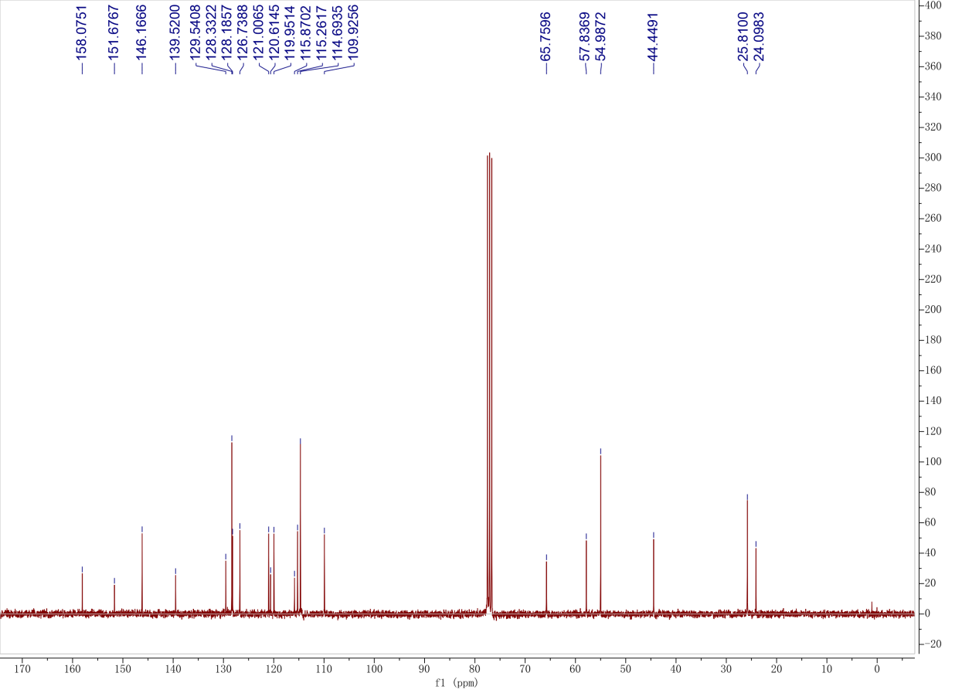

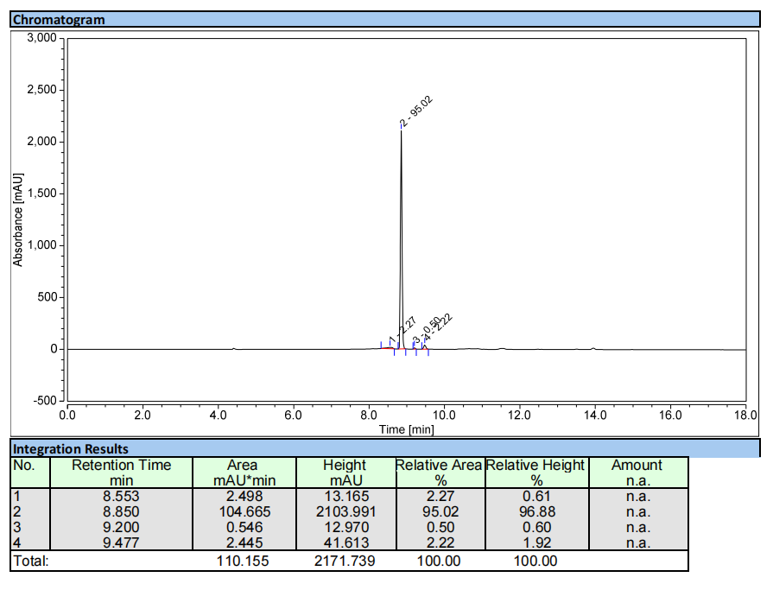
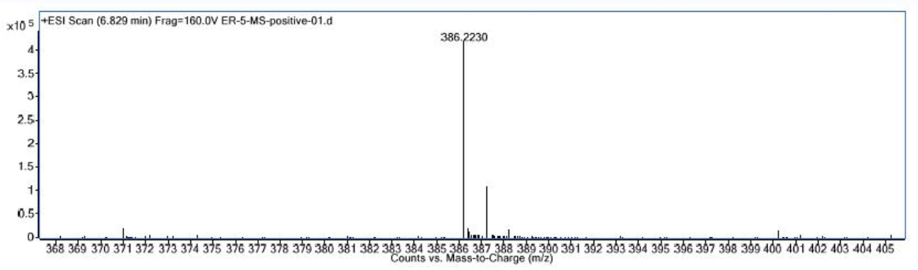

Compound 8c
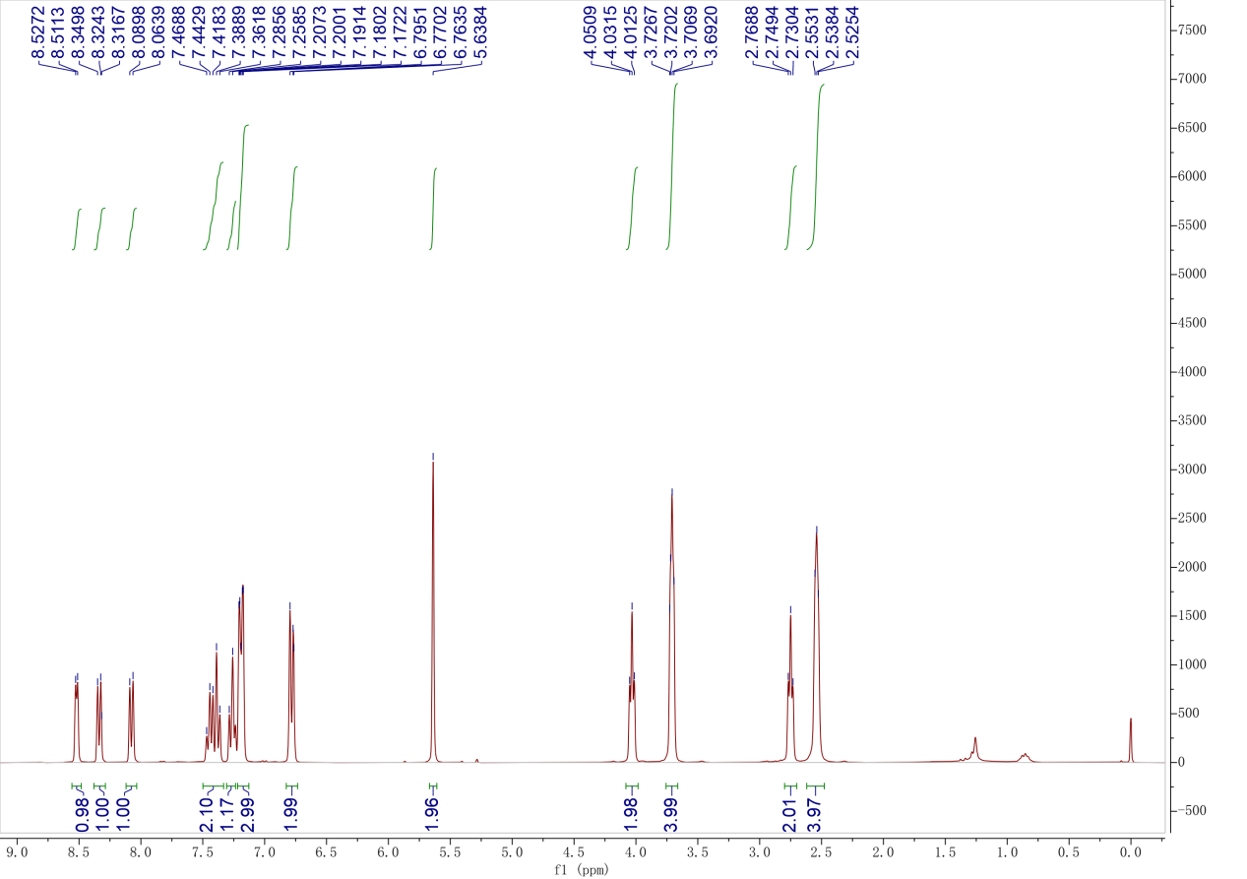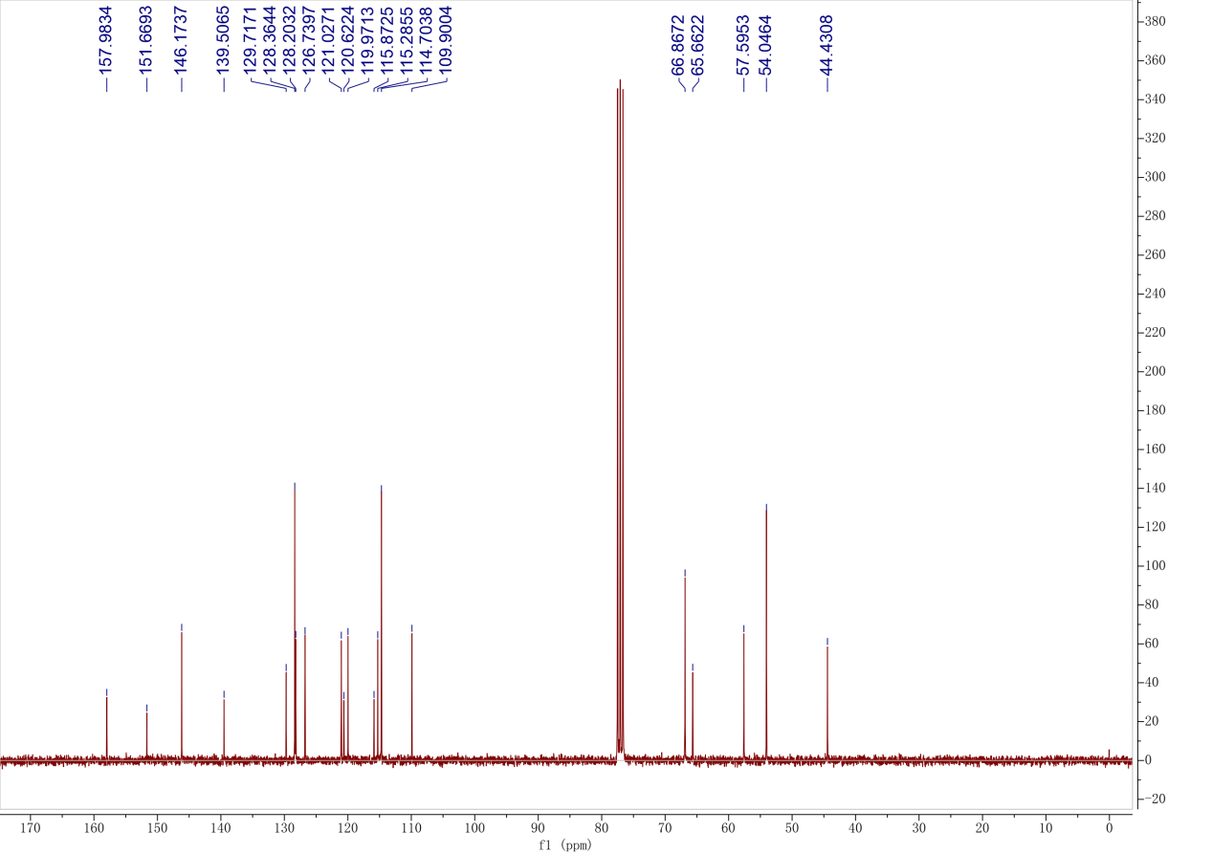

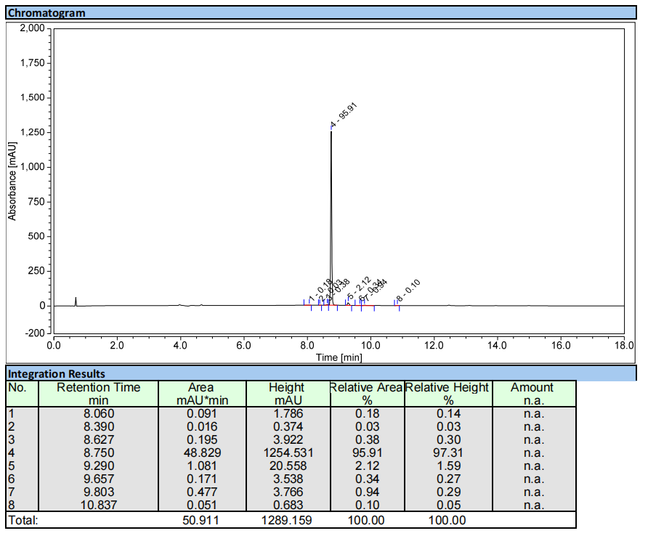
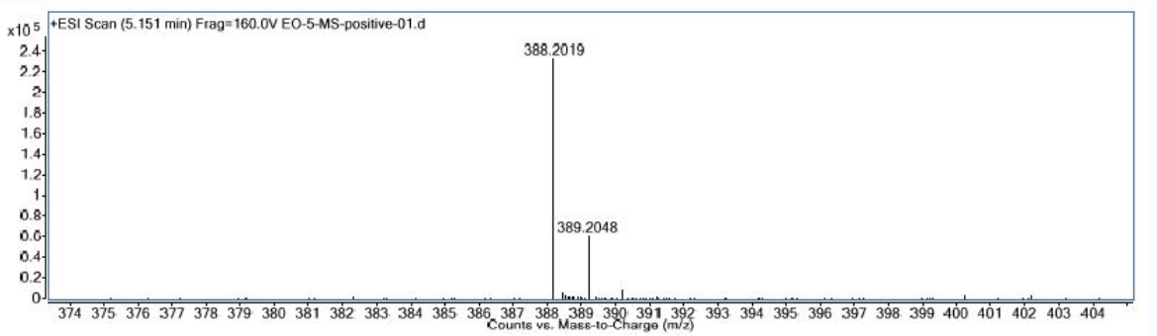

Compound 8d
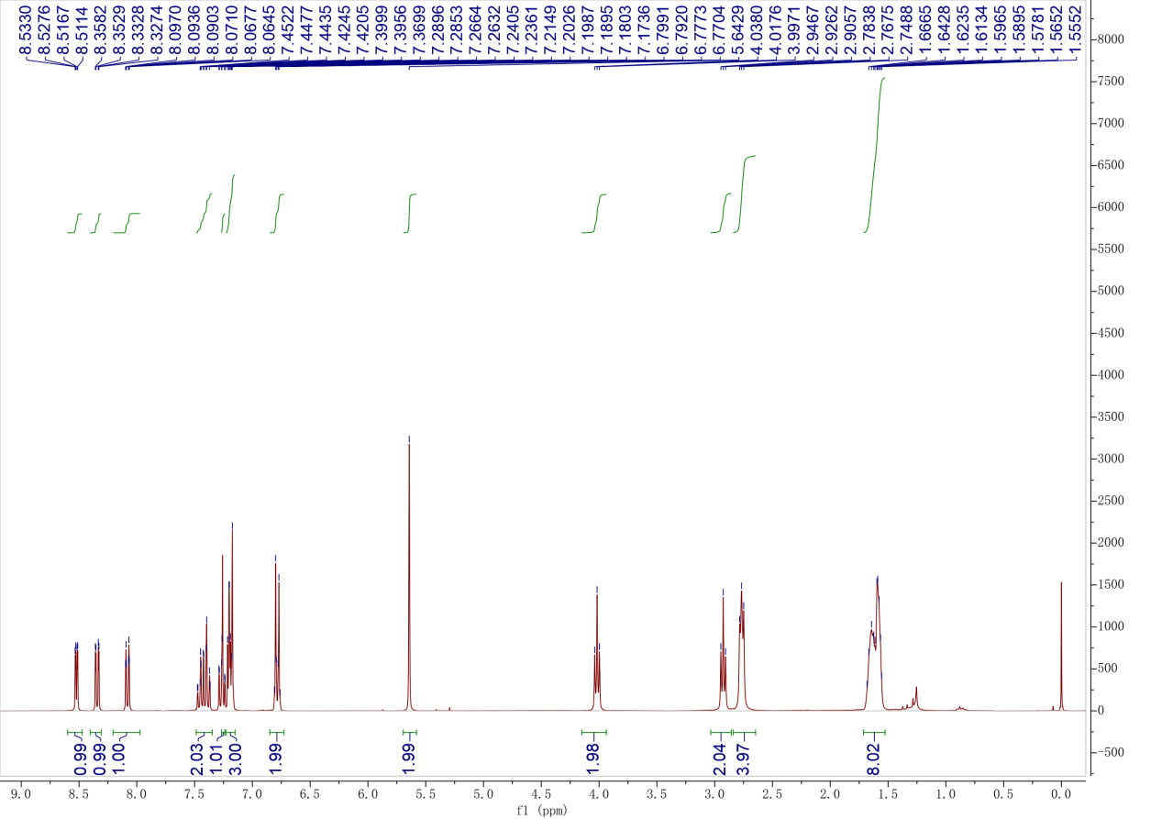
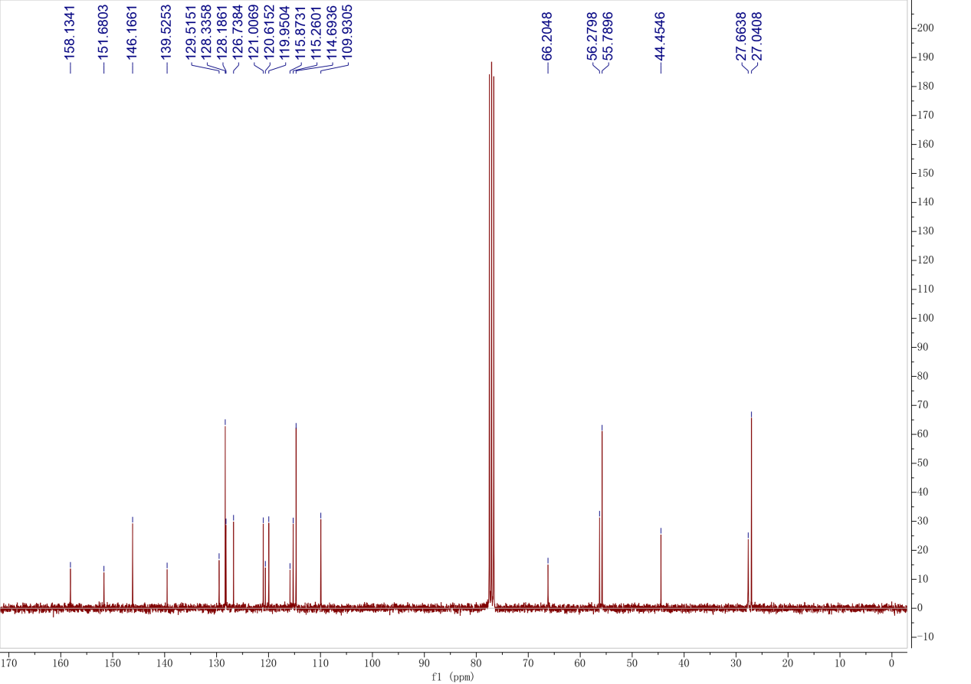

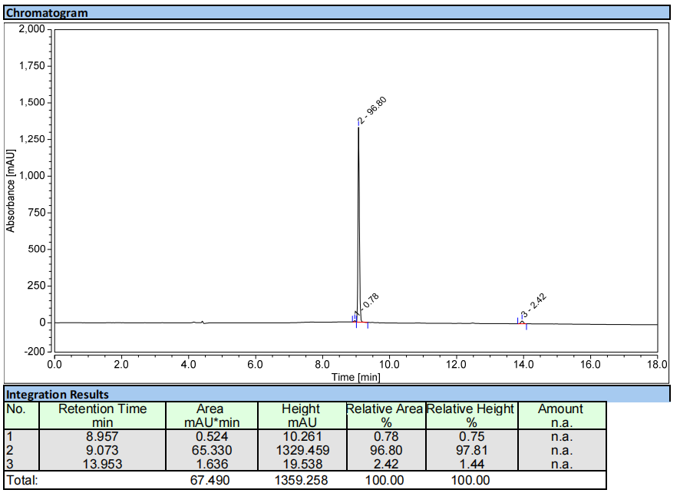
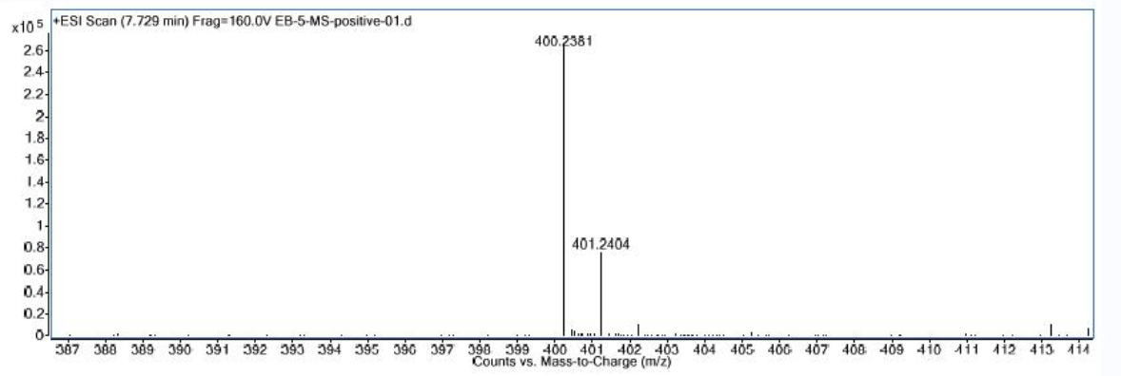

Compound 8e
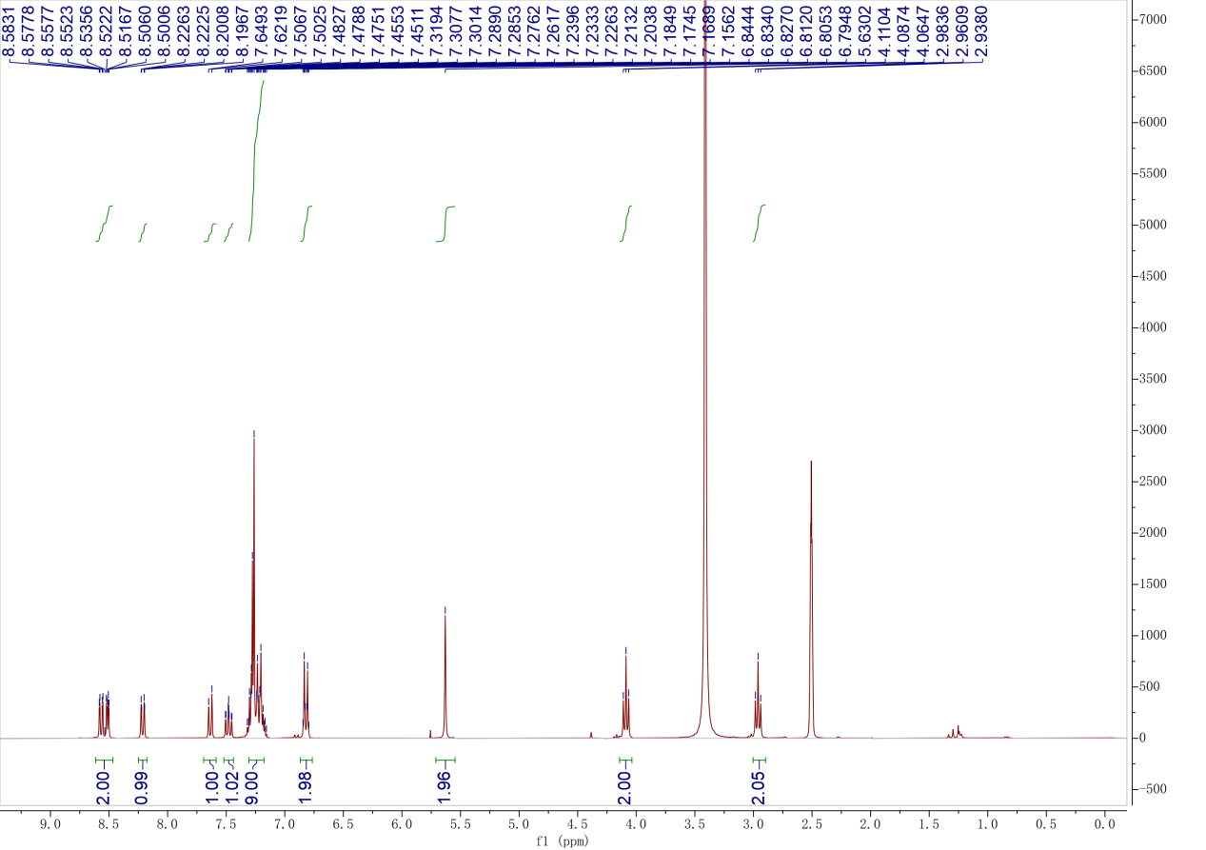
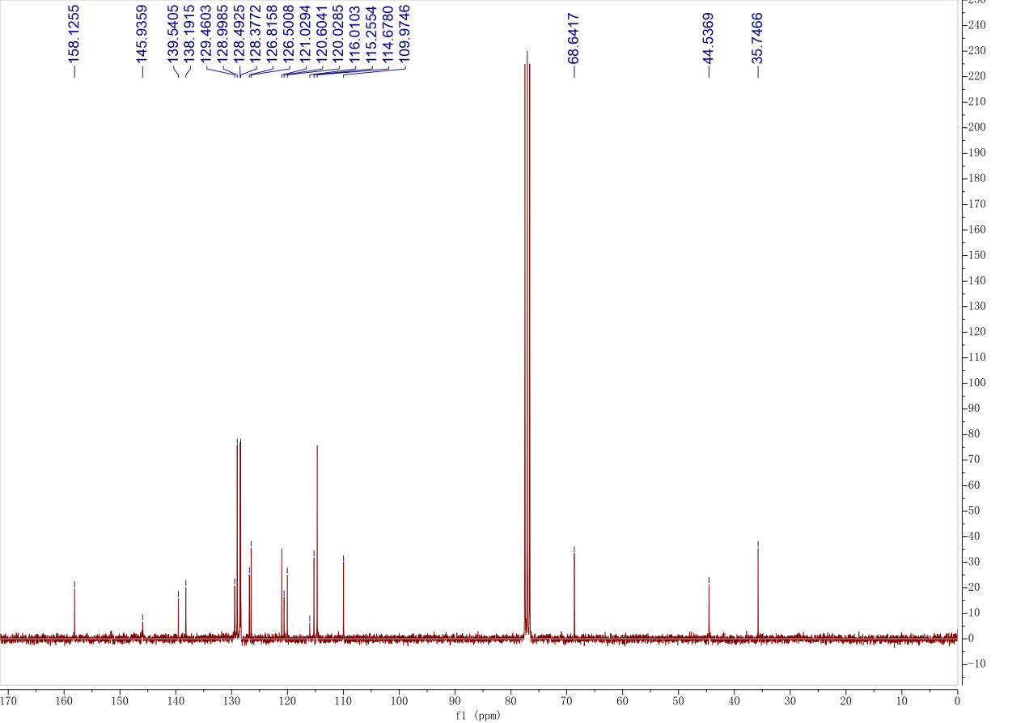
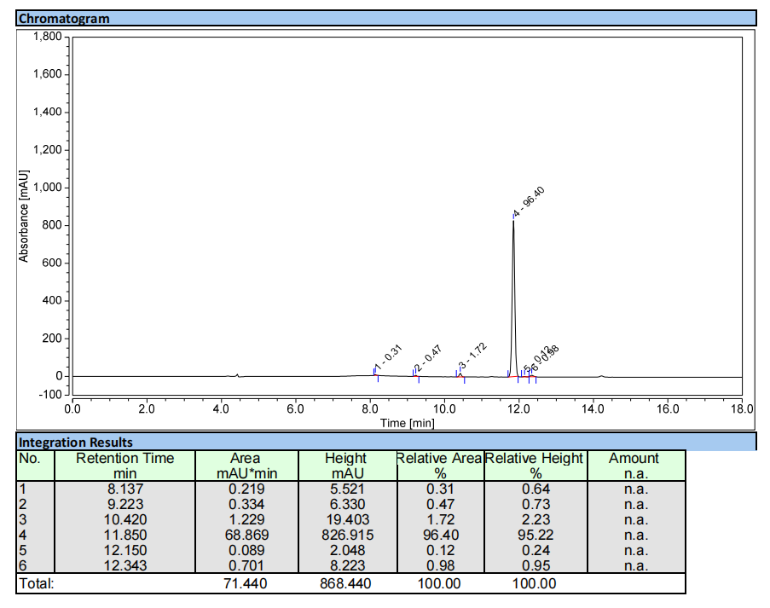
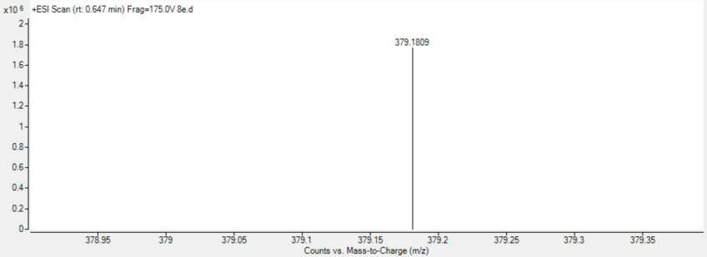

Compound 8f
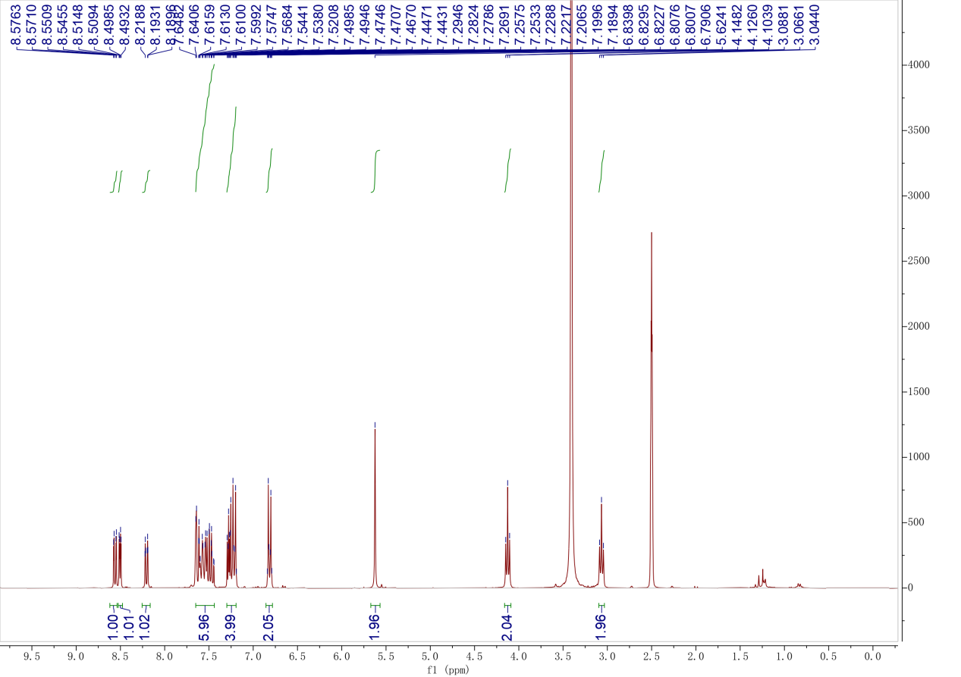
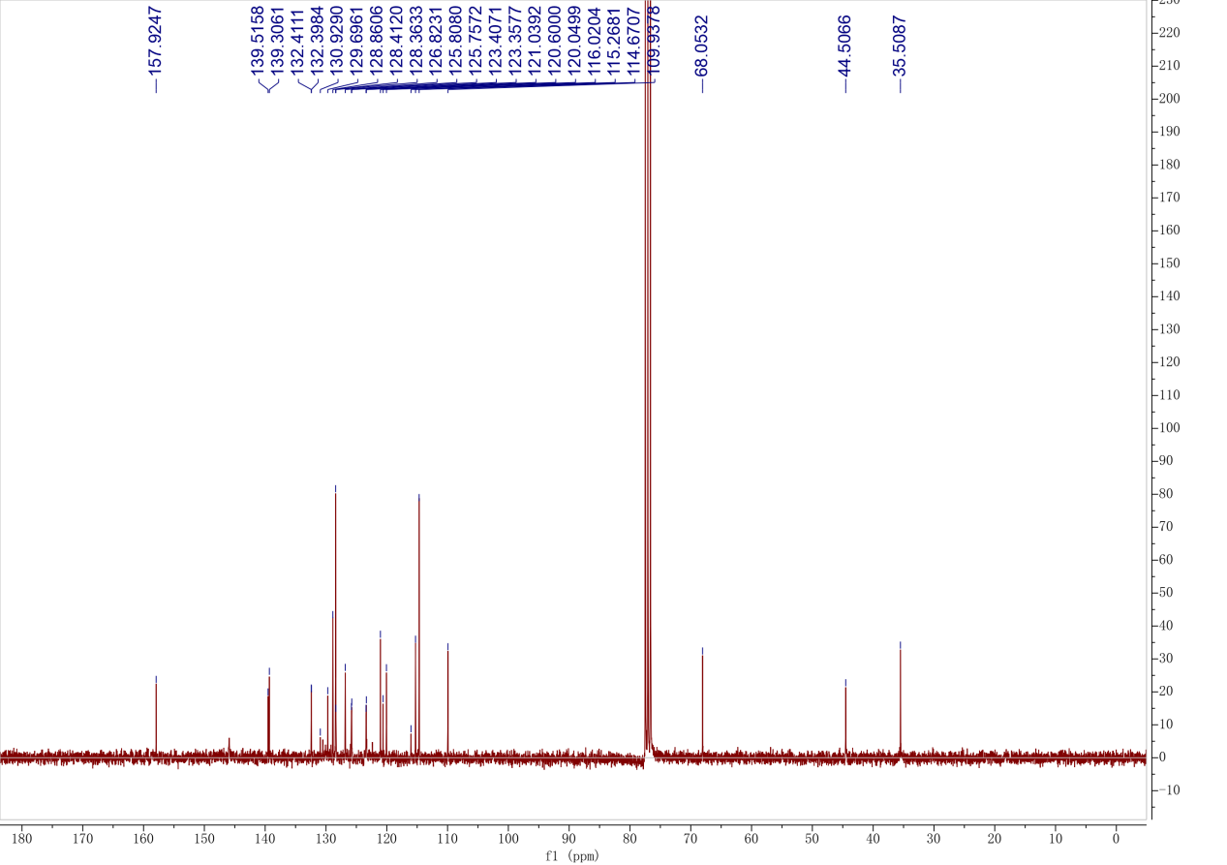
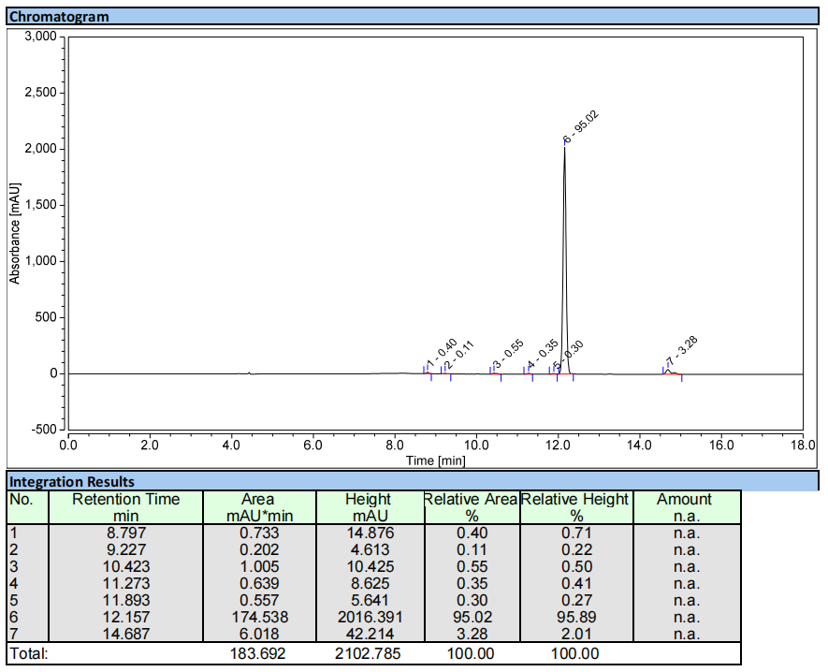
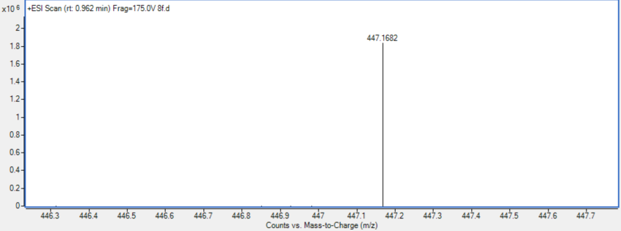

Compound 8g
