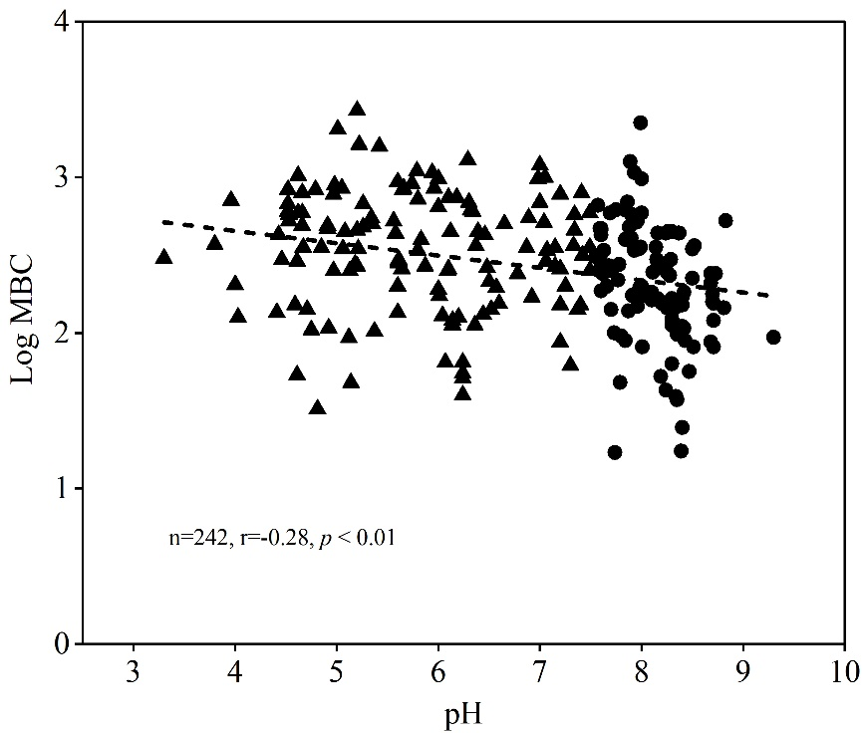

**Fig. S10** Correlation of soil microbial biomass carbon (logarithmic transformation) with soil pH