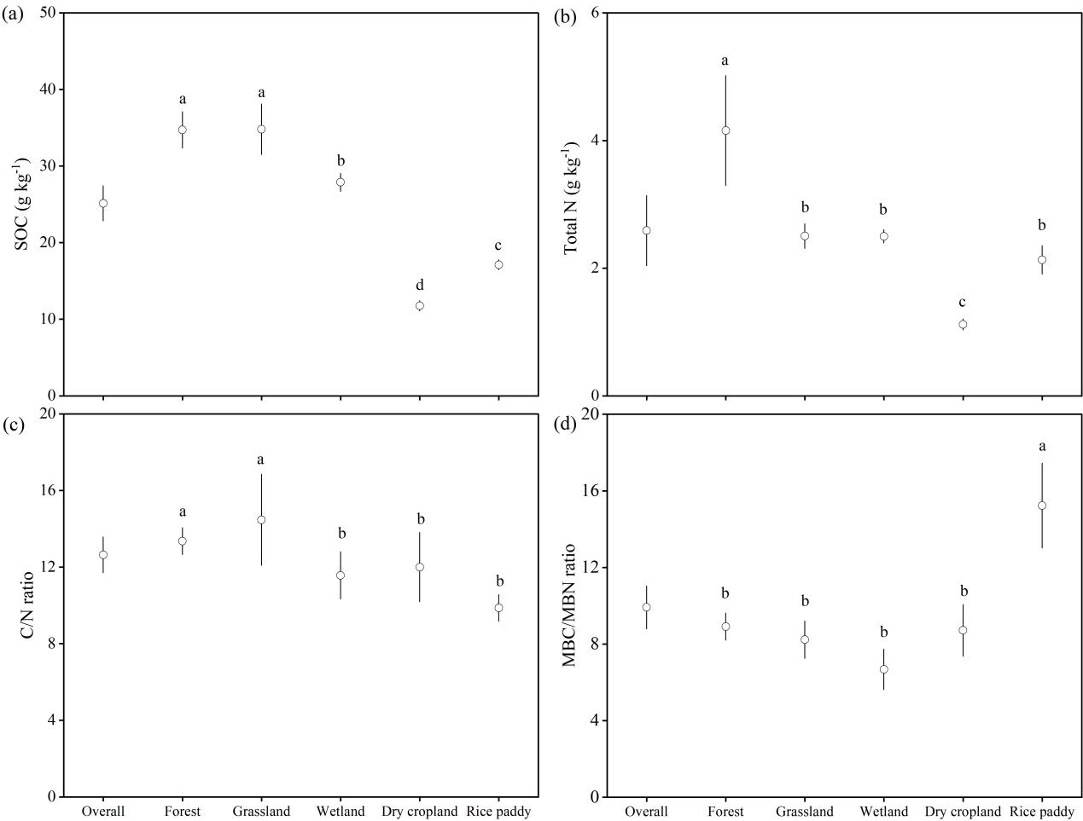

Fig. S9 Differences in SOC concentration (a), soil total N concentration (b), soil C/N ratio (c) and MBC/MBN ratios (d) between land uses (Different letters indicate significant differences of various variables between land uses at *p* < 0.05)