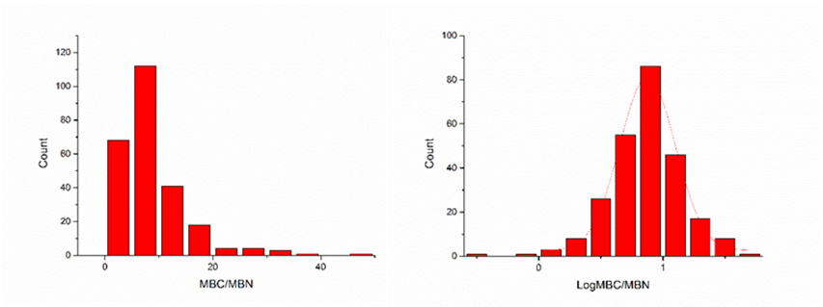

Fig. S8 Frequency distribution of soil microbial biomass carbon and soil microbial biomass nitrogen ratio (MBC/MBN) before (left) and after (right) Log10 transformation