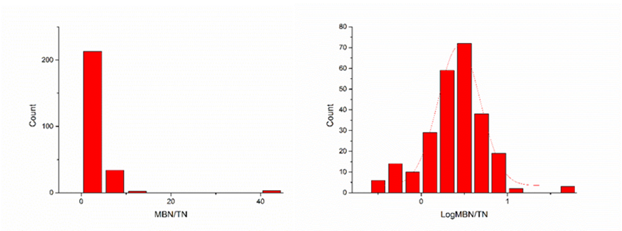

Fig. S7 Frequency distribution of soil microbial biomass nitrogen and soil total nitrogen ratio (MBN/TN) before (left) and after (right) Log10 transformation