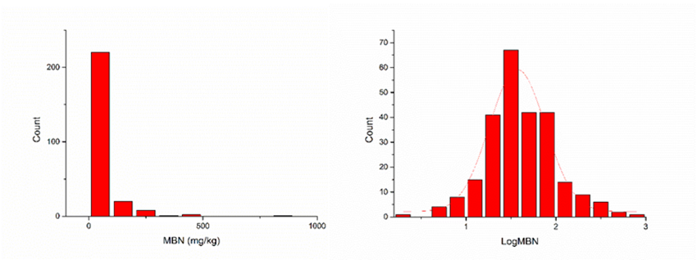

Fig. S6 Frequency distribution of soil microbial biomass nitrogen (MBN) before (left) and after (right) Log10 transformation