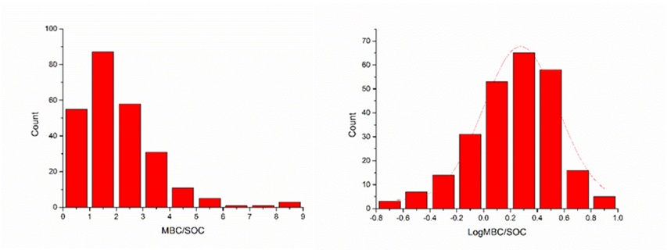

Fig. S5 Frequency distribution of soil microbial quotient (MBC/SOC) before (left) and after (right) Log10 transformation