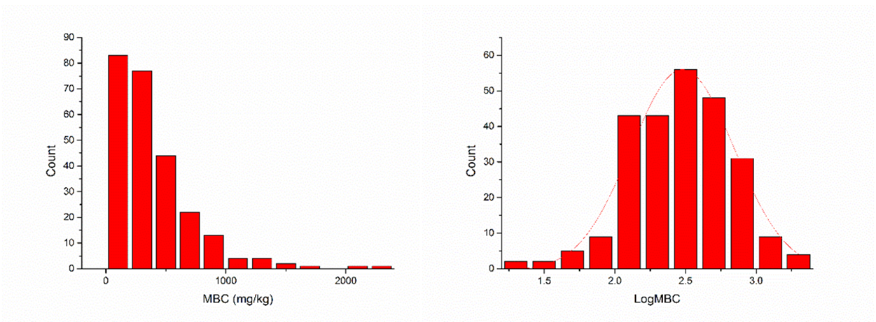

Fig. S4 Frequency distribution of soil microbial biomass carbon (MBC) before (left) and after (right) Log10 transformation