DETAILS AND SELECTION OF THE STATISTICAL MODELS APPLIED FOR LEAF vs CONTROL ANALYSIS

Linear mixed-effects model (LMM)
The data were analyzed using an LMM using the R language. The model used was:
$$Variable=Treatment+period+Treatment∗period+ID(plants)$$
The primary objective of this model was to assess the impact of treatment (inoculated or not) and period on the response variables. Period represented a continuous variable of time, shown in the figures as smoothed curves by weeks (see main text), with the time scale adjusted using average results for one-week intervals.
To account for the repeated measures structure, a random effect for individual plants (ID) was included. This allowed us to model within-plant correlations over time, since each plant was measured repeatedly, while also capturing between-plant variability.
Additional model components were included to address specific assumptions based on residual diagnostics. These are described below:
- Generalized linear mixed-effects model (GLMM)
Data were transformed using logarithmic or square root functions when normality assumptions were violated. However, if assumptions remained unmet even after transformation, alternative distributions suitable for count data (e.g., Poisson) were employed using the family argument in R.
- Heterocesdastic models
Variables that exhibited heteroscedasticity were incorporated into a dispersion structure using the function in R dispformula = ~ factor or dispformula = ~ factor1*factor2. This functionality allowed the residual variance to vary according to one or more factors (e.g., treatment or period), improving model fit and ensuring residual homogeneity.
$$Dispersion=treatment or period or treatmment∗period$$
- Natural Splines
To model nonlinear temporal trends in response variables (e.g., the number of healthy leaves, flowers, or fruits), natural splines were incorporated using the (ns)function from the splines package in R. The argument df = X specifies the degrees of freedom, which determines the number of internal knots placed where the tendency of the fitted curve changed.
$$Splines=ns(period, df=X)$$
In the model output tables, spline components are displayed in the fixed effects summary as period[X], where X denotes a specific segment of the period determined by the chosen degrees of freedom.
Model Selection
Optimal model selection was guided by a combination of graphical diagnostics using the DHARMa package in R and the Akaike Information Criterion (AIC). This method helps prevent overfitting and ensures that nonlinear patterns are accurately identified.

RESULTS FROM THE MODELS
Analysis LEAF Treatment vs Control
Because the leaf inoculation experiment was performed later than the root inoculation, the following graphs show each leaf parameter for the whole time the plants were in the greenhouse, during the pre-leaf inoculation period and the post-leaf inoculation, to highlight changes occurring after the inoculation. The post-inoculation period is marked by a green-shaded area on the graphs, starting from November 6.
Total Leaves
Plants assigned to both treatments produced a similar number of total leaves during the pre-inoculation phase. From 2 weeks post-inoculation (November 13) onward, plants from the foliar treatment produced more leaves than the control (Fig. 1S).
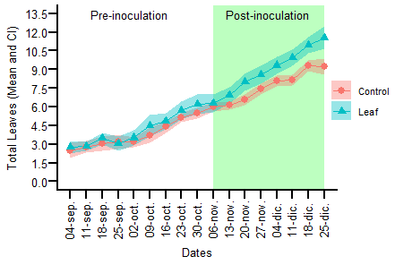
Fig. 1S Raw data for the variable Total Leaves based on weekly measurements. The points represent the mean, and the shaded bands indicate 95% confidence intervals.
Table 1S Statistical model and output summary for Total Leaves.
Model formula:
HT ~ treatment * period + (1 | ID)
Random Effects: Random intercept for ID (Plant)
Family: Gaussian (identity)
Splines: NO
Dispersión: ~ NO
Fixed Effects | Estimate | Std. Error | z value | p-value
(Intercept) | 1.690 | 0.041 | 40.78 | < 2e−16 | ***
treatment (Leaf vs Control) | 0.061 | 0.057 | 1.08 | 0.28070
period | 0.706 | 0.034 | 20.85 | < 2e−16 | ***
treatment × period | 0.175 | 0.057 | 3.06 | 0.00224 | **
Random Effects | Variance | Std. Dev.
ID | 0.0204 | 0.143
Residual | NA | NA
Dispersion Effects | Estimate | Std. Error | z value | p-value
(Intercept) | −4.637 | 0.133 | −34.82 | < 2e−16 | ***
treatment (Leaf vs Control) | 0.974 | 0.174 | 5.58 | 2.35e−08 | ***

Healthy Leaves
Plants that were assigned to both treatments produced a similar number of healthy leaves during the pre-inoculation period. From 3 weeks post-inoculation (November 20) onward, the foliar treatment produced more healthy leaves than the control until the end of the experiment (Fig. 2).
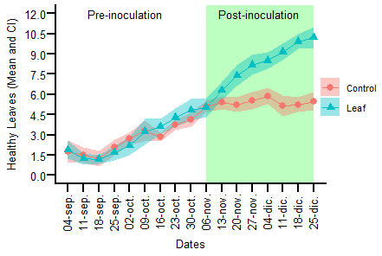
Fig. 2S Raw data for the variable Healthy Leaves based on weekly measurements. The points represent the mean, and the shaded bands indicate 95% confidence intervals.
Table 2S Statistical model and output summary for Healthy Leaves.
Model Formula: sqrt(HB) ~ treatment * ns(period, df = 3) + (1 | ID)
Random Effects: Random intercept for ID (Plant)
Family: Gaussian (identity)
Splines: NO
Dispersión: NO
Fixed Effects | Estimate | Std. Error | z value | p-value
(Intercept) | 2.047 | 0.085 | 24.150 | < 2e−16 | ***
treatment (Leaf vs Control) | 0.051 | 0.110 | 0.460 | 0.643
period [1] | 0.114 | 0.095 | 1.200 | 0.229
period [2] | 0.572 | 0.155 | 3.700 | 2.2e−04 | ***
period [3] | 0.049 | 0.069 | 0.720 | 0.472
treatment × period [1] | 0.639 | 0.124 | 5.150 | 2.69e−07 | ***
treatment × period [2] | 0.902 | 0.202 | 4.470 | 7.9e−06 | ***
treatment × period [3] | 0.743 | 0.090 | 8.290 | < 2e−16 | ***
Random Effects | Variance | Std. Dev.
ID | 0.048 | 0.218
Residual | 0.067 | 0.258
Flowers
Before leaf inoculation, plants that were later assigned to the foliar treatment exhibited higher flower production than those assigned to the control group; this increment started at the end of September. However, both treatments showed no increase in the number of flowers post-inoculation (Fig. 3).
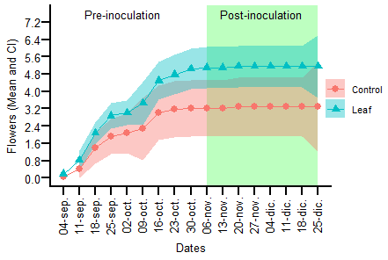
Fig. 3S Raw data for the variable Flowers based on weekly measurements. The points represent the mean, and the shaded bands indicate 95% confidence intervals.
Table 3S Statistical model and output summary for Flowers.
Model Formula: FL ~ treatment * ns(period, df = 1) + (1 | ID)
Random Effects: Random intercept for ID (Plant)
Family: Gaussian (identity)
Splines: NO
Dispersión: NO
Fixed Effects | Estimate | Std. Error | z value | p-value
(Intercept) | 3.208 | 0.838 | 3.830 | 1.2e−04 | ***
treatment (Leaf vs Ctrl) | 1.888 | 1.092 | 1.730 | 0.084 | .
period | 0.011 | 0.004 | 2.620 | 0.009 | **
treatment × period | −0.003 | 0.005 | −0.600 | 0.547
Random Effects | Variance | Std. Dev.
ID | 9.819 | 3.134
Residual | 0.014 | 0.119

Fruits
Before leaf inoculation, plants did not produce fruits until October 16th when all plants produced a similar number of fruits. Immediately after inoculation, fruit production increased only for the inoculated plants and during three weeks. Fruit production ceased after 4 weeks post-inoculation (December 4th) (Fig. 4).
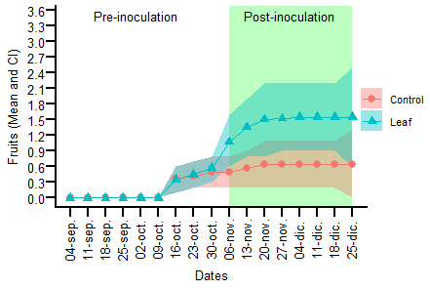
Fig. 4S Raw data for the variable Fruits based on weekly measurements. The points represent the mean, and the shaded bands indicate 95% confidence intervals.
Table 4S Statistical model and output summary for Fuits.
Model Formula: FR ~ treatment * ns(period, df = 2) + (1 | ID)
Random Effects: Random intercept for ID (Plant)
Family: Poisson (log)
Splines: NO
Dispersión: NO
Fixed Effects | Estimate | Std. Error | z value | p-value
(Intercept) | −3.164 | 0.997 | −3.170 | 0.002 | **
treatment (Leaf vs Control) | 1.407 | 1.100 | 1.280 | 0.201
period [1] | 0.527 | 0.671 | 0.780 | 0.433
period [2] | 0.109 | 0.344 | 0.320 | 0.752
treatment × period [1] | 0.991 | 0.793 | 1.250 | 0.211
treatment × period [2] | 0.139 | 0.393 | 0.350 | 0.725
Random Effects | Variance | Std. Dev.
ID | 6.165 | 2.483
Residual | NA | NA

Runners
Before leaf inoculation, plants did not produce runners until October 16th when all plants started and continue steadily until the end of the experiment, with plants that were assigned to the control group with slightly more runners than the inoculated plants (Fig. 5).
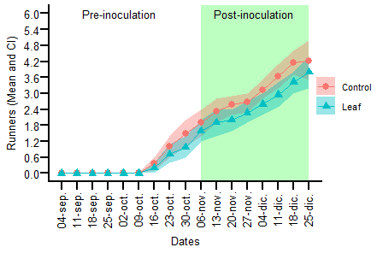
Fig. 5S Raw data for the variable Runners based on weekly measurements. The points represent the mean, and the shaded bands indicate 95% confidence intervals.
Table 5S Statistical model and output summary for Runners.
Model Formula: ES ~ treatment * week1 + (1 | ID)
Random Effects: Random intercept for ID (Plant)
Family: Gaussian (identity)
Splines: NO
Dispersión: NO
Fixed Effects | Estimate | Std. Error | z value | p-value
(Intercept) | 1.478 | 0.270 | 5.480 | 4.29e−08 | ***
treatment (Leaf vs Control) | −0.396 | 0.352 | −1.130 | 0.261
period | 3.480 | 0.314 | 11.070 | <2e−16 | ***
treatment × period | −0.221 | 0.410 | −0.540 | 0.590
Random Effects | Variance | Std. Dev.
ID | 0.704 | 0.839
Residual | 0.834 | 0.913

