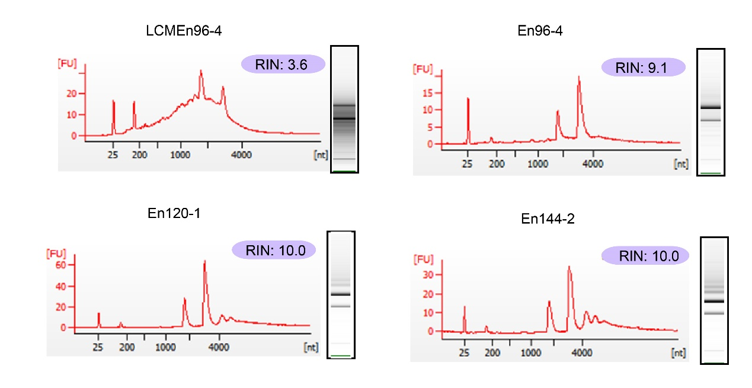

Supplemental Figure 1. Representative quality assessments of RNAs used in sequencing.

Electropherograms of sample RNAs extracted from LCM samples or free-hand samples. RNA Integrity Number (RIN) is a measure of RNA quality (Agilent Technologies).

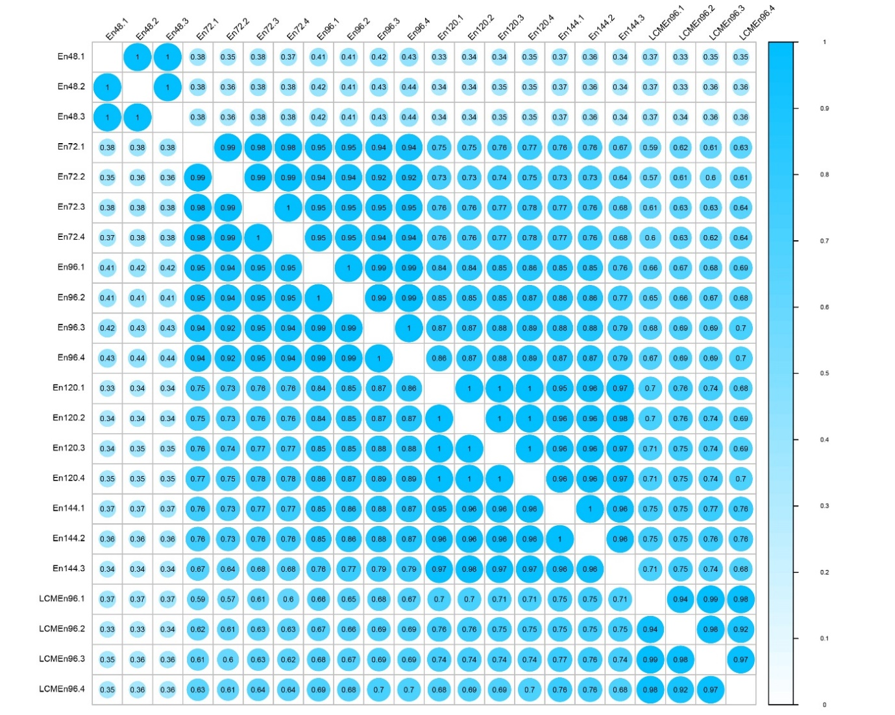

Supplemental Figure 2. SCC (Spearman's rank Correlation Coefficient) analysis of the mRNA data using log2-transformed FPKM values.

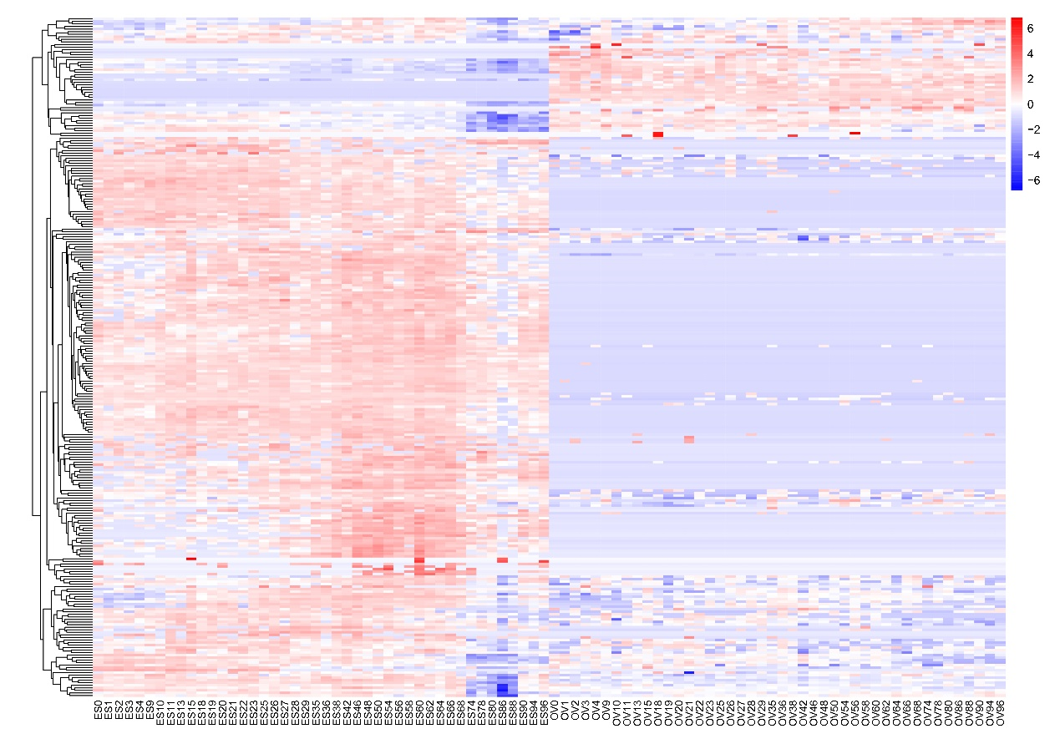

**Supplemental Figure 3.** Expression patterns of CE Gene Set in maize embryo sac and ovule by the public RNA-seq data [27].