Supporting Information
Dual-Metal Synergistic Coordination Enables Ultrasensitive and Ratiometric Multicolor Fluorescent Detection of Uranyl Ions
Zhaojing Yuan^{a,b}, Chengtao He^{b}, Ziqing Liu^{b}, Hui Qiu^{b}, Qiushuo Zheng^{b}, Xiangyang Hao^{a,*}, Long Yu^{b,*}, Xin Li^{b}, Mingtai Sun^{b}, Suhua Wang^{b,*}
ªBeijing Key Laboratory of Materials Utilization of Nonmetallic Minerals and Solid Wastes, National Laboratory of Mineral Materials, School of Materials Science and Technology, China University of Geosciences, Beijing 100083, China
^{b}Guangdong Provincial Key Laboratory for Green Agricultural Production and Intelligent Equipment, School of Environmental Science and Engineering, Guangdong University of Petrochemical Technology, Maoming, 525000, China
*Corresponding authors:
*E-mail: longyu@gdupt.edu.cn; haoxy@cugb.edu.cn; wangsh@gdupt.edu.cn

Contents
Supplementary Information-Texts：
Text S1 Materials and Reagents. S-3
Text S2 Apparatus and Methods. S-3
Text S3 Synthesis of EuZn-PMA. S-4
Text S4 Synthesis of Single-Metal Zn-PMA and Eu-PMA. S-5
Supplementary Information-Figures：
Fig. S1 Elemental distribution mapping of EuZn-PMA before and after interaction with UO₂²⁺. S-6
Fig. S2 Small-angle XRD patterns of EuZn-PMA and EuZn-PMA UO₂²⁺ binding. S-6
Fig. S3 Selection of buffer solutions. S-7
Fig. S4 Selection of pH. S-7
Fig.S5 Emission spectra of fluorescent probes. S-8
Supplementary Information-Tables：
Table S1 Comparison of the detection performance of EuZn-PMA with another fluorescent probe towards UO₂²⁺. S-9
Table S2 Recovery of UO₂²⁺ in water samples spike experiments (n = 3). S-9
Table S3 Data for RGB values of EuZn-PMA and EuZn-PMA@UO₂²⁺. S-9

Supplementary Information-Texts：
1. Materials and Reagents.
Zinc nitrate hexahydrate (Zn(NO₃)₂·6H₂O) and uranyl nitrate hexahydrate (UO₂(NO₃)₂·6H₂O) used in this experiment were purchased from Tianjin Damao Chemical Reagent Factory. Thorium nitrate (Th(NO₃)₄), lutetium(III) chloride hexahydrate (LuCl₃·6H₂O), samarium trichloride hexahydrate (SmCl₃·6H₂O), and barium chloride (BaCl₂) were purchased from Shanghai Aladdin Biochemical Technology Co. Pyromellitic acid hydrate (PMA) (C₁₀H₆O₈), calcium chloride (CaCl₂), lead chloride (PbCl₂), sodium chloride (NaCl), potassium chloride (KCl), manganese chloride tetrahydrate (MnCl₂·4H₂O), cobalt oxide (Co₂O₃), dysprosium nitrate (III) pentahydrate (Dy(NO₃)₃·5H₂O), magnesium hydroxide (Mg(OH)₂), and europium nitrate hexahydrate (Eu(NO₃)₃·6H₂O) were purchased from Shanghai Taitan Technology Co. Ltd. All the chemical reagents purchased were of analytical reagent grade and could be used directly in the experiment without further purification. Ultrapure water (18.25 MΩ·cm) was prepared with a microporous water purification system, and was used to prepare the aqueous solutions required for the experiments.
2. Apparatus and Methods.
The PHSJ-6L pH meter was applied for pH regulation and buffer solution pH determination. Excitation and emission fluorescence spectra were recorded via a Hitachi F-4600 fluorescence spectrophotometer. UV-vis absorption spectra were acquired using a Shimadzu UV-2600i spectrophotometer. Fourier transform infrared spectroscopy (FTIR) tests were carried out on a Nicolet 670 FTIR spectrometer. The surface micromorphology of samples was characterized by a Regulus 8220 field-emission scanning electron microscope (FE-SEM). A JEOL F200 thermal field-emission transmission electron microscope (TEM) was used to further observe the fine microstructure. X-ray powder diffraction (XRD) patterns were collected with an Ultima IV X-ray diffractometer. Zeta potential was measured using a Malvern Zetasizer Nano ZS90 instrument (DLS, UK). The specific surface area and pore structure parameters were analyzed by a Micromeritics ASAP 2460 automatic surface area and porosity analyzer (BET, USA). X-ray photoelectron spectroscopy (XPS) measurements were performed on a Thermo Scientific K-Alpha+ X-ray photoelectron spectrometer. Fluorescence lifetime was determined by a Horiba FluoroMax-4 spectrofluorometer equipped with a time-correlated single-photon counting (TCSPC) system, and the excitation wavelength was matched to the optimal excitation condition of the samples. Raman spectra were obtained on a Renishaw in Via confocal Raman microscope (UK) using a 532 nm excitation laser, with the scanning wavenumber range set from 100 to 3000 cm⁻¹.
3. Synthesis of EuZn-PMA.
The fluorescent probe was synthesized by combining pyromellitic acid (PMA) (C₁₀H₆O₈, 0.3 mmol, 0.0762 g), zinc nitrate hexahydrate (Zn(NO₃)₂·6H₂O, 0.3 mmol, 0. 0892 g), europium nitrate hexahydrate (Eu(NO₃)₃·6H₂O, 0.15 mmol, 0.0669 g), 20 mL of anhydrous ethanol, and 20 mL DMF were put into a beaker and sonicated for 10 min. After complete dissolution, they were transferred to a cleaned Teflon reaction vessel and then sealed in a stainless-steel autoclave reactor and heated at 160 °C for 12 h. At the end of the reaction, the mixed solution was taken out and washed three times with ultrapure water, sonicated for 10 min each time (ultrasonication power 100%), and then centrifuged in a centrifuge (8,000 rpm) for 5 min and the supernatant was discarded. The solid product was then washed three times with anhydrous ethanol, then sonicated and centrifuged. The washed products were dried in a vacuum oven at 50 °C for 24 h. To facilitate the subsequent experiments, the fluorescent probes were directly dispersed in ultrapure water to prepare a suspension of 1 mg/mL and stored in a refrigerator for backup.
4. Synthesis of Single-Metal Zn-PMA and Eu-PMA.
For comparison, single-metal Zn-PMA and Eu-PMA were prepared under the same synthetic conditions as EuZn-PMA. Zn-PMA was synthesized using pyromellitic acid (PMA) (C₁₀H₆O⁸, 0.3 mmol, 0.0762 g), zinc nitrate hexahydrate (Zn(NO₃)₂·6H₂O, 0.3 mmol, 0. 0892 g). Eu-PMA was synthesized using pyromellitic acid (PMA) (C₁₀H₆O₈, 0.3 mmol, 0.0762 g), europium nitrate hexahydrate (Eu(NO₃)₃·6H₂O, 0.15 mmol, 0.0669 g).

Supplementary Information-Figures：
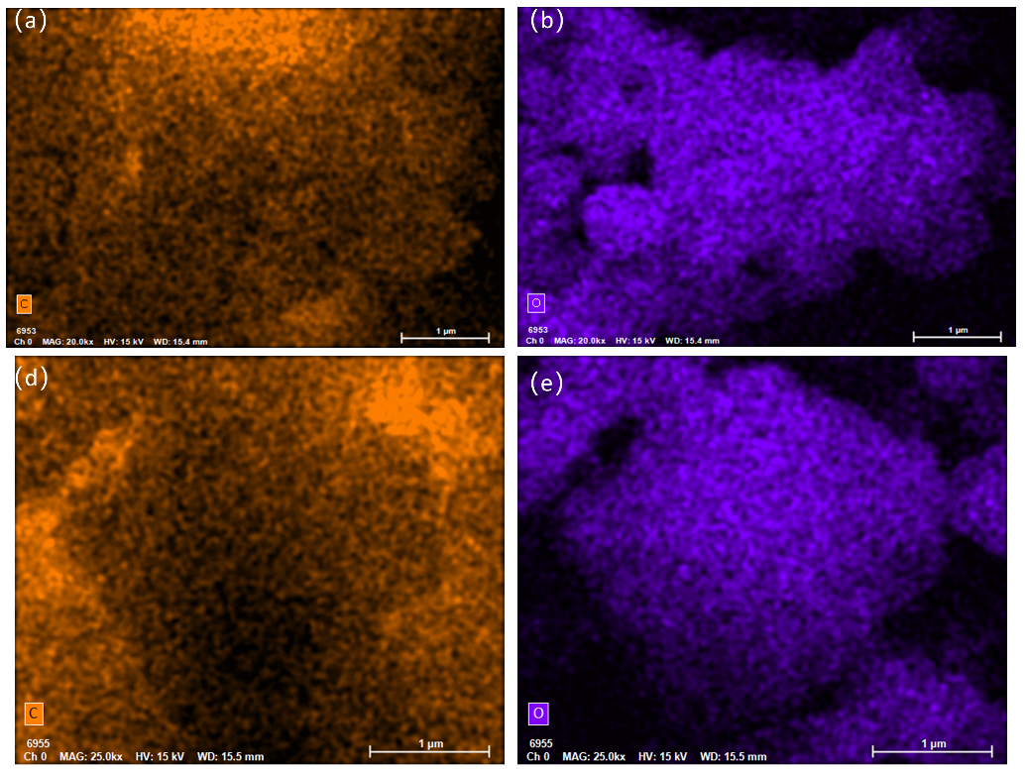
Fig. S1 Elemental distribution mapping of EuZn-PMA before and after interaction with UO₂²⁺. (a, b) EDS elemental mapping of C and O in the EuZn-PMA; (c, d) EDS elemental mapping of C and O in EuZn-PMA after interaction with UO UO₂²⁺.
Fig. S2 Small-angle XRD patterns of EuZn-PMA before and after UO₂²⁺ binding. A sharp diffraction peak at ~0.1° confirms the presence of well-defined lamellar ordering in the EuZn-PMA framework, indicating the formation of an ordered coordination structure rather than a fully amorphous aggregate. The slight decrease in peak intensity after UO₂²⁺ coordination suggests that the interaction does not destroy the core ordered structure of the probe.
Fig. S2 Selection of buffer solutions. Fluorescence ratio diagram of probes after reaction with uranium acetate under different buffer solution conditions.
Fig. S3 Selection of pH. Fluorescence ratio plots of fluorescent probes, uranyl, and probes after reaction with uranyl under different pH conditions.
Fig. S4 Fluorescence spectra of EuZn-PMA after reaction with UO₂²⁺ under different excitations.

Supplementary Information-Tables：
Table S1. Comparison of the detection performance of EuZn-PMA with other fluorescent probe towards UO₂²⁺.
Fluorescent Probes | LOD | Response model | Ref
Na/Eu-MOF | 49.7 nM | Turn-off | ^{[1]}
o-CDs-Rho | 53 nM | Ratiometric | ^{[2]}
AuNCs@OVA | 34.4 nM | Turn-on | ^{[3]}
GC-TFPB-AO | 21.25 nM | Turn-off | ^{[4]}
D-P5 | 83.2 nM | Turn-off | ^{[5]}
MPA@CdTe QD | 0.5 μM | Turn-off | ^{[6]}
r-CDs | 8.15 μM | Ratiometric | ^{[7]}
EuZn-PMA | 51 nM | Ratiometric | This work

Table S2. UO₂²⁺ Spiked Recovery Tests in Actual Water Samples (Data are based on n=3 independent measurements, and standard deviation (SD) reflects experimental reproducibility.)
Samples | Added(μΜ) | Detected(μΜ)ª | Recovery(%) | RSD(n=3, %)
Sea  Water | 1  2  4 | 1.02±0.04  1.98±0.07  4.05±0.09 | 102.0  99.0  101.3 | 3.9  3.5  1.9
Lake  Water | 1  2  4 | 0.98±0.03  1.89±0.04  4.10±0.10 | 98.0  94.5  102.5 | 3.1  2.1  2.4
Note: ª Mean value ± standard deviation (SD).
Table S3. Variation of fluorescence color RGB values of EuZn-PMA with UO₂²⁺ concentration. (Data are based on n=6 independent measurements, and standard deviation (SD) reflects experimental reproducibility.)
UO₂²⁺ Concentration (μM) | R (mean ± SD) | G (mean ± SD) | B (mean ± SD)
0 | 230.1 ± 4.5 | 27.9 ± 9.8 | 65.4 ± 9.3
2 | 246.9 ± 3.1 | 66.7 ± 3.5 | 67.1 ± 9.6
18 | 247.8 ± 6.2 | 171.2 ± 5.7 | 46.0 ± 6.3
24 | 251.8 ± 1.6 | 183.8 ± 1.6 | 105.0 ± 2.3
30 | 225.7 ± 2.7 | 220.6 ± 2.5 | 0.7 ± 0.8
42 | 191.7 ± 0.8 | 250.6 ± 1.0 | 0.3 ± 0.5
50 | 183.0 ± 1.5 | 250.3 ± 0.5 | 0.2 ± 0.4
60 | 175.0 ± 1.9 | 252.2 ± 1.2 | 0.3 ± 0.5

Reference
[1] Guo F, Han X-L, Li D-F, Li C-Y, Li D-P, et al. 2024. Highly effective fluorescence detection of UO₂²⁺ ions by an anionic Na/Eu heterometallic metal–organic framework with Lewis basic chelating sites. Chemical Engineering Journal https://doi.org/10.1016/j.cej.2024.156232
[2] Wang D, Zhang L-J, Liu M-H, Du F-F, Shen Z-Y, et al. 2023. Aggregation enhanced FRET: A simple but efficient strategy for the ratiometric detection of uranyl ion. Journal of Hazardous Materials https://doi.org/10.1016/j.jhazmat.2023.131497
[3] Cheng T, Zhuang Z, He G, Lu A, Zhou J, et al. 2024. Assembly of protein-directed fluorescent gold nanoclusters for high-sensitivity detection of uranyl ions. International Journal of Biological Macromolecules https://doi.org/10.1016/j.ijbiomac.2024.134883
[4] Zhen D, Liu C, Deng Q, Li L, Grimes CA, et al. 2024. Novel olefin-linked covalent organic framework with multifunctional group modification for the fluorescence/smartphone detection of uranyl ion. ACS Applied Materials Interfaces https://doi.org/10.1021/acsami.4c05522
[5] Zhang L, Jia M, Wang X, Gao L, Zhang B, et al. 2023. A novel fluorescence sensor for uranyl ion detection based on a dansyl-modified peptide. Spectrochimica Acta Part A: Molecular Biomolecular Spectroscopy https://doi.org/10.1016/j.saa.2023.122403
[6] Chen X, Mei Q, Yu L, Ge H, Yue J, et al. 2018. Rapid and on-site detection of uranyl ions via ratiometric fluorescence signals based on a smartphone platform. ACS applied materials interfaces https://doi.org/10.1021/acsami.8b13765
[7] Qian J, Cao N, Zhang J, Hou J, Chen Q, et al. 2020. Field-portable ratiometric fluorescence imaging of dual-color label-free carbon dots for uranyl ions detection with cellphone-based optical platform. Chinese Chemical Letters https://doi.org/10.1016/j.cclet.2020.05.004

