Supplementary Information

Tuning the formation of structural defects in metal-organic framework catalyst via linker engineering to boost the production of biomass-derived lactic acid

Yueyue Tang¹, Heng Huang¹, Jiayi Peng¹, Haijie Yu¹, Yujie Wang¹ and Jianjian Wang^{1,2}*

¹ School of Chemistry and Chemical Engineering, Institute of Advanced Interdisciplinary Studies, Multi-scale Porous Materials Center, Chongqing University, Chongqing, 401331, P.R. China.
² Xinjiang Key Laboratory of New Energy and Energy Storage Technology, Xinjiang Institute of Technology, Aksu 843100, P.R. China.
* Corresponding author: wangjianjian@cqu.edu.cn.

Experimental
Chemicals
Glucose, lactic acid (LaA), nickel dinitrate hexahydrate, N,N-dimethylformamide (DMF), 2,5-dihydroxyterephthalic acid (DHTA), 5-hydroxymethyl-2-furaldehyde (HMF), methanol, ethanol, sucrose, starch, and cellulose were purchased form Aladdin company. Salicylic acid (SA) was purchased form MACKLIN company. Corn cobs and pine leaves were obtained from virgin corn cobs and pine leaves after breaking and sieving treatment.
Characterization
X-ray diffraction (XRD) analysis was conducted on a PANalytical X’Pert Powder diffractometer. Nitrogen adsorption-desorption isotherms were measured using a MICROTRAC BEL BELSORP MAX analyzer, and pore size distribution was calculated using the non-local density functional theory (NLDFT) model. The sample morphology was characterized by transmission electron microscopy (TEM) and high-resolution TEM (HRTEM) using a Thermo Scientific Talos 200S microscope. Thermogravimetric (TG) analysis was performed on a NETZSCH STA 449 F3 thermobalance. X-ray photoelectron spectroscopy (XPS) measurements were carried out on a Thermo Scientific K-Alpha spectrometer. Electron paramagnetic resonance (EPR) spectra were recorded on a Bruker EPR200-Plus spectrometer to detect oxygen vacancy signals. Fourier-transform infrared (FTIR) spectra were obtained using a Thermo Scientific Nicolet iS50 spectrometer. Ultraviolet-visible (UV-Vis) spectroscopy was performed on a Shimadzu UV-3600 spectrophotometer. Inductively Coupled Plasma-Optical Emission Spectroscopy (ICP-OES) was conducted using an Agilent 5110 system.
Fig. S1 (a-c) TEM images as well as the corresponding EDS elemental mappings of MOF-74(Ni), MOF-74(Ni)-25SA and MOF-74(Ni)-50SA

Fig. S2 XRD patterns of MOF-74(Ni)-xSA and simulated MOF-74(Ni)

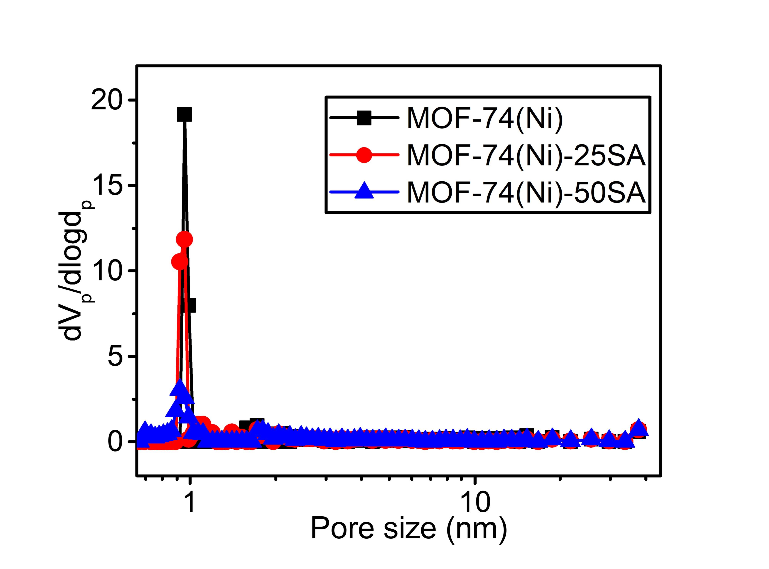
Fig. S3 Pore size distributions of MOF-74(Ni), MOF-74(Ni)-25SA and MOF-74(Ni)-50SA

Table S1 Specific surface area, pore volume and Ni content of MOF-74(Ni), MOF-74(Ni)-25SA and MOF-74(Ni)-50SA
Catalyst | Specific surface area  (m²/g) | Pore volume  (cm³/g) | Ni content  (wt%)
MOF-74-Ni | 766 | 0.41 | 25.7
MOF-74-Ni-25SA | 756 | 0.39 | 25.7
MOF-74-Ni-50SA | 431 | 0.27 | 26.9

Fig. S4 FTIR spectra of MOF-74(Ni), MOF-74(Ni)-25SA and MOF-74(Ni)-50SA

Fig. S5 UV–Vis DR spectra of MOF-74(Ni), MOF-74(Ni)-25SA and MOF-74(Ni)-50SA

Table S2 O 1s XPS analytic results of MOF-74(Ni), MOF-74(Ni)-25SA, fresh and recycled MOF-74(Ni)-50SA
Catalyst | O_{L} (%) | O_{V} (%) | O_{S} (%)
MOF-74(Ni) | 49.5 | 35.5 | 15.0
MOF-74(Ni)-25SA | 27.1 | 43.3 | 29.6
Fresh MOF-74(Ni)-50SA | 22.5 | 48.2 | 29.3
Recycled MOF-74(Ni)-50SA from Run5 | 39.3 | 42.3 | 18.4

Fig. S6 Comparison of the activity of MOF-74(Ni)-50SA catalyst with that over YnbO₄^{[1]} (140 °C, 5 h, glucose/catalyst = 50/20 (mg/mg)), ZIF-8^{[2]} (160 °C, 24 h, glucose/catalyst = 225/160 (mg/mg)), γ-AlO(OH)^{[3]} (170 °C, 24 h, glucose/catalyst = 50/50 (mg/mg)), UiO-66^{[4]} (190 °C, 1 h, glucose/catalyst = 54/20 (mg/mg)), Sn/Al@AC^{[5]} (180 °C, 20 min, glucose/catalyst = 100/200 (mg/mg)), Mg-MOF-74^{[6]} (200 °C, 3 h, glucose/catalyst = 60/20 (mg/mg)) for the conversion of glucose to LaA in the batch reactor. The information in parenthese was reaction condition

Table S3 Comparison of the catalytic performances of different catalysts in the catalytic conversion of glucose to LaA.
Catalyst | Glucose dosage (mg) | Catalyst dosage (mg) | Reaction conditions | Conv. (%) | LaA yield (%) | Reference
MOF-74(Ni)-50SA | 100 | 50 | 170 °C, 4 h | 99.8 | 51.7 | This work
YnbO₄ | 50 | 20 | 140 °C, 5 h | 96.3 | 19.6 | [1]
ZIF-8 | 225 | 160 | 160 °C, 24 h | 98.1 | 19.8 | [2]
γ-AlO(OH) | 50 | 50 | 170 °C, 24 h | 92.0 | 23.9 | [3]
UiO-66 | 54 | 20 | 190 °C, 1 h | 97.2 | 33.6 | [4]
Mg-MOF-74 | 60 | 30 | 200 °C, 3 h | >99 | 35.0 | [6]
Sn/Al@AC | 100 | 200 | 180 °C, 20 min | >99 | 42.0 | [5]

Fig. S7 Catalytic performances of MOF-74(Ni)-50SA with different amounts of glucose as the substrate at 170 ℃ for 4 h

Fig. S8 Catalytic performance of MOF-74(Ni)-50SA with different dosages at 170 ℃ for 4 h

Fig. S9 Catalytic conversion of (a) dihydroxyacetone (DHA) and (b) pyruvaldehyde (PAL) over MOF-74(Ni)-xSA catalysts

Fig. S10 Proposed reaction route for the conversion of glucose to LaA over MOF-74(Ni)-50SA

Fig. S11 (a) Ni 2p and (b) O 1s XPS spectra of fresh and recycled MOF-74(Ni)-50SA

Fig. S12 LaA yields using different primary biomass as the substrate over MOF-74(Ni)-50SA catalyst. Reaction conditions: 100 mg of substrate, 10 mL of water, 170 ℃, 4 h, 0.4Mpa of N₂
Note: Reactions marked with an asterisk (*) were conducted at 190 °C for 8 h, with all other conditions remaining constant

References
[1] Kim M, Ronchetti S, Onida B, Ichikuni N, Fukuoka A et al. 2020. Lewis acid and base catalysis of YNbO₄ toward aqueous-phase conversion of hexose and triose sugars to lactic acid in water. ChemCatChem 12(1):350–359 http://doi.org/10.1002/cctc.201901435
[2] Murillo B, Zornoza B, De La Iglesia O, Téllez C, Coronas J. 2016. Chemocatalysis of sugars to produce lactic acid derivatives on zeolitic imidazolate frameworks. Journal of Catalysis 334:60–67 http://doi.org/10.1016/j.jcat.2015.11.016
[3] Takagaki A, Jung JC, Hayashi S. 2014. Solid lewis acidity of boehmite γ-AlO(OH) and its catalytic activity for transformation of sugars in water. RSC Adv. 4(82):43785–43791 http://doi.org/10.1039/C4RA08061K
[4] Boonmark S, Ponchai P, Adpakpang K, Wannapaiboon S, Thongratkaew S et al. 2024. Valorizing natural-abundant glucose to lactic acid using a MOF-808 catalyst under green hydrothermal conditions. Chemical Communications 60(37):4890–4893 http://doi.org/10.1039/D4CC00393D
[5] Kupila R, Lappalainen K, Hu T, Romar H, Lassi U. 2021. Lignin-based activated carbon-supported metal oxide catalysts in lactic acid production from glucose. Applied Catalysis A: General 612:118011 http://doi.org/10.1016/j.apcata.2021.118011
[6] Lu X, Wang L, Lu X. 2018. Catalytic conversion of sugars to methyl lactate over Mg-MOF-74 in near-critical methanol solutions. Catalysis Communications 110:23–27 http://doi.org/10.1016/j.catcom.2018.02.027

