Supporting information
Sustainable carbon‑based composites with integrated toughening and electromagnetic interference shielding performance enabled by Flash‑Joule‑heating
Jianlong Chen¹, Junchao Ren¹, Mengde Huang¹, Chengyu Yu¹, Shijing Song¹, Yuanyuan Xu¹, Guangbing Zhao¹, Hao Nie¹, Hanwu Lei², Deli Zhang^{3*}, Qingfa Zhang^{1*}
¹School of Engineering, Anhui Agricultural University, Hefei, Anhui, 230036, China
²Department of Biological Systems Engineering, Washington State University, Richland 99354, United States
³College of Agricultural Engineering and Food Science, Shandong University of Technology, Zibo, Shandong, 255049, China
∗Corresponding authors:
Email address: zhangdeli@sdut.edu.cn (D. Zhang); zhangqingfa@ahau.edu.cn (Q. Zhang), Tel: +86 13287889072
Results
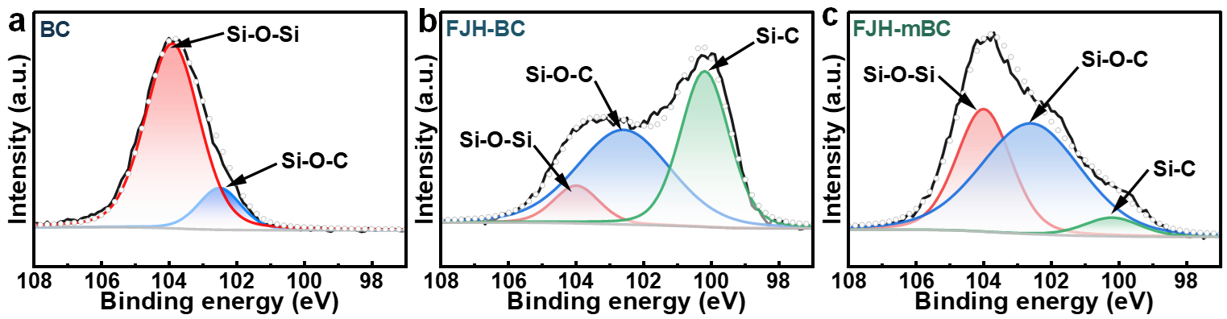
Fig. S1. High-resolution Si2p XPS spectra of (a) BC, (b) FJH-BC, and (c) FJH-mBC.

