Supplementary materials
Reusable magnetic SERS platform functionalized with covalent organic polymers for trace-level and machine-learning-assisted uranyl detection
Wentao Zhang¹, Jing Ma¹, Yiyan Zhang¹, Suhua Wang², Xiangke Wang¹, Zhenli Sun^{1,}*
¹MOE Key Laboratory of Resources and Environmental System Optimization, College of Environmental Science and Engineering, North China Electric Power University, Beijing 102206, China
²School of Environmental Science and Engineering, Guangdong University of Petrochemical Technology, Maoming, 525000, China
*Corresponding author, E-mail: sunliva@ncepu.edu.cn

Contents
Table S1 Summary of SERS substrates reported for uranyl detection with corresponding Raman shifts, detection limits, and regeneration capabilities. 2
Fig. S1 Magnetization curves of FA and FA@tPF. 3
Fig. S2 TEM images of FA@tPF with scale bars of 100 nm and 50 nm. 4
Fig. S3 XPS survey spectra show the elemental changes before and after the synthesis of tPF on the FA surface. 5
Fig. S4 The characteristic peak intensities of uranyl detected by FA@tPF among different batches. 6
Fig. S5 Zeta potentials of FA@tPF before and after uranyl adsorption. 7
Fig. S6 SERS spectra of FA@tPF for detecting uranyl ions at different NaCl concentrations. 8
Fig. S7 Peak areas of the O=U=O bond during three cycles of adsorption and desorption. 9
Fig. S8 SERS spectra of FA@tPF over six adsorption and desorption cycles. 10
Fig. S9 (a) TEM image of FA@tPF after elution with Na₂CO₃; (b) FT-IR spectra of FA@tPF before adsorption, after uranyl adsorption, and after elution with Na₂CO₃. 11
Fig. S10 Grad-CAM visualization for SERS spectral classification of adsorbed uranyl using a CNN model. 12
Materials Synthesis 13
The calculation formula of the enhancement factor (EF): 14

Table S1 Summary of SERS substrates reported for uranyl detection with corresponding Raman shifts, detection limits, and regeneration capabilities.
Substrate | Raman shift(cm⁻¹) | Detection limit | Regeneration | Ref
APA-modified gold nanoparticles | 828 | 8×10⁻⁷ M | NO | ^{[1]}
Au nanostar | 870, 843 |  | NO | ^{[2]}
Fe₃O₄-Au@CdTe | 828 | 10⁻⁶ M | NO | ^{[3]}
IE Ag@Au@SiO₂ | Centered at 800-870 | 1.1×10⁻⁷ M | NO | ^{[4]}
AgNR@Al₂O₃ | 720, 828 | 2.3×10⁻⁹ M | NO | ^{[5]}
citrate-stabilized AgNPs | 750 | 6×10⁻⁸ M | NO | ^{[6]}
Ag | 707 | 7.4×10⁻⁸ M | NO | ^{[7]}
Ag | 714 | 1×10⁻⁸ M | NO | ^{[8]}
AgNR SERS Tape | centered at 730-790 | 1×10⁻⁷ M | NO | ^{[9]}
Au@MHA | 821, 833, 846 |  | NO | ^{[10]}
Au@ZIF-8 | 828 | 5 × 10⁻⁷ M | NO | ^{[11]}
Ag/Ag₂O–COF | 705-715 | 8.9×10⁻¹⁰ M | NO | ^{[12]}
FA@ZIF8 | 829 | 10⁻⁷ M | NO | ^{[13]}
Ag/SA SMH | 715 | 6.7×10⁻⁹ M | NO | ^{[14]}
AgNR@Al₂O₃ | 715 | 6.7×10⁻⁶ M | NO | ^{[15]}
Ag₂O aggregates | 715 | 10⁻⁷ M | NO | ^{[16]}
Au nanostar | 818 |  | NO | ^{[17]}
This work | 850 | 5×10⁻⁸ M | Yes | This work

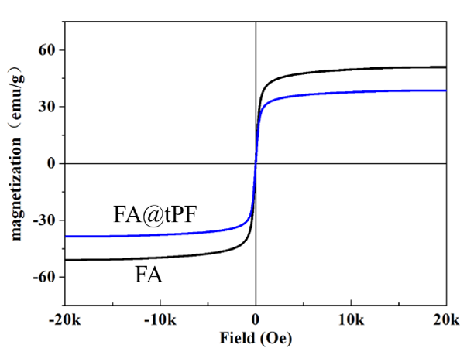

Fig. S1 Magnetization curves of FA and FA@tPF.
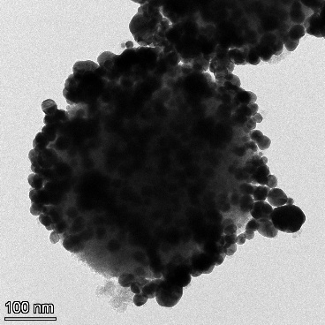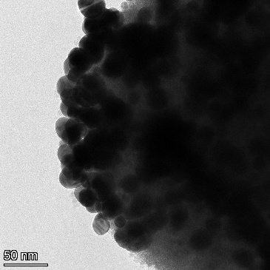

Fig. S2 TEM images of FA@tPF with scale bars of 100 nm and 50 nm.

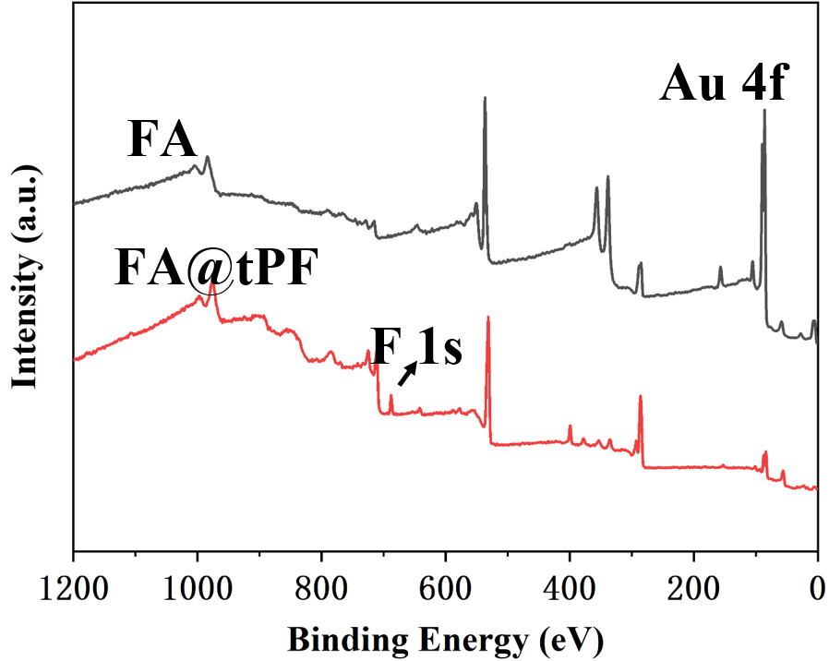

Fig. S3 XPS survey spectra show the elemental changes before and after the synthesis of tPF on the FA surface.
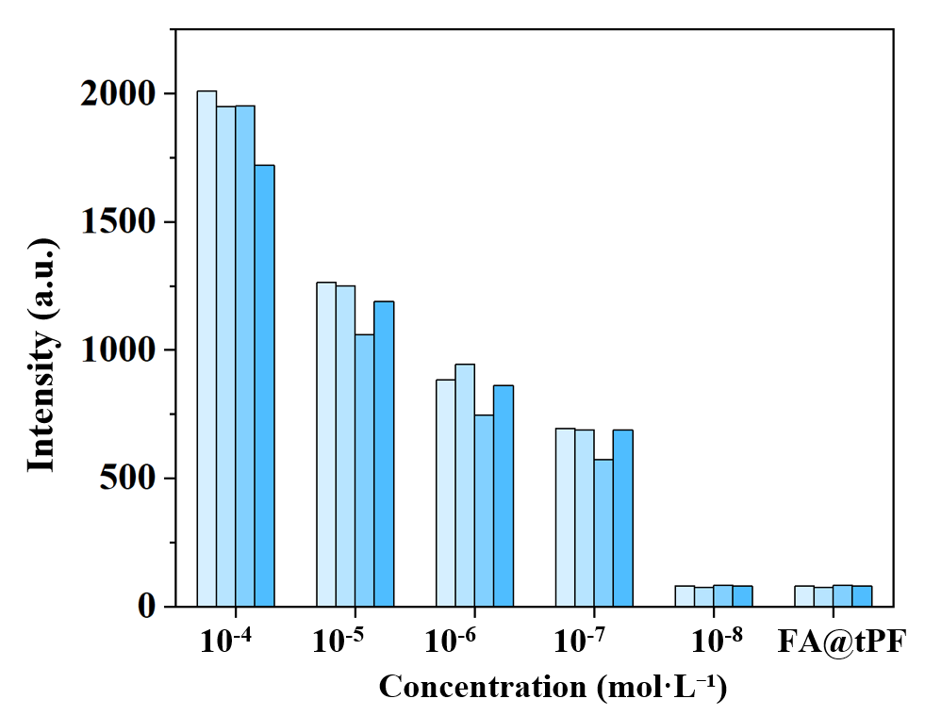

Fig. S4 The characteristic peak intensities of uranyl detected by FA@tPF among different batches.
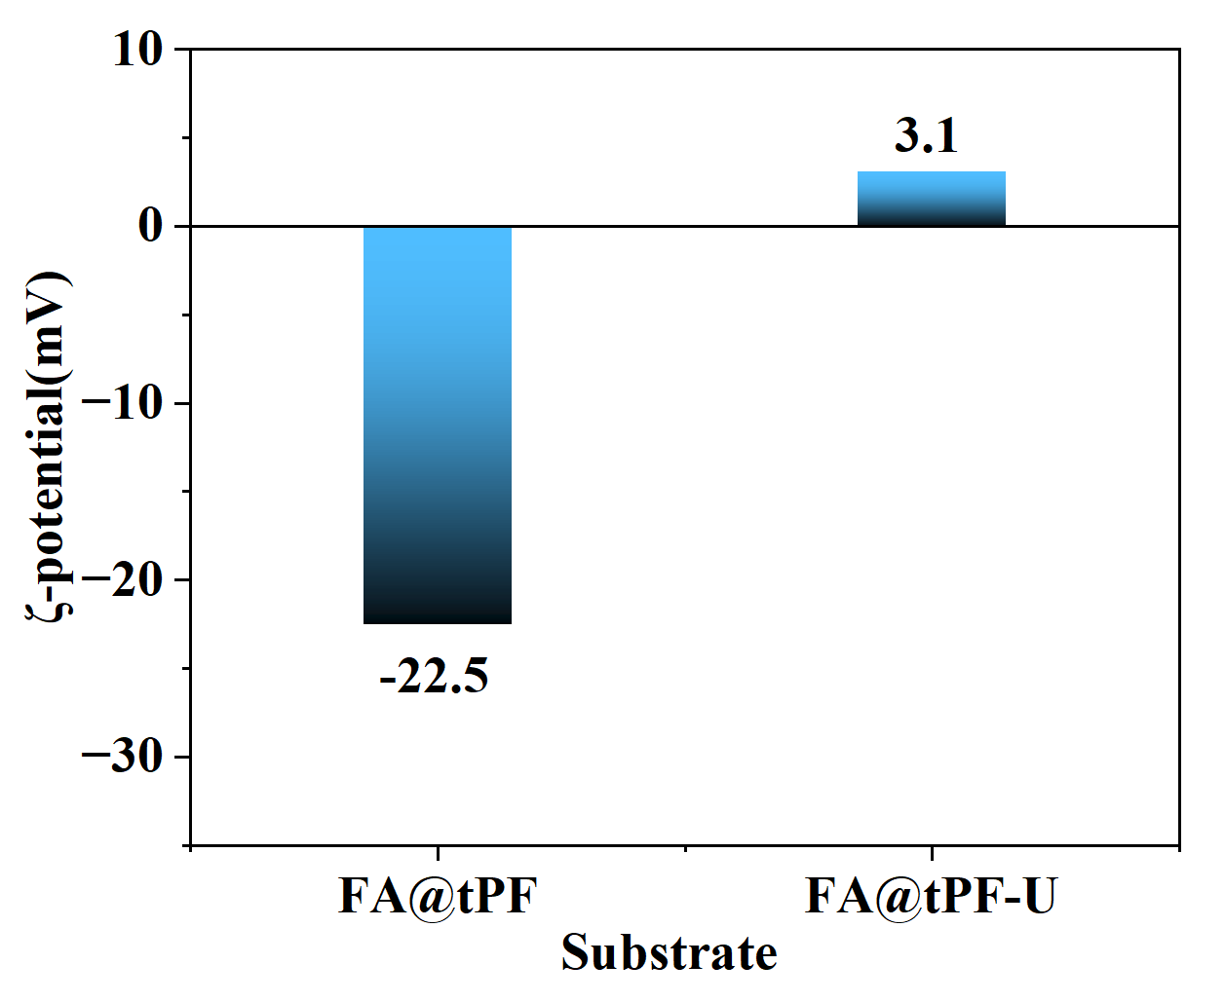

Fig. S5 Zeta potentials of FA@tPF before and after uranyl adsorption.

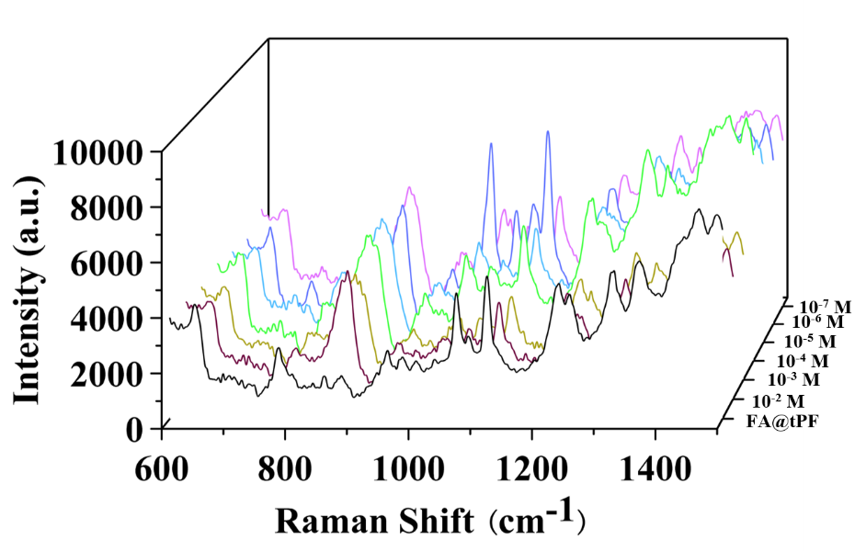

Fig. S6 SERS spectra of FA@tPF for detecting uranyl ions at different NaCl concentrations.

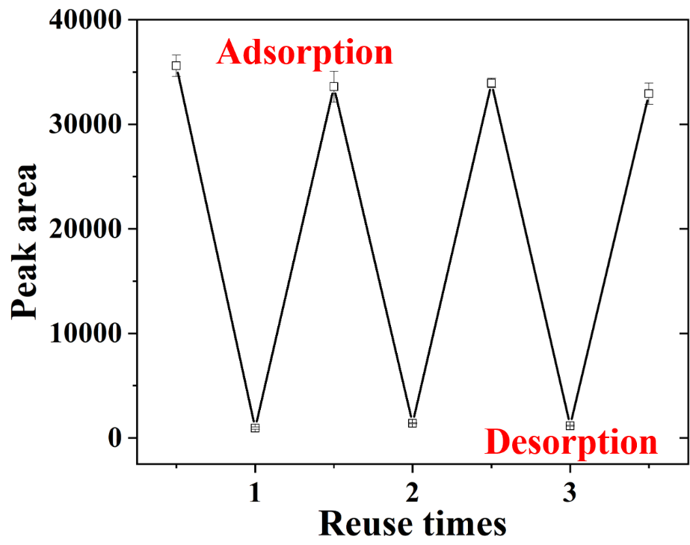

Fig. S7 Peak areas of the O=U=O bond during three cycles of adsorption and desorption.
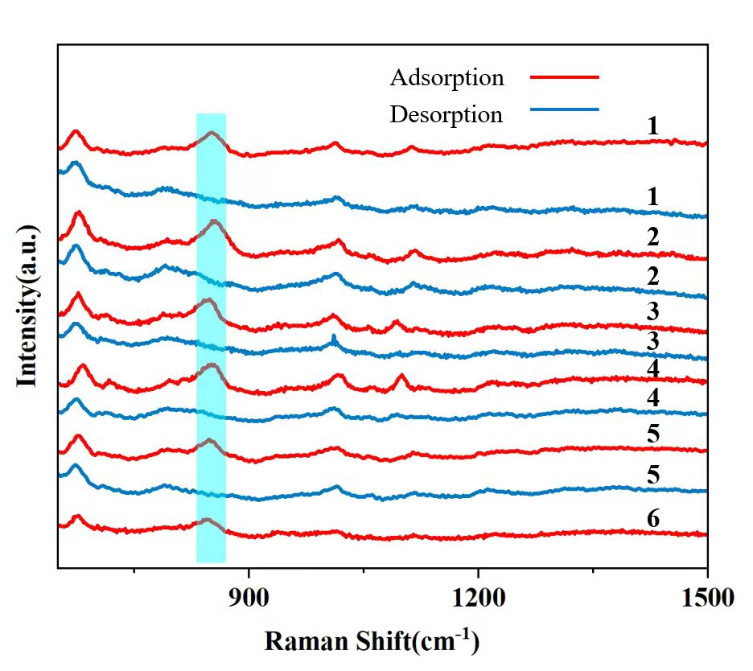

Fig. S8 SERS spectra of FA@tPF over six adsorption and desorption cycles.
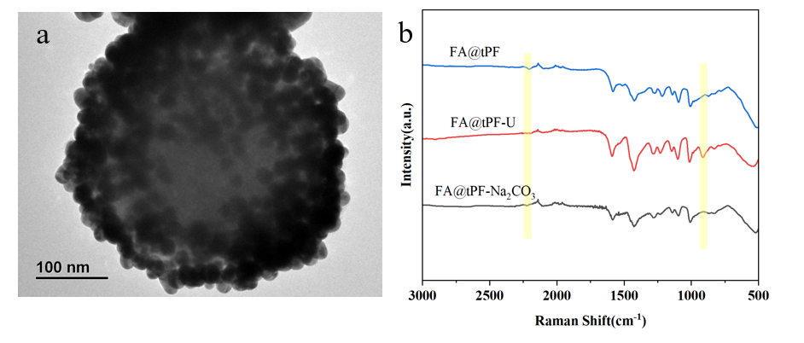

Fig. S9 (a) TEM image of FA@tPF after elution with Na₂CO₃; (b) FT-IR spectra of FA@tPF before adsorption, after uranyl adsorption, and after elution with Na₂CO₃.

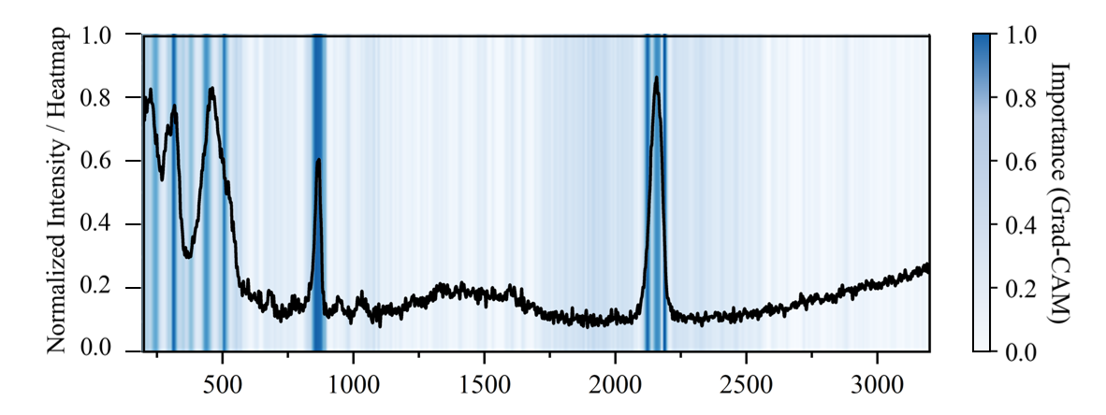

Fig. S10 Grad-CAM visualization for SERS spectral classification of adsorbed uranyl using a CNN model.

Materials Synthesis
FA: A total of 184 mL of DI water was added into a 500 mL conical flask, followed by the addition of 8 mL of 2% HAuCl₄ solution, and the mixture was heated to 130 °C under magnetic stirring for 20 min. Subsequently, 8 mL of Na₃Ct aqueous solution (400 mg of Na₃Ct dissolved in 8 mL of DI water) was added, and the reaction was continued at 130 °C for another 20 min. The heating was then stopped, and the solution was allowed to cool to room temperature under continuous stirring.
FA@ZIF-8: 0.76 mL of Zn(NO₃)₂·6H₂O solution (0.45 g of Zn(NO₃)₂·6H₂O dissolved in 7.5 mL of methanol) was added to the FA nanoparticles (NPs) dispersed in 3 mL of methanol after magnetic separation and removal of the supernatant, followed by the addition of 2-MIM solution (0.26 g of 2-MIM dissolved in 3.6 mL of methanol). The mixture was reacted at room temperature for 3 h under shaking conditions. Afterwards, the obtained FA@ZIF-8 substrate was magnetically separated, washed three times with methanol and DI water, respectively, and finally dispersed in 1.5 mL of ultrapure water for further experiments.

The calculation formula of the enhancement factor (EF):
$$EF=\frac{I_{SERS}}{I_{RS}}×\frac{C_{RS}}{C_{SERS}}$$
where IS_{ERS} and I_{RS} represent the Raman intensities obtained from the SERS spectrum and the normal Raman reference spectrum, respectively, and C_{SERS} and C_{RS} correspond to the analyte concentrations under the two measurement conditions. The reference spectrum used for EF calculation is the normal Raman spectrum of the target analyte (10⁻² mol·L⁻¹) measured under identical instrumental conditions.

References
[1] Ruan CM, Luo WS, Wang W, Gu BH. Surface-enhanced Raman spectroscopy for uranium detection and analysis in environmental samples. Anal. Chim. Acta. 2007, 605 (1), 80-86. DOI: 10.1016/j.aca.2007.10.024.
[2] Harder RA, Wijenayaka LA, Phan HT, Haes AJ. Tuning gold nanostar morphology for the SERS detection of uranyl. J. Raman. Spectrosc. 2021, 52 (2), 497-505. DOI: 10.1002/jrs.5994.
[3] Sun CM, Dong WR, Peng JX, Wan XL, Sun ZL, et al. Dual-mode fluorescence-SERS sensor for sensitive and selective detection of uranyl ions based on satellite Fe₃O₄-Au@CdTe nanostructure. Sens. Actuators, B 2020, 325. DOI: 10.1016/j.snb.2020.128644.
[4] Phan HT, Geng SH, Haes AJ. Microporous silica membranes promote plasmonic nanoparticle stability for SERS detection of uranyl. Nanoscale 2020, 12 (46), 23700-23708. DOI: 10.1039/d0nr06296k.
[5] Jiang JL, Ma LW, Chen J, Zhang PC, Wu HX, et al. SERS detection and characterization of uranyl ion sorption on silver nanorods wrapped with Al₂O₃ layers. Microchim. Acta. 2017, 184 (8), 2775-2782. DOI: 10.1007/s00604-017-2286-0.
[6] Jiang JL, Wang SF, Deng H, Wu HX, Chen J, et al. Rapid and sensitive detection of uranyl ion with citrate-stabilized silver nanoparticles by the surface-enhanced Raman scattering technique. R. Soc. Open Sci. 2018, 5 (11), 181099. DOI: 10.1098/rsos.181099.
[7] Bhandari D, Wells SM, Retterer ST, Sepaniak MJ. Characterization and Detection of Uranyl Ion Sorption on Silver Surfaces Using Surface Enhanced Raman Spectroscopy. Anal. Chem. 2009, 81 (19), 8061-8067. DOI: 10.1021/ac901266f.
[8] Dutta S, Ray C, Sarkar S, Pradhan M, Negishi Y, et al. Silver Nanoparticle Decorated Reduced Graphene Oxide (rGO) Nanosheet: A Platform for SERS Based Low-Level Detection of Uranyl Ion. ACS Appl. Mater. Interfaces 2013, 5 (17), 8724-8732. DOI: 10.1021/am4025017.
[9] Jiang JL, Zhao FT, Shi SW, Du YF, Chen J, et al. In Situ Surface-Enhanced Raman Spectroscopy Detection of Uranyl Ions with Silver Nanorod-Decorated Tape. ACS Omega 2019, 4 (7), 12319-12324. DOI: 10.1021/acsomega.9b01574.
[10] Phan HT, Vinson C, Haes AJ. Gold Nanostar Spatial Distribution Impacts the Surface-Enhanced Raman Scattering Detection of Uranyl on Amidoximated Polymers. Langmuir 2021, 37 (16), 4891-4899. DOI: 10.1021/acs.langmuir.1c00132.
[11] Yuan C, Ge HW, Cao BM, Wang SH. SERS detection of uranyl based on MOF-coated gold nanooctahedron hybrid. Anal. Sci. 2024, 40 (12), 2111-2116. DOI: 10.1007/s44211-024-00646-z.
[12] Gai T, Jiang JL, Wang SF, Zhang L, Ren YM, et al. Highly sensitive and selective determination of uranyl ions based on Ag/Ag₂O-COF composite SERS substrate. Talanta 2024, 277, 126407. DOI: 10.1016/j.talanta.2024.126407.
[13] Wang N, Du JJ, Li X, Ji XL, Wu YL, et al. Magnetic MOF Substrates for the Rapid and Sensitive Surface-Enhanced Raman Scattering Detection of Uranyl. Anal. Chem. 2023, 95, 12956-12963. DOI: 10.1021/acs.analchem.3c02696.
[14] Gai T, Jiang JL, Wang SF, Ren YM, Yang SL, et al. Photoreduced Ag⁺/sodium alginate supramolecular hydrogel as a sensitive SERS membrane substrate for rapid detection of uranyl ions. Anal. Chim. Acta. 2024, 1316, 342826. DOI: 10.1016/j.aca.2024.342826.
[15] Jiang JL, Du YF, Deng H, Zhang ZJ, Wang SF, et al. Surface-enhanced Raman spectroscopy detection of uranium oxides assisted by Ag₂O. Appl. Surf. Sci. 2022, 577, 151968. DOI: 10.1016/j.apsusc.2021.151968.
[16] Wang SF, Yang SL, Wu HX, Jiang JL, Shao L, et al. The contribution of photoinduced charge-transfer enhancement to the SERS of uranyl(VI) in a uranyl-Ag₂O complex. Sci. Bull. 2019, 64 (5), 315-320. DOI: 10.1016/j.scib.2019.01.025.
[17] Lu G, Johns AJ, Neupane B, Phan HT, Cwiertny DM, et al. Matrix-Independent Surface-Enhanced Raman Scattering Detection of Uranyl Using Electrospun Amidoximated Polyacrylonitrile Mats and Gold Nanostars. Anal. Chem. 2018, 90 (11), 6766-6772. DOI: 10.1021/acs.analchem.8b00655.

