Iron and Phosphoric Acid Co-Modified Fishbone Char for Olefin-Rich Bio-Oil Production from Waste Agricultural Films via Microwave-Assisted Pyrolysis
Yue Zhang ^{d.e#}, Jie Yang^{a#}, Dengle Duan^{b.c}, Xun Chen^{d.e}, Xiaoyan Lan^{d.e}, Lu Gan^{d.e}, Leilei Dai^{f}, Yunpu Wang^{g}, Roger Ruan^{h}, Erguang Huo^{i}, Rongge Zou^{j}, Jian Zhang^{d.e}, Lianfu Zhangª*, Jian Zhang^{d.e}*, Yunfeng Zhao^{d.e}**
ª School of Food Science and Technology, Jiangnan University, 1800 Lihu Avenue, Wuxi, Jiangsu 214122, China
^{b} Key Laboratory of Renewable Energy and Guangzhou Institute of Energy Conversion, Chinese Academy of Sciences, Guangzhou 510640, China
^{c} Guangdong Provincial Key Laboratory of Lingnan Specialty Food Science and Technology, Zhongkai University of Agriculture and Engineering, Guangzhou 510225, China
^{d} Key Laboratory of Agricultural Product Processing and Quality Control of Specialty(Co-construction by Ministry and Province)，School of Food Science and Technology, Shihezi University, Shihezi, Xinjiang 832003, China
^{e} Key Laboratory for Food Nutrition and Safety Control of Xinjiang Production and Construction Corps，School of Food Science and Technology, Shihezi University, Shihezi, Xinjiang 832003, China）
^{f} Key Laboratory of Energy Thermal Conversion and Control, School of Energy and Environment, Southeast University, Nanjing, China
^{g} State Key Laboratory of Food Science and Technology, Nanchang University, Nanchang 330047, China
^{h} Center for Biorefining and Department of Bioproducts and Biosystems Engineering, University of Minnesota, 1390 Eckles Ave., St. Paul, MN 55108, USA
^{i} Jiangsu Key Laboratory of Micro and Nano Heat Fluid Flow Technology and Energy Application, School of Physical Science and Technology, Suzhou University of Science and Technology, Suzhou, 215009, China
^{j} Department of Biological Systems Engineering, Washington State University, Richland, WA 99354, USA
*Corresponding author: Lianfu Zhang: +86 13812192381, E-mail address: lianfu@jiangnan.edu.cn
*Corresponding author: Jian Zhang: +86 18997731657, E-mail address: zhangjian0411@163.com
**Corresponding author: Yunfeng Zhao: +86 17770049762, E-mail address:
#These authors contributed equally to this work.
catalog
Section1. 1
Fig. S1: TG-DTG curve of plastic pyrolysis of plastic film. 2
Fig. S2: Schematic diagram of microwave-assisted catalytic pyrolysis experimental device. 3
Fig. S3: TG and DTG curves for catalysts. 4
Fig. S4: FI-RT profiles of catalysts. . 5
Fig. S5: Yield and composition of products at different acidities. 6
Fig. S6: Yield and composition of products at different loading levels. 7
Table S1: Elemental and Proximate Analysis of ground film plastics. 8

Section1
The chemical composition of the oil was analysed using an Agilent 8890-5977B Gas Chromatography-Mass Spectrometry (GC-MS) system equipped with a 30 m × 250 μm × 0.25 μm HP-5 MS capillary column with a thickness of 0.25 μm.The warming procedure started with a 5-minute hold at 45 °C, followed by a 5 °C/min ramp up to 210 °C, followed by a 10 °C/min rapid ramp up to 280 °C for 10 minutes. The temperature was then increased rapidly at 10 °C/min for 10 minutes until 280 °C was reached. Individual components were not calibrated, but the percentage area of the corresponding total ion current peak was used to estimate the proportion of each component. A volume of 1 μL was injected for each test, and the MS scans ranged from 40 to 500 amu. The spectra of the liquid oils were compared to the NIST MS Spectral Library database to determine their chemical composition.

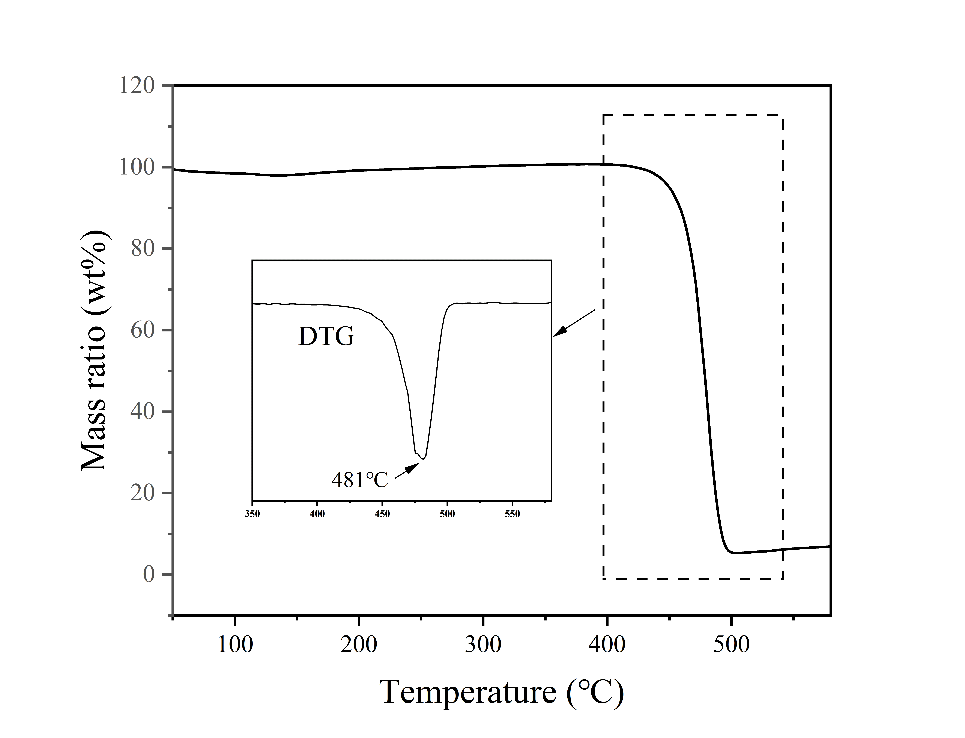

Fig S1. TG-DTG curve of plastic pyrolysis of plastic film.

Fig. S2. Schematic diagram of microwave-assisted catalytic pyrolysis experimental device.

Fig. S3. TG and DTG curves for (a) FC, (b) 30P@FC, and (c) 20Fe-30P@FC.

Fig. S4. FI-RT profiles of FC, 30P@FC and 20Fe-30P@FC calcined catalysts.

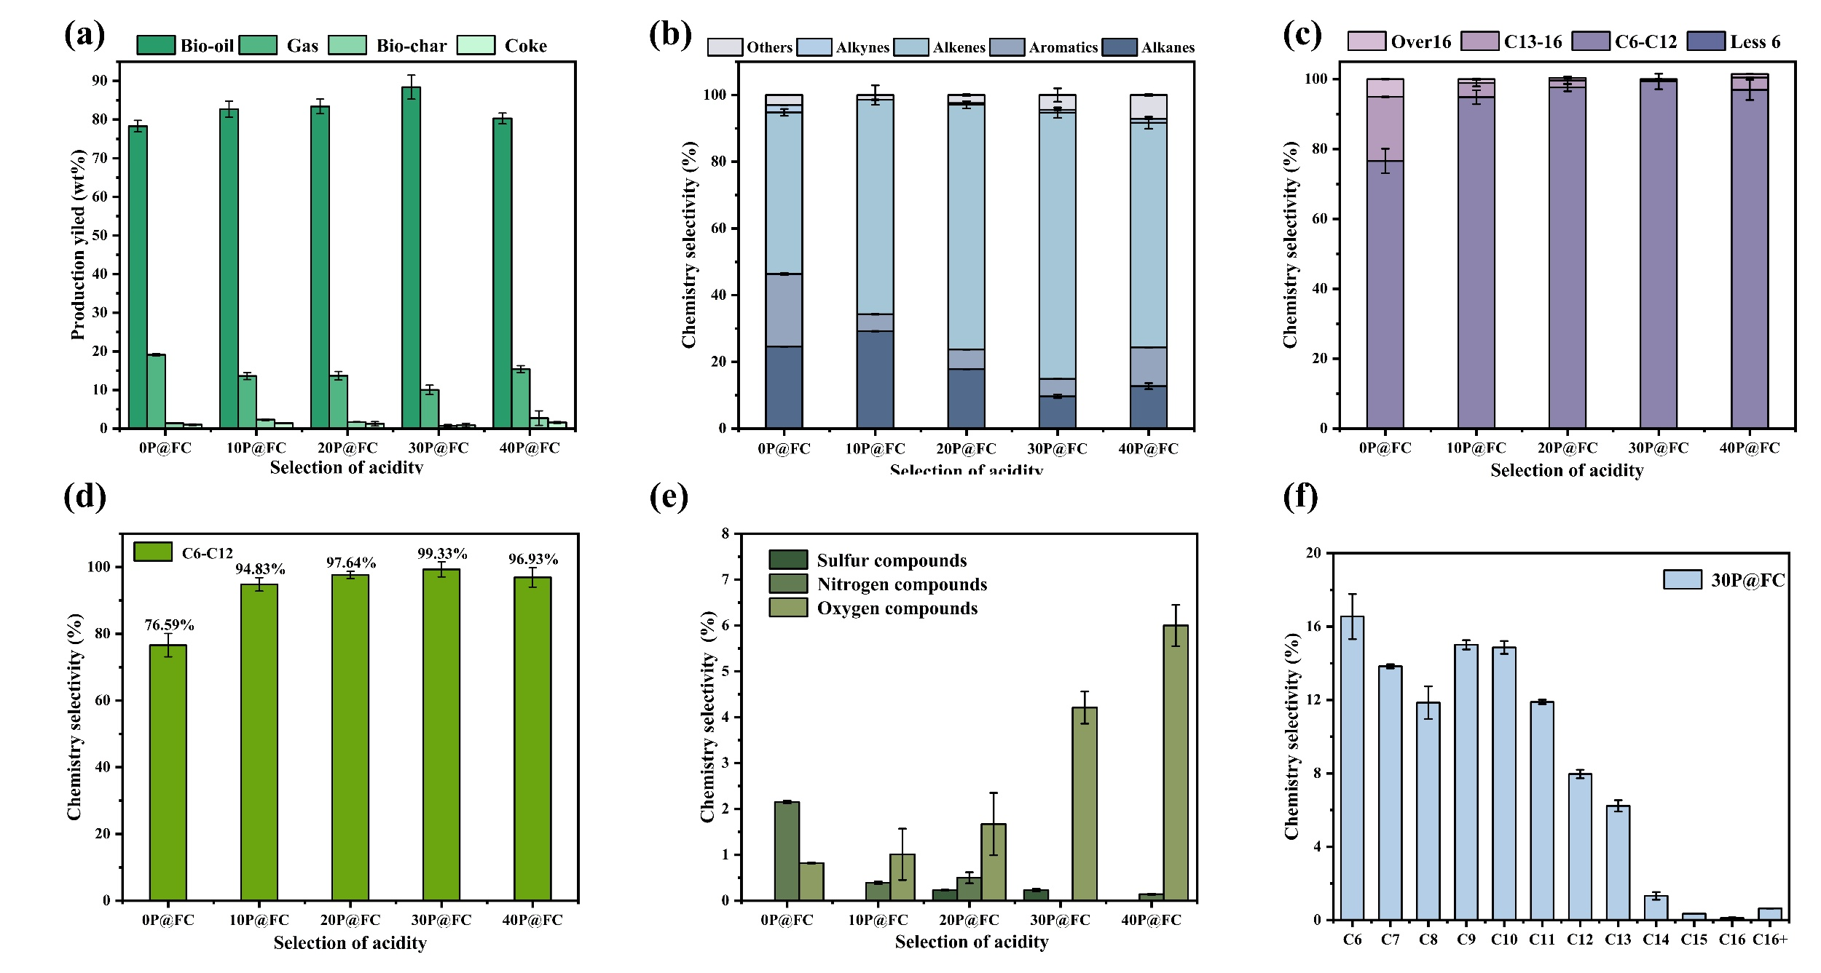

Fig. S5. Yield and composition of products at different acidities; (a) Pyrolysis products; (b) Bio-oil composition; (c) Distribution of carbon numbers in bio-oil; (d) Content of C6-C12 compounds in bio-oil; (e) Distribution of other substances in bio-oil; (f) Distribution of carbon numbers at optimal acidity.

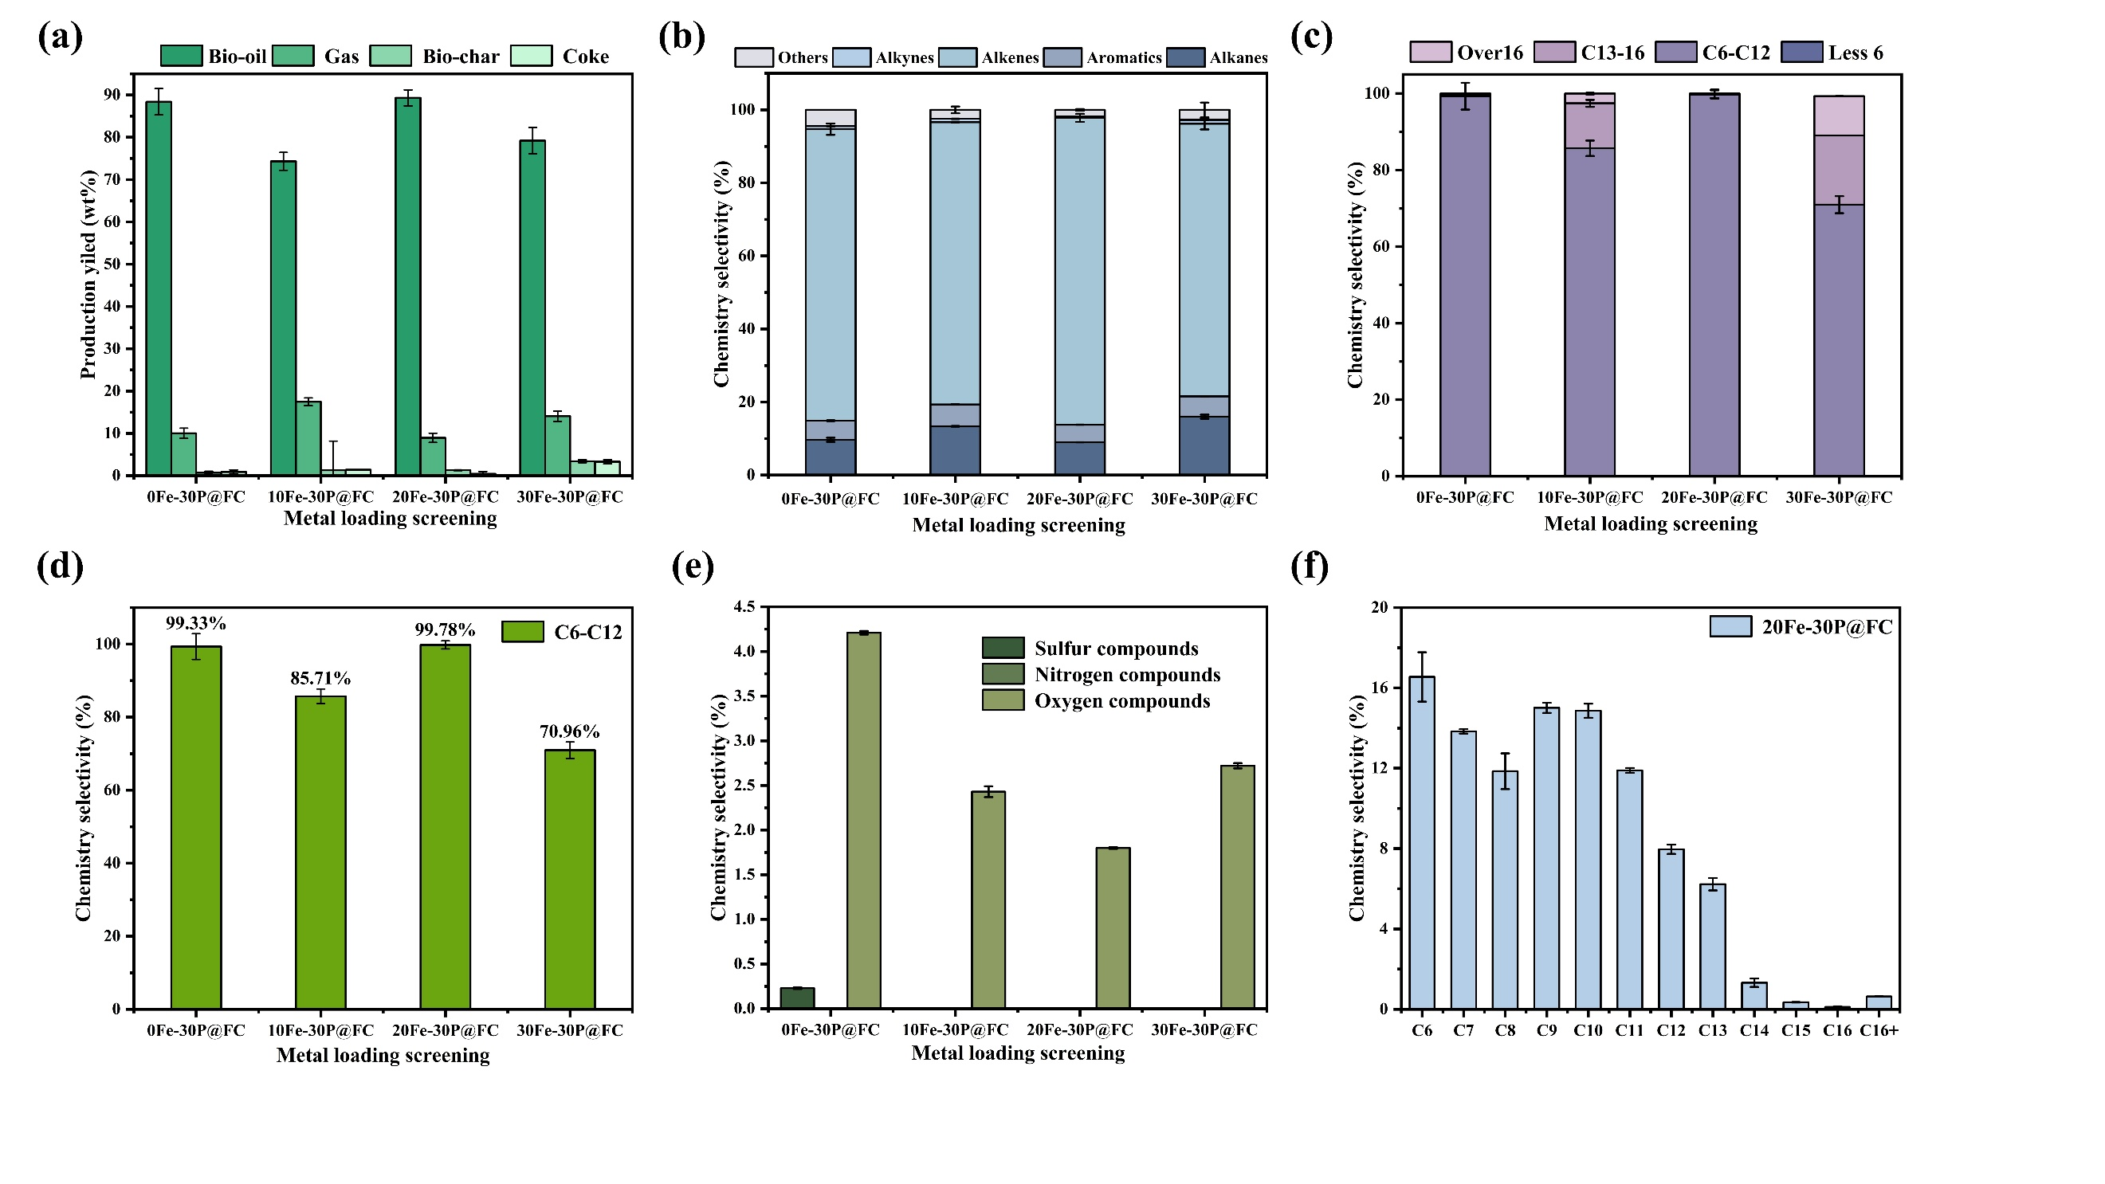Fig. S6. Yield and composition of products at different loading levels; (a) Pyrolysis products; (b) Bio-oil composition; (c) Distribution of carbon numbers in bio-oil; (d) Content of C6-C12 compounds in bio-oil; (e) Distribution of other substances in bio-oil; (f) Distribution of carbon numbers at optimal acidity.

Table S1. Elemental and Proximate Analysis of agricultural plastic films.
Raw materials |  | APF
Ultimate analysis(wt.%) | C | 85.87
 | H | 11.91
 | O | 2.18
 | N | 0.00
 | H/Cª | 1.63
 | O/C^{b} | 0.02
Proximate analysis (wt.%) | Moisture | 0.28
 | Ash | 0.03
 | Volatile | 99.89
 | Fixed carbon | 0.00
HHV/(MJ/kg^{c}) |  | 43.17
Notes:
ª Hydrogen-to-carbon (H/C) molar ratio.
^{b} Oxygen-to-carbon (O/C) molar ratio.
^{c} HHV=0.3419C+1.1783H-0.1034O-0.0211Ash

