Adsorption of methylene blue dye and potato processing wastewater using bimetallic activated hydrochar: batch and fixed bed column experiments
Milad Jalilian¹, Bisma Nawazish¹, Regiane Taborda¹, Quan Sophia He^{2,*}, Yulin Hu^{1,*}
¹ Faculty of Sustainable Design Engineering, University of Prince Edward Island, Charlottetown, PE, C1A 4P3, Canada
² Department of Engineering, Dalhousie University, Truro, NS, B2N 5E3, Canada
Corresponding authors: Drs. Yulin Hu (yulinhu@upei.ca); Quan Sophia He (Quan.He@Dal.Ca)

List of Figures
Figure S1. Image of the tube furnace used to make activated hydrochar.
Figure S2. Calibration curve for MB adsorption.
Figure S3. Deconvoluted Fe 2p3 and Cu 2p2 peaks of fresh (top) and used MAHC (bottom).
Figure S4. Deconvoluted N1s peak of used MAHC.
Figure S5. Deconvoluted C 1s peaks of fresh (left) and used MAHC (right).
Figure S6. Deconvoluted O 1s peaks of fresh (left) and used MAHC (right).

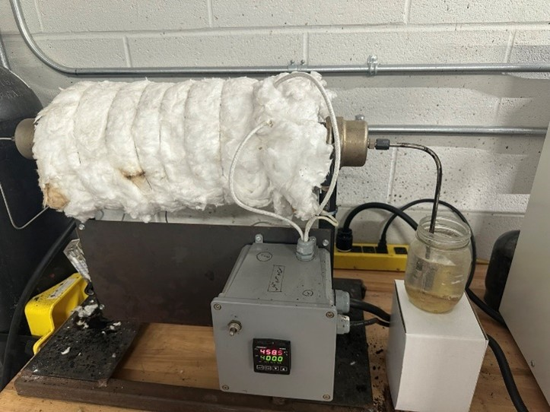
Figure S1. Image of the tube furnace used to make activated hydrochar.

Figure S2. Calibration curve for MB adsorption.

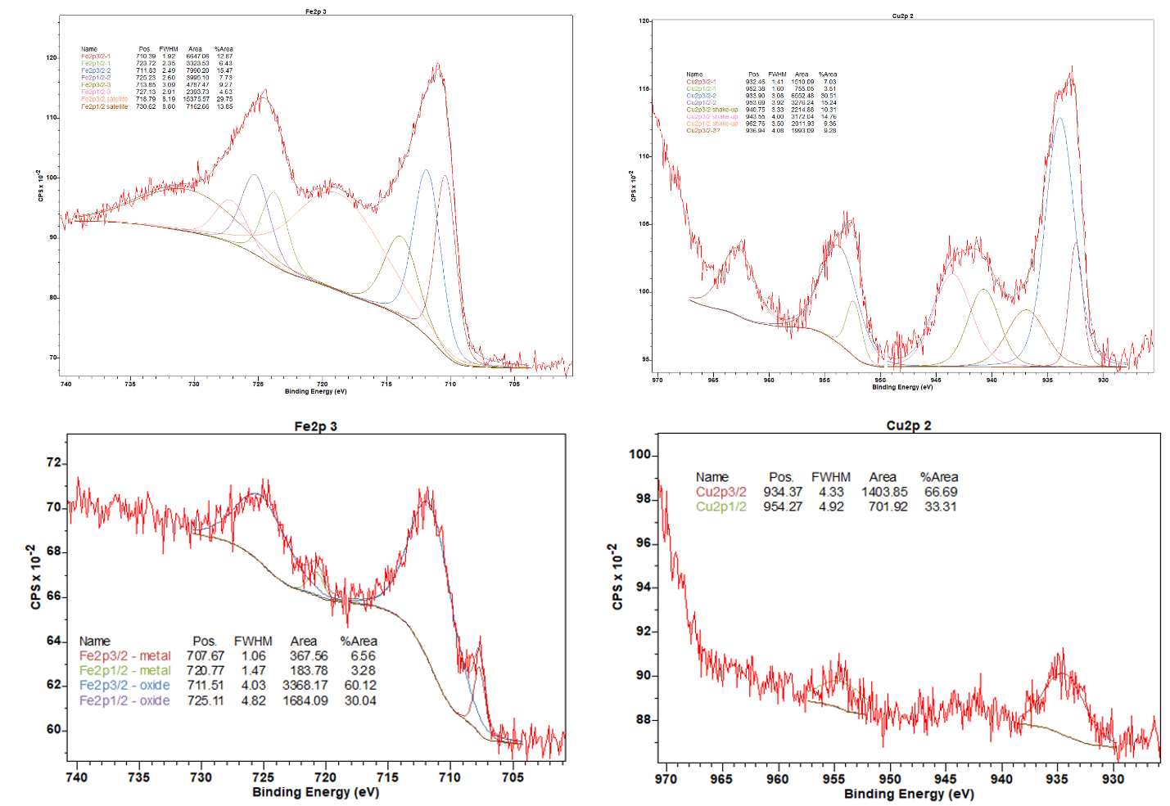
Figure S3. Deconvoluted Fe 2p3 and Cu 2p2 peaks of fresh (top) and used MAHC (bottom).

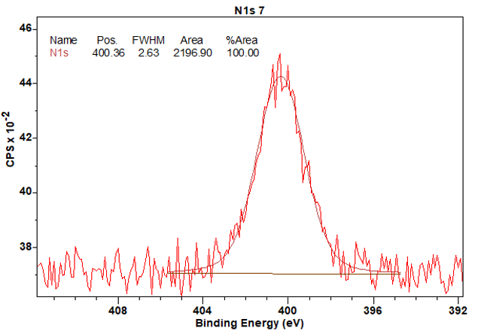
Figure S4. Deconvoluted N1s peak of used MAHC.

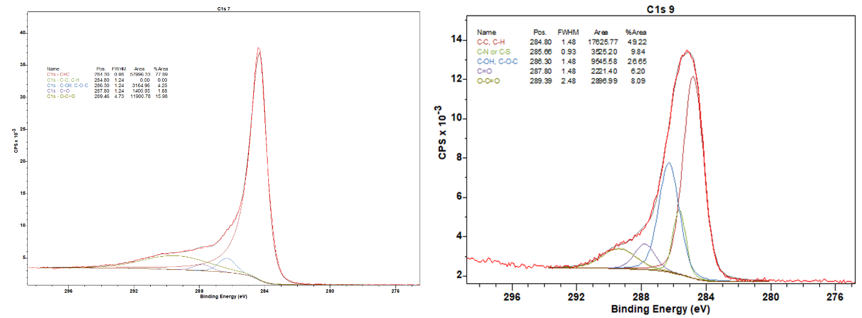
Figure S5. Deconvoluted C 1s peaks of fresh (left) and used MAHC (right).

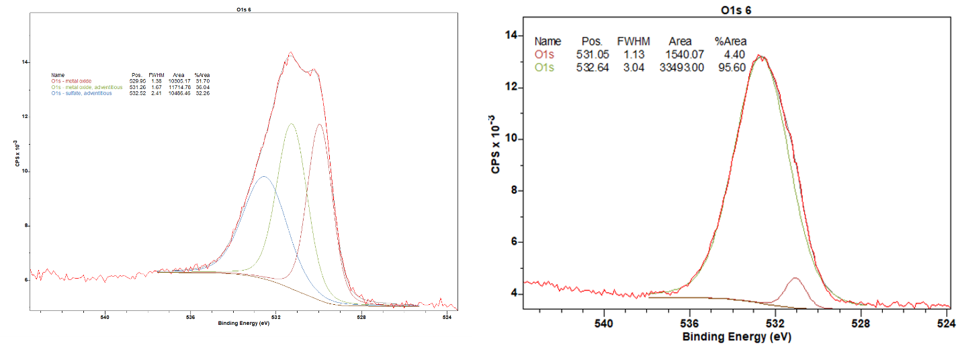
Figure S6. Deconvoluted O 1s peaks of fresh (left) and used MAHC (right).

