Controlling catalyst deactivation: temperature regulation for the directed synthesis of easily regenerable and refractory tar in the pyrolysis of waste films
Chentao Tan ^{a.b}, Xiaoyan Lan ^{a.b}, Xun Chen ^{a.b}, Yunpu Wang ^{c}, Leilei Dai ^{d}, Erguang Huo ^{e}, Hang Gou ^{a.b}, Yuting Jiang ^{a.b}, Jian Zhang ^{a.b}, Yue Zhang ª, Haiyan Yan ^{a.b*}, Yunfeng Zhao ^{a.b*}
ª Key Laboratory of Agricultural Product Processing and Quality Control of Specialty(Co-construction by Ministry and Province), School of Food Science and Technology, Shihezi University, Shihezi, Xinjiang 832003, China
^{b} Key Laboratory for Food Nutrition and Safety Control of Xinjiang Production and Construction Corps, School of Food Science and Technology, Shihezi University,
Shihezi, Xinjiang 832003, China
^{c} State Key Laboratory of Food Science and Technology, Nanchang University, Nanchang 330047, China
^{d} Key Laboratory of Energy Thermal Conversion and Control, School of Energy and Environment, Southeast University, Nanjing, China.
^{e} Jiangsu Key Laboratory of Micro and Nano Heat Fluid Flow Technology and Energy Application, School of Physical Science and Technology, Suzhou University of
Science and Technology, Suzhou 215009, China

Methods for Supplementary data
The morphologies of the fresh catalyst and waste catalyst were examined using a Hitachi SU8000 field emission scanning electron microscope at an accelerating voltage of 10 kV.
The tar samples were analyzed using an Agilent Technologies gas chromatography-quadrupole mass spectrometry (GC-MS) system. The tar samples were directly injected without any pretreatment. The subsequent analysis was carried out using a GC-MS system equipped with an Agilent HP-5 chromatographic column (model 8890-5977B). The condensable components were identified by comparing the mass spectra with the NIST14 mass spectral database, and the main components were further verified by comparing with standard mass spectra.
Non-isothermal pyrolysis experiments were conducted on the used catalyst samples using a thermogravimetric analyzer. 5-10 mg of the samples were precisely weighed and placed in an alumina crucible. The samples were then heated from room temperature to 800°C at three different heating rates of 5, 10, and 20 °C/min under a high-purity nitrogen atmosphere (flow rate of 50 mL/min), and the mass change of the samples with temperature was continuously recorded.Based on the data from thermogravimetric experiments, the apparent activation energy was calculated using three model-free kinetic methods of equal conversion rate.The conversion rate (α) was calculated from the thermogravimetric data. Within the range of conversion rate (α) from 0.1 to 0.9, a point was taken every 0.1, and the above three methods were respectively applied. All linear fittings were conducted using the least square method through OriginPro software.
S1 Pyrolysis Kinetic Theory
The overall pyrolysis reaction can be generally described by the following expression:
$\text{materials}\underset{→}{\text{k}\left(\text{t}\right)}\text{volatiles}\left(\text{liquid }\text{oils+syngas}\right)\text{+char}$
To predict reaction behavior and optimize the degradation process, it is essential to determine relevant pyrolysis kinetic parameters. The reaction rate for the conversion of a material from the solid to the volatile state can be described by:
$\frac{\text{dα}}{\text{dt}}\text{=}\text{kf}\text{(α)}$
The conversion rate within the sample is denoted by α, where t represents time. The mathematical model describing the reaction mechanism is denoted by f(α), and k is a temperature-dependent parameter characterizing the weight loss rate during pyrolysis. Then, the conversion rate of the pyrolysis process is defined as:
$\text{α}\text{=}\frac{{\text{m}}_{\text{0}}\text{-}{\text{m}}_{\text{t}}}{{\text{m}}_{\text{0}}\text{-}{\text{m}}_{\text{f}}}$
The sample masses at the initial moment, time t, and the final transformation are expressed as m₀, m_{t,} and m_{f,} respectively. Subsequently, the corresponding reaction rates can be obtained from the Arrhenius equation:
$\text{k=A}{\text{e}}^{\text{-(}{{\text{E}}_{\text{a}}}/{\text{RT}}\text{)}}$
Where A represents the pre-exponential factor (min⁻¹), E denotes the activation energy (kJ·mol⁻¹), R is the universal gas constant (8.314 J·mol⁻¹·K⁻¹), and T stands for the reaction temperature (K). By combining Equations (2) and (4), the reaction rate can be expressed as:
$\frac{\text{dα}}{\text{dt}}\text{=A}{\text{e}}^{{{\text{E}}_{\text{a}}}/{\text{RT}}}\text{f(α)}$
Additionally, the heating rate is denoted by：
$\text{β}\text{=}\frac{\text{dT}}{\text{dt}}$
After solving Eqs. (5) and (6), their corresponding integral forms become:
$\text{g}\left(\text{α}\right)\text{=}\int_{\text{0}}^{\text{a}}{\frac{\text{dα}}{\text{f(α)}}\text{=}\frac{\text{A}}{\text{β}}\int_{{\text{T}}_{\text{0}}}^{\text{T}}{{\text{e}}^{\text{-(}{{\text{E}}_{\text{α}}}/{\text{RT}}\text{)}}\text{dT}}}$

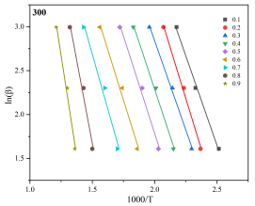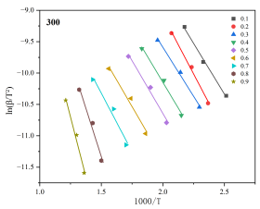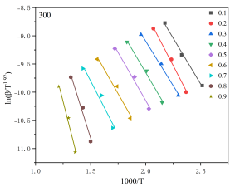
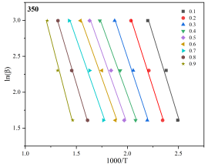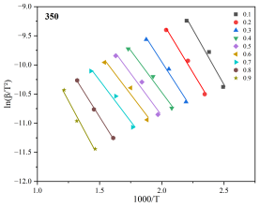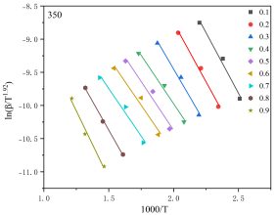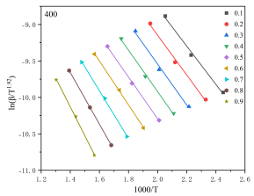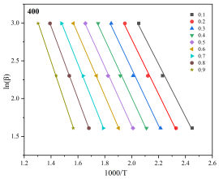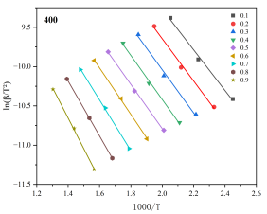
Fig.S1 Non-model fitting chart of tar pyrolysis kinetics over catalysts at different catalytic temperatures.

Fig.S2 Distribution of oxygen-containing compounds in tar (excluding antioxidants)

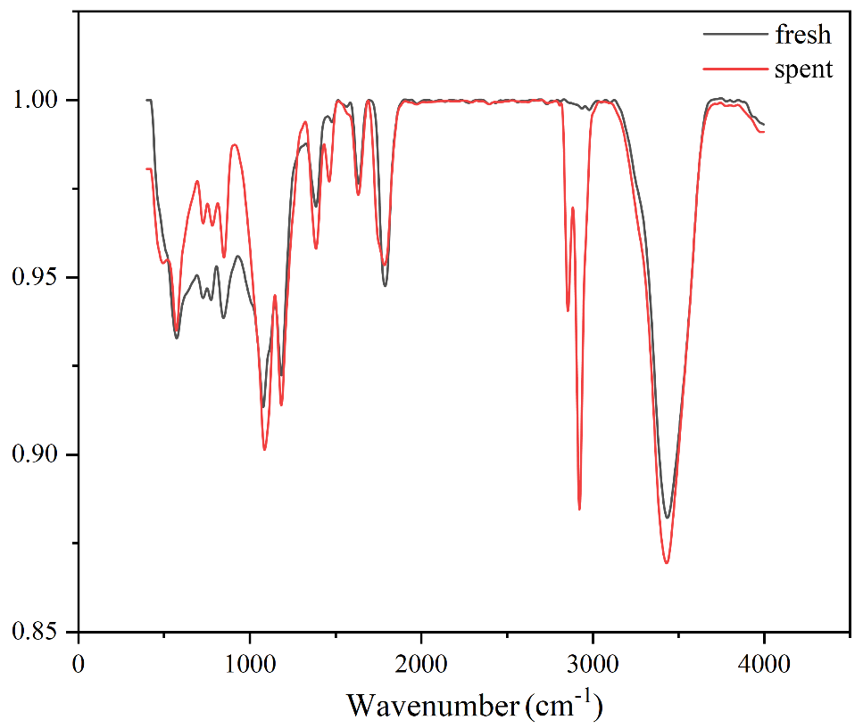
Fig.S3 Fourier-transform infrared (FTIR) spectra of fresh and spent walnut shell-derived carbon-based catalysts
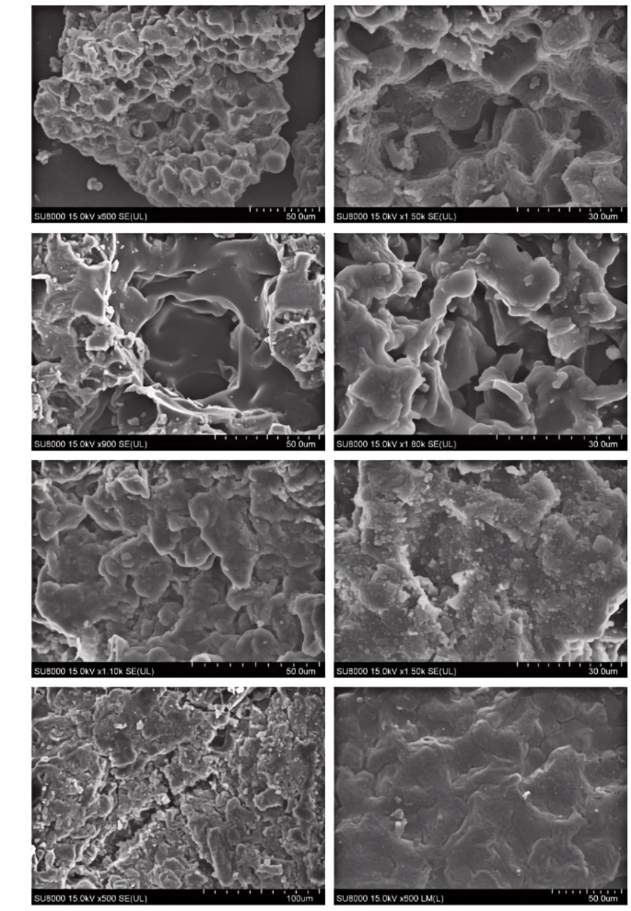
400
350
300
Fresh
Fig. S4 SEM of waste catalysts at different catalytic temperatures.

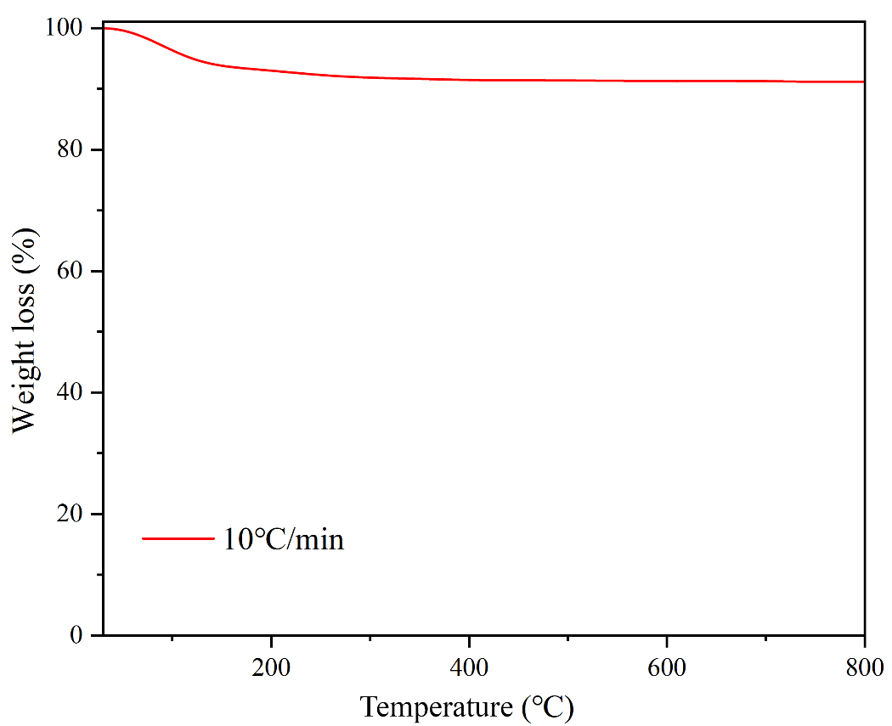
Fig. S5 Thermogravimetric curve of the fresh catalyst at a heating rate of 10 ℃/min.

Table S1 Comparison of product distributions under different catalytic temperature systems
Temperature (℃) | Oil Yield (wt%) | Gas Yield (wt%) | Tar Deposited (wt%)
300 | 66.2 | 21.2 | 12.6
350 | 72.0 | 19.8 | 8.2
400 | 64.0 | 30.4 | 5.6
Table S2 Comparison of the specific surface area of fresh and spent catalysts
Type | m²/g
fresh | 51.9447
waste | 1.1381

