Anchoring chitosan on phytic acid-doped polyaniline as capacitive deionization electrodes for uranium capture from wastewater.
Chenxiao Hong^{a,b}, Jing Wang^{a,b}, Sana Shafi^{a,b}, Jiayao Hu^{a,b}, Junyi Chen^{b}, llhom Halimov^{c}, Jiaxing Li^{a,b*}
ª University of Science and Technology of China, Hefei 230026, PR China
^{b} Institute of Plasma Physics, Hefei Institutes of Physical Science, Chinese Academy of Sciences, Hefei 230031, PR China
^{c} Navoi State University of Mining and Technologies
* Email address: lijx@ipp.ac.cn (J. Li), Tel: +86-551-65591771.

Supplementary Experiment
Chemicals
All reagents were obtained from commercial suppliers and were used without further purification, unless otherwise stated. The seawater was collected in Qingdao, Shandong, China.
Instrumentation
The Fourier transform infrared (FT-IR) measurement was carried out on a Nicolet 5700 FT-IR spectrophotometer (IR-Prestigr, Shimadzu, Japan), with KBr discs in the range of 4000 to 400 cm⁻¹. The morphology was observed by fieldemission scanning electron microscope (SEM, S-4800, Hitachi, Japan). The local chemical analysis was performed by EDX (energy dispersive X-ray analysis) in the SEM. The contact angles were recorded by an automatic video micro contact angle measuring instrument (JY-82B Kruss DSA). X-ray photoelectron spectroscopy (XPS) measurement was performed using a Thermo ESCALAB 250 X-ray photoelectron spectrometer, using monochromatized Al Kα as the excitation source. The energy calibrations were made against the C 1s peak. The UV spectrophotometer (UV-2600, Shimadzu, Japan) was used to probe the uranyl ion concentration in the single aqueous solution. The concentration of the metal ion in mixed solution was detected using the inductively coupled plasma-optical emission spectrometry (PE-8000 PerkinElmer, America). The pH of solution was measured by an S-3C model pH meter. All of the electrochemical measurements were conducted by an electrochemical working station (CHI 760E) in a three electrode system.
Physicochemical Sorption Experiments
To determine the maximum adsorption capacity of CS/PA-PANI for uranyl ions, PA-PANI powder was dispersed in uranyl solution (uranyl nitrate hexahydrate was used to prepare the solution) with initial concentration range of 50 ~ 1000 mg L⁻¹ at a fixed material-to-solution ratio of 0.5 g L⁻¹ to create a good dispersion and then shaken for 24 h.
Electrochemical Tests
The electrochemical performance was systematically evaluated using a three-electrode configuration on a CHI660E electrochemical workstation. The working electrode consisted of graphite plates coated with active materials , while a 1.0 cm × 1.0 cm platinum mesh served as the counter electrode. A mercury/mercurous sulfate electrode (Hg/Hg2SO₄) was employed as the reference electrode. The electrolyte contained 500 mg L⁻¹ UO₂²⁺ in an aqueous solution. Cyclic voltammetry (CV) was conducted within a voltage range of −1.0 to 0.6 V at scan rates of 10, 30, 50, 80, and 100 mV s⁻¹. Electrochemical impedance spectroscopy (EIS) was carried out at open circuit voltage over a frequency range of 0.01–1000 kHz.
Electricity consumption calculation
The electricity consumption for extracting a unit of uranium (EC/KWh Kg⁻¹) were calculated by Eq. (S1) as follows :
$$\begin{aligned}EC=\frac{U\int{Idt}}{3600(C_{0}−C_{e})V_{s}}\#(S−1)\end{aligned}$$

where, $C_{0}$ (g L⁻¹) and $C_{e}$ (g L⁻¹) are the initial and final concentrations of uranium, respectively; and $V_{s}$ (L) are the solution volume of samples, respectively. $I$ (A) is the applied current, $U$ (V) is the value of applied voltage; $t$ (s) is time of electrosorption.
Supplementary Tables
Table S1. Fitting parameters of adsorption kinetics of uranium by electro-adsorption and physicochemical adsorption.
Concentration | Pseudo-first-order model |  |  | Pseudo-second-order model
Concentration | R² | q_{e} | K₁ (h⁻¹) | R² | q_{e} | K₂ (g·mg⁻¹·h⁻¹)
Electrosorption | 0.9736 | 937.36 | 0.4825 | 0.9850 | 1018.09 | 6.68×10⁻⁴
Physicochemical adsorption | 0.9910 | 595.66 | 0.1385 | 0.9947 | 708.49 | 2.15×10⁻⁴

Table S2. The uranium adsorption isotherm parameters of CS/PA-PANI.
Isotherm model
Langmuir |  | Freundlich
q_{m} (mg·g⁻¹) | 973.13 | n | 3.9325
K_{L} (L·mg⁻¹) | 0.0493 | K_{F} (mg g⁻¹) (L mg⁻¹)^{1/n} |  | 360.79
R² | 0.9817 | R² | 0.8078

Table S3. Ion concentration of simulated seawater.
Element | U | V | Fe | Co | Ni | Cu | Zn | Pb | Mg | Ca
Simulated seawater (μg g⁻¹) | 330 | 152 | 141 | 530 | 101 | 65 | 408 | 34.6 | 1.2*10⁵ | 0.6*10⁵

Table S4. Ion concentration of natural seawater.
Element | U | V | Fe | Co | Ni | Cu | Zn | Pb | Mg | Ca | Na
Natural seawater (μg g⁻¹) | 2.4 | 2.7 | 1.3 | 5.3 | 1.9 | 0.5 | 4.6 | 0.4 | 1.1*10⁵ | 0.4*10⁵ | 1.0*10⁶

Table S5. Comparison of electrosorption performance of CS/PA-PANI with other reported materials.
CDI electrode material | Adsorption capacity (mg g⁻¹) | Ref.
Carbon nanospheres | 194 | ^{[1]}
Chitosan/biocarbon | 207.6 | ^{[2]}
GO/PPy | 246.5 | ^{[3]}
MAFP/GO/CS | 260.6 | ^{[4]}
CC/PANI | 282.2 | ^{[5]}
MIL-101-NH2 | 331.4 | ^{[6]}
CNT/MnO2/PPy | 339.5 | ^{[7]}
MOF/MWCNTs | 410.3 | ^{[8]}
CSPA | 429.1 | ^{[9]}
COFs-AO | 478.5 | ^{[10]}
Phosphate | 545.7 | ^{[11]}
NHC-CMS | 581.5 | ^{[12]}
MIP-202/MXene | 582.4 | ^{[13]}
CS-PBTCA | 631.9 | ^{[14]}
FeOOH | 709.4 | ^{[15]}
CS/PA-PPy | 799.3 | ^{[16]}
Porous polymer | 831.5 | ^{[17]}
CS/PA-PANI | 942.3 | This work

Supplementary Figures
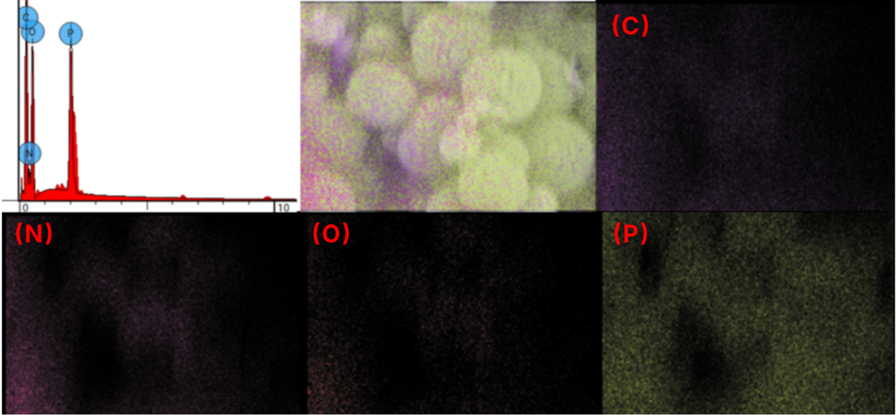
Figure S1. EDS mapping spectra of CS/PA-PANI.
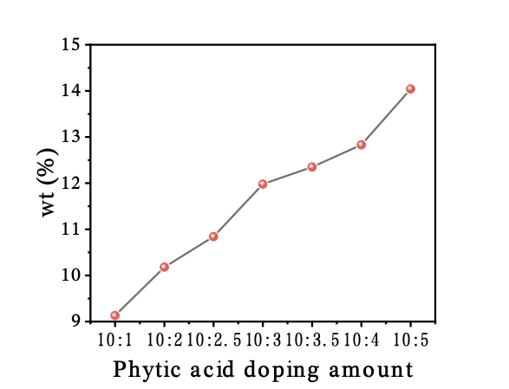
Figure S2. Relationship between phytic acid incorporation level and phosphorus content.
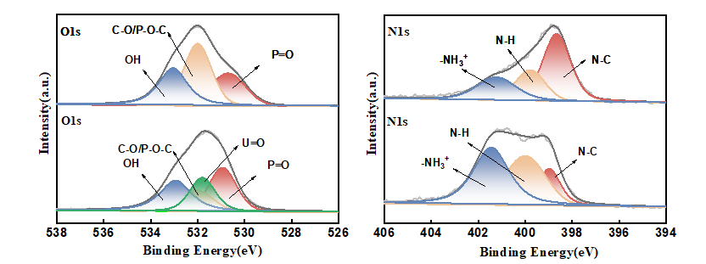
Fig. S3. High-resolution O 1s and N 1s spectra of CS/PA-PANI before and after uranium capture.

[1] Jin M, Huang X, Wang Z, Chan V, Hu J, et al. 2023. Mn, N co-doped carbon nanospheres for efficient capture of uranium (VI) via capacitive deionization. Chemosphere 342:140190 doi:10.1016/j.chemosphere.2023.140190
[2] Tang X, Zhou L, Xi J, Ouyang J, Liu Z, et al. 2021. Porous chitosan/biocarbon composite membrane as the electrode material for the electrosorption of uranium from aqueous solution. Separation and Purification Technology 274:119005 doi:10.1016/j.seppur.2021.119005
[3] Shuang M, Zhou L, Liu Y, Yu H, Ao X, et al. 2023. Electrodeposition nanofabrication of graphene oxide/polypyrrole electrodes with high hybrid specific capacitance for enhancing U (VI) electrosorption. Journal of Environmental Chemical Engineering 11:111498 doi:10.1016/j.jece.2023.111498
[4] Ren Q, Xia H, Wang Y, Lv J, Yuan D, et al. 2024. Novel malonamide-amidoxime bifunctional polymers decorated graphene oxide/chitosan electrode for enhancing electrosorptive removal of uranium (VI). Separation and Purification Technology 330:125292 doi:10.1016/j.seppur.2023.125292
[5] Yu H, Zhou L, Liu Y, Ao X, Ouyang J, et al. 2023. Biocarbon/polyaniline nanofiber electrodes with high hybrid capacitance and hierarchical porous structure for U (VI) electrosorption. Desalination 564:116773 doi:10.1016/j.desal.2023.116773
[6] Guo D, Yan C, Huang B, Jin T, Liu Z, Qian Y. 2025. Combining electrosorption and electrochemical reduction mechanisms for uranium removal using 1, 2, 3, 4-butane tetracarboxylic acid-modified MIL-101: an in-depth exploration of uranyl–adsorbent interactions. Inorganic Chemistry 64:1777-87 doi:10.1021/acs.inorgchem.4c04304
[7] Liu Y, Zhou L, Ouyang J, Ao X, Shuang M, Adesina AA. 2024. Electrodeposition nanofabrication of carboxylated carbon nanotubes/α-MnO2 nanorods/polypyrrole composites as high hybrid capacitance electrodes for efficient U (VI) electrosorption. Separation and Purification Technology 334:125989 doi:10.1016/j.seppur.2023.125989
[8] Hu Q, Wang D, Liang J, Liu Z, Li J. 2024. Porous carbonized N-doped MOF-199 modified with MWCNTs for the deionization of uranium (VI). Separation and Purification Technology 330:125494 doi:10.1016/j.seppur.2023.125494
[9] Huang J, Huang B, Jin T, Liu Z, Huang D, Qian Y. 2022. Electrosorption of uranium (VI) from aqueous solution by phytic acid modified chitosan: An experimental and DFT study. Separation and Purification Technology 284:120284 doi:10.1016/j.seppur.2021.120284
[10] Yang S, Luan Z, Li W, Cheng X, Ye Z, Hu B. 2024. Two-dimensional sp2 carbon-conjugated COFs electrode for efficient electro-adsorption of uranium. Separation and Purification Technology 330:125378 doi:10.1016/j.seppur.2023.125378
[11] Liao Y, Wang M, Chen D. 2019. Electrosorption of uranium (VI) by highly porous phosphate-functionalized graphene hydrogel. Applied Surface Science 484:83-96 doi:10.1016/j.apsusc.2019.04.103
[12] Li Q, Zhou J, Xu Y, Jin Z, Zhou H. 2025. Interface-driven electronic modulation enhances US coordination in carbon-confined Co-Mo sulfide heterojunctions for electrochemical uranium extraction. Chemical Engineering Journal:164881 doi:10.1016/j.cej.2025.164881
[13] Zhang Y, Zhou J, Wang D, Cao R, Li J. 2022. Performance of MXene incorporated MOF-derived carbon electrode on deionization of uranium (VI). Chemical Engineering Journal 430:132702 doi:10.1016/j.cej.2021.132702
[14] Yang S, Yan C, Huang B, Jin T, Guo D, et al. 2025. PBTCA-modified self-crosslinked chitosan gels for efficient electrosorption of uranium from wastewater. Desalination:118984 doi:10.1016/j.desal.2025.118984
[15] Jiao R, Chen Z, Zeng S, Wang D, Li J. 2023. Electrosorption of uranium (VI) by sulfonic acid‑decorated FeOOH nanorods. Journal of Environmental Chemical Engineering 11:111275 doi:10.1016/j.jece.2023.111275
[16] Zhao X, Chen D, Shi M, Zhao R. 2024. Anchoring chitosan/phytic acid complexes on polypyrrole nanotubes as capacitive deionization electrodes for uranium capture from wastewater. International Journal of Biological Macromolecules 270:132491 doi:10.1016/j.ijbiomac.2024.132491
[17] Tang W, Li D, Zhang X, Guo F, Cui C, et al. 2023. A modified freezing-casted conductive hierarchical porous polymer composite electrode for electrochemical extraction of uranium from water. Separation and Purification Technology 319:124087 doi:10.1016/j.seppur.2023.124087

