Co-upcycling of polyurethane and biomass for synthesizing functionalized N-doped hierarchical porous carbon for high-performance aqueous zinc-ion hybrid capacitors
Guanyu Zhang, Tianqi Cao, Zengjian Guo, Xuesong Zhang *, Lujia Han
Engineering Laboratory for AgroBiomass Recycling & Valorizing, College of Engineering, China Agricultural University, Beijing 100083, China
*Corresponding author, E-mail: xszhang@cau.edu.cn (X. Zhang)

Supplementary

Supplementary Figures
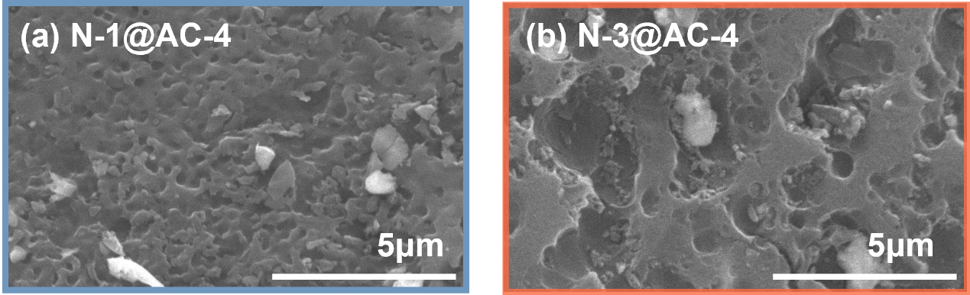
Fig. S1 SEM images of N-1@AC-4 and N-3@AC-4.

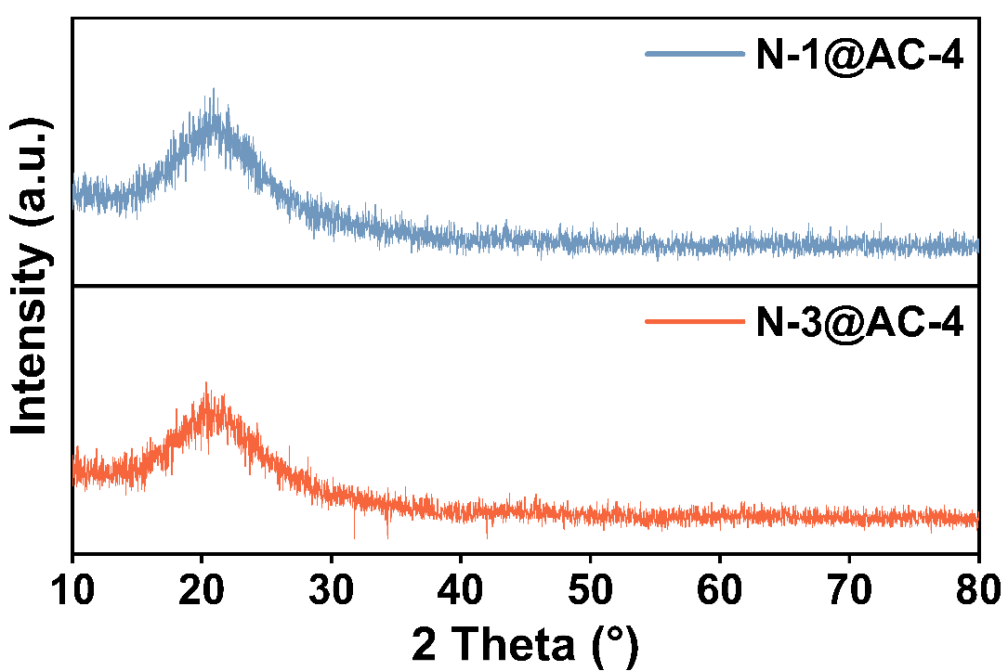
Fig. S2 XRD spectra of N-1@AC-4 and N-3@AC-4.

Fig. S3 XPS survey spectra of N-3@AC-4.

Fig. S4 High-resolution XPS N 1s spectra of N-3@AC-4.

