Supplemental materials

Biochar-induced charosphere microenvironment modulates soil cadmium bioavailability and wheat uptake

Liqiang Cui^{a,b}, Wei Wang^{a,b}, Guixiang Quan^{a,b}, Hui Wang^{a,b}, Kiran Hina^{c}, Qaiser Hussain^{d}, Yuming Liu^{e※}, Jinlong Yan^{a,b*}

ª School of Environmental Science and Engineering, Yancheng Institute of Technology, No. 211 Jianjun East Road, Yancheng 224051, China
^{b} Jiangsu Engineering Research Center of Biomass Waste Pyrolytic Carbonization & Application, Yancheng 224051, P. R. China
^{c} Department of Environmental Sciences, Hafiz Hayat Campus, University of Gujrat, Gujrat, 54000, Pakistan.
^{d} Institute of Soil and Environmental Sciences, Pir Mehr Ali Shah Arid Agriculture University, Rawalpindi, 46300, Pakistan.
^{e} Tinghu District Agricultural Technology Comprehensive Service Center, No. 55 Qingnian East Road, Yancheng, 224003, China
※Corresponding author. E-mail: thrjb513@163.com
* Co-Corresponding author. E-mail: yjlyt4788@126.com

Supplementary file 1. Methods for Supplementary data
Soil organic carbon (SOC) was detected with dichromate oxidation method, cation exchange capacity (CEC) with via the sodium acetate exchange method. Soil pH was measured using a glass electrode in water with soil-to-solution rate of 1:2.5. The soil water and water-soluble salt were detected by gravimetric method. Total soil nitrogen (total N) was determined using the semimicro-Kjeldahl procedure. Total soil phosphorus (total P) was measured using the NaOH fusion–Mo–Sb anti-spectrophotometric method. Total soil potassium (total K) was measured using the NaOH fusion and detected with flame atomic absorption spectrometry (TAS-986, Persee, China).
Plant total Cd concentration: A 0.50 g plant sample was placed in a 100 mL beaker and predigested overnight, at room temperature, in a 10 mL solution of concentrated HNO₃ and HClO₄ (4:1, v:v). The following day, the beakers were placed on an electric heating plate, the temperature raised from 100 to 200 ºC over 30 min, and then the temperature was increased to 250 °C until the solution changed to colorless and ~ 2 mL of solution remained. The solutions were then removed, cooled, brought to a 25 mL final volume, and filtered through a 0.45 µm membrane filter. The Cd concentration in the digestate was determined with Atomic Absorption Spectrophotometry (AAS, TAS-986, Persee, China).
Fourier Transform Infrared Spectroscopy (FTIR) were recorded in the region of 400-4000 cm⁻¹ by using a Waltham Nexus-670 FTIR Spectrometer (NEXUS-670, NICOLET, USA) with a resolution of 1.0 cm. The biochar pellets were prepared by using KBr powder. Infrared spectra were separated using Systat Peakfit, Version 4.12 (Seasolve, China).
X-ray Photoelectron Spectroscopy (XPS) was used to analyze surface properties in approximately 10 nm depth of biochars. XPS measurements were conducted using an ESCALAB 250Xi (THERMO FISHER, USA), equipped with a focused monochromatized Al Kα radiation (hν = 1486.6 eV). The X-ray spot size was 500 μm. Survey scan spectra in the 1351 – 0 eV binding energy range were recorded with a pass energy of 100.0 eV, others in 20.0 eV.
Scanning electron microscope with energy dispersive spectroscopy (SEM-EDS) was carried out on Nova NanoSEM 450 (FEI, USA) and AZtec X-MaxN 80 (Oxford, UK). SEM was operated at 15 kV with a probe current of 0.6 nA to which a Bruker silicon drift detector EDS system had been interfaced.

Table S1. Basic paddy soil (0 to 15 cm depth) and biochar (g kg⁻¹) properties.
 | pH  (H₂O) | Organic  C | Total  N | Total  P | Total  K | CEC | Total Cd  (mg kg⁻¹) | Total Pb  (mg kg⁻¹)
Soil | 6.07 | 20.7 | 3.19 | 0.82 | 11.4 | 18.0 | 22.6 | 713.3
Biochar | 10.4 | 467 | 5.90 | 14.4 | 11.5 | 21.7 | 0.03 | 12.9
CEC: cation exchange capacity (cmol kg⁻¹).

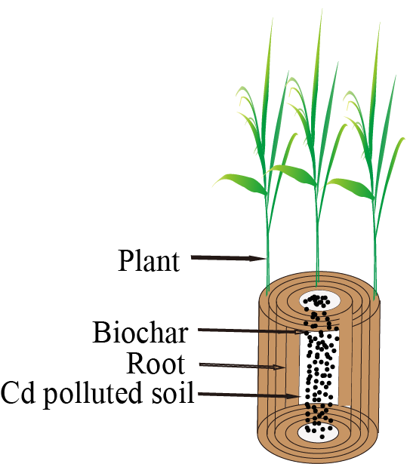
Fig. S1 the biochar box and experiment design

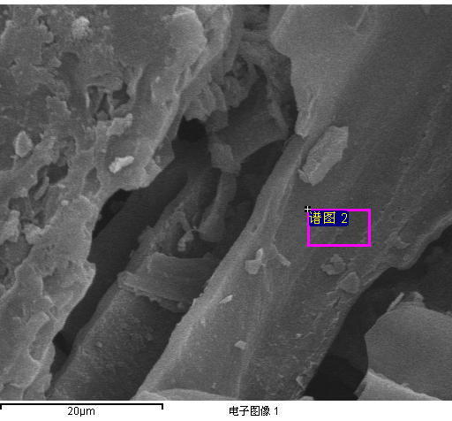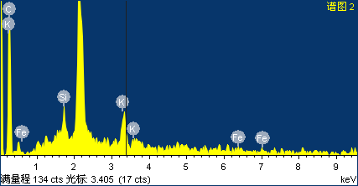
1

1

A
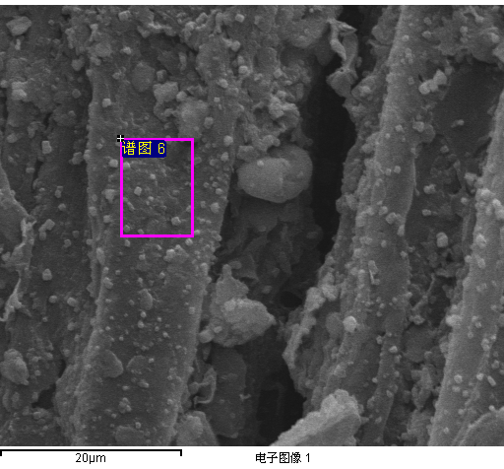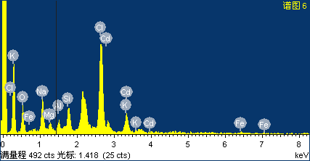

2

2
B
Fig. S2 SEM-EDS elemental maps of elements in raw biochar (A) and 7.5% biochar applied in soil (B)

Fig. S3 Peak fits of biochar in soil C1s (A), O1s(B) and raw biochar C1s (C), O1s(D)

Fig. S4 Infrared spectra of raw biochar and 7.5% biochar applied in soil

Fig. S5 The PCA analyses (PC2 and PC3) with biochar application, soil properties and plant Cd concentration in the charosphere experiment

