Supporting Information
Affinity and Selectivity of Oxygen- and Nitrogen-Containing Functional Groups toward U(VI)
Yuanyuan Zhu¹, Xuemei Cui¹, Wenbo Dong^{2 *}, Yue Chen⁵, Xiaolong Zhang^{1, *} and Shubin Yang ^{1, *}
¹ School of Chemistry and Chemical Engineering, Yantai University, Yantai 264005, P.R. China
² Helmholtz Institute for Polymers in Energy Applications Jena (HIPOLE Jena), Lessingstrasse 12-14, 07743 Jena, Germany.
³ Yantai-Jingshi Institute of Material Genome Engineering, Yantai 264006, P.R. China

* Corresponding author,
E-mail: wenbo.dong@helmholtz-berlin.de, xiaolongzhang@ytu.edu.cn (X.L. Zhang) and shubinyang@ytu.edu.cn (S. Yang).

- Experimental Section
1.1 Chemicals and Reagents
All reagents were procured from commercial sources and utilized without further purification. Graphite is purchased from Shanghai Shanpu Chemical Co., Ltd, China. Chemicals such as sodium nitrate, potassium permanganate, concentrated sulfuric acid, nitric acid, hydrogen peroxide, pyrrole, aniline, thiophene, furan and uranium nitrate hexahydrate (UO₂(NO₃)₂•6H₂O) are purchased from Macklin Biochemical Co., Ltd., China. Ultrapure water (18.2 MΩ) was obtained from a Milli-Q® IQ 7000 water purification system (Merck KGaA, Germany) for all experiments.
1.2 Characterization.
The as-synthesized samples were characterized by scanning electron microscopy (SEM, JSM-7900F, JEOL), X-ray diffraction (XRD, SmartLab3, Rigaku) using Cu Kα radiation (λ = 0.154 nm), and Fourier transform infrared spectroscopy (FTIR, Frontier, PerkinElmer) in the range of 4000-400 cm⁻¹. The elemental composition and chemical state of the samples were analyzed by X-ray photoelectron spectroscopy (XPS, Thermo Scientific, ESCALAB Xi+). TGA (PerkinElmer, STA 8000) under N₂ atmosphere, heating from 35 ºC to 800 ºC at a heating rate of 10 ºC/min. Thermal stability was evaluated by thermogravimetric analysis (TGA) on a PerkinElmer STA 8000 instrument under a nitrogen atmosphere, with a heating rate of 10 °C/min from 35 to 800 °C.
1.3 Adsorption and desorption study.
The functionalized graphene-based adsorbent suspension was mixed with U(VI) solutions of varying concentrations to achieve the desired concentrations for different components. The pH of the solutions was subsequently adjusted using 0.1 M HNO₃ and 0.1 M NaOH. After shaking for 24 h to attain adsorption equilibrium, the mixtures were centrifuged to separate the solid phase from the solution. The final concentration of U(VI) ions is determined by ultraviolet spectrophotometer at 650 nm (Lambda 365, PerkinEImer)[1].
The adsorption capacity Q_{e} (mg/g) and the adsorption efficiency (%) of U(VI) can be expressed as the following equations[2]:
$Q_{e}=\left(C_{0}-C_{e}\right).\frac{V}{m}$ (1)
$Adsorption efficiency=\frac{C_{0}-Ce}{C_{0}}×100\%$ (2)
where C₀ and C_{e} are the initial and equilibrium concentrations (mg/L) of U(VI), respectively in aqueous phase; V and m represent the volume (L) of the solution and the weight (mg) of adsorbents. Experiments are performed in duplicates.
To evaluate the reusability of the composite material, the desorption study[3] was regenerated using 1 mol/L HCl as the desorption agent at 298 K. The desorption efficiency (%) was calculated as shown in equation:
$Desorption efficiency =\frac{{(Q}_{e}-Q_{e}^{,})}{Q_{e}}×100\%$ (3)
where Q_{e} and Q_{e}’ represent the adsorption capacities (mg/g) at adsorption equilibrium and desorption equilibrium, respectively.
- Computational details.
The computational results in this study were based on first-principles density functional theory (DFT). The generalized gradient approximation (GGA) in the form of the Perdew-Burke-Ernzerhof (PBE) functional and projector augmented wave (PAW) potentials was employed to account for electron-ion interactions[4]. Due to the use of periodic boundary conditions, a vacuum spacing of 30 Å was introduced between layers to prevent interlayer interactions. Spin-polarized calculations were unrestricted during the optimization process[5]. The Brillouin zone k-point mesh was set to 1 × 1 × 1. The parameters adopted are well-justified and ensure high computational accuracy.
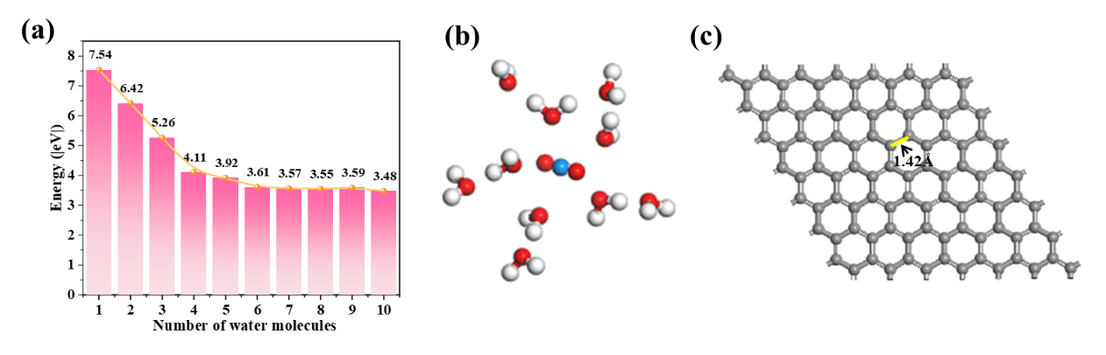
Fig. S1 (a) Energy change as the number of H₂O molecules increases. (b) The most stable structure of [UO₂(H₂O)₁₀]²⁺. (c) The most stable structure of GF.
To determine the optimal structure of the U(VI) ion, we gradually added explicit water molecules to its structure and calculated the hydration energy change. While the number of water molecules is larger than 5, the hydration energy changes are around 3.5eV (Fig. S1a), indicating that the hydration environment becomes stable enough. Finally, the uranyl system with ten explicit water molecules [UO₂(H₂O)₁₀]²⁺ is selected to be the uranyl model for further calculation.
GF primitive cell was imported and its inherent symmetry was disabled. Based on this, a 7 × 7 × 1 supercell model containing 98 carbon atoms was constructed to serve as the foundational framework for subsequent simulations of the GF system. Geometric optimization was performed on both the GF model and the uranyl ion (UO₂²⁺), yielding the stable configurations shown in Fig. S1b-1c. The optimized GF retains a two-dimensional planar hexagonal honeycomb structure, with a C–C bond length of 1.420 Å and a C–C–C bond angle of 120.020°. Each carbon atom is electrically neutral, resulting in an overall charge-neutral GF system, which is consistent with previous report[6]. The adsorption energy (E_{ads})[7, 8] is calculated as follows Eqs. (4-5):
$E_{ads}=E_{GF+UO_{2}^{2+}}-E_{GF}-E_{UO_{2}^{2+}}$ (4)
$E_{ads}^{'}=E_{C}-E_{0}$ (5)
where E_{GF}, E_{UO2}²⁺, E_{GF+UO2}²⁺ are the energies of GF, U(VI) ions, and the complex of GF with U(VI) ions, respectively. E՛_{ads}, E_{C,} and E₀ are the energies of total adsorption energy of the system, coordination adsorption energy, and the zero-point adsorption energy, respectively.

- Supplementary Figures

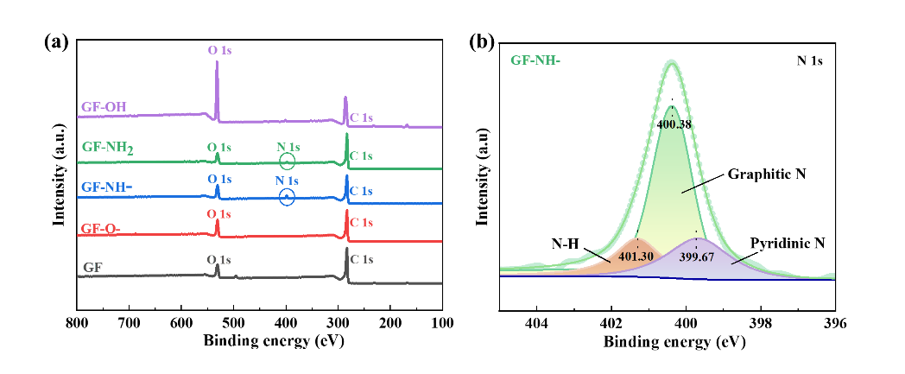
Fig. S2 Wide-scan XPS survey of GFs materials (a) and XPS N 1s of GF-NH- (b).

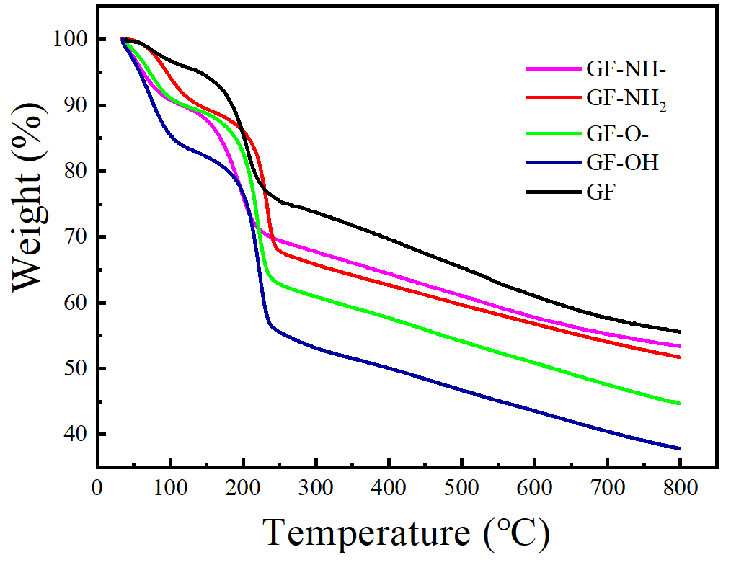
Fig. S3 TGA curves of GFs materials.

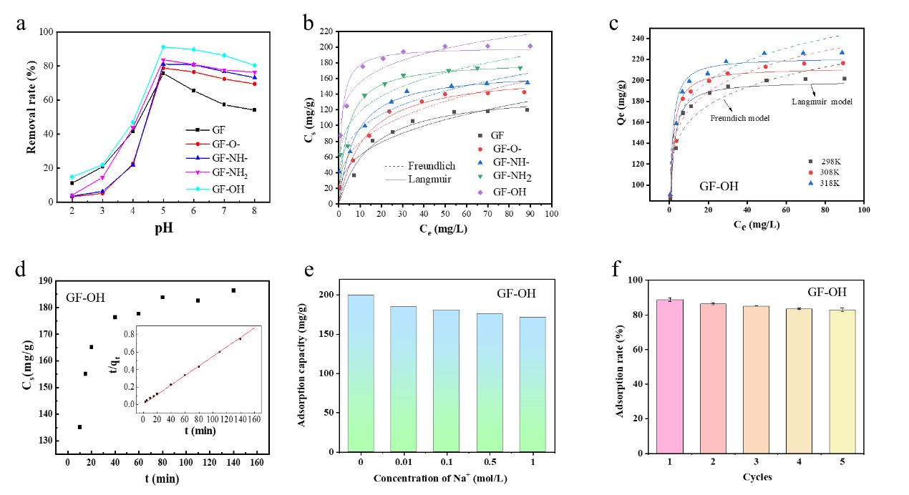
Fig. S4 Effects of (a) pH, (b) U(VI) concentration, (c) temperature, (d) contact time, (e) Na⁺ concentration, and (f) reuse cycles on U(VI) sorption by GFs.

Table S1 Adsorption isotherm parameters of U(VI) on GFs for Langmuir and Freundlich models
T | Material |  | Langmuir model |  |  |  | Freundlich model
T | Material |  | K_{L}  (L/mg) | Q_{s max}  (mg/g) | R² |  | K_{F}  (mg^{1−n} L^{n}/g) | n | R²
298 K | GF |  | 0.067 | 144.958 | 0.956 |  | 34.528 | 2.521 | 0.927
298 K | GF-O |  | 0.084 | 167.566 | 0.970 |  | 44.960 | 2.780 | 0.945
298 K | GF-NH- |  | 0.133 | 170.171 | 0.946 |  | 60.155 | 3.495 | 0.910
298 K | GF-NH₂ |  | 0.253 | 181.779 | 0.900 |  | 81.395 | 3.946 | 0.882
298 K | GF-OH |  | 0.885 | 199.403 | 0.946 |  | 117.124 | 6.132 | 0.853
308 K | GF-OH |  | 0.978 | 212.155 | 0.923 |  | 124.945 | 6.038 | 0.851
318K | GF-OH |  | 1.117 | 221.764 | 0.942 |  | 132.482 | 6.070 | 0.842

Table S2. Comparison of maximum sorption capacity (Q_{s max}) of U(VI) on various graphene-based materials.
Materials | Q_{s max} (mg/g) | References
RGO | 47 | [9]
GO | 97.5 | [10]
LGO | 108.3 | [11]
SGO | 116 | [11]
HOOC-GOs | 103.09 | [8]
PANI/GO | 1960 | [12]
GO/PPy | 147.1 | [13]
AGO | 353.5 | [14]
GO-COOH | 344.1 | [2]
GF-OH | 221.764 | This work

Table S3 Kinetic parameters of U(VI) adsorption by GFs.
Materials | pseudo-first-order |  |  |  | pseudo-second-order
 | R² | k₁ | q_{e} |  | R² | k₂ | q_{e}
 | R² | (min⁻¹) | (mg/g) |  | R² | (g·mg⁻¹/min) | (mg/g)
GF-O | 0.957 | 0.037 | 153.38 |  | 0.998 | 0.0006 | 167.22
GF-NH | 0.953 | 0.016 | 164.60 |  | 0.988 | 0.0004 | 173.91
GF-NH₂ | 0.806 | 0.023 | 149.40 |  | 0.999 | 0.0039 | 180.49
GF-OH | 0.973 | 0.168 | 179.17 |  | 0.999 | 0.0016 | 180.03

Table S4 Thermodynamic parameters of U(VI) adsorption by GF-OH.
T (K) | ΔG (kJ·mol⁻¹) | ΔH (kJ·mol⁻¹) | ΔS (J·mol⁻¹K⁻¹)
298 | -12.252
308 | -13.185 | 15.570 | 93.365
318 | -14.119

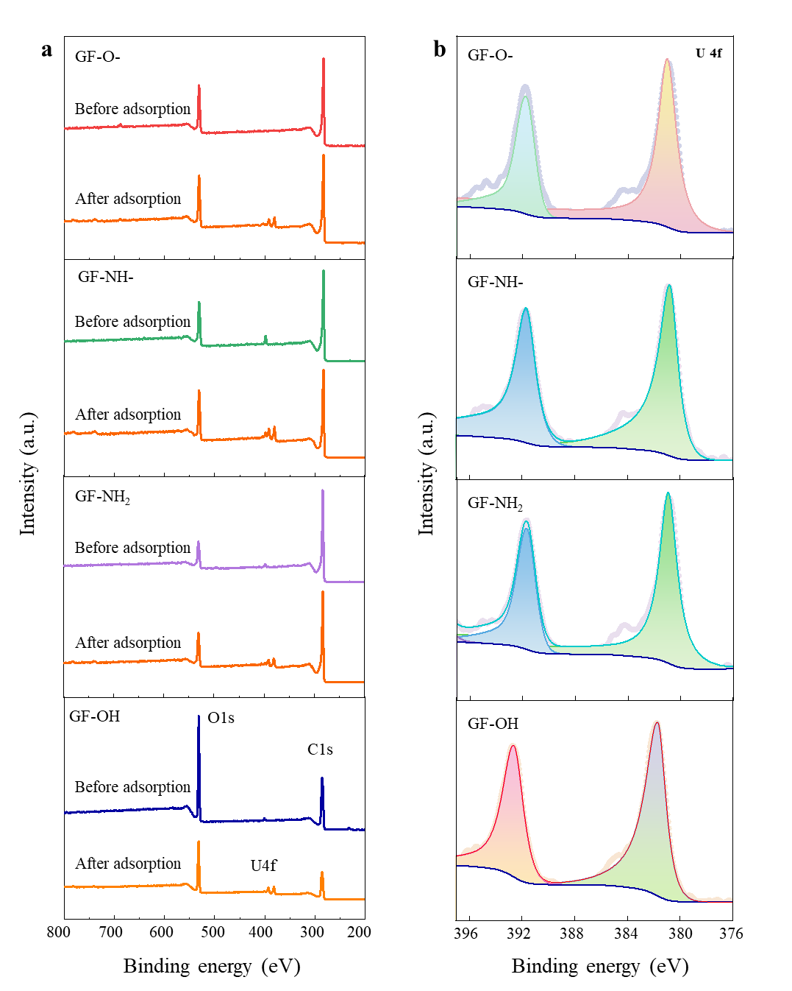
Fig. S5. Wide-scan XPS spectra (a) and high-resolution U 4f spectra (b) of GFs.

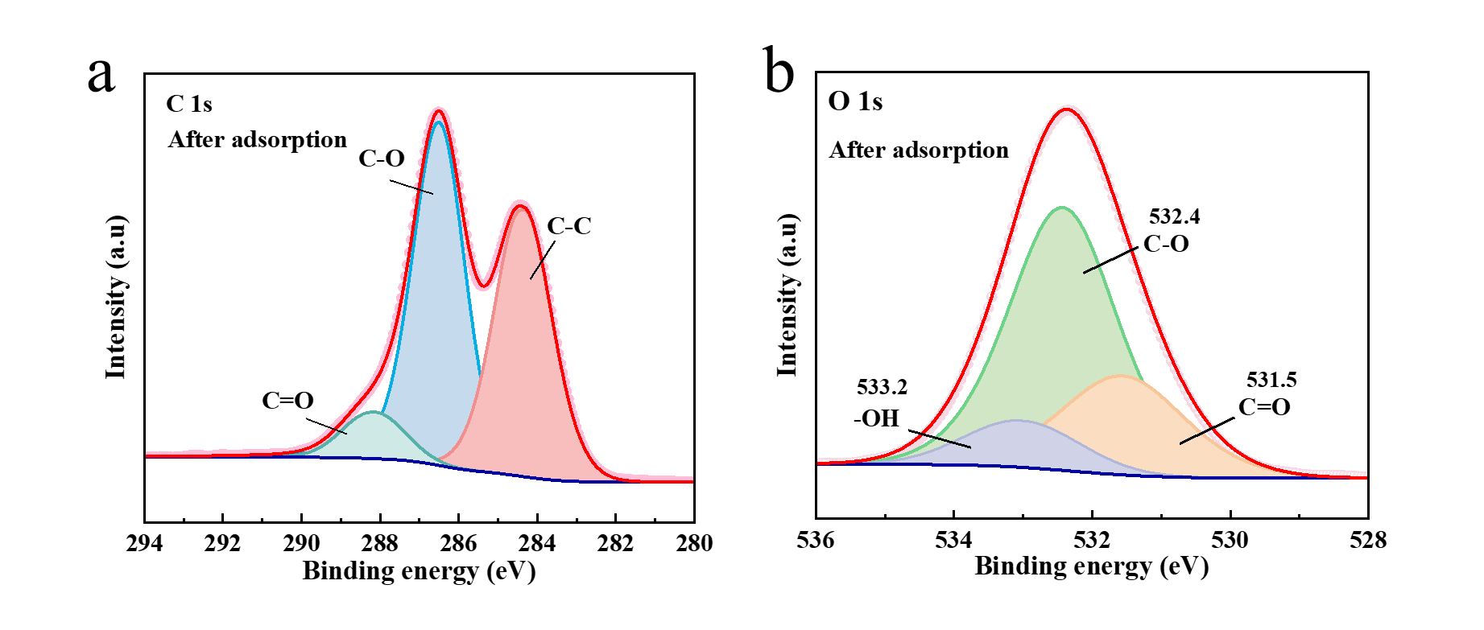
Fig. S6. XPS C1s (a) and XPS O 1s (b) of GF-OH after adsorption of U(VI).

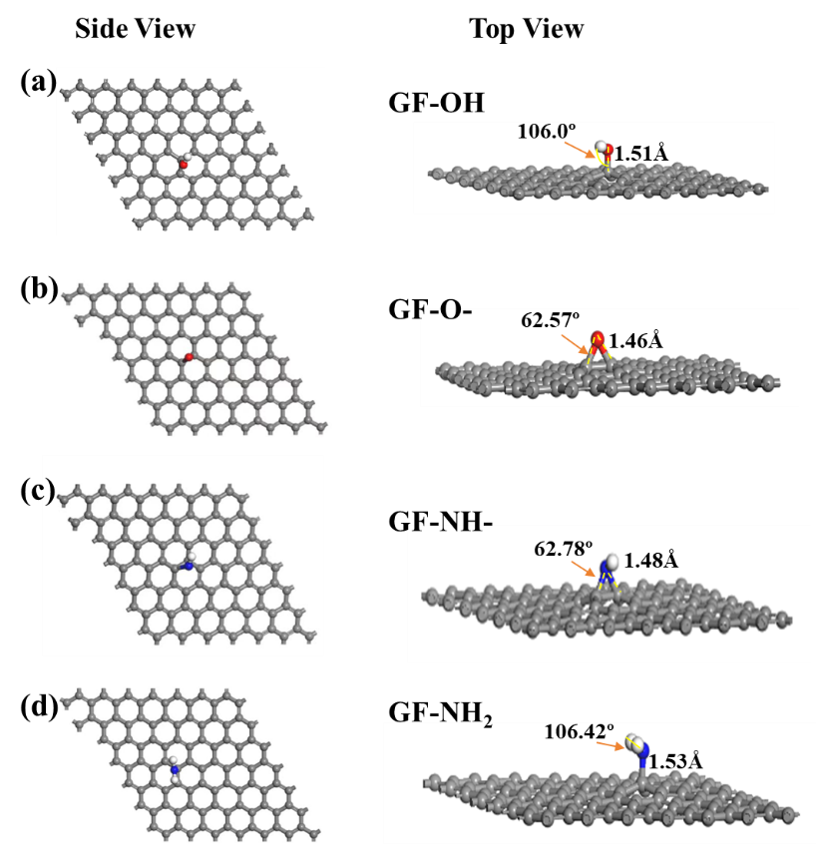
Fig. S7 Optimized structures of GF-OH (a), GF-O- (b), GF-NH- (c) and GF-NH₂ (d).

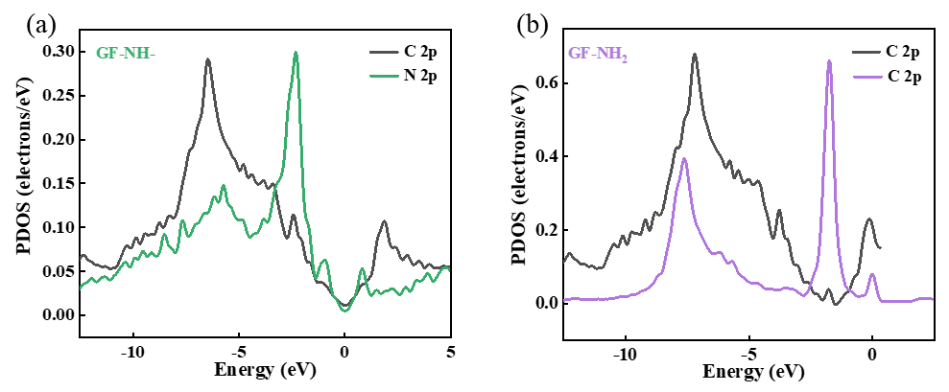
Fig. S8 The partial density of state (PDOS) for the labeled C atoms (2p orbital) and N atoms (2p orbital) in GF-NH- (a) and GF-NH₂ (b).

References
[1] Pang, H., S. Huang, Y. Wu, D. Yang, X. Wang, S. Yu, Z. Chen, A. Alsaedi, T. Hayat, and X. Wang, Efficient elimination of U(vi) by polyethyleneimine-decorated fly ash. Inorganic Chemistry Frontiers, 2018.5(10):2399-2407.
[2] Cui, X., X. Xie, Y. Li, Y. Chen, Y. Ma, and S. Yang, How to Evaluate the Chemical Affinity of -OH and -COOH Functional Groups Toward U(VI). Molecules, 2024.29(23):5614.
[3] Duan, S., Y. Wang, X. Liu, D. Shao, T. Hayat, A. Alsaedi, and J. Li, Removal of U(VI) from aqueous solution by amino functionalized flake graphite prepared by plasma treatment. ACS Sustainable Chemistry & Engineering, 2017.5(5):4073-4085.
[4] Grimme, S., Semiempirical GGA-type density functional constructed with a long‐range dispersion correction. Journal of Computational Chemistry, 2006.27(15):1787-1799.
[5] Chen, S., F. Zheng, J. Feng, H. Dong, and Y. Li, Theoretical study on single-side fluorinated graphene for lithium storage. Applied Surface Science, 2021.560:150033.
[6] Yao, L.-H., M.-S. Cao, H.-J. Yang, X.-J. Liu, X.-Y. Fang, and J. Yuan, Adsorption of Na on intrinsic, B-doped, N-doped and vacancy graphenes: A first-principles study. Computational Materials Science, 2014.85:179-185.
[7] Yang, S.B., C.L. Chen, Y. Chen, J.X. Li, D.Q. Wang, X.K. Wang, and W.P. Hu, Competitive Adsorption of Pb^{II}, Ni^{II}, and Sr^{II} Ions on Graphene Oxides: A Combined Experimental and Theoretical Study. ChemPlusChem, 2015.80(3):480-484.
[8] Sun, Y.B., S.B. Yang, Y. Chen, C.C. Ding, W.C. Cheng, and X.K. Wang, Adsorption and Desorption of U(VI) on Functionalized Graphene Oxides: A Combined Experimental and Theoretical Study. Environ. Sci. Technol. , 2015.49(7):4255-4262.
[9] Li, Z.J., F. Chen, L.Y. Yuan, Y.L. Liu, Y.L. Zhao, Z.F. Chai, and W.Q. Shi, Uranium(VI) adsorption on graphene oxide nanosheets from aqueous solutions. Chem. Eng. J., 2012.210(0):539-546.
[10] Zhao, G., T. Wen, X. Yang, S. Yang, J. Liao, J. Hu, D. Shao, and X. Wang, Preconcentration of U(VI) ions on few-layered graphene oxide nanosheets from aqueous solutions. Dalton Trans., 2012.41(20):6182-6188.
[11] Liu, X., J. Sun, X. Xu, A. Alsaedi, T. Hayat, and J. Li, Adsorption and desorption of U(VI) on different-size graphene oxide. Chemical Engineering Journal, 2019.360:941-950.
[12] Shao, D., G. Hou, J. Li, T. Wen, X. Ren, and X. Wang, PANI/GO as a super adsorbent for the selective adsorption of uranium(VI). Chemical Engineering Journal, 2014.255(0):604-612.
[13] Hu, R., D. Shao, and X. Wang, Graphene oxide/polypyrrole composites for highly selective enrichment of U(vi) from aqueous solutions, in Polymer Chemistry. 2014, The Royal Society of Chemistry. p. 6207-6215.
[14] Liao, S.K., Y. Li, J.B. Cheng, J. Yu, W.J. Ren, and S.B. Yang, Active and selective removal of U(VI) from contaminated water by plasma-initiated polymerization of aniline/GO. Journal of Molecular Liquids, 2021.344:117687.

