Supporting information for
Stable Isotope Evidence for Biochar Nanoparticles as Potential Nanocarriers Boosting Nitrogen Delivery in Soybean
Zexuan Geng ª, Heng Zhang ª, Meiyan Wang ª, Jiadong Cheng ª, Xiaoyi Xu ª, and Fei Lian ^{a*}
ª Institute of Pollution Control and Environmental Health, and School of Energy and Environmental Engineering, Hebei University of Technology, Tianjin 300401, China.

*Corresponding author: lianfei2000@126.com

Total:
Text S1 to S14
Fig. S1 to S10
Table S1 to S7

Text S1: Preparation of ¹⁵N-labeled NBC.
Dried corn stover powder (0.15 mm) was combined and thoroughly stirred in deionized (DI) water with ¹⁵N-labeled urea (99% abundance) at a mass ratio of 2:1 for 24 h. The resulting mixture was oven-dried at 60 °C and carbonized at 400 °C and 700 °C, respectively, in a muffle furnace at a N₂ atmosphere for 2 h. The resultant powders were ground using a planetary ball mill (TJX-450, China) and then passed through a 100-mesh sieve. ¹⁵N-labeled NBC was fractionated from the bulk BC powders. Briefly, an aliquot of the samples was mixed with DI water and sonicated at 120 W for 30 min to achieve extensive release of dissolved BC. The resulting suspension was filtered through a pre-fired glass fiber membrane (0.7 μm). The samples retained on the membrane were re-sonicated and subjected to another round of filtration. This procedure was repeated three times to ensure that most of the desired components could pass through the membrane. The filtrate was freeze-dried and stored in the dark at 4 °C before use.
Text S2: NBC Measurement.
TEM measure: A solution of NBC (0.1 mg/mL) was applied in 20 µL onto a carbon-supported copper mesh (T10023, Tianld) and subsequently dried under infrared light. Transmission electron microscopy (TEM) images were captured using a Talos F200X electron microscope model (Thermo Fisher, Wilmington, USA) with an accelerating voltage of 200 kV.
XPS test: A quantity of 20 mg of NBC powder was evenly deposited onto aluminum foil. The powder was compressed using a hydraulic press, subsequently sectioned, and exposed for XPS testing. XPS spectra were captured employing a Thermo Scientific K-Alpha X-ray photoelectron spectrometer (Thermo Fisher, USA) equipped with a Mono AlKa source, utilizing an excitation voltage of 1486.6 eV. Binding energy calibration relied on C1s at 284.8 eV.
AFM test: Samples of NBC were dispersed in an ethanol solution for sonication. Subsequently, a few drops of the well-dispersed liquid were added, drop by drop, onto a mica sheet, dried, and then subjected to Atomic Force Microscope (AFM) imaging using a Bruker Dimension Icon instrument (Bruker, Billerica, USA).
Text S3. Analysis of Soil Physicochemical Properties.
The physicochemical properties of the soil, including pH, total nitrogen (TON), soil organic matter (SOM), and anion exchange capacity (CEC), were assessed before soybean planting. Urease and nitrate reductase activities in the soil were determined using kits from Beijing Solarbio Science & Technology Co., Ltd. All reagents, samples, and standards were prepared following the manufacturer's protocol, with calculations performed according to the provided instructions.
Alkaline dissolved nitrogen was determined using the alkaline diffusion method. Briefly, Briefly, 5-g samples of soil were distilled with 2 mol L⁻ ¹ NaOH for 5 h and then with 10 mol L⁻ ¹ NaOH for 7 min. Boric acid (40 g L⁻ ¹) was used to absorb the liberated NH₃ using the method of direct steam distillation. Soil alkali-hydrolyzable nitrogen content was quantified by conductometric titration.^{[1]} Soil bulk density and porosity were measured by the cutting ring method (100 cm³ core volume). Three replicate cores were taken from each treatment group, oven‑dried at 105 °C to constant weight, and bulk density was calculated as the ratio of dry soil mass to core volume. Total porosity was calculated as: Porosity (%) = (1 – Bulk density / Particle density) × 100, assuming a particle density of 2.65 g/cm³.^{[2]}
Text S4: Detailed procedure for Chlorophyll Fluorescence Parameters.
Detailed procedure for basic modulation of the chlorophyll fluorometer, baseline calibration and zero calibration according to the user manual of the device. Select healthy plant leaves, remove surface moisture, and allow the sample to acclimatize under dark conditions for 30 minutes. Place the plant sample in the sample slot of the chlorophyll fluorometer and ensure that the sample surface is facing the light source. Start the excitation light source and irradiate the sample. WinControl-3 software was used to obtain the electron transfer rate (ETR), actual photosynthetic efficiency (ΔF/Fm') of PSII, non-photochemical quenching coefficients (NPQ), and photochemical quenching coefficients (qP) parameters.
Text S5: Total Nitrogen Content Test Parameters and Calculation Formulas.
The laboratory standards utilized were organic standards from Elemental: CYS (N=11.66%), BBOT (N=6.51%), and MET (N=9.39%). The determination of elemental nitrogen content was conducted with the left furnace maintained at 950 ℃ (with a gradual increase in temperature: 400 ℃, 600 ℃, 800 ℃, and 950 ℃), the column box set at 65 ℃, the carrier gas adjusted to 140 mL/min, and the reference gas conFig.d to 100 mL/min for the inlet. The injection delay was set at 12 seconds, while oxygen flow was maintained at 250 mL/min, injected for 5 seconds.
The elemental percentage was calculated using the following formula:
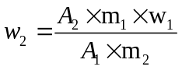 (1)

where: A₁-peak area of the standard sample;
A₂-peak area of the unknown sample;
m₁-mass of the weighed standard sample (mg);
m₂-mass of the unknown sample (mg);
w₁-known percent content of elements in the standard sample (%);
w₂-the content of elements in the unknown sample corresponding to the standard sample (%);

Text S6: Determination of δ¹⁵N in Amino Acids from Soybean Fruits.
Extraction and purification of amino acids: The sample was weighed and placed in a polytetrafluoroethylene muffled jar. Subsequently, 6 mol/L hydrochloric acid was added, and thoroughly mixed, and the jar was purged with N2 for 30 seconds to eliminate air. Following the airtight seal, hydrolysis occurred for 24 hours at 110°C in a constant-temperature drying oven. The resulting hydrolysate was then desiccated on a heating plate at 100 ℃. Dissolution was carried out using 0.1 mol/L hydrochloric acid, followed by centrifugation at 8000 r/min for 10 minutes. Amino acid purification was achieved through a strong cation exchange column (CNWBOND SCX SPE Cartridge, Anple, Shanghai), with elution performed using 4 mol/L ammonia.
Derivatization of amino acids: Purified amino acids underwent a derivatization process by adding them to 2 mL of 1 mol/L sulfoxide chloride dissolved in isopropanol. Esterification took place at 100 ℃ for 1 h, followed by drying the product at 60 ℃ under a gentle nitrogen flow. The resultant product was dissolved in 200 μL of pyridine, and then 200 μL of pivaloyl chloride was added to the reaction after heating at 60 ℃ for 60 min. This step produced N-pivaloyl, O-isopropyl ester, which was further dissolved in 2 mL of dichloromethane. The solution underwent extraction three times with 3 mL of ultrapure water. The organic phase was isolated, shaken with anhydrous sodium sulfate, and left to dehydrate for 1 h. Following centrifugation, the organic phase was dried under a gentle nitrogen flow. The solvent was replaced with hexane, and the mixture was gradually passed through a silica column (silica gel 200-400 mesh, inner diameter 4 mm). The silica column underwent activation three times using hexane, and ethyl acetate was used for elution to eliminate excessive acylating agents and other impurities that could adversely affect the GC performance. The eluate, obtained by blow-drying with a gentle stream of nitrogen at room temperature, was dissolved in hexane and subsequently used for determining amino acid monomer concentrations and nitrogen isotope analysis.
Text S7: Chromatography and Mass Spectrometry Conditions.
The specific setup of GC-MS: The DB-5MS capillary column (60 m × 0.25 mm ID, 0.25 μm film thickness) was used with an inlet temperature of 250 ℃. A split-flow injection was performed with a ratio of 1:10, and the injection volume was 1 μL. Helium was used as the carrier gas with a flow rate of 1 mL/min, and the purge flow rate was set at 3 mL/min. The heating program began at an initial temperature of 60 ℃, held for 5 min, then ramped at 3 ℃/min to 220 ℃, followed by a 10 ℃/min increase to 300 ℃, with a final hold at 300 ℃ for 20 min. The electron ionization (EI) source was maintained at 250 ℃, with the interface temperature set to 280 ℃. The solvent delay time was 12 min, and the mass scan range was from m/z 50 to 450 in scan mode.
The specific setup of GC-C-IRMS： ADB-5MS capillary column (60 m × 0.32 mm ID, 0.25 μm film thickness) was employed for gas chromatography. The inlet temperature was maintained at 280 ℃, with a non-split injection of 1 μL volume. Helium gas served as the carrier gas at a flow rate of 1.5 mL/min. The heating-up procedure was initiated at 60 ℃, followed by a ramping protocol of 15 ℃/min to reach 130 ℃, then 3 ℃/min to 220 ℃. Finally, a rate of 10 ℃/min was applied to reach 300 ℃, maintained for 25 minutes.
Text S8: Quantitative Real-Time PCR analysis.
Real-time PCR was conducted with a 2xM5 HiPer SYBR Premix Es Taq kit (PolyMax, MF787-01) on a fluorescent quantitative PCR instrument (Roche, LightCycler480). Fresh roots were ground into fine powders using liquid nitrogen. Total RNA extraction was performed utilizing Trizol Reagent (Life Technologies, 15596018). The purity and concentration of RNA were assessed using a small molecule protein nucleic acid assay (Thermo Fisher, Nanodrop-2000). Subsequently, 1 μg of RNA was transcribed into cDNA through reverse transcription polymerase chain reaction using the GeniuScriptTM RT SuperMix with gDNA Eraser 2.0 kit (Boyue, M5RT04).
Text S9: Soil Microorganism Determination.
High-throughput sequencing of the bacterial 16S rRNA gene V3-V4 region was performed to characterize the soil microbial community composition. After quality filtering, high-quality sequences with an average read length of ~422 bp were retained, and amplicon sequence variants (ASVs) were generated using DADA2 for downstream analysis. Soil samples from the inter-root region were collected and subjected to a 12-hour drying process at 60°C. DNA quantification was conducted using Nanodrop, and the quality of DNA extraction was assessed through 1.2% agarose gel electrophoresis. The upstream primer sequence used for sequencing was ACTCCTACGGGGAGGCAGCA, and the downstream primer sequence was GGACTACHVGGGTWTCTAAT. Following the sequencing of the V3-V4 region, raw reads (raw PE) were acquired, and filtering was applied to eliminate low-quality fragments and recover valid tags. Target fragments underwent PCR amplification using Pfu high-fidelity DNA polymerase from All Style Gold. Subsequently, magnetic bead purification was employed to recover the amplification products. For every 25 μl of PCR products, 0.8 times the volume of magnetic beads (Vazyme VAHTSTM DNA Clean Beads) was added. The supernatant was adsorbed on a magnetic rack for 5 minutes after sufficient suspension through shaking, and then it was aspirated using a pipette gun. The process included adding 20 μl of 0.8x magnetic bead wash solution, repeating the steps, and introducing 200 μl of 80% ethanol. The beads, placed on the magnetic rack in the reverse direction, adhered to the opposite side of the PCR tube, and the supernatant was pipetted out after complete adsorption. The mixture was left at room temperature for 5 minutes to allow the alcohol to evaporate completely Elution was performed by adding 25 μl Elution Buffer. After placing the PCR tube on the adsorption rack for 5 minutes to fully absorb, the supernatant was pipetted into a clean 1.5 ml centrifuge tube for storage. The recovered products underwent fluorescence quantification using the Quant-iT PicoGreen dsDNA Assay Kit, with a Microplate reader (BioTek, FLx800) serving as the quantification instrument. Based on the fluorescence quantification results, each sample was mixed in the appropriate proportion according to the sequencing volume requirement. Sequencing libraries were prepared using Illumina's TruSeq Nano DNA LT Library Prep Kit, and high-throughput sequencing was executed on the machine.
Text S10: The Specific Setup of EA-IRMS.
In the oxidation tube, a sequence from top to bottom comprises: a quartz crucible, chromium oxide, copper oxide, and silver cobalt oxide, with interposed quartz cotton layers between each pair of substances and at the tube's base. Conversely, the reduction tube is filled from top to bottom with quartz chips, high-purity copper reduction, and quartz cotton at intervals, including the tube's bottom. The water removal tube is charged with magnesium perchlorate. Operational parameters: oxidation tube temperature: 1050 ℃; reduction tube temperature: 640 ℃; GC column temperature: 55 ℃; helium pressure: 30 psi; helium flow rate: 18 ml/min; oxygen pressure: 31 psi. Before sample analysis, three blanks were established, and every 12 samples were interspersed with two standards.
The international standard N_{2-atm} served as the reference standard for the δ¹⁵N_{TN} value, calculated using the formula:
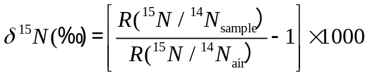 （2）
where R (¹⁵N/¹⁴N_{air}) represents the nitrogen isotope abundance ratio in air. δ¹⁵N_{TN} values were analyzed with an accuracy of ±0.2‰.
The determination and calculation of stable isotopes were conducted using ¹⁵N and expressed through Eq (3). where R_{sample} is the ratio of ¹⁵N/¹⁴N in the sample, R_{standard} is the ratio of ¹⁵N/¹⁴N in the standard. The ¹⁵N/¹⁴N in the elemental nitrogen standard (air nitrogen bank) is 0.368 percent. The δ value can be converted into the ¹⁵N/¹⁴N ratio (r) using Eq (4). Subsequently, the r value is converted into the mass fraction of ¹⁵N (W_{15N} ​) based on Eq (5), representing the ratio of the total atomic weight of ¹⁵N to the total atomic weight of nitrogen. The mass of ¹⁵N in the experiment is determined using Eq (6), where W_{N%}, obtained from an IRMS, represents the mass fraction of nitrogen in the dried plant sample; m_{dry} denotes the dry weight after the experiment, while m_{15N(NBC)} represents the weight of ¹⁵N in NBC. The m_{NBC} refers to the total mass of NBC in the exposed plant tissue sample, as described in Eq (7). The proportion of NBC absorbed by different soybean organs, expressed as a percentage of the dry weight after the experiment, is given by W%.
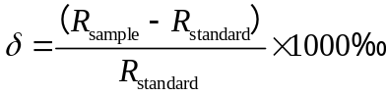 (3)
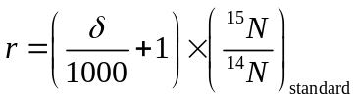 (4)
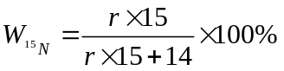 (5)
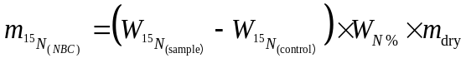 (6)
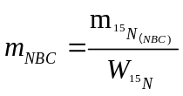 (7)
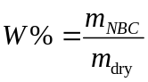 (8)
Text S11: NanoSIMS Analysis.
Fresh soybean nodules (less than 0.5 mm in diameter) were fixed overnight at 4°C with a solution of 2% paraformaldehyde and 2% glutaraldehyde. The samples were sectioned with a LEICA EM UC7 ultrathin microtome to obtain 100 nm sections, and then the sections were examined by scanning electron microscope (SEM). Before NanoSIMS measurements, root tumor sections were sputter-coated with 7 nm Platinum (Pt) using a BRIGHT sputter coater to ensure electrical conductivity. For NanoSIMS measurements, the region of interest was pre-sputtered with a positively charged cesium (Cs⁺) primary ion beam for 3 minutes, during which reactive Cs⁺ ions were injected into the sample to increase the yield of secondary ions. The sample surface was rasterized with a Cs⁺ primary ion beam at a current of 1 pA. The primary ions were focused into a nominal spot diameter of ≤100 nm. The analysis area was 40 µm × 40 µm, performed with a physical resolution of approximately 70 nm (i.e., probe size) and an image resolution of 256 × 256 pixels for sequential scanning of the finely focused Cs+ primary ion beam (1 pA beam current). Images were acquired as multilayer stacks with a dwell time of 10 ms per pixel per cycle.
Text S12: NBC Stability Assessment in the Soil.
To evaluate the structural stability of NBC in the soil, both N release assays in root exudates and NBC mineralization experiments were conducted. (i) N release assays: 20 mg of NBC was dispersed in 500 mL of aqueous solution containing soybean root exudates (10 mg TOC/L) through sonication and subjected to stirring at 150 rpm using a magnetic stirrer at 25 ºC for 7 d. After that, the supernatant was collected through centrifugal ultrafiltration (1500 rpm, 20 min) using a Millipore ultrafiltration tube (MWCO = 3000 Da), followed by N content analysis using a continuous flow analyzer (SEAL Analytical, Germany). The pH of the aqueous solution was 5.3. The root exudates were collected and quantified according to our previous study ^{[3]}. (ii) N mineralization monitoring: NBC was thoroughly mixed with 500 g of soil in a 1-L borosilicate glass vessel to achieve final concentrations of 25 mg/kg, with a blank control (no NBC added) included. Three replicates were prepared per treatment for N mineralization monitoring, followed by incubation at 25 °C in the dark for 60 d. During incubation, soil moisture was maintained at 70% WHC; no additional nutrients were added. On incubation days 0, 10, 20, 30, 40, 50, and 60, 30-mL gas samples were collected from the headspace (i.e., the gaseous space above the soil surface inside each vessel) of each incubation vessel using a gas-tight locking syringe. After each sampling, the vessel was left open for ~20 min to allow air exchange before being resealed for the next measurement ^{[4]}. The collected gas samples were transferred into pre-evacuated gas-tight vials (e.g., Labco Exetainer®). δ¹⁵N analysis of headspace gas was performed using the EA-IRMS as mentioned above.
Text S13: Reactive Oxygen Species Determination in Soybean Leaves.
Leaf tissue preserved in liquid nitrogen was ground and then mixed with a 50 mM phosphate buffer solution (pH 8.6) including 10 mM Tiron and half a percent of Tween-20 by volume, at a temperature of 4 ºC. The resulting mixture was quickly passed through a 0.22 μm syringe membrane filter (polyethersulfone, Milipore), and the eluate mixed thoroughly with 5,5-dimethyl-1-pyrrolidine-N-oxide (DMPO, Macklin, 98%) as spin-trapping agent, and 20 μL of this liquid was added to a microcapillary tube (50 μL, Hirschmann, GER) for the measurement. The following parameters were employed: microwave frequency of 9.7675 GHz, modulation frequency of 100 kHz, microwave power of 20 mW, modulation amplitude of 1 G, receiver gain of 5.0×10³, sweep width of 100 G, and center field of 3350 G ^{[5]}.
Text S14: Analysis of NBC Degradation Products in Soybean Leaves.
Fresh soybean leaves (0.5 g) were directly frozen in liquid nitrogen and ground into a fine powder. Subsequently, 5 mL of 80% methanol aqueous solution (containing 0.1% formic acid, for intracellular protein precipitation and polar metabolite stabilization) pre-cooled to 4 °C was added to the powder. After vortexing for 30 s, the mixture was sealed and incubated at 4 °C for 10 min to facilitate intracellular fluid elution. The mixture was then centrifuged at 12,000 rpm for 15 min in a 4 °C refrigerated centrifuge; the supernatant was collected and vacuum-filtered through a 0.22 μm PVDF membrane to obtain pure intracellular fluid, which was stored at 4 °C ^{[6]}. (2) Soybean + NBC: Pure intracellular fluid was obtained following the same freezing, grinding, and extraction procedures as the blank control. A 2 mL aliquot of the pure intracellular fluid was transferred to a 5 mL reaction tube, and 1 mg·mL⁻¹ NBC stock solution was added; the mixture was vortexed for 10 s to homogenize. The reaction tube was placed in a 37 °C light-protected incubator for a 24-h reaction, with gentle inversion every 6 h to ensure sufficient contact between the intracellular fluid and NBC. (3) NBC + •OH (positive control): 1 mg·mL⁻¹ NBC was mixed with 100 μM ferrous sulfate (FeSO₄) and 1 mM hydrogen peroxide (H₂O₂) in 50 mM phosphate-buffered saline (PBS, pH 7.4) to generate •OH via the Fenton reaction. The reaction mixture was incubated at room temperature for 24 h before extraction, with gentle inversion every 6 h. All treatment groups were analyzed using a liquid chromatography-mass spectrometry (LC-MS) system equipped with an electrospray ionization (ESI) source, while the mass spectrometer (ESI-Q-TOF-MS, Compact, Bruker) was operated in negative ion mode with a scanning range of mass-to-charge ratio (m/z) of 50–1500 ^{[7,8]}.

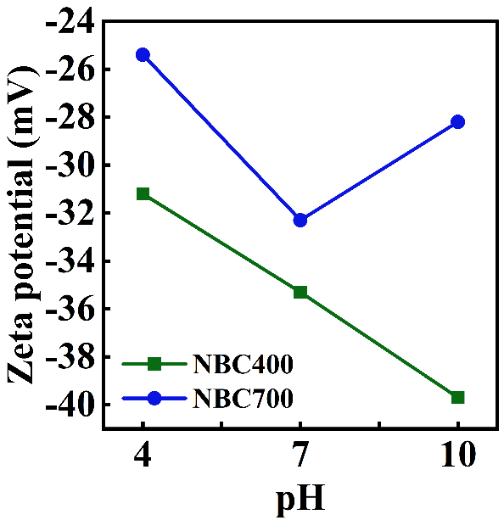
Fig. S1. Zeta potentials of NBC400 and NBC700 at different pHs.

Fig. S2. Hydrodynamic diameters (D_{h}) of NBC400 at different pHs.

Fig. S3. Hydrodynamic diameters (D_{h}) of NBC700 at different pHs.

Fig. S4. Photograph of soybean roots cultivated in pots with 80 days treated by different concentrations of NBC400 and NBC700, respectively.

Fig. S5. Dynamics of δ¹⁵N abundance in gases collected from NBC-amended and control soils over a 60-day monitoring period.

Fig. S6. The effect of NBC on the activities of soil nitrate reductase (S-NR) and urease (S-UE) in the rhizosphere of soybean.
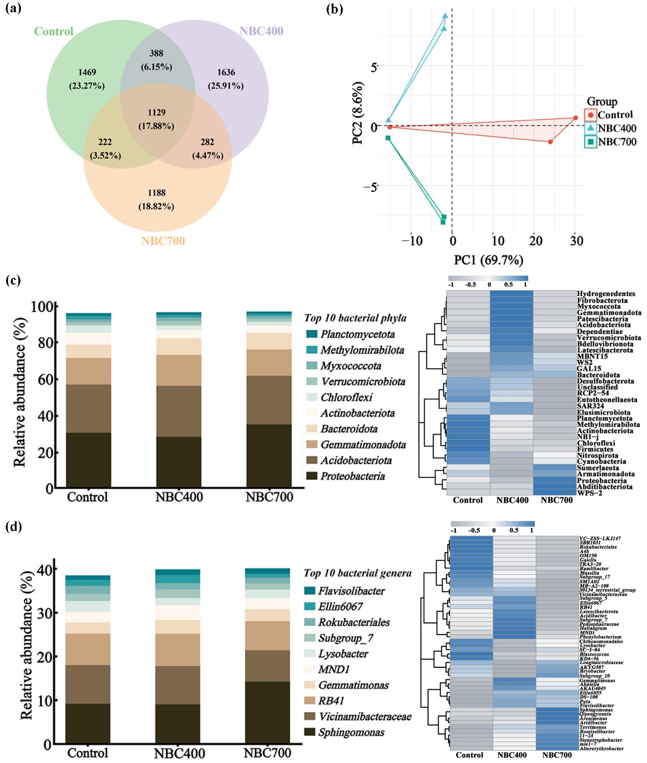
Fig. S7. Impacts of NBC on the microbial community composition and structure in soils. (a) Venn diagrams of all raw data of bacteria in soil; (b) principal component analysis diagrams of bacteria; (c) relative abundance of the top 10 bacterial phyla and heat map of 50 species of bacteria; (d) relative abundance of the top 10 bacterial genera and heat map of 50 species of bacteria in the rhizosphere. The dosage of NBC400 and NBC700 was 5 mg/kg, respectively.

Fig. S8. Analysis of microbial diversity indexes of bacterial in the rhizosphere in the presence of NBC400 and NBC700.

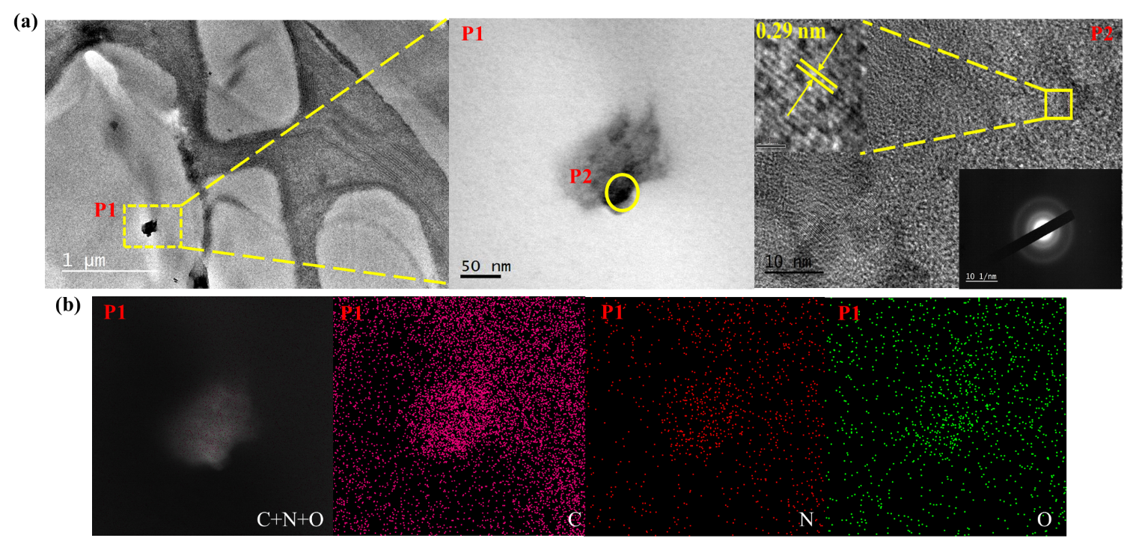
Fig. S9. TEM characterization of ultrathin sections of soybean leaves treated with NBC400. (a) TEM analysis showing region P1 and P2; Magnified TEM image of P2; HRTEM image of P2 revealing lattice fringes (0.29 nm spacing) with the corresponding SAED pattern inset. (b) Elemental distribution analysis of region P1: Overlay and individual elemental maps of C, N, and O.

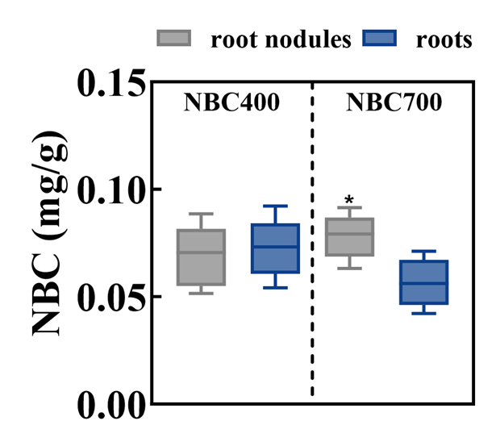
Fig. S10. Accumulation of NBC in soybean root nodules and roots quantified by ¹⁵N isotopic analysis; * represents a significant difference compared with the roots of NBC700 at P < 0.05. The application rates of NBC400 and N700 were 5.0 mg/kg.

Table S1. Physical and chemical properties of soil in different treatment groups.
Indicators | Before | NBC400 | NBC700
Porosity (%) | 42.3 | 48.6 | 46.9
Bulk Density (g cm⁻³) | 1.52 | 1.36 | 1.39
Alkaline Dissolved Nitrogen (kg ha⁻¹) | 165 | 175 | 171
pH | 7.46 | 7.53 | 7.56
Total N (%) | 1.31 | 1.42 | 1.44
SOM (%) | 9.44 | 10.16 | 9.72
CEC (cmol/kg) | 22.95 | 21.76 | 23.24

Table S2. List of primers used in this study.
Gene-specific primers used for qRT-PCR
 | Forward Primer | Reverse Primer
Actin | CACACTTGCCACGTTTCACCTC | GTATTCCGGTGGTGGGAGAAAG
NR2 | TTGCAGGCATGTAAGCCAGA | AACCCCGCCATGTCAAACTT
NiR | TAACAATCGGAAAACGAGGGA | GCTTTTCTTAGTAGGATTTGGTCTC
GS1β | CGTTGTGGAGGGAAGGGAATG | ACACTCTCATCTTCTCTCTCTCTCTCTC
GOGAT | CCGTTCCCGAAACTTCCACCCC | TCCATTGGGCTTGGCCTTTCCA
GmGS1α1 | TGAGGTTGATGAGATCCGAAA | TAACACCAAACAGAGTCATTCACC
GmGS1α2 | GGAGACCTTTTTCTTCCTCACAG | GACTAATTTCCGGGGTTTCG
GmGS1β1 | TAACAATCGGAAAACGAGGGA | GCTTTTCTTAGTAGGATTTGGTCTC
GmGS1β2 | CGAGGGAAAGGAATAGAAAACA | GTGGAAGCCATGAGCAAAACT
GmGS1γ2 | AACAACAGGCGAGGTAGTCACA | GCAACGTCAAAACAATCACATG

Table S3. δ¹⁵N values (‰) of ¹⁵N-labeled nano-BC (NBC400, NBC700) and their corresponding unlabeled counterparts.

Sample Name | δ¹⁵N‰
NBC400 | 150811
NBC700 | 162136
Nano-BC | 137.4
Nano-BC | 143.3

Table S4. Percentage of C, N, and O in NBC determined by XPS.
Element | NBC400 | NBC700
C | 61.17% | 65.07%
N | 33.31% | 31.57%
O | 5.52% | 3.36%

Table S5. Percentage of functional groups determined by XPS.
Element |  | NBC400 | NBC700
C1s | C=C/C-C | 55.48% | 57.34%
C1s | C-OH | 29.19% | 36.62%
C1s | C=O | 15.33% | 6.04%
N1s | pyridinic N | 26.84% | 40.57%
N1s | pyrrolic N | 38.70% | 41.51%
N1s | graphitic N | 34.46% | 17.92%
O1s | C=O | 89.19% | 73.87%
O1s | C-O | 10.81% | 26.13%

Table S6. Total nitrogen content in the fruits, leaves, roots, and nodules of soybean treated by 5.0 mg/kg of NBC in the pot experiment.
Groups | N content (g/kg)
 | Control | NBC400 | NBC700
fruits | 42.5±1.43^{b} | 50.1±2.13ª | 41.1±1.35^{c}
leaves | 19.4±2.03ª | 19.5±1.36ª | 15.8±1.13^{b}
roots | 21.9±1.44^{b} | 22.7±1.14ª | 19.8±1.48^{c}
nodules | 32.7±1.12ª | 27.8±1.27^{c} | 29.3±1.17^{b}

Table S7. Selected amino acid contents in the fruits of soybean treated by NBC.
Amino acids | Amino acid content (mg/g)
Amino acids | Control | NBC400 | NBC700
Ala | 7.0±0.8^{b} | 9.9±1.3ª | 7.1±0.5^{b}
Gly | 4.6±1.1^{c} | 7.1±0.5ª | 5.4±1.5^{b}
Val | 23.5±0.7^{b} | 28.0±1.2ª | 27.9±0.9ª
Leu | 42.1±0.6^{c} | 50.7±0.8ª | 42.9±1.3^{b}
Ile | 18.6±1.4^{b} | 22.0±0.7ª | 16.0±1.1^{c}
Pro | 27.1±0.6^{c} | 31.8±0.6ª | 28.4±1.2^{b}
Asp | 7.9±0.4^{b} | 12.1±0.7ª | 7.2±0.3^{c}
Thr | 2.5±0.6^{b} | 3.7±0.4ª | 2.2±0.3^{c}
Ser | 4.1±0.7^{b} | 5.9±1.4ª | 3.4±0.6^{c}
Met | 15.6±0.6ª | 12.8±0.3^{b} | 12.7±0.4^{b}
Glu | 14.0±0.7^{c} | 21.7±1.5ª | 14.5±0.6^{b}
Phe | 47.7±1.6^{c} | 59.2±1.4ª | 50.5±0.9^{b}
Lys | 53.5±1.3^{c} | 103.5±1.5ª | 77.2±1.7^{b}
Tyr | 10.5±0.6^{c} | 14.9±0.8ª | 11.0±0.6^{b}

References:
[1] Chen BL, Yang HK, Song WC, Liu CY, Xu J, et al. 2016. Effect of N fertilization rate on soil alkali-hydrolyzable N, subtending leaf N concentration, fiber yield, and quality of cotton. CROP JOURNAL 4: 323-330 doi: 10.1016/j.cj.2016.03.006
[2] Zhang Y, Cao FC, Huang LC, Zhou YW, Yang Z. 2020. Comparative Study and Simulation of Soil Infiltration Performance in Open Green Space. TEHNICKI VJESNIK-TECHNICAL GAZETTE 27: 812-818 doi: 10.17559/TV-20191230171234
[3] Gu S, Lian F, Han Y, Taherymoosavi S, Mitchell D, et al. 2022. Nano-biochar modulates the formation of iron plaque through facilitating iron-involved redox reactions on aquatic plant root surfaces. Environmental Science: Nano 9: 1974-1985 doi: 10.1039/d2en00032f
[4] Sheng Y, Zhan Y, Zhu L. 2016. Reduced carbon sequestration potential of biochar in acidic soil. Science of the Total Environment 572: 129-137 doi: https://doi.org/10.1016/j.scitotenv.2016.07.140
[5] Huang C, Xia T, Niu J, Yang Y, Lin S, et al. 2018. Transformation of ¹⁴C-labeled graphene to ¹⁴CO₂ in the shoots of a rice Plant. Angewandte Chemie-International Edition 57: 9759-9763 doi: 10.1002/anie.201805099
[6] Tarek K, Farid A, Safwat G. 2025. Extraction of grape seeds by different solvents affects the activities of the resultant extract. AMB Express 15: 51 doi: 10.1186/s13568-025-01851-3
[7] Ouandaogo HS, Diallo S, Odari E, Kinyua J. 2023. Phytochemical Screening and GC-MS Analysis of Methanolic and Aqueous Extracts of Ocimum kilimandscharicum Leaves. ACS Omega 8: 47560-47572 doi: 10.1021/acsomega.3c05554
[8] Liu Z, Xu X-Y, Xu F, Su R-D, Li B, et al. 2025. Diatomic "catalytic/co-catalytic" Fe/Mo catalysts promote Fenton-like reaction to treat organic wastewater through special interfacial reaction enhancement mechanism. Water Research 274: 123147 doi: https://doi.org/10.1016/j.watres.2025.123147

