Supplementary File 1: Supporting materials to this study.

1.CH₄ formation reactions
Through the analysis of MD trajectories of D4 pyrolysis simulation at 2000 K, we identified eleven reactions (R1)~(R11) involved in CH₄ generation during D4 pyrolysis process. Of these, ten reactions result in CH₄ production via CH₃ hydrogen abstraction, comprising about 91% of the total. The frequency of CH₄ production events is 19, with 18 instances attributed to CH₃ hydrogen abstraction, making up approximately 94.7%. Consequently, hydrogen abstraction by ·CH₃ is the predominant pathway for CH₄ formation.
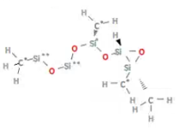
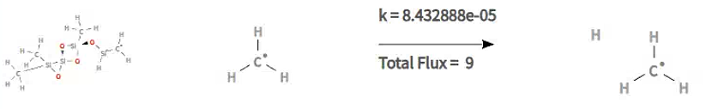
CH₄
CH₃
(R1)
+
+
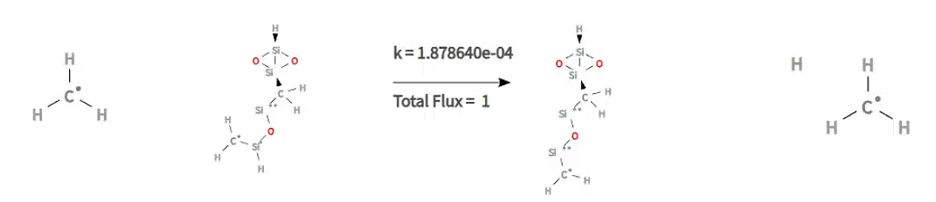
(R2)
+
+
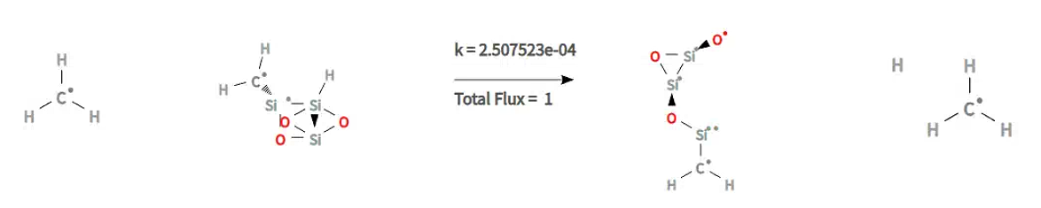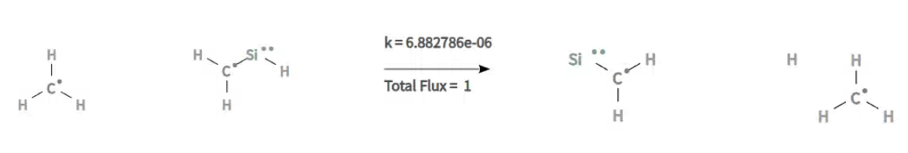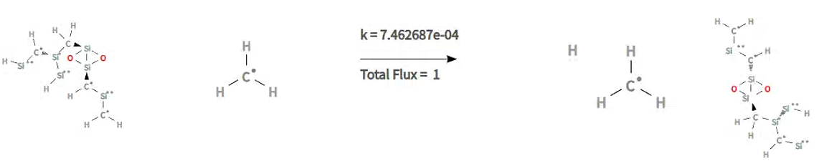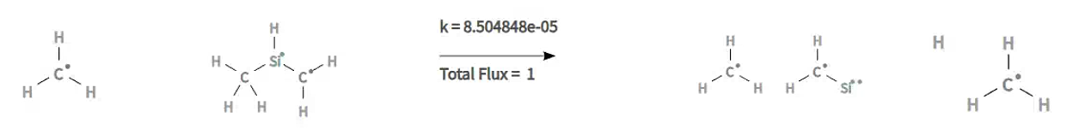
(R6)
(R5)
(R4)
(R3)
+
+
+
+
+
+
+
+

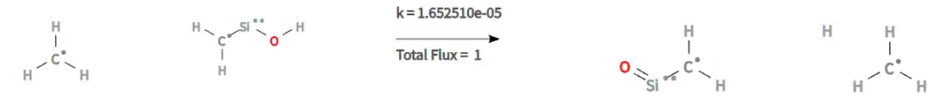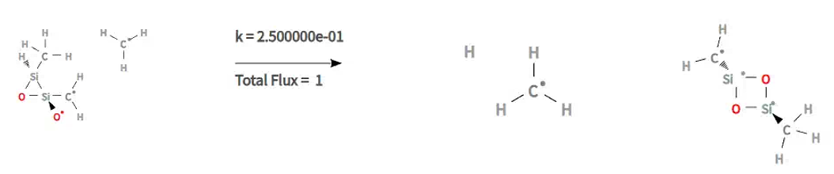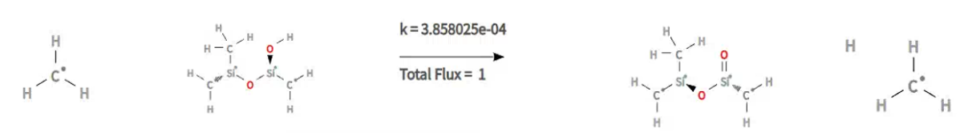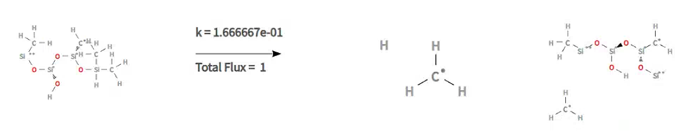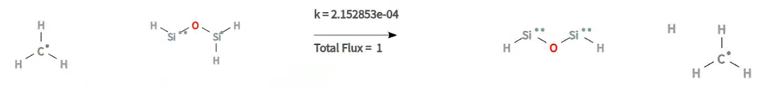
(R7)
+
+
(R11)
(R10)
(R9)
(R8)
+
+
+
+
+
+

- ReaxFF MD simulations at 1300 K and 1400 K
Figure S1 shows the variation of molecule number of D4 verse simulation time at the temperatures of 1300 K and 1400 K. At these two temperatures, the thermal decomposition rate of D4 becomes very slow. Though the simulation time has been extended to 1 ns, almost no thermal decomposition occurs for the case of 1300 K, and only a small number of D4 molecules decompose after 450 ps for the case of 1400 K. These two simulation cases indicate that the computational cost is expansive using ReaxFF MD simulation to capture the D4 thermal decomposition at the temperature below 1500 K.
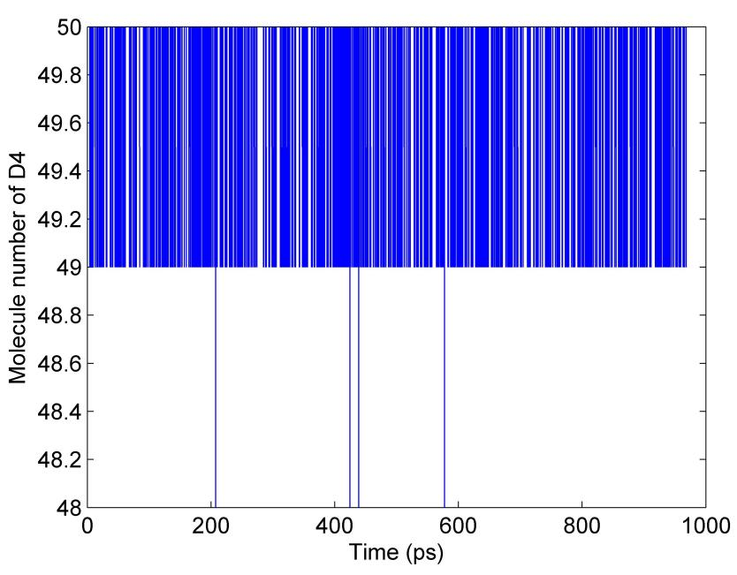
- 1300 K
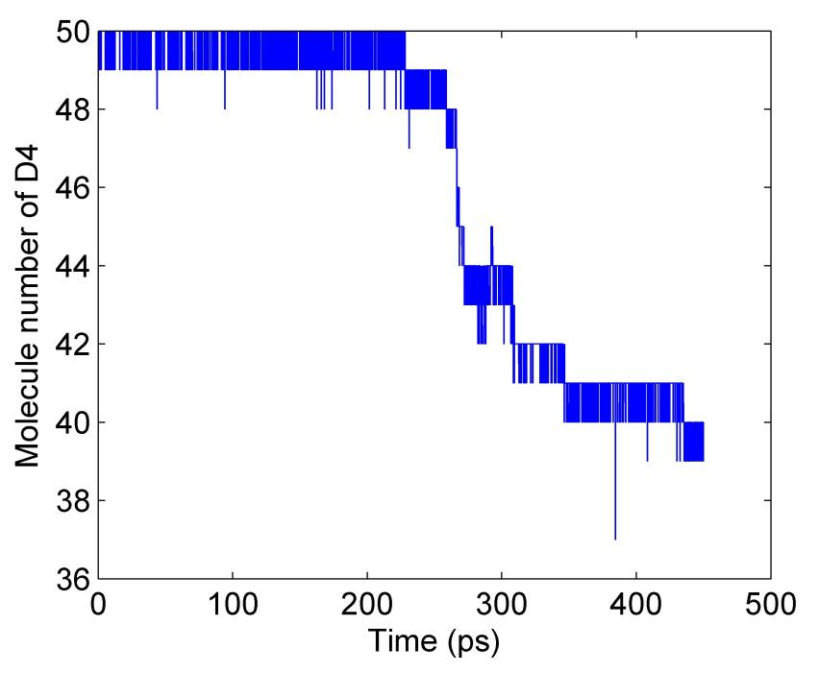
- 1400 K
Fig. S1. Variation of D4 molecule number verse simulation time.

- Verification of the dominance of radical chain reactions
Figures S2-S4 show the evolution of molecules numbers of D4, ·CH₃ and CH₄ at the temperatures of 1500K, 1800 K, 2200 K, and 2600 K. The results show that the increasing of temperature greatly promotes the decomposition of D4, and the ·CH₃ concentration rises sharply and remains at a high level within a short time after the simulation starts. This directly proves Si-C bond homolysis acts as a fast initiation step. The peak and steady-state concentrations of ·CH₃ increase significantly with rising temperature, indicating high temperature also greatly promotes radical generation. Overlaying the ·CH₃ generation curve with the D4 decay curve on the same timeline visually shows the strong temporal correlation between the explosive growth of ·CH₃ and the rapid consumption of D4.
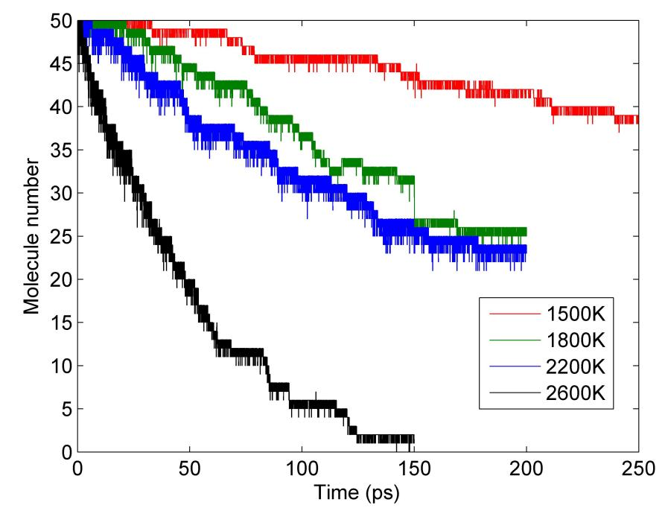
Fig. S2. D4 molecule number decay verse time at different temperatures.
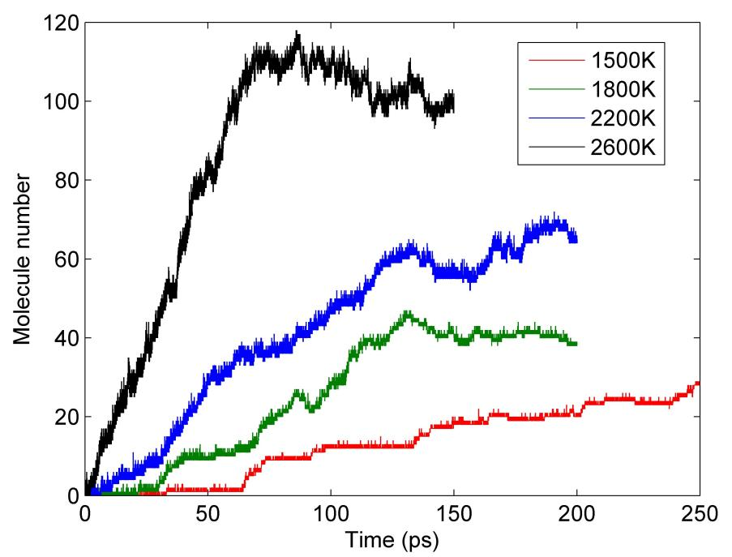
Fig. S3. CH₃ radicals number increase verse time at different temperatures.

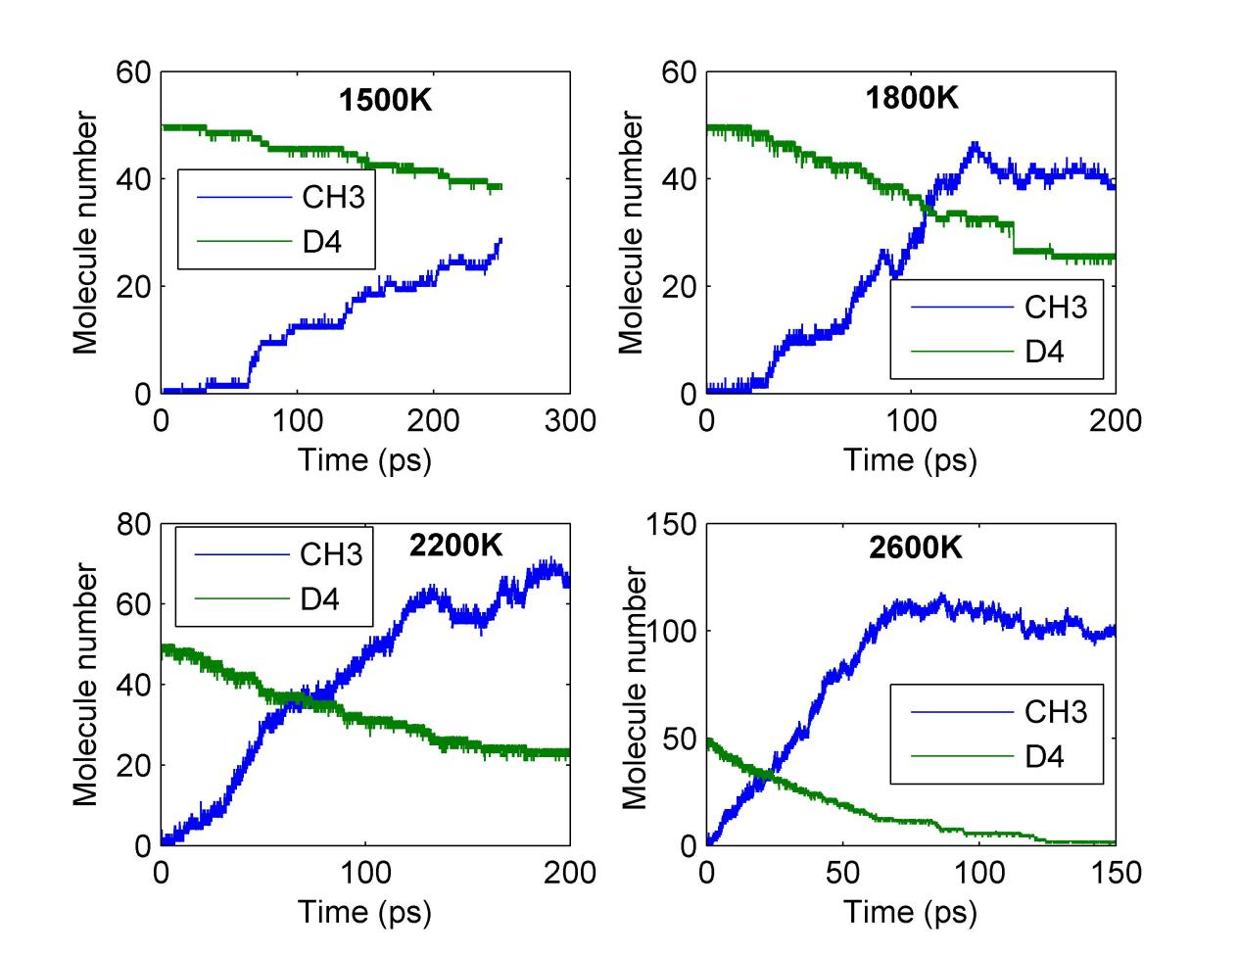
Fig. S4. Variation of D4 molecules number and CH₃ radicals number verse time at different temperatures.

