Supplementary File 1:

Exploring Reaction Mechanism for Ammonia Combustion: Reactive Molecular Dynamics Simulations and Kinetic Modeling Study

Shuhao Li^{a,*}, Kunqi Wang^{b,*}, Licheng Zhongª, Shuanghui Xi^{c,*}, Zhikun Caoª, Xiao Guoª, Junxing Hou^{d}, Zhenhua Wenª

ª School of Aero Engine, Zhengzhou University of Aeronautics, Zhengzhou 450046, China
^{b} AECC Chengdu Engine Company Ltd., Chengdu 610503, China
^{c} School of Mechanical Engineering, Zhengzhou University of Aeronautics, Zhengzhou 450046, China
^{d} School of Aerospace Engineering, Zhengzhou University of Aeronautics, Zhengzhou 450046, China
* Corresponding author, E-mail: lish@zua.edu.cn; wkq0213@163.com; xishuanghui@zua.edu.cn

Fig. S1 Evolution of key species during ammonia pyrolysis.

Fig. S2 The variation of key species over time under different equivalence

ratios.
Fig. S3 The variation of key species over time under different temperatures.

The analyzed models include those proposed by Otomo et al. ^{[1]}, Mei et al. ^{[2]}, Han et al. ^{[3]}, Zhang et al. ^{[4]}, Wang et al. ^{[5]}, and Zhu et al. ^{[6]}, hereafter referred to as the Otomo, Mei, Han, Zhang, Wang, and Zhu models, respectively. Under stoichiometric conditions (ϕ = 1.0) at 1 atm and 1600 K, comparative analysis revealed significant variations in primary reaction pathways among the different mechanisms, as shown in Fig. S4. Species highlighted in red, blue, and orange denote components exhibiting notable discrepancies across models. The Otomo, Mei, and Zhang models consistently identified NO₂ and N₂H₃ among their 15 key species in primary reaction pathways, though N₂H₄ remained absent from these pathways. Conversely, the Han and Wang models excluded N₂H₃ from their critical species lists, while the Zhu model omitted NO₂ from its primary substance inventory.
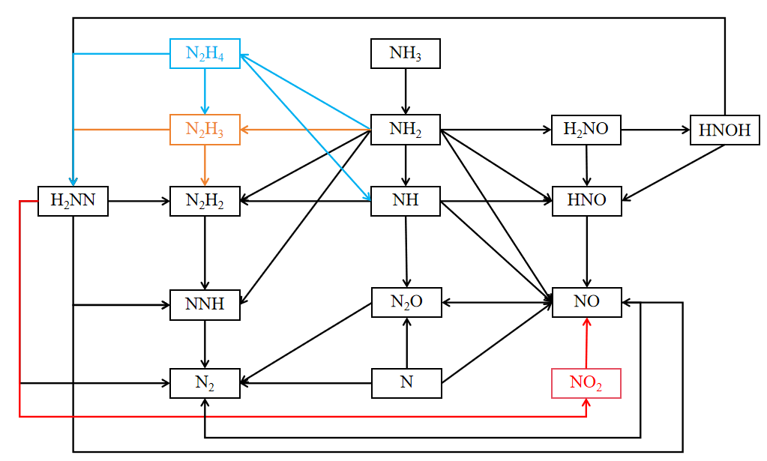
Fig. S4 The main reaction pathways of different model.

Table S1 lists the reactions with a reaction channel proportion of more than 1% in the two main reaction pathways for the formation of NO from NH₃, that is, the proportion of each channel in the reaction pathways of NH₃ → NH₂ → NH → HNO → NO and NH₃ → NH₂ → H₂NO (HNOH) → HNO → NO. A horizontal line indicates that the reaction does not exist in this mechanism. It is found that there are significant differences in the reaction channels of various mechanisms, and there are some missing important reactions in each mechanism.

Table S1 Analysis of reaction channels in ammonia combustion reaction networks
Reaction channels |  | Proportion
 |  | Otomo model | Mei model | Han model | Zhang model | Wang model | Zhu model
NH₃→NH₂ | +OH | 61.2% | 65.1% | 61.4% | 62.1% | 62.6% | 57.0%
NH₃→NH₂ | +O | 17.2% | 14.6% | 22.4% | 14.9% | 21.5% | 17.0%
NH₃→NH₂ | +H | 16.2% | 10.8% | 5.8% | 11.0% | 5.1% | 13.0%
NH₂→NH | +NH₂ | 14.3% | 9.1% | 10.1% | 10.4% | 12.0% | 16.7%
NH₂→NH | +H | 9.4% | 1.4% | 2.8% | 4.7% | 3.0% | 4.5%
NH₂→NH | +OH | 1.7% | 2.8% | 5.0% | 1.4% | 1.9% | 2.0%
NH₂→NH | +O | <1% | <1% | <1% | <1% | <1% | 1.6%
NH₂→H₂NO | +O₂ | <1% | <1% | <1% | <1% | <1% | 2.1%
NH₂→H₂NO | +HO₂ | 1.8% | 6.6% | <1% | 2.1% | <1% | <1%
NH→HNO | +O₂ | 5.4% | 6.2% | 9.4% | 11.7% | 9.8% | 9.4%
NH→NO | +O₂ | 1.7% | 1.9% | 1.7% | 3.3% | 1.9% | 2.6%
NH→NO | +O | <1% | <1% | 1.6% | 1.3% | <1% | <1%
H₂NO→HNOH | +M | 13.3% | 8.7% | 26.1% | 12.1% | 26.1% | 9.4%
H₂NO→HNO | +NH₂ | 5.0% | 4.7% | 7.4% | 15.3% | 8.1% | 3.2%
H₂NO→HNO | +H | 10.8% | 10.0% | / | 6.5% | / | 1.6%
H₂NO→HNO | +O₂ | <1% | <1% | / | 2.4% | / | 1.0%
H₂NO→HNO | +OH | 9.7% | 12.4% | / | <1% | / | <1%
H₂NO→HNO | +HO₂ | <1% | 4.0% | / | 1.2% | / | <1%
H₂NO→HNO | +O | 2.4% | 2.7% | / | 2.2% | / | <1%
HNOH→HNO | +NH₂ | 8.5% | 6.4% | 7.8% | 6.5% | 8.0% | 6.4%
HNOH→HNO | +H | 3.8% | 3.8% | 5.4% | 4.3% | 4.7% | 1.9%
HNOH→HNO | +HO₂ | <1% | 2.9% | <1% | <1% | <1% | <1%
HNOH→HNO | +OH | <1% | 1.1% | 1.1% | <1% | <1% | <1%
HNOH→HNO | +O | <1% | <1% | 1.3% | 1.3% | 1.1% | <1%
HNO→NO | +NH₂ | 1.6% | 8.5% | 12.3% | 12.5% | 16.5% | 23.1%
HNO→NO | +O₂ | 11.4% | 11.5% | / | 17.8% | / | 14.8%
HNO→NO | +H | 9.4% | 5.3% | 18.3% | 11.2% | 21.1% | 6.3%
HNO→NO | LR | 24.7% | 17.7% | 12.3% | 9.0% | 14.2% | 4.8%
HNO→NO | +OH | 2.2% | 1.9% | 4.5% | 3.0% | 5.4% | <1%
HNO→NO | +NH | / | <1% | / | 2.1% | / | /
HNO→NO | +O | <1% | <1% | 2.1% | <1% | 2.5% | <1%
N₂H₄→NH | +O | <1% | / | / | / | / | /
N₂H₄→NH | +N | / | / | / | / | / | <1%
N₂H₄→NH | +M | / | / | 45.4% | / | 45.6% | /
N₂H₄→N₂H₃ | +NH₂ | <1% | <1% | / | <1% | / | 28.3%
N₂H₄→N₂H₃ | +OH | <1% | <1% | <1% | <1% | <1% | 8.8%
N₂H₄→N₂H₃ | +H | <1% | <1% | <1% | <1% | <1% | 7.6%
N₂H₃→N₂H₂ | +M | 6.7% | 24.0% | / | 46.7% | / | 37.8%
N₂H₃→N₂H₂ | +NH | <1% | 1% | / | <1% | / | 1.5%
N₂H₃→N₂H₂ | +NH₂ | 2.2% | 2.3% | <1% | <1% | <1% | <1%
N₂H₃→N₂H₂ | +H | 2.5% | 1.1% | <1% | <1% | <1% | <1%
N₂H₃→N₂H₂ | +O | 1.3% | <1% | <1% | <1% | <1% | <1%
N₂H₃→H₂NN | +OH | 4.3% | 1.3% | / | <1% | / | 2.6%
N₂H₃→H₂NN | +NH₂ | 28.3% | 20.1% | / | <1% | / | 1.9%
N₂H₂→NNH | +NH₂ | 10.0% | 5.9% | 14.3% | 11.4% | 15.5% | 20.5%
N₂H₂→NNH | +H | 20.1% | 14.3% | 24.6% | 29.1% | 24.0% | 16.9%
N₂H₂→NNH | +M | 7.9% | 18.7% | <1% | 5.7% | <1% | 7.6%
N₂H₂→NNH | +NH | 5.2% | 2.0% | 2.6% | 1.1% | 2.3% | 1.7%
N₂H₂→NNH | +OH | 2.3% | 1.9% | 4.3% | <1% | 4.1% | 1.7%
N₂H₂→NNH | +O | 3.0% | 2.0% | 3.8% | <1% | 3.6% | 1.2%
H₂NN→N₂ | LR | / | / | / | / | / | 49.9%
NNH→N₂ | LR | 49.1% | 14.0% | 47.5% | 46.9% | 47.4% | 46.5%
NNH→N₂ | +O₂ | <1% | 35.5% | 1.6% | 2.9% | 1.6% | 3.1%

Table S2 Reaction parameters related to H₂N₂O
No. | Reaction | Rate coefficients
No. | Reaction | A(cm³/mole·s) | n | Ea(cal/mole)
R2-1 | NH₂+NO=H₂N₂O | 7.2264E+12 | -1.20 | -2.1E+02
R2-2 | NH+NO=HNNO | 7.8286E+12 | 0.00 | -8.33E+02
R2-3 | H₂N₂O+H=HNNO+H₂ | 6.00E+13 | 0.00 | 0.00
R2-4 | H₂N₂O+OH=HNNO+H₂O | 3.00E+13 | 0.00 | 0.00

Table S3 Updated reactions and their parameter information
No. | Reaction | Rate coefficients
No. | Reaction | A(cm³/mole·s) | n | Ea(cal/mole)
R3-1 | O+H₂=OH+H | 8.24E+14 | 0.00 | 19175
R3-2 | H+O₂(+M)=HO₂(+M) | 9.70E+11 | 0.44 | 0.00
R3-3 | NH₂+O=H+HNO | 0.58E+13 | -6.5E-02 | -188
R3-4 | NH₂+O=NH+OH | 0.59E+03 | 2.84 | -2.78E+03
R3-5 | NH₂+OH=NH+H₂O | 6.04E+04 | 2.52 | -616.032
R3-6 | NH₂+N=N₂+H+H | 3.80E+13 | 0.00 | 0.00
R3-7 | NH₂+N=H₂+N₂ | 4.45E+13 | 0.00 | 0.00
R3-8 | NH+H=N+H₂ | 3.85E+11 | 0.71 | 931
R3-9 | N₂O+H=N₂+OH | 7.00E+14 | 0.00 | 1.81E+04
R3-10 | NH₃+HO₂=NH₂+H₂O₂ | 3.073 | 3.839 | 17260
R3-11 | NH₂+HO₂=H₂NO+OH | 2.65E+12 | 0.166 | -938
R3-12 | NH₂+HO₂=NH₃+O₂ | 4.74E+18 | -1.91 | 306
R3-13 | NH₂+NO₂=H₂NO+NO | 9.60E+11 | 0.11 | -1186
R3-14 | NH₂+NO₂=N₂O+H₂O | 1.20E+11 | 0.11 | -1186
R3-15 | NH₂+NH₂(+M)=N₂H₄(+M) | 6.10E+14 | -0.414 | 66.0
R3-16 | H₂NO+NH₂=HNO+NH₃ | 7.90E+05 | 1.94 | -580
R3-17 | H₂NO+O₂=HNO+HO₂ | 2.53E+05 | 2.19 | 1.80E+04
R3-18 | NO+HO₂=NO₂+OH | 3.10E+12 | 0.00 | -480
R3-19 | NH₃+O=NH₂+OH | 1.03E+02 | 3.18 | 6.739.9
R3-20 | NH+OH=H+HNO | 9.51E+14 | -0.314 | -308
R3-21 | NH+NO=N₂O+H | 9.70E+14 | -0.78 | 20
Fig. S5 Laminar burning velocity comparison verification (The experimental data are from Hayakawa et al. ^{[7]}, Kohansal et al. ^{[8]}, Alvarez et al. ^{[9]}, Shrestha et al. ^{[10]}, Zhou et al. ^{[11]})

Fig. S6 Ignition delay time comparison validation (The experimental data are from Shu et al.^{[12]})
Fig. S7 shows the comparative results of ignition delay time predictions between the combustion model developed in this work and that developed by Dai et al.^{[14]}. Both mechanisms demonstrate consistent overall predictive capability and variation trends for ignition delay time. However, the mechanism developed in this work predicts shorter ignition delay times compared to that developed by Dai et al., with the discrepancy becoming more pronounced at higher pressures. At 60 atm, the predicted values are approximately 48.5% faster overall.
Fig. S7 Comparison of the predictive capabilities of two combustion mechanisms (This model and Dai et al. ^{[14]}) for ignition delay time.

Fig. S8 Component concentration comparison validation (The experimental data are from Osipova et al. ^{[13]})

Fig. S9 Analysis of ROP of OH, NH₂, and NH.
References
[1]Otomo J, Koshi M, Mitsumori T, Iwasaki H, Yamada K. Chemical kinetic modeling of ammonia oxidation with improved reaction mechanism for ammonia/air and ammonia/hydrogen/air combustion. International Journal of Hydrogen Energy, 2018, 43: 3004-3014.
[2]Mei BW, Zhang XY, Ma SY, Cui ML, Guo HW, Cao ZH, Li YY. Experimental and kinetic modeling investigation on the laminar flame propagation of ammonia under oxygen enrichment and elevated pressure conditions. Combustion and Flame, 2019, 210: 236-246.
[3]Han XL, Wang ZH, He Y, Zhu YQ, Cen KF. Experimental and kinetic modeling study of laminar burning velocities of NH3/syngas /air premixed flames. Combustion and Flame, 2020, 213: 1-13.
[4]Zhang X, Moosakutty SP, Rajan RP, Younes M, Sarathy SM. Combustion chemistry of ammonia/hydrogen mixtures: jet-stirred reactor measurements and comprehensive kinetic modeling. Combustion and Flame, 2021, 234: 111653.
[5]Wang Z, Ji CW, Zhang TY, Wang D, Zhai YF, Wang S F. Experimental and numerical study on laminar premixed NH3/H2/O2/air flames. International Journal of Hydrogen Energy, 2023, 48(39): 14885-14895.
[6]Zhu YX, Curran HJ, Girhe S, Murakami Y, Pitsch H, Senecal K, Yang LJ, Zhou CW. The combustion chemistry of ammonia and ammonia/hydrogen mixtures: A comprehensive chemical kinetic modeling study. Combustion and Flame, 2024, 260: 113239.
[7]Hayakawa A, Goto T, Mimoto R, Arakawa Y, Kudo T, Kobayashi H. Laminar burning velocity and Markstein length of ammonia/air premixed flames at various pressures. Fuel, 2015, 159: 98-106.
[8]Kohansal M, Kiani M, Masoumi S, Nourinejad S, Ashjaee M, Houshfar E. Experimental and Numerical Investigation of NH3/CH4 Mixture Combustion Properties under Elevated Initial Pressure and Temperature. Energy & Fuels, 2023, 37(14): 10681-10696.
[9]Alvarez LF, Shaffer J, Dumitrescu CE, Askari O. Laminar burning velocity of Ammonia/Air mixtures at high pressures. Fuel, 2024, 363: 130986.
[10]Shrestha KP, Lhuillier C, Barbosa AA, Brequigny P, Contino F, Rousselle CM, Seidel L, Mauss F. An experimental and modeling study of ammonia with enriched oxygen content and ammonia/hydrogen laminar flame speed at elevated pressure and temperature. Proceedings of the Combustion Institute, 2021, 38(2): 2163-2174.
[11]Zhou SK, Cui BC, Yang WJ, Tan HZ, Wang JH, Dai HC, Li LY, Rahman Z, Wang XX, Deng SH, Wang XB. An experimental and kinetic modeling study on NH3/air, NH3/H2/air, NH3/CO/air, and NH3/CH4/air premixed laminar flames at elevated temperature. Combustion and Flame, 2023, 248: 112536.
[12]Shu B, Vallabhuni SK, He X, Issayev G, Moshammer K, Farooq A, Fernandes RX. A shock tube and modeling study on the autoignition properties of ammonia at intermediate temperatures. Proceedings of the Combustion Institute, 2019, 37(1): 205-211.
[13]Osipova KN, Zhang XY, Sarathy SM, Korobeinichev OP, Shmakov AG. Ammonia and ammonia/hydrogen blends oxidation in a jet-stirred reactor: Experimental and numerical study. Fuel, 2022, 310: 122202.
[14]Dai LM, Gersen S, Glarborg P, Levinsky H, Mokhov A. Experimental and numerical analysis of the autoignition behavior of NH3 and NH3/H2 mixtures at high pressure. Combustion and Flame, 2020, 215: 134-144.
[15]Krishna Prasad Shrestha, Binod Raj Giri, Ronan Pelé, Khalid Aljohani, Pierre Brequigny, Fabian Mauss, Fabien Halter, Lam K. Huynh, Christine Mounaïm-Rousselle. A comprehensive chemical kinetic modeling and experimental study of NH3_methanol/ethanol combustion towards net-zero CO2 emissions. Combustion and Flame, 2025, 274: 113954.

