Supplementary Material: Supplementary information to this study.

Non-reactive shock tube data-based model to reproduce non-ideal gas-dynamics effects to predict ignition delay times

Lennard Pinna^{1*}, Hong-Quan Do¹, Julien Jouanguy¹, Luis Le Moyne¹
¹Université Bourgogne Europe, DRIVE UR 1859, 58000 Nevers, France

Corresponding author:
Lennard_pinna@ube.fr

Keywords: Shock tube, Ignition delay time, Non-ideal effects, Chemical kinetic modeling, Contact surface bump

S1 Real gas effects behind the reflected shock wave
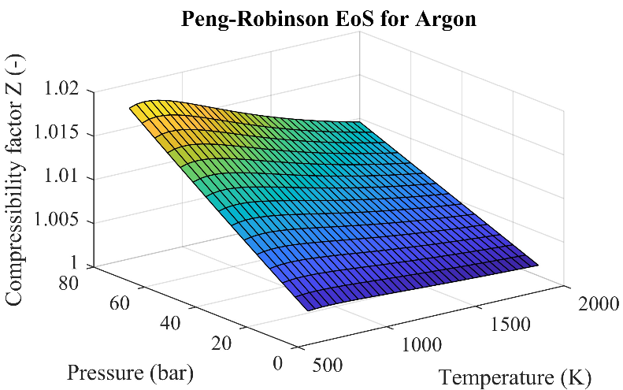
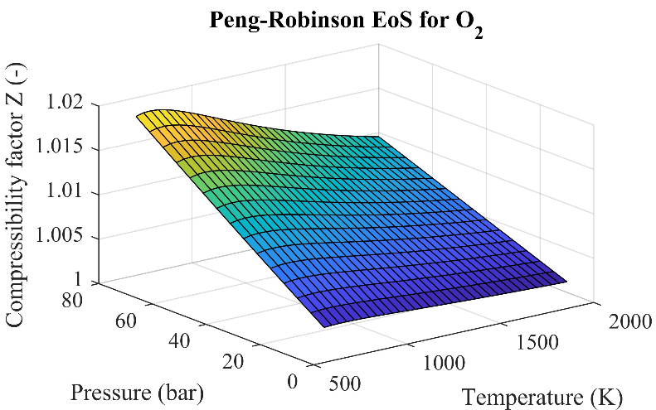
In order to use either the VTIM or the QPRO methods, we need to consider real gas effects due to low temperatures and high pressures in shock tubes. Davidson et al.^{[1]} compared the compressibility factor of argon for pressures between 6 to 50MPa and temperatures from 1280 to 1830K using the Peng-Robinson equation of state with measured state variables (pressure, density and temperature) for argon at 16.5, 30 and 50MPa and validate the use of equation of state over the tested range of conditions. However, differences were reported at 50MPa, which, in our case, is far above the working pressures reached by our shock tube (4.5MPa maximum prior to combustion). In our work, the compressibility factor for our working conditions was determined by using the same cubic equations of state developed by Peng and Robinson^{[2]}.

Figures S1a Peng-Robinson equation of state for Argon describing the compressibility factor for a temperature range of 700 to 2000 K and a pressure range of 10 to 80 bar. Figures S1b Peng-Robinson equation of state for O₂ describing the compressibility factor for a temperature range of 700 to 2000 K and a pressure range of 10 to 80 bar.

We reported the compressibility factor to be less than 1.02 in both cases for a temperature range of 700 to 2000 K and pressures from 10 to 80 bar by applying the equations of state for both argon and O₂. For the conversion of the pressure rise to both a volume change VTIM and the internal energy change QPRO methods, the real gas effects behind the reflected shock wave were neglected due to the close-to-1 compressibility factor describing an ideal gas behavior.

S2 Pressure traces of different non-reactive mixtures with different initial temperatures
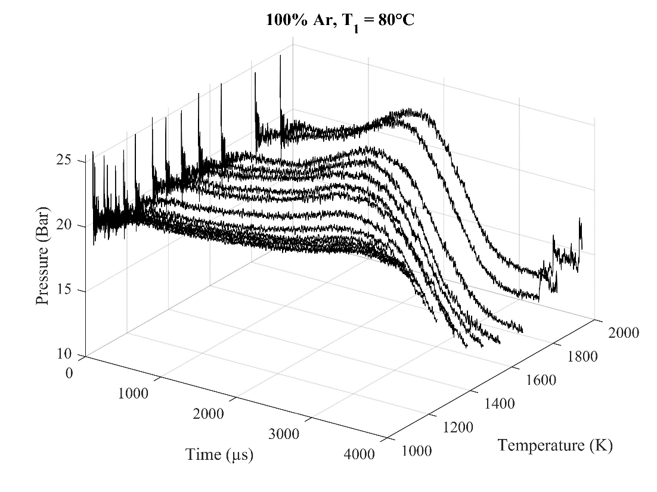
Figure S2 Non-reactive pressure traces of argon at 20 bar with an initial temperature T₁ of 80°C in the driven section at the different tested temperatures T₅ ranging from 1030 to 1940 K.

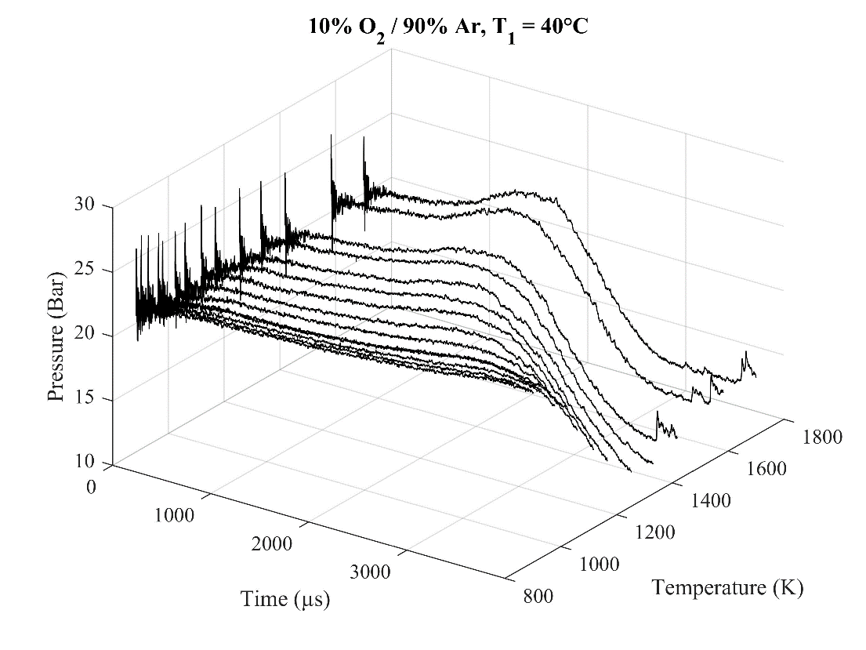
Figure S3 Non-reactive pressure traces of a mixture with 90% argon and 10% O₂ at 20 bar with an initial temperature T₁ of 40°C in the driven section at the different tested temperatures T₅ ranging from 890 to 1700 K.
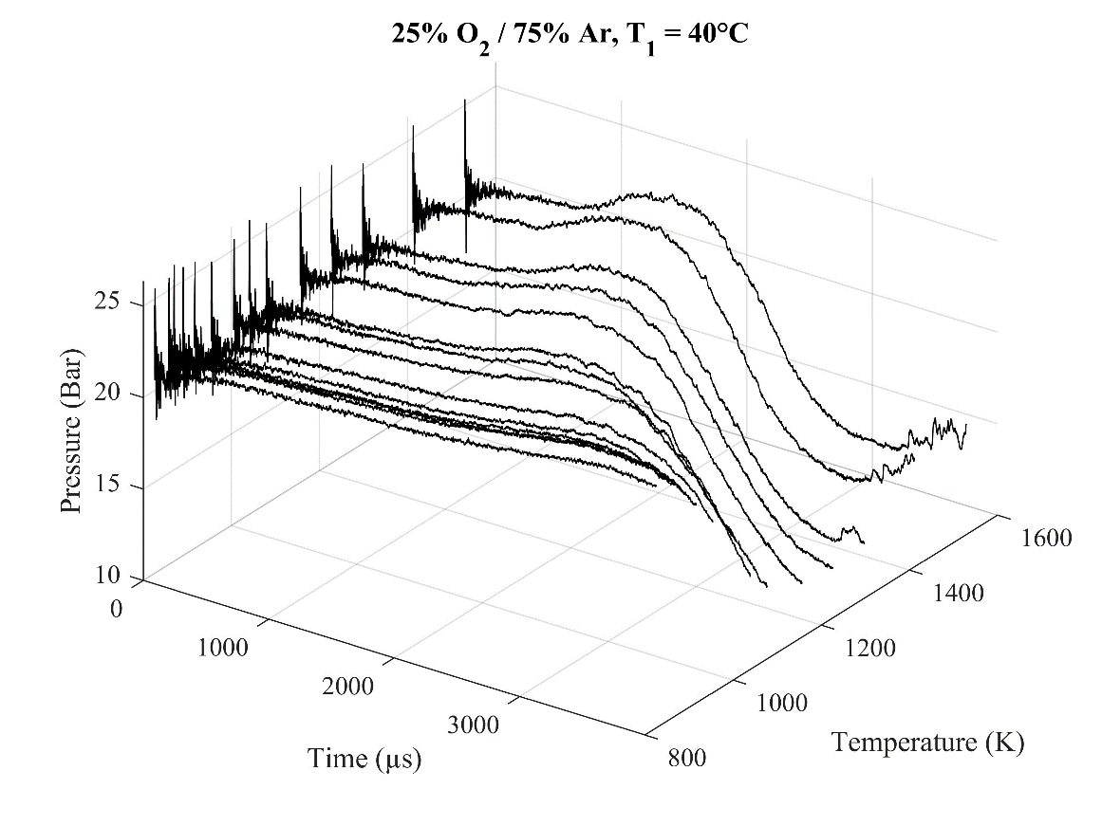
Figure S4 Non-reactive pressure traces of a mixture with 75% argon and 25% O₂ at 20 bar with an initial temperature T₁ of 40°C in the driven section at the different tested temperatures T₅ ranging from 825 to 1530 K.

As the temperature/incident shock wave velocity rises, non-ideal effects are stronger and the pressure rise can be divided into two sections: a first linear rise and a second more important caused by the contact surface bump^{[3]}. These two step pressure rises are observable for all the tested conditions (Fig S.2-4). These same pressure traces are used to generate pressure functions to reproduce the non-ideal effects in the kinetic models by interpolation as explained later in this document and by using either the variable volume or the heat transfer approach. The different pressure traces may look very similar but neglecting the slight differences in pressure variation may lead to misprediction of the ignition delay time in model or lead to develop inaccurate combustion kinetic models due to inexact conditions of pressure and temperature.

S3 Effects of the initial temperature on the pressure trace behind the reflected shock wave
In this section, other parameters were studied to justify the choice of using both normalized pressure traces and temperature as the parameter for the interpolation.

S3.1 Pressure traces depending on the temperature behind the reflected shock wave
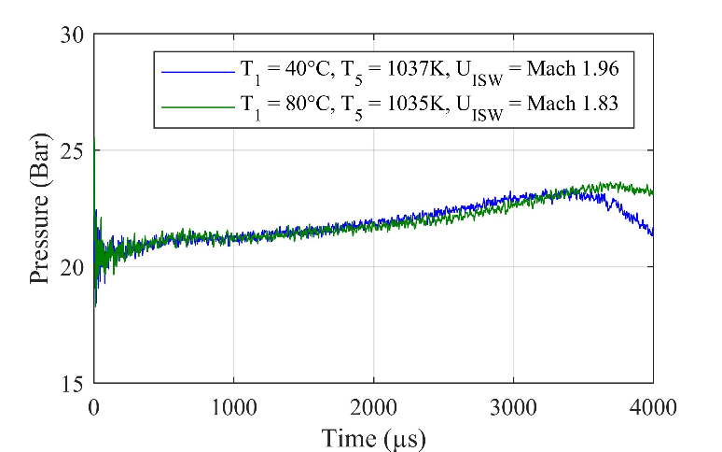
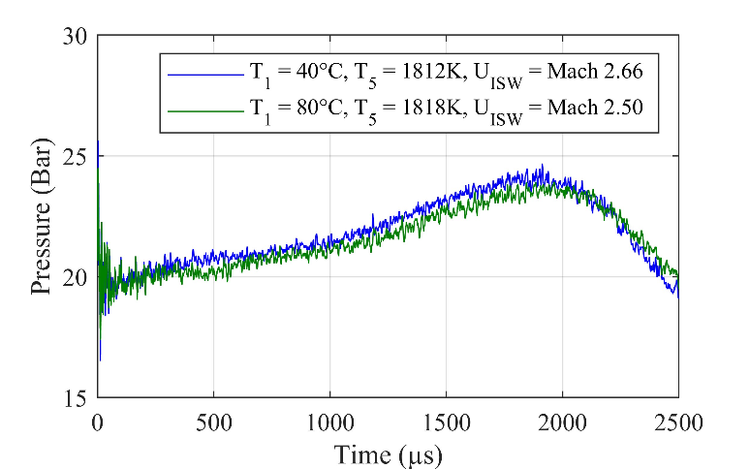
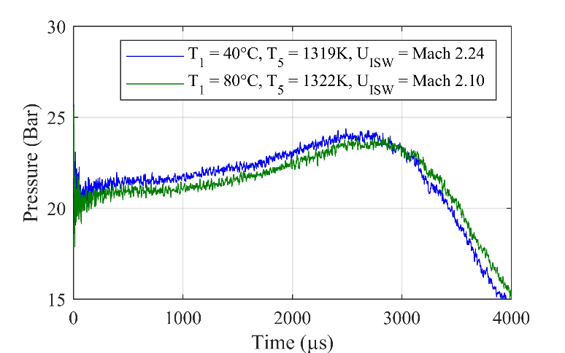
(a)
(b)
(c)
Figure S5 Impact of the initial temperature in the driven section on the pressure increase in argon.
The normalized pressure in the main paper reduces the differences related to the initial pressure P₅ behind the reflected shock wave. As we are not able to perfectly reproduce the same initial pressure P₅, we must mitigate all possible sources of differences for the interpolation.

S3.2 Normalized pressure trace depending on the Mach number of the incident shock wave
Aside from the parameters used for comparison and the fact that the pressure traces matched regardless of the initial temperature in the driven section of the shock tube, using another parameter such as the Mach number of the incident shock wave for the interpolation may have undesirable effects. The Mach number has been used in Mark’s work^{[4]} on non-idealities behind reflected shock wave to compare the evolution of the effects. However, in the method, the goal is to use a parameter common to all combustion kinetic study to provide a similar pressure trace regardless of T₁.

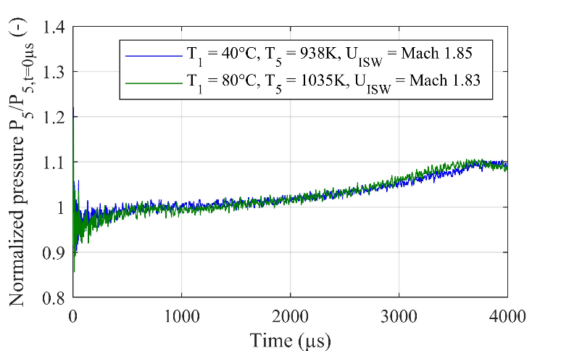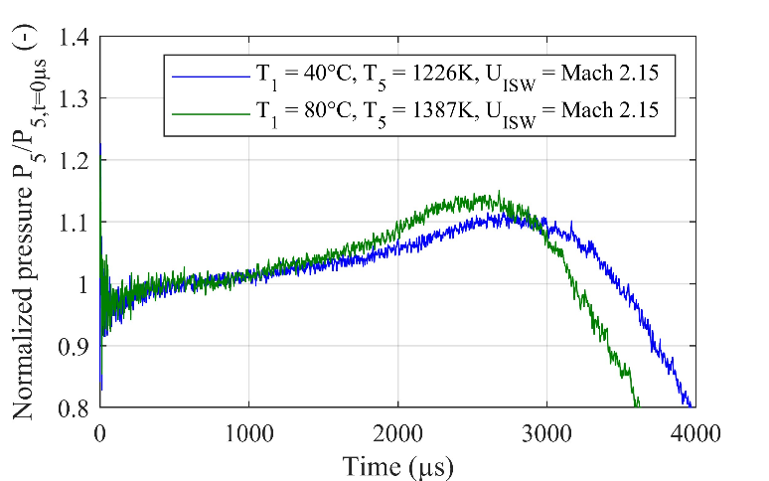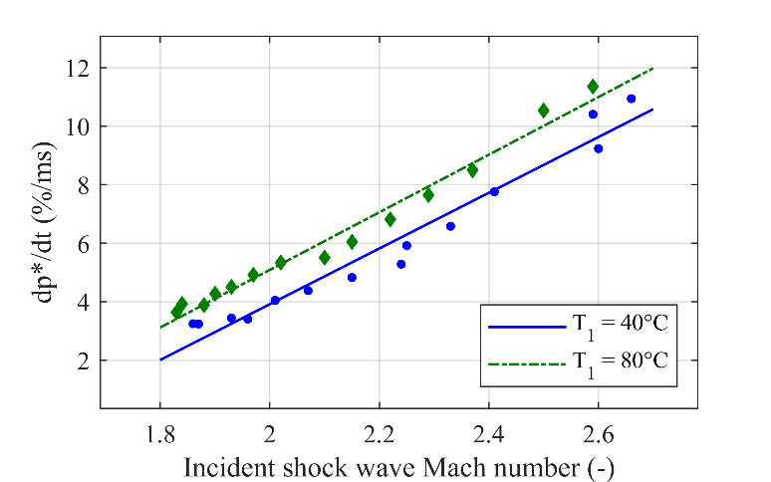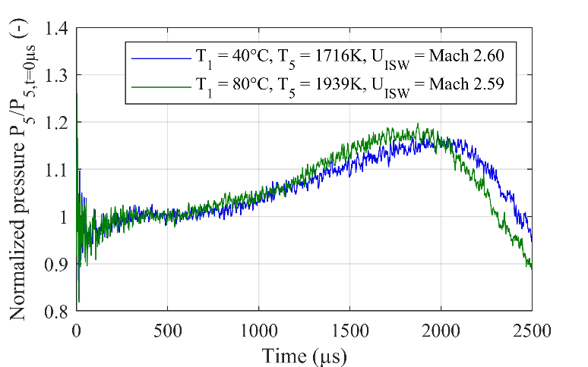
(a)
(b)
(c)
(d)
Figure S6 Impact of the initial temperature in the driven section on the pressure increase in argon depending on the Mach number. The pressures are normalized to compensate for the different initial pressure P₅ behind the reflected shock wave. The mean pressure gradient dp*/dt was determined using the work of Hargis et al.^{[5]}. The lines in (d) are a linear fit of experimental data.

The pressure traces are similar for the lowest shock wave speeds but as it increases, significant differences in the pressure traces are noticeable. For similar speeds, the non-idealities are stronger with higher initial temperatures. This could be explained using the physical speed of the shock wave. Mach 2.15 corresponds to approximately 709 m/s in argon at 40°C whereas it would correspond to 754 m/s at 80°C. The higher the physical speed, the sooner the arrival of the expansion wave and the contact surface bump as well as stronger pressure rise.

S4 Effects of the concentration of diatomic gas on the pressure trace behind the reflected shock wave
In a similar manner to the previous section, other parameters were studied to justify the choice of using both normalized pressure traces and temperature as the parameter for the interpolation.
S4.1 Pressure traces depending on the temperature behind the reflected shock wave
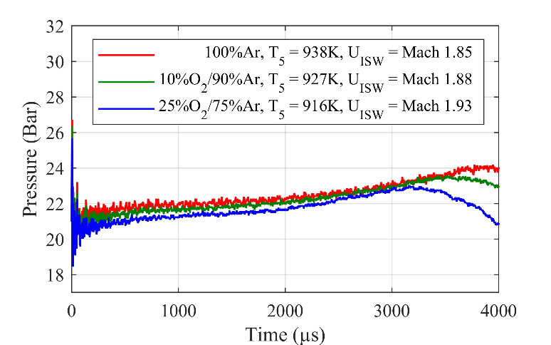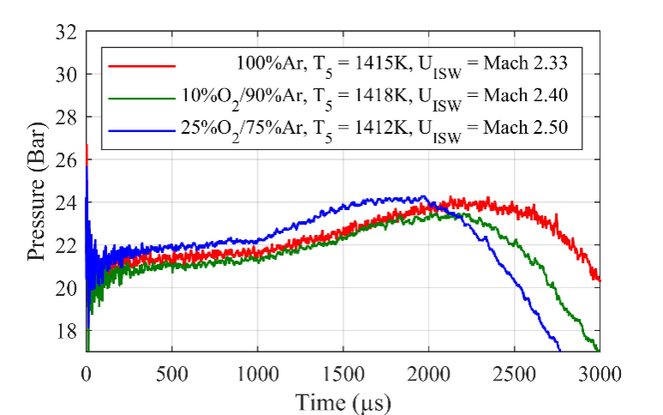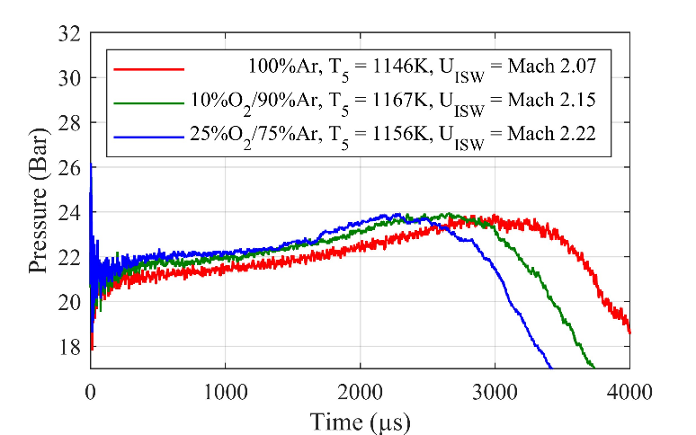
(a)
(b)
(c)
Figure S7 Impact of the dioxygen concentration in argon on the pressure increase.
As previously mentioned, the normalized pressure mitigates all possible sources of differences for the interpolation, especially regarding the initial pressure P₅ at t = 0 µs.

S4.2 Normalized pressure trace depending on the Mach number of the incident shock wave
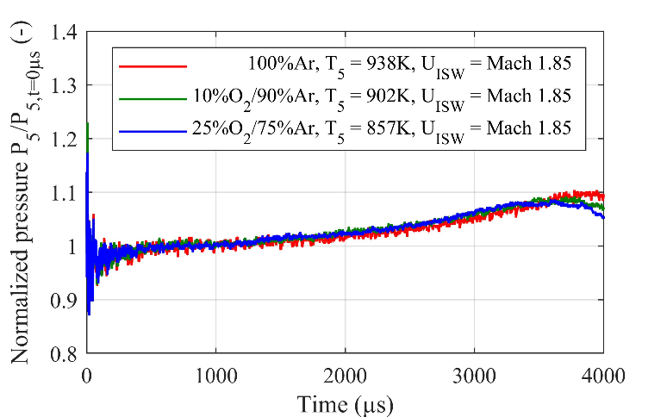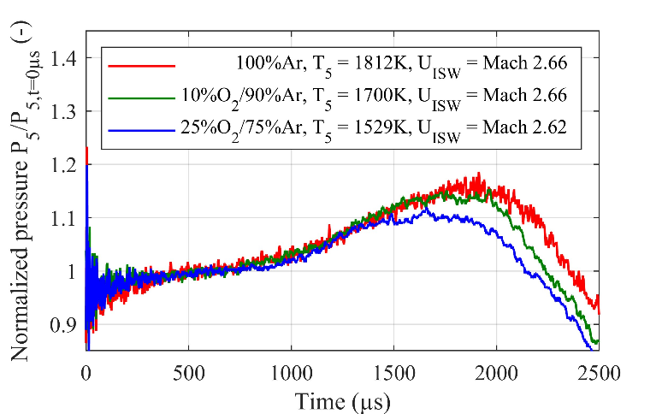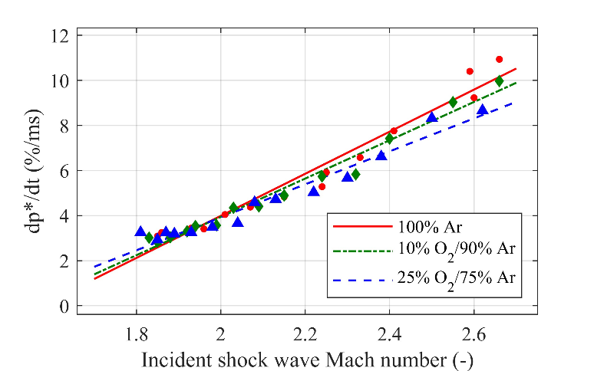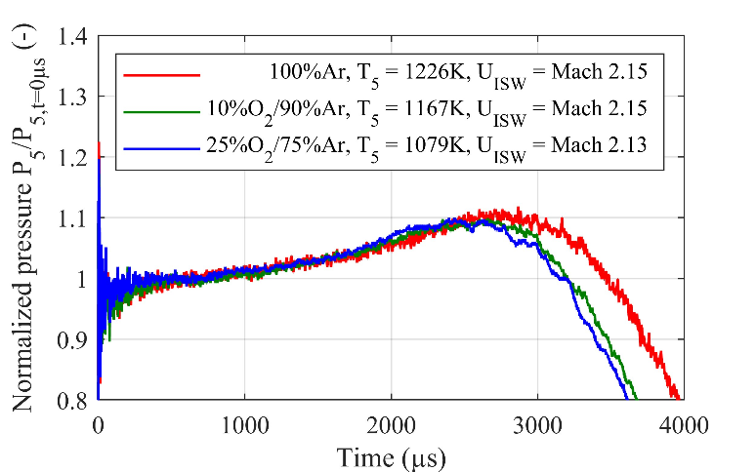
(a)
(b)
(c)
(d)
Figure S8 Impact of the dioxygen concentration in argon on the pressure increase. The mean pressure gradient was determined using the work of Hargis et al.^{[5]}. The lines in (d) are linear a fit of experimental data.

The presence of a diatomic gas, O₂, in a monoatomic one, argon, reveal similar pressure rises prior to the pressure decrease related to the expansion wave arrival in the test section when comparing the Mach number of the incident shock wave U_{ISW}. The differences in the Fig. S8d with the relative pressure gradients are mostly due to the contact surface bump interaction impacting the test section for longer duration with lower concentrations of O₂.
In this case, similar Mach number lead to similar physical shock wave speed. For example, Mach 2.15 corresponds to approximately 709 m/s in pure argon whereas it would correspond to 711 m/s for 10% O₂ and 709 m/s for 25% O₂. To provide similar incident shock wave, the pressure ratio P₄/P₁ between the driver and the driven section had to be higher as the concentration of O₂ rose, which may have been the cause of the sooner arrival of the expansion wave.

S5 Method to generate intermediate pressure traces by interpolation using fit functions
The polynomial or exponential fit functions have the forms as follows:
$$P_{POL}\left(t\right)=a_{0}t^{0}+a_{1}t^{1}+…+a_{n}t^{n}$$ | Eq.S1
$$P_{EXP}\left(t\right)=a_{0}\exp^{b_{0}×t}$$ | Eq.S2
With $P_{POL}(t)$, $P_{EXP}(t)$ being the pressure as a function of time $t$ according to polynomial or exponential fit function and $a_{i}$ and $b_{i}$ are the coefficients that will be interpolated.
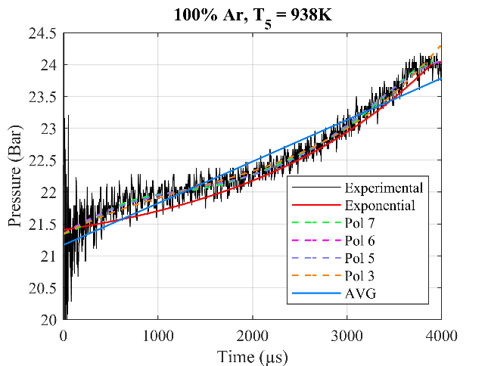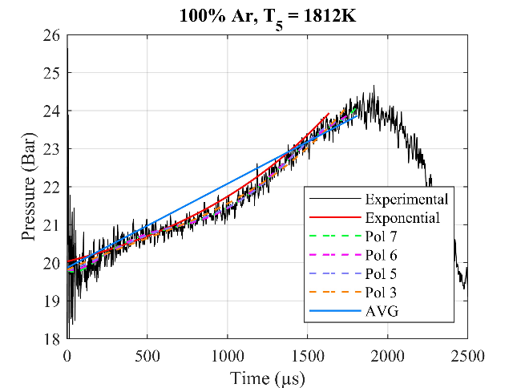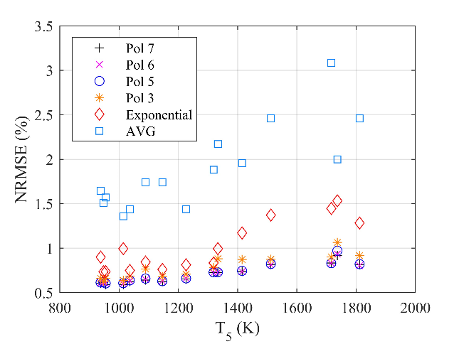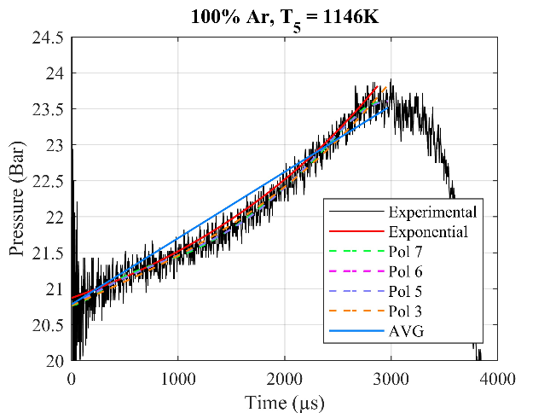
(a)
(b)
(c)
(d)
Figure S9 Comparison of different pressure fit functions to match the measured non-reactive pressure trace of argon at 20 bar with an initial temperature of 40°C in the driven section at low (a), medium (b) and high (c) temperature behind the reflected shock wave and their corresponding normalized root mean square error (NRMSE) at each fitted temperature (d).

The exponential and polynomial fits were compared. The exponential fit does not provide a good enough matching of the pressure regarding the initial pressure rise, the transition to the higher pressure rise or the pressure rise attenuation at the end of the test time simultaneously. The polynomial fit functions were therefore chosen as they provide better fits for different conditions. The low order (3rd degree) polynomial function provided better matching compared to the exponential fit.
The normalized root mean square error (NRMSE) quantifies the differences between the fit and the experimental data and was used to determine the fit function to reproduce the pressure trace in kinetic models. On the Figure S9d, the 3rd order polynomial fit revealed a much better fit to the experimental data with a NRMSE below 1% compared to the exponential fit with an error below 1.5% and the average pressure rise below 3%. To determine which order to use for the polynomial fit, the consecutive order of polynomial was compared using ignition delay time with the relation below until convergence was reached and the pressure traces were properly fitted.

$$\begin{aligned}{Err}_{rel,i}=\frac{IDT_{pol,i}−IDT_{pol,i+1}}{IDT_{Pol, i}} \#\end{aligned}Eq.S3$$
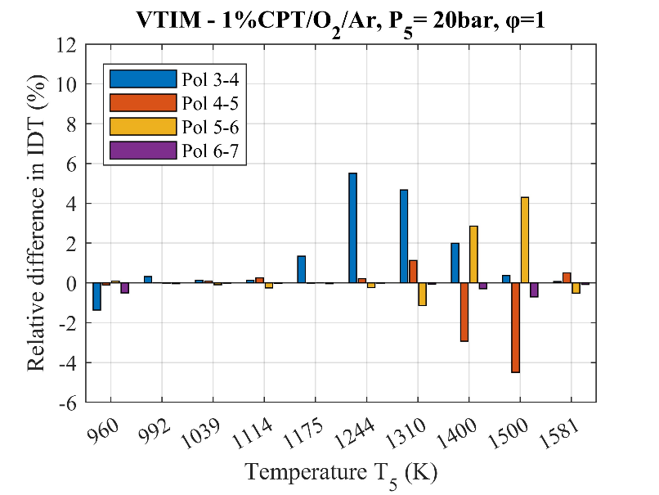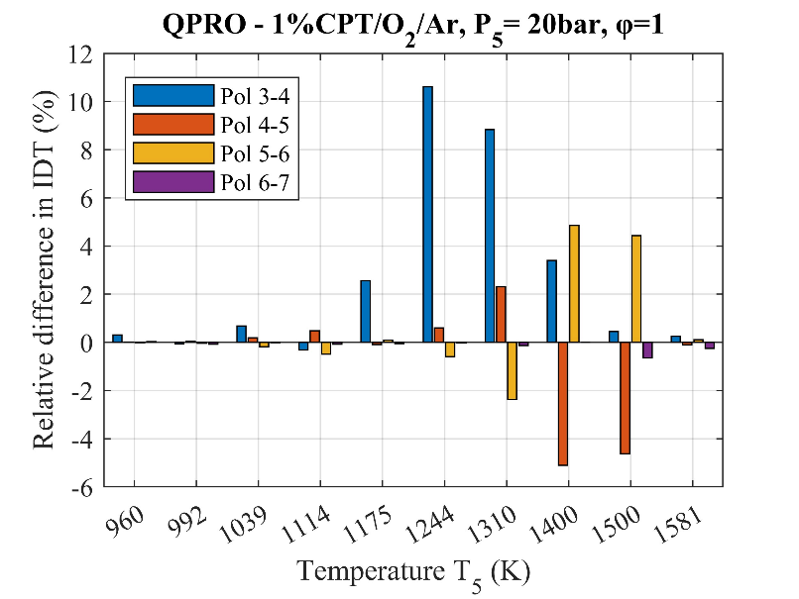
(b)
(a)

Figure S10 (a) Relative difference in ignition delay time* between consecutive polynomial order at different temperatures for 1%CPT/7.5%O₂/Ar at 20bar using the VTIM approach to reproduce the measured non-reactive pressure trace in Ansys Chemkin. (b) Relative difference in ignition delay time between consecutive polynomial order at different temperatures for 1%CPT/7.5%O₂/Ar at 20 bar using the QPRO approach to reproduce the measured non-reactive pressure trace in Ansys Chemkin.

The figures show for both the VTIM and the QPRO methods the relative differences in ignition delay time, as the relation above suggests, between two order of polynomial fit functions. As the order increases, the ignition delay times in both methods converge. The low-order polynomial functions were underfitting the high temperature pressure traces as the pressure gradient were increasing in the figure S.9.a-c. With the 3rd order starting to diverge from higher order fit at 1244 K, then the 4th and 5th order started to diverge at 1400 K. The 6th order was the lowest order polynomial that converged regardless of the temperature.
For short duration at high temperature, the pressure rise starts to become negligible, and the methods provide slight differences compared to constant volume and energy assumption.
A fit curve of the average pressure rise was also compared and did provide proper matching. Using it for reactive mixture may cause misprediction due to the fact that for combustions occurring prior to the contact surface bump, the pressure rise would have taken the contact surface bump into account even though that shouldn’t have happened.
Regarding the creation of inert pressure traces for the kinetic models, its coefficients are determined between the two closest incident shock wave (or temperature) conditions from the non-reactive pressure trace as follows:
$$X=\frac{U_{ISW,sup}−U_{ISW,reactive}}{U_{ISW,sup}−U_{ISW,inf}}→a_{i}=a_{i,inf}X+a_{i,sup}(1−X)$$ | Eq.S4
$U_{ISW,reactive}$ is the incident shock wave velocity of the experimental results with reactive mixture. The closest inferior and superior incident shock wave velocity from the non-reactive pressure traces are considered, respectively $U_{ISW,inf}$ and $U_{ISW,sup}$.
$X$ is the coefficient determining the “distance” between the superior closest condition $U_{ISW,sup}$ from non-reactive data and the measured condition $U_{ISW,reactive}$ at which combustion occurs with the reactive mixture over the difference between the superior and the inferior closest condition $U_{ISW,inf}$. If $X$ is closer to 1, the pressure obtained will be closer to the superior condition pressure trace.
$a_{i,inf}$ corresponds to the coefficients of the inferior non-reactive pressure trace whereas $a_{i,sup}$ are the coefficients of the non-reactive superior pressure traces. $a_{i}$ is the interpolated coefficient creating the pressure trace for the measured intermediate conditions.
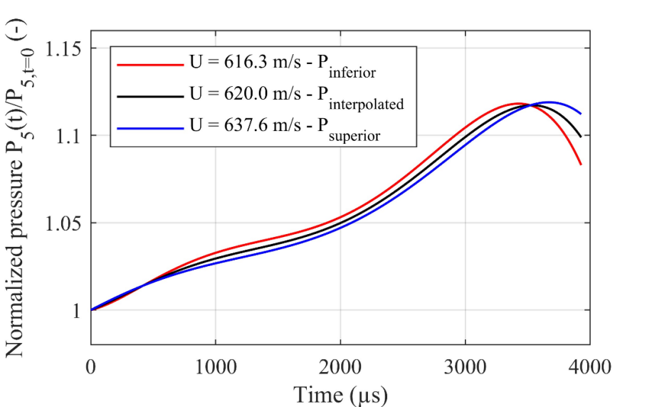
Figure S11 Creation of a time-dependent interpolated and normalized pressure function from two non-reactive normalized and fitted pressure functions to account for pressure rise in kinetic models.

S6 Comparison of the reactive pressure trace measured in the shock tube, the constant U V assumptions and the methods VTIM and QPRO with the kinetic model of THF using Ansys Chemkin.
Comparing NRMSE between the averaged and the instantaneous pressure change reveal differences, moreover, the graphs with the experimental data and the fitted curves also reveal the same differences
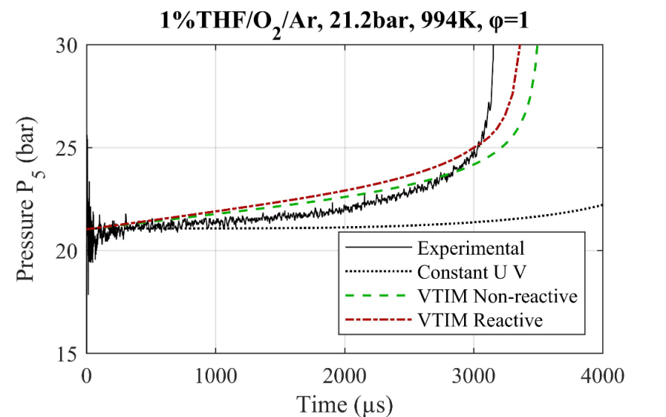
Figure S12 Comparison of the pressure trace of the combustion of 1%THF/O2/Ar at 21.2 bar and 994 K for an equivalence ratio of 1 with the kinetic model of Tetrahydrofuran from Do et al^{[6]}. The solid line is the measured pressure trace of the reactive mixture and the dot line is the constant internal energy and volume assumption. The green and red lines are respectively the computed pressure traces using the variable volume method based on average reactive pressure gradient (VTIM Reactive) and average non-reactive pressure gradient of argon at 20 bar and initial temperature of 40°C (VTIM Non-reactive).

Both pressure traces from the kinetic models are overpredicting the real pressure behind the reflected shock wave with the reactive mixture prior to combustion. The reactive based data is slightly above the non-reactive one yet it provides an ignition delay time of 3532 µs with the non-reactive data and 3392 µs for the reactive one, hence largely improving the prediction of the ignition delay time of 3230 µs in the experiment compared to the initial 4692 µs for the constant volume and internal energy approach.
The reactive pressure trace is slightly above the non-reactive as it accounted for chemical-related non-idealities. As the reaction takes place, the energy changes causing the pressure to increase and the combustion to occur sooner.
The non-reactive pressure traces are used to account for gas-dynamics-only effects. The differences in predicted ignition delay time now relay on the precision of the fitted pressure trace and the assumption concerning the relation between the pressure increase and the temperature change.
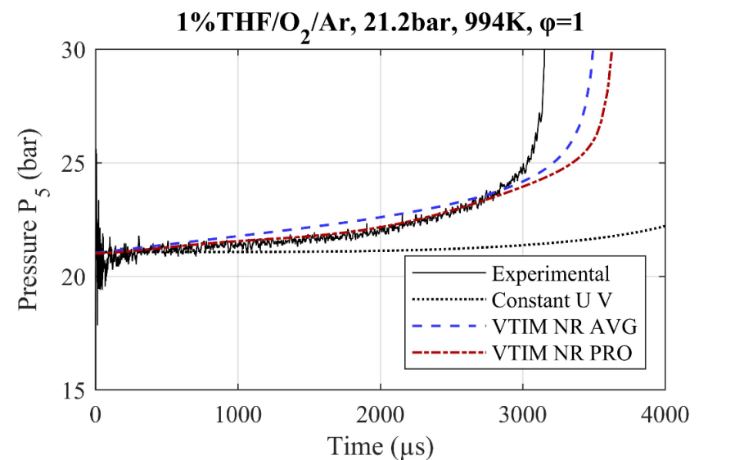
Figure S13 Pressure trace of 1%THF/O₂/Ar at 21.2 bar and 994 K for an equivalence ratio of 1 with the kinetic model of Tetrahydrofuran from Do et al.^{[6]}. Comparison between the average pressure gradient (AVG) and the pressure gradient as a function of time (PRO) for the reproduction of the non-ideal effects in Chemkin with the variable volume method VTIM.

The first figure is the comparison of the pressure trace of the combustion of 1%THF/O₂/Ar at 21.2 bar and 994 K for an equivalence ratio of 1 with the kinetic model of Tetrahydrofuran from Do et al.^{[6]}. The solid line is the measured pressure trace of the reactive mixture and the dot line is the constant internal energy and volume assumption. The red and blue line are respectively the computed pressure traces with the variable volume method (VTIM) using on average pressure gradient (AVG) and pressure gradient as a function of time (PRO) from non-reactive pressure traces of argon (NR) at 20 bar and initial temperature of 40°C.
Using averaged non-reactive data for the variable volume, the pressure remains slightly overestimated compared to the experimental results causing the ignition delay time to be shorter than the pressure trace. This is due to reactive mixture effects increasing the pressure prior to the combustion that is considered twice. This highlights the importance of avoiding the reactive pressure traces when reproducing non-ideal effects to predict ignition delay times.
Using the non-averaged and non-reactive pressure traces, the predicted pressure rise in with the reactive mixture is very close to the experimentally measured pressure trace. The only difference resides in the ignition delay time. The use of the time-dependent pressure provides much better prediction of the pressure rise prior to ignition, leaving only the kinetic mechanism as only variable for the different ignition delay time as long as the polytropic process assumed is right.
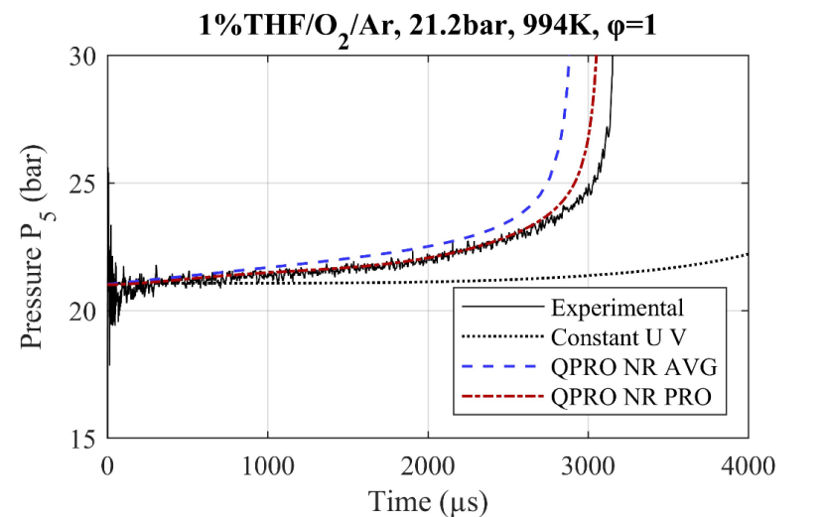
Fig S14 Pressure trace of 1%THF/O₂/Ar at 21.2 bar and 994 K for an equivalence ratio of 1 with the kinetic model of Tetrahydrofuran from Do et al.^{[6]}. Comparison between the average pressure gradient (AVG) and the pressure gradient as a function of time (PRO) for the reproduction of the non-ideal effects in Chemkin with the variable internal energy method QPRO.

The second figure is the same comparison of the pressure trace of the combustion of 1%THF/O₂/Ar at 21.2 bar and 994 K for an equivalence ratio of 1 with the kinetic model of Tetrahydrofuran from Do et al.^{[6]}. The red and blue line are respectively the computed pressure traces with the internal energy change method (QPRO) based on average pressure gradient (AVG) and pressure gradient as a function of time (PRO) from non-reactive pressure traces of argon (NR) at 20 bar and initial temperature of 40°C.
The same comments can be done compared to the VTIM methods but as the QPRO causes the temperature to rise quicker for the same pressure rise, the ignition delay times are significantly shortened. Thus, only leaving the kinetic mechanism and the relation between the pressure and temperature as the only causes for the difference between the predicted and the measured ignition delay times.

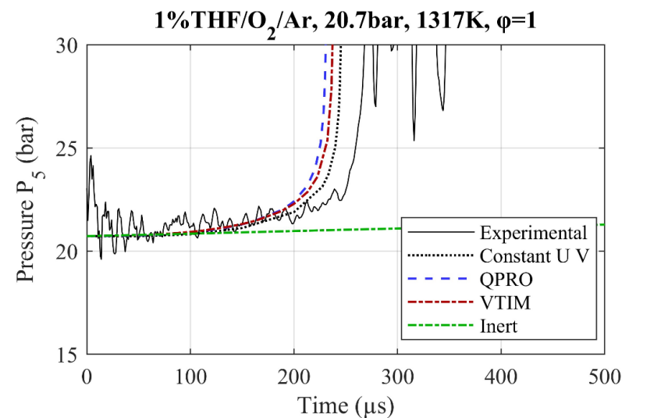
Fig S15 Pressure trace of 1%THF/O₂/Ar at 20.7 bar and 1317 K for an equivalence ratio of 1 with the kinetic model of Tetrahydrofuran from Do et al.^{[6]}. Comparison between the QPRO and VTIM for the reproduction of the non-ideal effects in Chemkin with the variable internal energy method QPRO in blue and the variable volume method VTIM in red. The constant U V assumption is kept as reference as the black dotted line and the green dotted and dashed line correspond to the non-reactive pressure trace used for correction (dp*/dt at 5.9 %/ms from 0 to 300 µs).

For shorter ignition delay times, the correction brought by either VTIM or QPRO method is minimal, the pressure reproduced in this case up until 200 microseconds would correspond to 0.25bar or 1.2% rise relative to the initial pressure P₅ considered behind the reflected shock wave. This pressure increase relates to about 5.9 K for the VTIM method and 14.2 K for the QPRO method for the inert mixture.

S7 Methods applied to the combustion of PENT-2-OH / MHX3D with O₂ in Argon

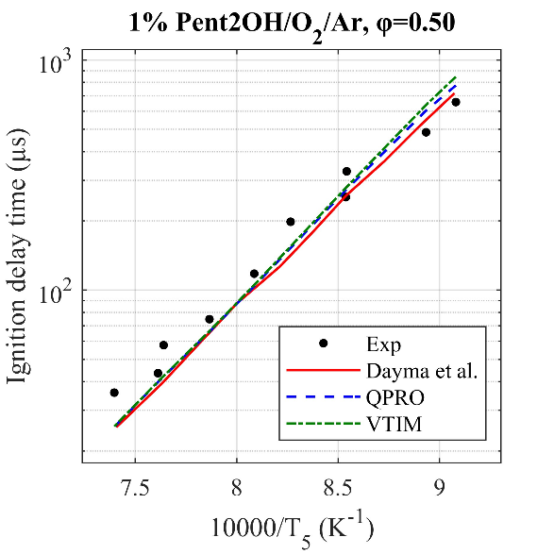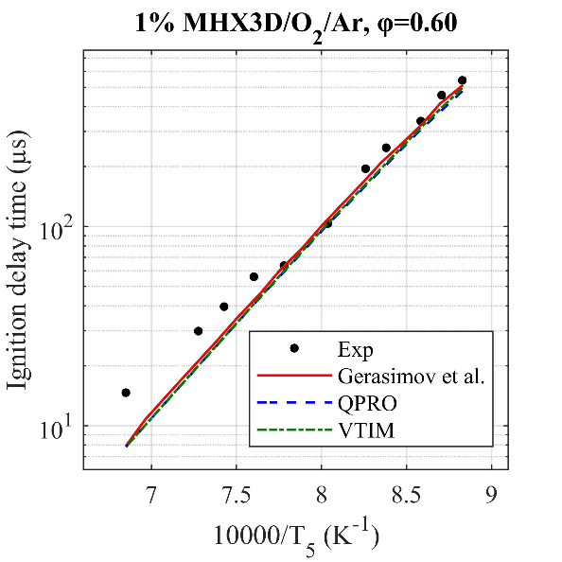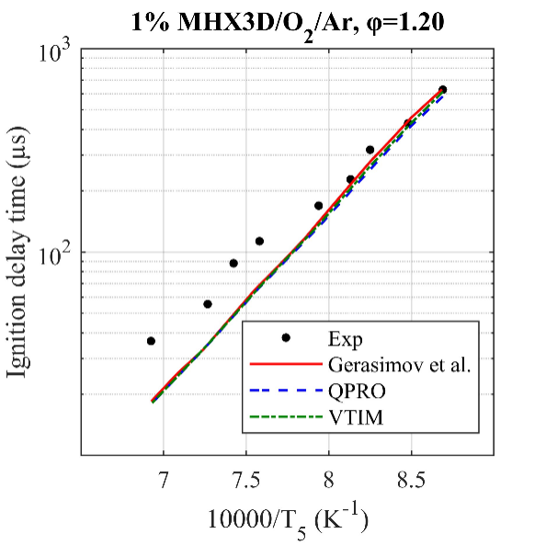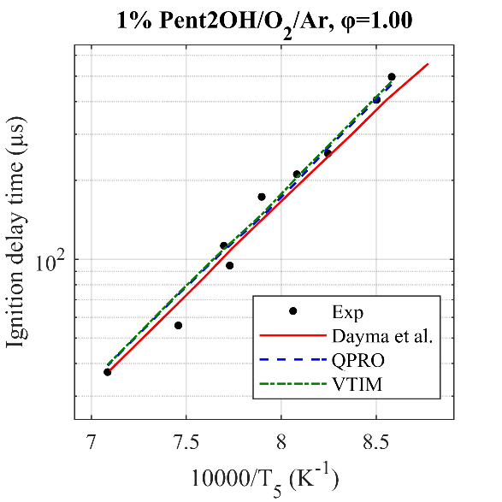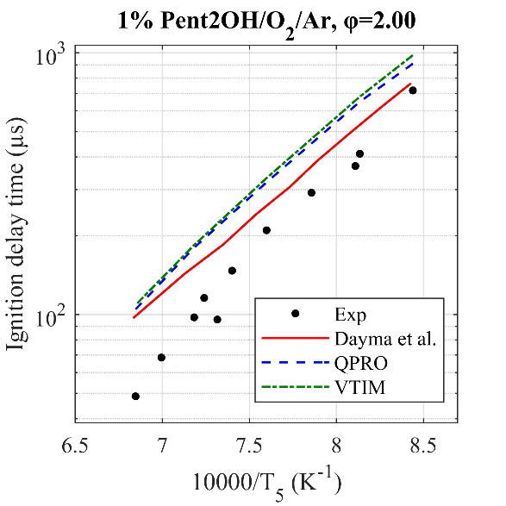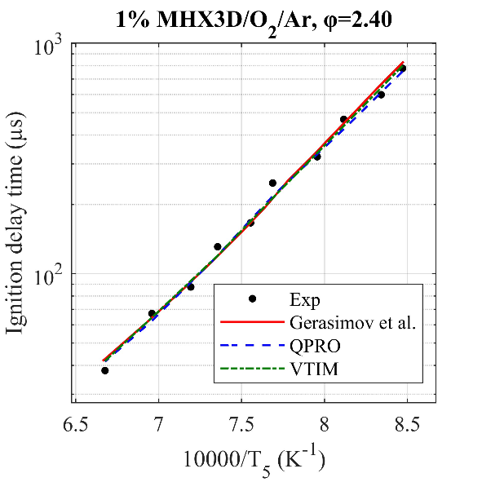
(a)
(b)

(d)
(e)
(c)
(f)
Figure S16 Ignition delay times of 1% Pentan-2-ol at 20 bar in O₂ and argon (Pent2OH/O₂/Ar) for equivalence ratios of 0.5, 1.0 and 2.0 and for 1% Methyl-3-hexenoat at 20 bar in O₂ and argon (MHX3D/O₂/Ar) for equivalence ratios of 0.6, 1.2 and 2.4 with the combustion kinetic model of Pentan-2-ol and MHX3D with the ignition delay times computed by Dayma et al. ^{[7]} and Gerasimov et al.^{[8]} respectively, as well as the variable volume and the heat transfer approach. Exp are experimental data from Dayma et al. ^{[7]} and Gerasimov et al ^{[8]}. Line, dash line and dash dot line are the numerical results.

The mechanism used to predict ignition delay times were provided in Dayma’s work regarding the combustion of Methyl-3-Hexenoat and in Gerasimov’s work for Pentan-2-ol. In both cases, the correction brought by the methods is not significant due to short ignition delay times, below 1000 microseconds as not enough change in pressure and temperature can be done to the model to further change the reaction speed. The accuracy of the model mostly relies on the chemical kinetic models and if there are no other underlying effects of reactive mixtures.

S8 Limitations from the QPRO and VTIM approaches
For the different models tested, we determined the relative error between the model using the constant internal energy and volume assumption (Constant U V), the variable volume approach (VTIM) and the internal energy change approach (QPRO) based on non-reactive time-dependent pressure trace and the experimental results. This allowed us to determine the limitations in corrections for the chemical kinetic models in many cases.
The relative error has been calculated using the equation below:
$$RE=\frac{τ_{experiment}−τ_{model}}{τ_{experiment}}$$
With $τ$ being the ignition delay time and $RE$ the relative error. Whenever the relative error is below 0%, the model is overpredicting ignition delay time, thus additional temperature and pressure from either QPRO or VTIM method can compensate differences between the model and the experiment. For the opposite case with the relative error above 0%, the method can only improve the model’s accuracy by reducing the temperature or the pressure, which has not been observed with the non-reactive pressure traces of argon in our shock tube thus any improvement in our shock tube for RE > 0% do not seem probable.
First with cyclopentane diluted at 1% in the mixture, corresponding to the Figure 6.a-c from the manuscript.

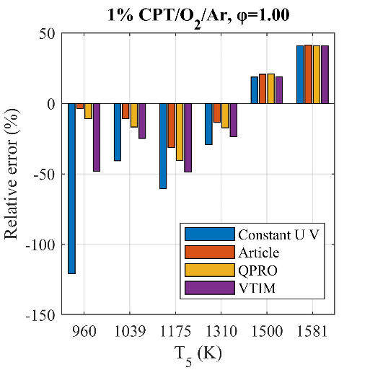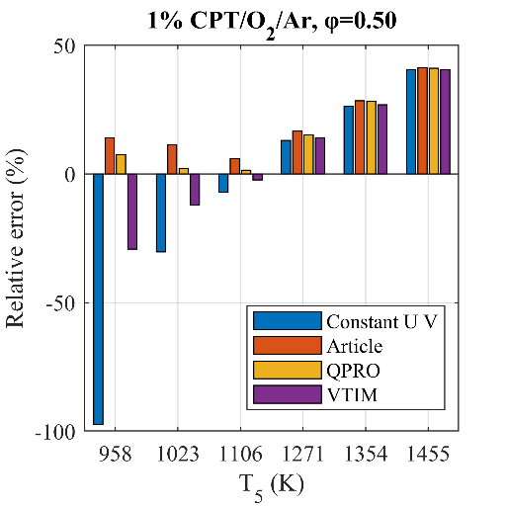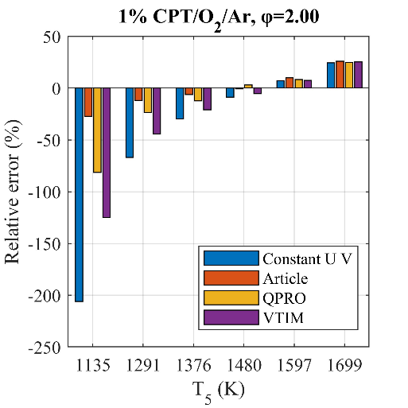
(a)
(b)
(c)
Fig. S17. (a-c) Relative error between the model using the Constant U V assumption in blue, the results of the article from Do et al.^{[6]} in orange with a constant heat loss correction, the QPRO and the VTIM method respectively in yellow and purple based on non-reactive time-dependent pressure gradients for CPT at Φ=1.00 (a), 0.50 (b) and 2.00 (c).
The combustion of 1% CPT reveal overpredicted ignition delay times from the Constant U V assumption using the kinetic model at low temperature with negative relative differences. The results from the article uses a constant heat loss taken from reactive mixture for the correction. Most of them are corrected using any method, with the QPRO reducing the differences much more than the variable volume solution and the article strongly reducing the ignition delay times, noticeably shifting the relative error. As the temperature increases and the ignition delay time duration decreases, the relative differences between the model and the experiment converge and any method cannot provide sufficient temperature or/and pressure change prior to ignition to approach the experimental delay times. Thus, differences persist at high temperature that cannot be truthfully corrected using any method to reproduce gas-dynamics effects into the model. Then with tetrahydrofuran diluted at 1% in the mixture, corresponding to the Figure 7.a-c from the manuscript.

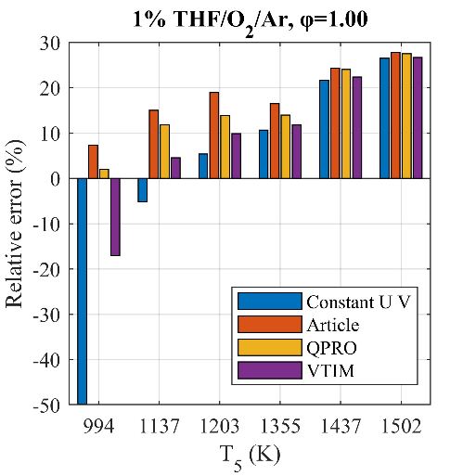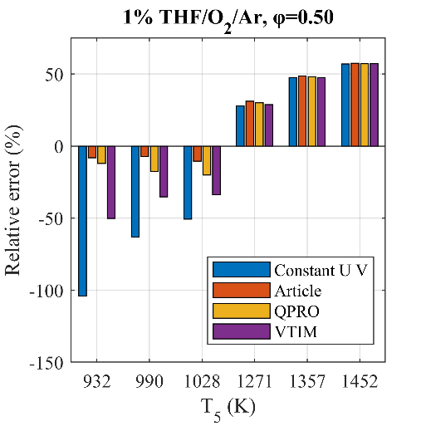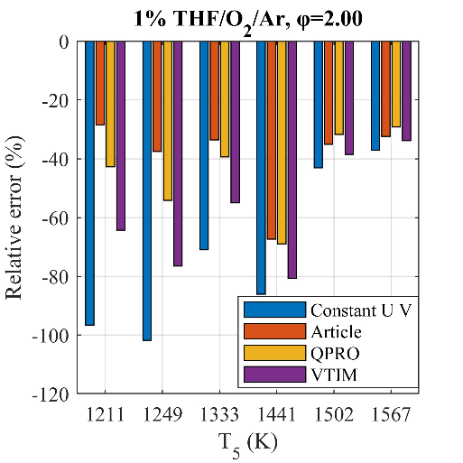
(a)
(b)
(c)
Fig. S18. (a-c) Relative error between the model using the Constant U V assumption in blue, the results of the article from Do et al.^{[6]} in orange with a constant heat loss correction, the QPRO and the VTIM method respectively in yellow and purple based on non-reactive time-dependent pressure gradients for THF at Φ=1.00 (a), 0.50 (b) and 2.00 (c).

Regarding the combustion of 1% THF in the high-pressure shock tube, significant improvement can be made at low temperatures. However, similar to the CPT combustion, as the temperature increases, the relative differences between the model and the experiment converge as the time span during which any method cannot provide sufficient changes prior to ignition to approach the experimental values. Differences beyond 20% persist for the case of Φ=1.00 for temperatures above 1440 K, for the case of Φ=0.50 for temperatures above 1210 K and below -25% for the case of Φ=2.00 over the whole temperature range.
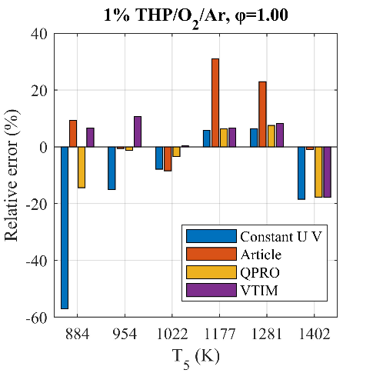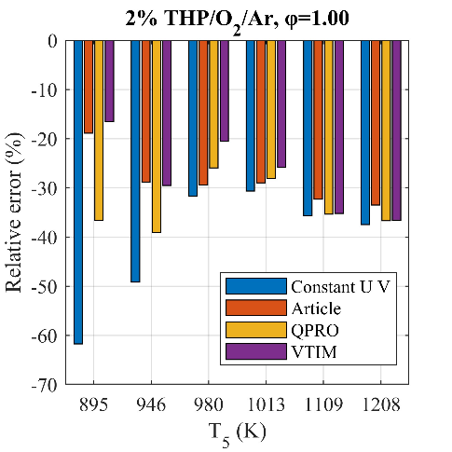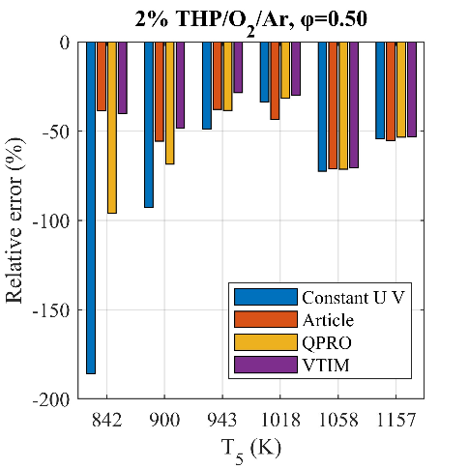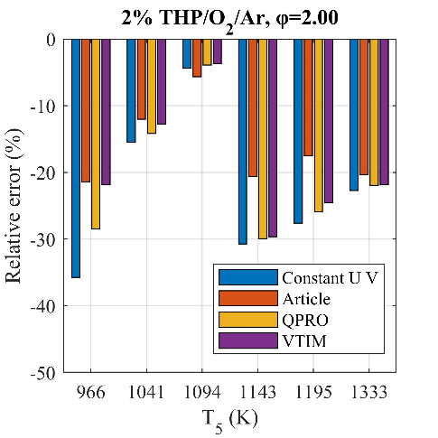
(a)
(c)
(b)
(d)
Fig. S19. (a-d) Relative error between the model using the Constant U V assumption in blue, the results from the article of Goldsborough et al.^{[9]} in orange with a constant heat loss correction, the QPRO and the VTIM method respectively in yellow and purple based on non-reactive time-dependent pressure gradients for 1%THP at Φ=1.00 (a), and 2%THP at Φ=0.50 (b), 1.00 (c) and 2.00 (d).

Regarding the combustion of THP, related to the Figure 8.a-d from the manuscript, the model predicts well the ignition delay times overall. The remaining differences may be attributed to the uncertainties from the experimental setup for relative error above 20%. Similar to the precedent cases, as the temperature rises, no more correction to the model can be brought for negative relative differences.

Reference
1. Davidson DF, Petersen EL, Hanson RK. Shock Tube Measurements of the Equation of State of Argon!
2. Peng DY, Robinson DB. 1976. A New Two-Constant Equation of State. Industrial & Engineering Chemistry Fundamentals 15:59–64
3. Campbell MF, Parise T, Tulgestke AM, Spearrin RM, Davidson DF, et al. 2015. Strategies for obtaining long constant-pressure test times in shock tubes. Shock Waves 25:651–65
4. Mark H., 1958. The Interaction of a Reflected Shock Wave with the Boundary Layer in a Shock Tube. NACA Technical Memorandum.
5. Hargis JW, Petersen EL. 2017. Shock-Tube Boundary-Layer Effects on Reflected-Shock Conditions with and Without CO2. AIAA Journal 55:902–12
6. Do H, Lefort B, Serinyel Z, LeMoyne L, Dayma G. 2024. Comparative study of the high‐temperature auto‐ignition of cyclopentane and tetrahydrofuran. International Journal of Chemical Kinetics 56:199–209
7. Dayma G, Serinyel Z, Carbonnier M, Bai J, Zhu Y, et al. 2021. Oxidation of pentan-2-ol – part II: Experimental and modeling study. Proceedings of the Combustion Institute 38:833–41
8. Gerasimov IE, Knyazkov DA, Bolshova TA, Shmakov AG, Korobeinichev OP, et al. 2020. Methyl-3-hexenoate combustion chemistry: Experimental study and numerical kinetic simulation. Combustion and Flame 222:170–80
9. Goldsborough SS, Jespersen MC, Santner JS, Sivaramakrishnan R, Do HQ, et al. 2025. Experimental and modeling study of the autoignition behavior of a saturated heterocycle: Pyrrolidine. Combustion and Flame 277:114134

