Supplementary File 1: supplementary description, figures and tables to this study.

GAS-PHASE OXYDATION CHEMISTRY OF THE THREE CRESOL ISOMERS

Olivier Herbinet^{a*}, Ismahane Mezianeª, Nicolas Delortª, Hans-Heinrich Carstensen^{b}, Frédérique Battin-Leclercª

ªUniversité de Lorraine, CNRS, LRGP, F-54000 Nancy, France
^{b}Fundación Agencia Aragonesa para la Investigación y el Desarrollo (ARAID), Zaragoza, Spain

SUPPLEMENTARY INFORMATION

Table of content

I. Product identification and quantification 4
II. Mechanisms for the oxidation of cresol isomers 9
1. Heats of reaction for selected H abstraction reactions 9
2. Potential energy surfaces relevant for the development of the cresol sub-mechanism 10
A. Unimolecular decomposition reactions of o-methylphenoxy radicals 10
B. Reactions of o-cresyl radicals with molecular oxygen 11
B1. O₂ addition to o-methylphenoxy radical 11
B2. O₂ addition to o-hydroxybenzyl radical 12
B3. O₂ addition to m-hydroxy,o-methylphenyl radical 13
B4. O₂ addition to p-hydroxy,m-methylphenyl radical 14
B5. O₂ addition to p-methyl,m-hydroxyphenyl radical 15
B6. O₂ addition to m-methyl,o-hydroxyphenyl radical 16
C. Reactions of m-cresyl radicals with molecular oxygen 17
C1. O₂ addition to m-methylphenoxy radical 17
C2. O₂ addition to m-hydroxybenzyl radical 18
C3. O₂ addition to o’-methyl,o-hydroxyphenyl radical 19
C4. O₂ addition to p-hydroxy,o-methylphenyl radical 20
C5. O₂ addition to m’-methyl,m-hydroxyphenyl radical 21
C6. O₂ addition to p-methyl,o-hydroxyphenyl radical 22
D. Reactions of p-cresyl radicals with molecular oxygen 23
D1. O₂ addition to p-methylphenoxy radical 23
D2. O₂ addition to p-hydroxybenzyl radical 24
D3. O₂ addition to m´-methyl,o-hydroxyphenyl radical 25
D4. O₂ addition to m´-hydroxy,o-methylphenyl radical 26
3. Comparison between CBS-QB3 and G4 energies and T1 values 27
4. Structures of new species included in the cresol sub-mechanism 29
5. Reactions included in the cresol sub-mechanism 35
III. JSR results 40
IV. Flow rate analyses for m- and p-cresol 43
V. LBV sensitivity analysis: 10 most sensitive reactions and C₃₊ reaction sensitivity analysis a φ = 1.2 45
V.1 o-Cresol 45
V.2 m-Cresol 46
V.3 p-Cresol 47
V.4 C₃₊ reaction sensitivity analysis a φ = 1.2 48
VI. Additonnal comparsions for m-cresol literature data [3] 49
VII. References 50

Product identification and quantification
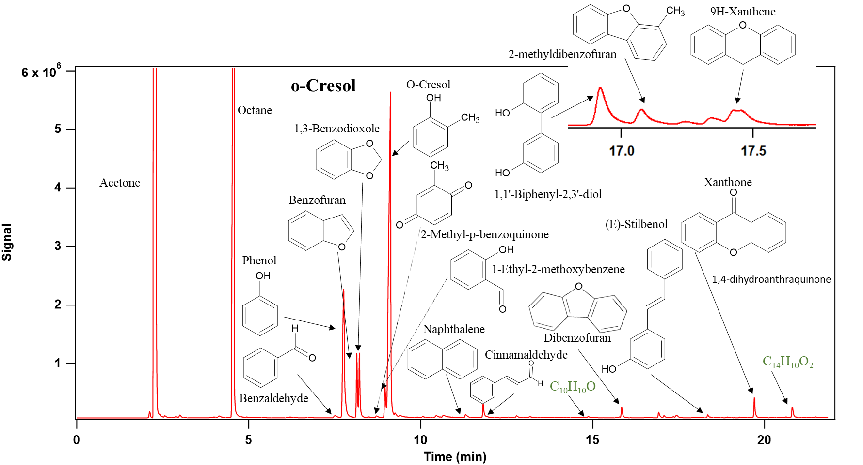
Figure SI.1: Chromatogram of heavy compounds (containing more than 6 carbon atoms) obtained during the oxidation of
o-cresol at T = 950 K, and Φ = 1 (HP5 FID-Offline analysis).
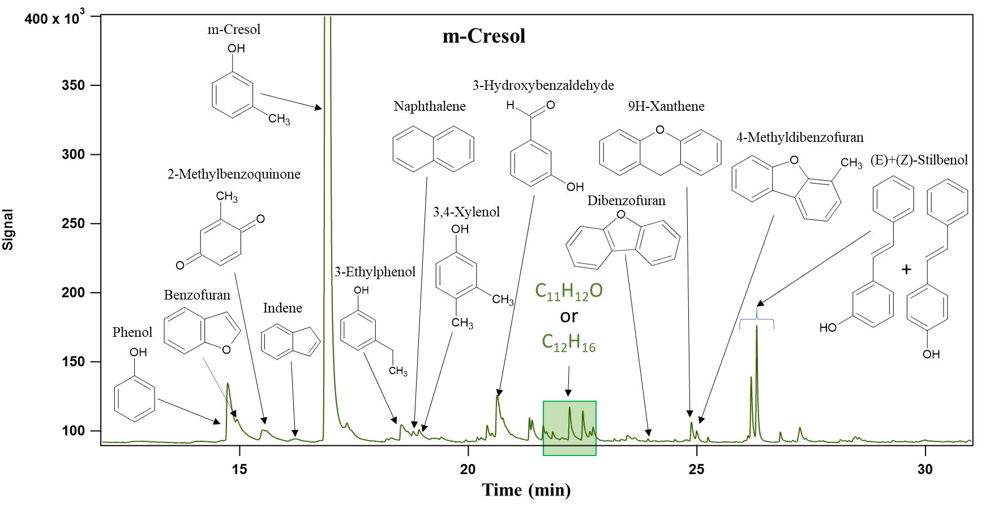
Figure SI.2: Chromatogram of heavy compounds (containing more than 6 carbon atoms) obtained during the oxidation of
m-cresol at T = 950 K, and Φ = 1 (HP5 FID-Offline analysis).
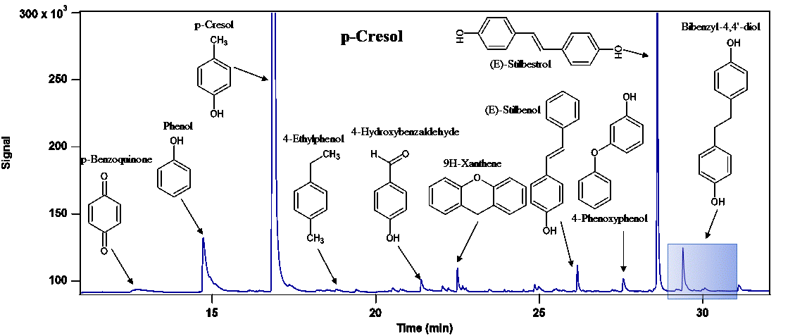
Figure SI.3: Chromatogram of heavy compounds (containing more than 6 carbon atoms) obtained during the oxidation of
p-cresol at T = 950 K, and Φ = 1 (HP5 FID-Offline analysis).

Table SI.1: Structure of the species of Figure 3b.

Chemical name | The structure
p-Benzoquinone
Phenol
Benzofuran
1,3-Benzodioxole
2-methyl-p-benzoquinone | 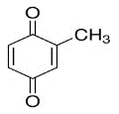
Hydroxybenzaldehyde* | 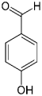
9H-Xanthene
Naphthalene | 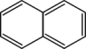
Cinnamaldehyde
Xanthone | 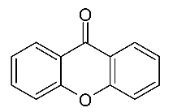
4-Stilbenol*
C₁₄H₁₂O₂ | Not identified
* drawn in the case of p-cresol.

Table SI.2: Carbon-atom balances (in %) recorded for the oxidation of cresol isomers.

Mechanisms for the oxidation of cresol isomers

Heats of reaction for selected H abstraction reactions

Table SII.1: Heats of reaction (G4 level, 298 K) for H atom abstraction from the three cresol isomers by various abstracting species: cresol isomer + X → cresol isomer radical + HX. Exothermic channels are colored in red.
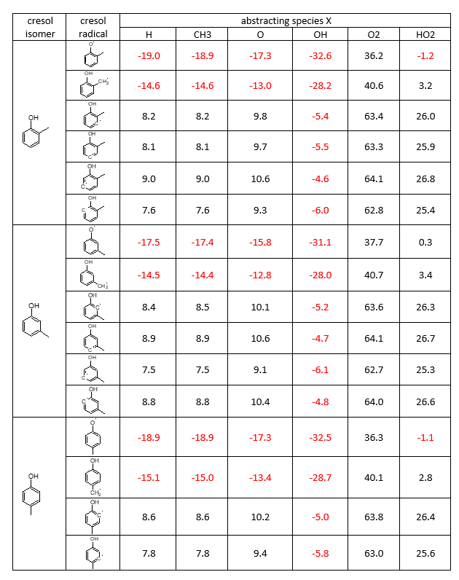

2. Potential energy surfaces relevant for the development of the cresol sub-mechanism

A. Unimolecular decomposition reactions of o-methylphenoxy radicals

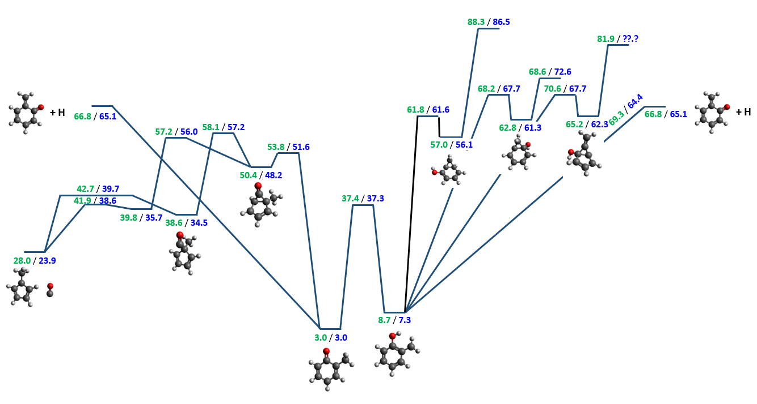
Figure SII-1: PES for methyl substituted phenoxy decomposition. Enthalpies at 298 K in kcal/mol are calculated either at the CBS-QB3 (green) or G4 (blue) level of theory.

B. Reactions of o-cresyl radicals with molecular oxygen

B1. O₂ addition to o-methylphenoxy radical

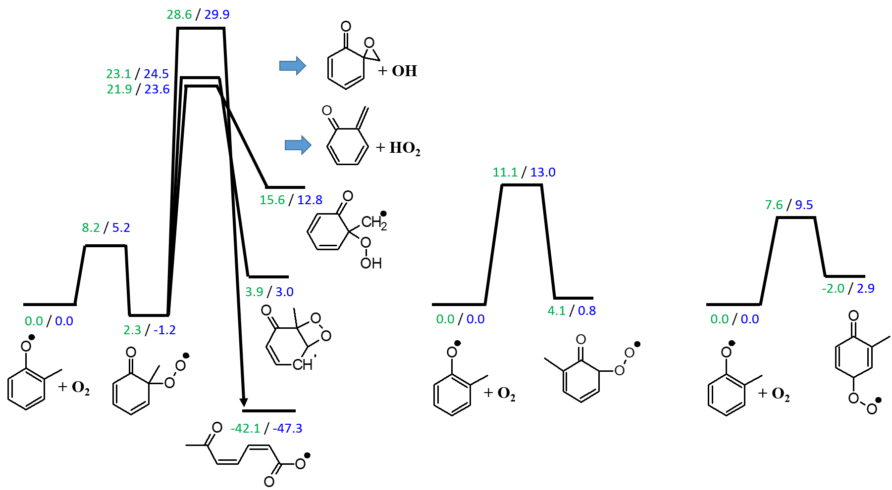

Figure SII-2a Simplified PES for O₂ addition pathways to o-methylphenoxy radical. Enthalpies at 298 K in kcal/mol are calculated at the CBS-QB3 (green) and G4 (blue) level of theory. The scheme is scaled according to the G4 data.

O₂ addition to any of the three carbon radical sites of o-methylphenoxy leads to approximately thermoneutral products, which can easily re-dissociate, while any forward reaction to different bimolecular products has a high barrier. The reactions on this PES are considered unimportant for cresol oxidation.

B2. O₂ addition to o-hydroxybenzyl radical

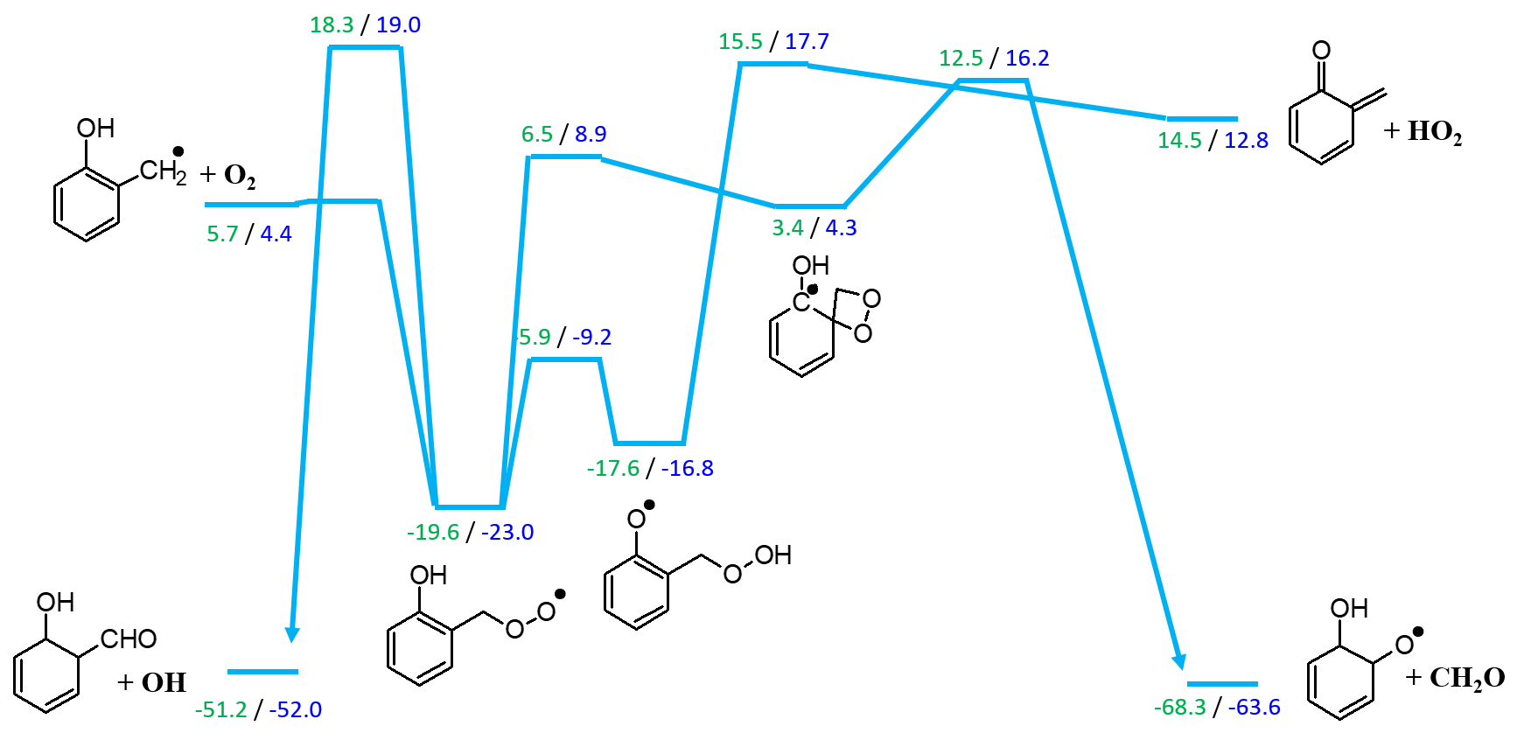
Figure SII-2b Simplified PES for O₂ addition pathways to o-hydroxybenzyl radical. Enthalpies at 298 K in kcal/mol are calculated at the CBS-QB3 (green) and G4 (blue) level of theory. The scheme is scaled according to the G4 data.

The peroxy bond formed in the addition to the benzyl radical site is with about 27 kcal/mol rather weak. Consequently, all reaction pathways that lead (eventually) to new bimolecular products proceed through barriers above the enthalpy for re-dissociation. All shown pathways are included in the kinetic model, because the barriers are only a few kcal/mol above the reactant energy and because the reverse reaction of the HO₂ channel provides a mechanism for ortho quinone methide consumption. Note, that additional molecular oxygen addition pathways similar to those shown for o-methylphenoxy are possible but ignored since the bond strengths are believed to be much lower than that for forming the o-hydroxyphenyperoxy radical shown in this scheme.

B3. O₂ addition to m-hydroxy,o-methylphenyl radical

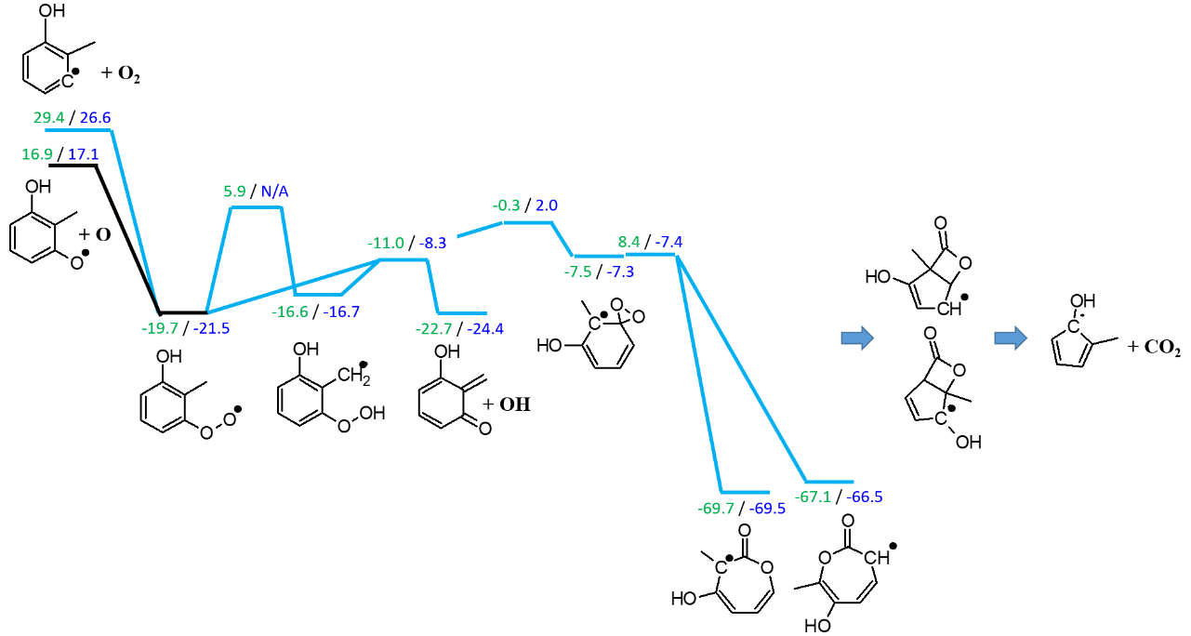
Figure SII-2c Simplified PES for O₂ addition pathways to m-hydroxy,o-methylphenyl radical. Enthalpies at 298 K in kcal/mol are calculated at the CBS-QB3 (green) and G4 (blue) level of theory. The scheme is scaled according to the G4 data, if available.

The PES for O₂ addition to the aryl radical in ortho position to the methyl group shows that an approximately 48 kcal/mol strong peroxy bond is formed. The high exothermicity of the O₂ addition step opens several channels to bimolecular products. The final steps for CO₂ release (alternative CO production channels are also possible) are not studied but assumed to be similar than found by [1] in their phenyl + O₂ study and not rate determining. The pathways shown in blue are included in the mechanism.

B4. O₂ addition to p-hydroxy,m-methylphenyl radical

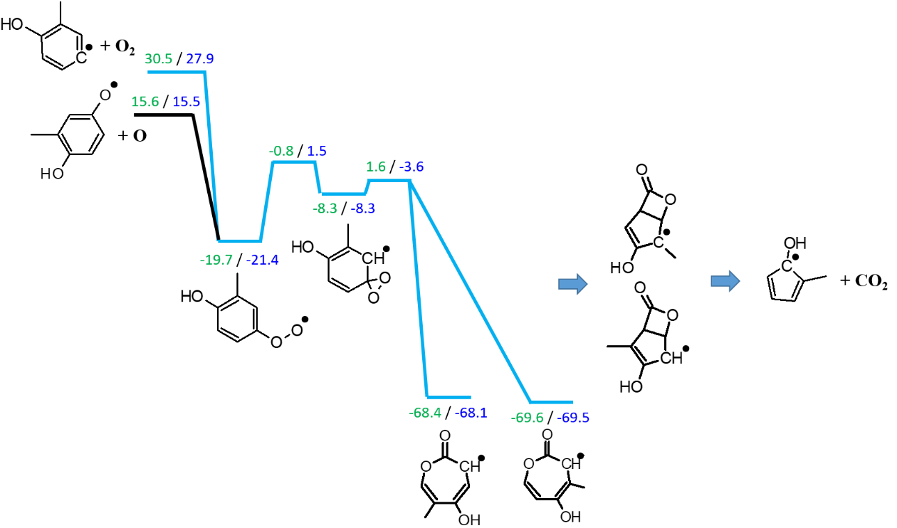
Figure SII-2d Simplified PES for O₂ addition pathways to p-hydroxy,m-methylphenyl radical. Enthalpies at 298 K in kcal/mol are calculated at the CBS-QB3 (green) and G4 (blue) level of theory. The scheme is scaled according to the G4 data.

The CO₂ forming pathway is clearly lower in energy compared to the release of atomic oxygen. An internal H abstraction channel as seen in Figure SII-2c does not exist here since both, the OH and CH₃ groups are too far away from the peroxy radical. In the proposed cresol sub-mechanism, only the channel in blue is considered. Furthermore, the high exothermicity allows to lump the reaction steps into a single one with the initial barrier forming the bottleneck.

B5. O₂ addition to p-methyl,m-hydroxyphenyl radical

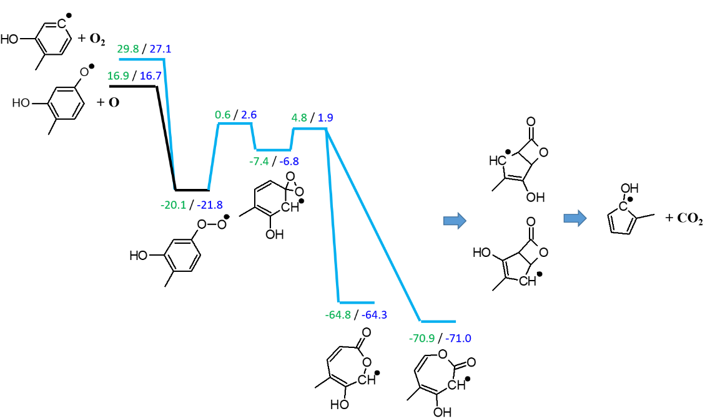
Figure SII-2e Simplified PES for O₂ addition pathways to p-methyl,m-hydroxyphenyl radical. Enthalpies at 298 K in kcal/mol are calculated at the CBS-QB3 (green) and G4 (blue) level of theory. The scheme is scaled according to the G4 data.

This PES is similar to that shown in Figure SII-2d: Intramolecular H abstraction is not possible. Only the CO₂ formation pathway shown in blue is considered using lumping to avoid the need to increase the number of species in the mechanism.

B6. O₂ addition to m-methyl,o-hydroxyphenyl radical

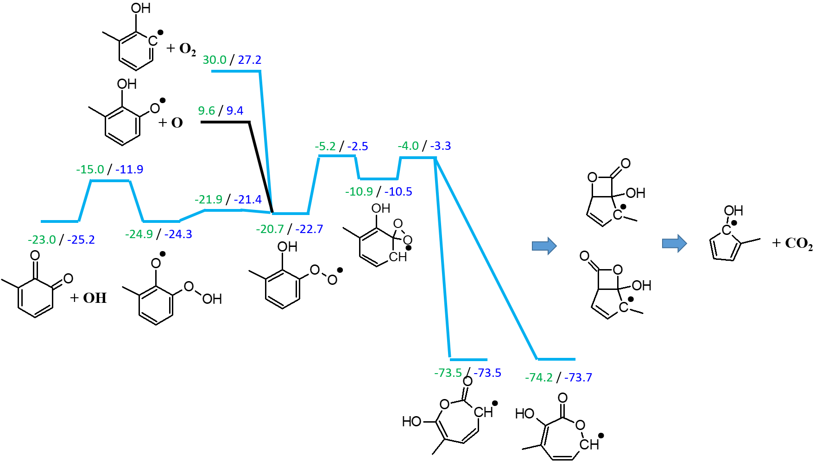
Figure SII-2f Simplified PES for O₂ addition pathways to m-methyl,o-hydroxyphenyl radical. Enthalpies at 298 K in kcal/mol are calculated at the CBS-QB3 (green) and G4 (blue) level of theory. The scheme is scaled according to the G4 data.

This PES is similar to that in Figure SII-2c, because the proximity of the peroxy group to the hydroxyl group allows for internal hydrogen migration followed by OH release from the hydroperoxy group via β-scission. This channel is expected to favorably compete with the CO₂ channel which is also included in the mechanism. The pathways in blue are included in the cresol sub-mechanism.

C. Reactions of m-cresyl radicals with molecular oxygen

C1. O₂ addition to m-methylphenoxy radical
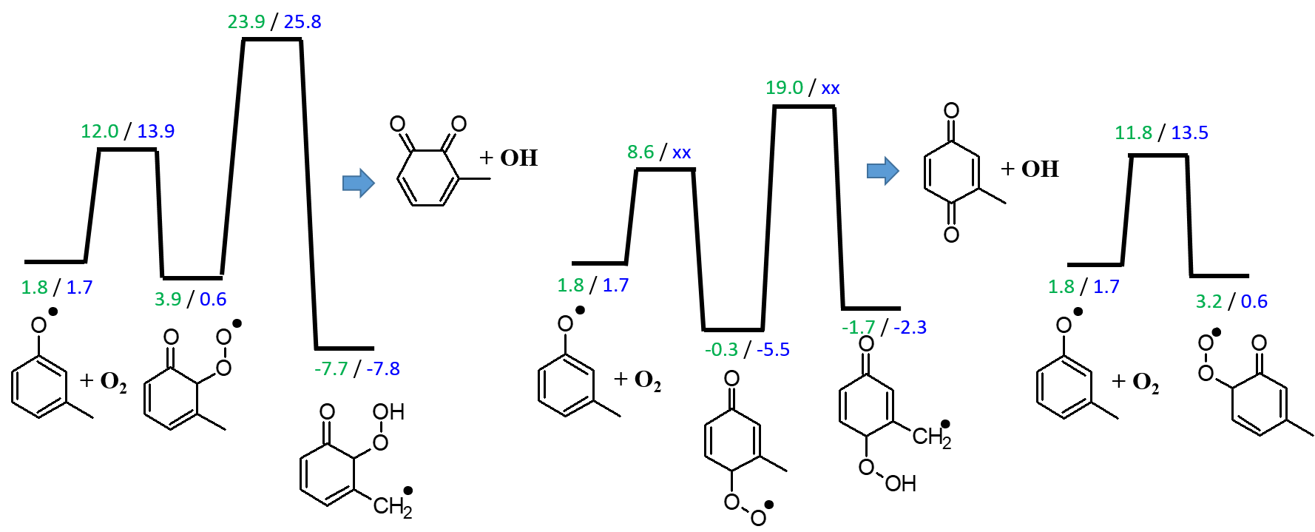
Figure SII-2g Simplified PES for O₂ addition pathways to m-methylphenox radical. Enthalpies at 298 K in kcal/mol are calculated at the CBS-QB3 (green) and G4 (blue) level of theory. The scheme is scaled according to the G4 data.

Similar to the o-methylphenoxy case, O₂ addition to m-methylphenoxy leads to very weakly bounded adducts, which are prone to re-dissociate. The barriers for the formation of different bimolecular products are rather high. None of these pathways have been considered in the development of the cresol sub-mechanism.

C2. O₂ addition to m-hydroxybenzyl radical
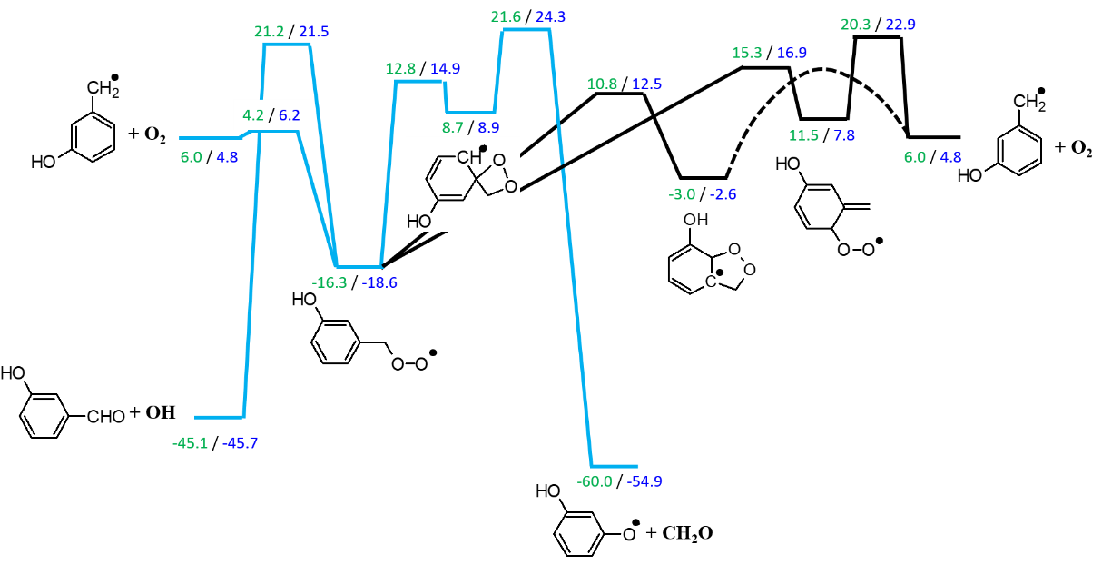
Figure SII-2h Simplified PES for O₂ addition pathways to m-hydroxybenzyl radical. Enthalpies at 298 K in kcal/mol are calculated at the CBS-QB3 (green) and G4 (blue) level of theory. The scheme is scaled according to the G4 data.

This scheme only considers the O₂ addition to the benzylic radical site and ignores additions to the ring as they are higher in energy as one can see on the right hand side of Figure SII-2h: the ortho peroxy methide radical (7.8 kcal/mol relative G4 energy) isomerizes highly exothermically to m-hydroxybenzylperoxy (-18.6 kcal/mol relative energy at G4 level). Compared to the o-hydroxybenzyl case, this m-hydroxybenzyl PES lacks the intramolecular H abstraction pathway and HO₂ elimination pathway. The channels in blue are included in the sub-mechanism but they should not be important. The pathways in black only lead to the initial reactants, hence they are ignored.

C3. O₂ addition to o’-methyl,o-hydroxyphenyl radical
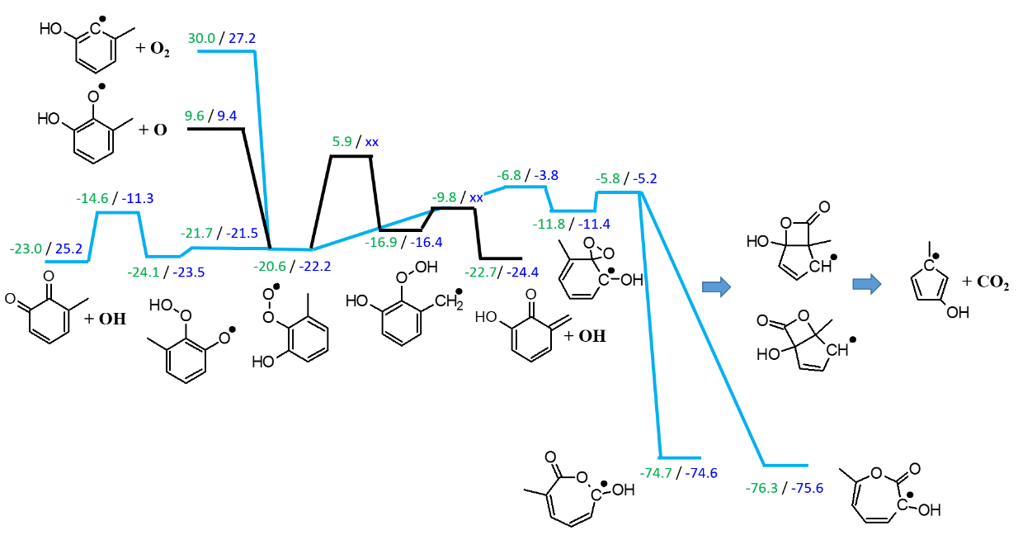

Figure SII-2i Simplified PES for O₂ addition pathways to o’-methyl,o-hydroxyphenyl radical. Enthalpies at 298 K in kcal/mol are calculated at the CBS-QB3 (green) and G4 (blue) level of theory. The scheme is scaled according to the G4 data, if available.

Similar to the ortho cresyl chemistry, O₂ addition to the aryl radical ortho to the hydroxyl and methyl groups yields a peroxy radical which may abstract a H atom from the neighboring group, which ultimately leads to OH release and the formation of either a quinone or a quinone methide. As can be seen in the PES, intramolecular H abstraction is much easier (lower barrier) from the hydroxyl group than from the methyl group and latter is not further considered in the sub-mechanism development. Besides the OH release channel, the highly exothermic CO₂ formation pathway is included in the cresol sub-mechanism. Both pathways are marked blue.

C4. O₂ addition to p-hydroxy,o-methylphenyl radical
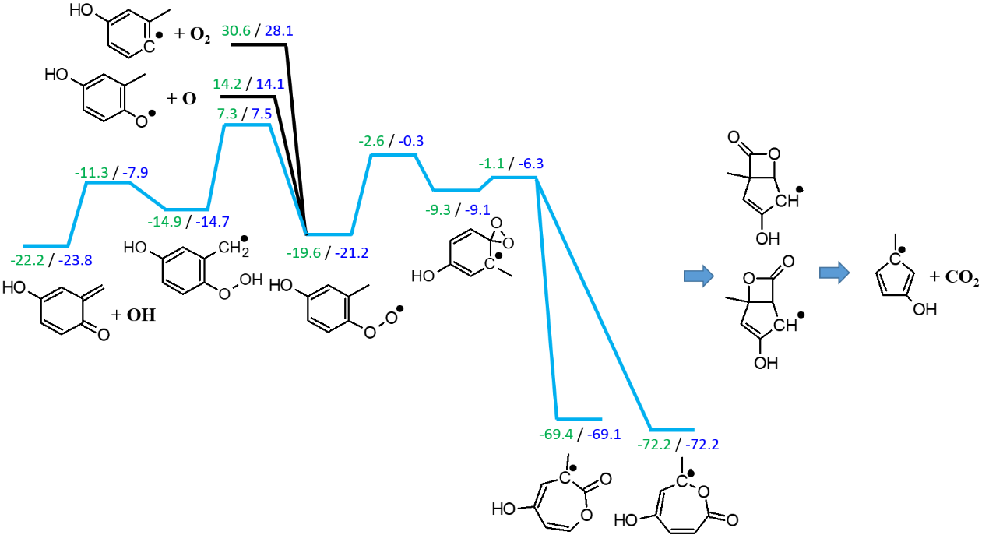
Figure SII-2j Simplified PES for O₂ addition pathways to p-hydroxy,o-methylphenyl radical. Enthalpies at 298 K in kcal/mol are calculated at the CBS-QB3 (green) and G4 (blue) level of theory. The scheme is scaled according to the G4 data.

The peroxy radical is location in close proximity to the methyl group, which allows intramolecular abstraction of a hydrogen. Subsequent OH elimination produces the shown quinone methide. The second channel considered is the CO₂ production pathway starting from the spiro intermediate. Note, that the CO₂ path has the lowest overall barrier unlike in the cases shown in Figures SII-2f and SII-2i, in which the peroxy radical is ortho to the hydroxyl group, which stabilizes the barrier through H bond formation. The considered pathways are marked blue.

C5. O₂ addition to m’-methyl,m-hydroxyphenyl radical
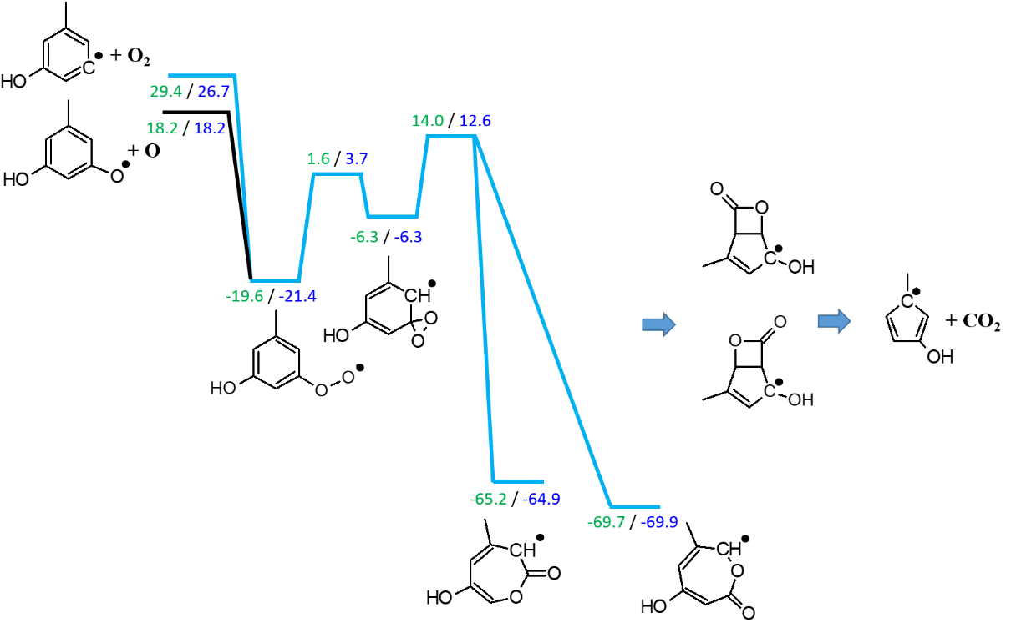
Figure SII-2k Simplified PES for O₂ addition pathways to m’-methyl,m-hydroxyphenyl radical. Enthalpies at 298 K in kcal/mol are calculated at the CBS-QB3 (green) and G4 (blue) level of theory. The scheme is scaled according to the G4 data.

Only the CO₂ formation channel (blue) is included in the cresol sub-mechanism as intramolecular H abstraction reactions are not possible.

C6. O₂ addition to p-methyl,o-hydroxyphenyl radical
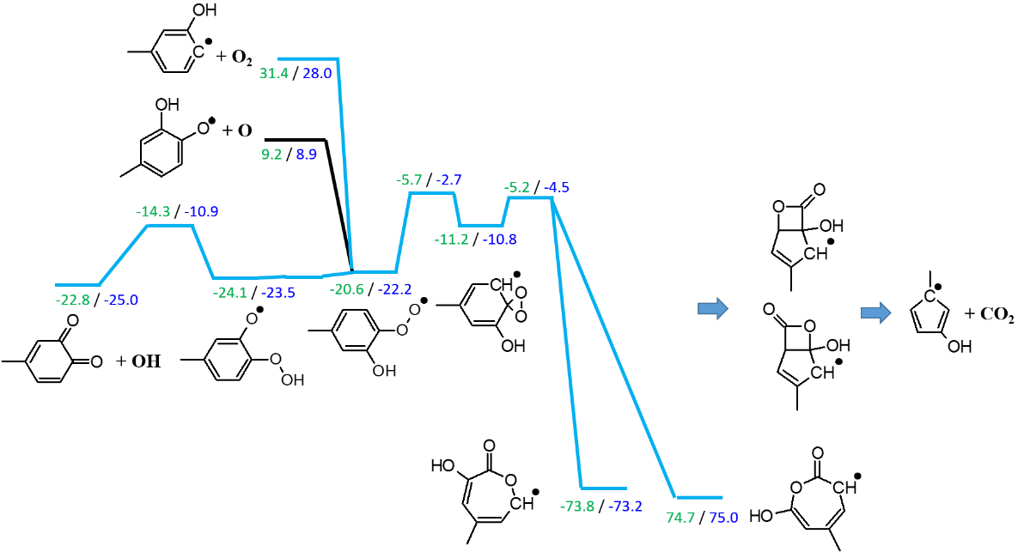

Figure SII-2l Simplified PES for O₂ addition pathways to p-methyl,o-hydroxyphenyl radical. Enthalpies at 298 K in kcal/mol are calculated at the CBS-QB3 (green) and G4 (blue) level of theory. The scheme is scaled according to the G4 data.

The peroxy radical formed through O₂ addition to the aryl radical is located in ortho position to the hydroxyl group. This proximity allows for approximately barrierless intramolecular H abstraction, which reflects the low bond strength of the phenolic hydrogen bond. Formation of the quinone species through OH elimination is the lowest energy pathway, which is considered in the cresol sub-mechanism together with the CO₂ producing pathway.

D. Reactions of p-cresyl radicals with molecular oxygen

D1. O₂ addition to p-methylphenoxy radical
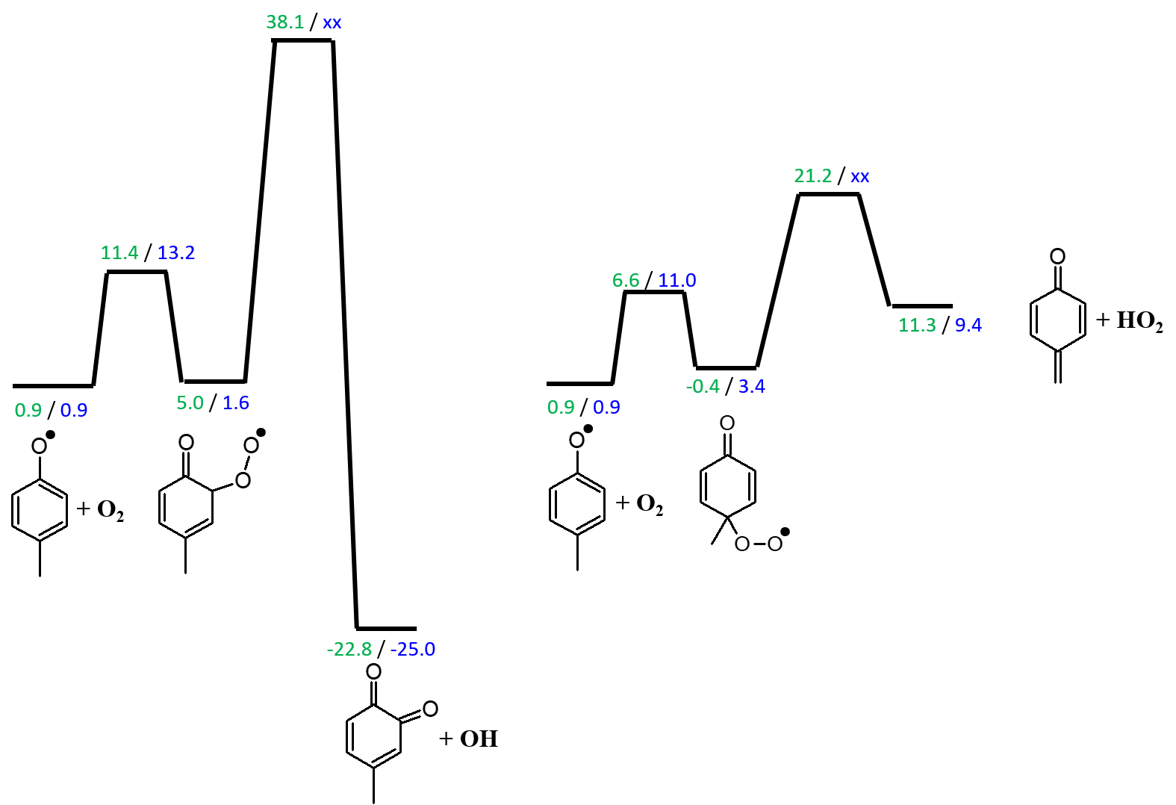
Figure SII-2m Simplified PES for O₂ addition pathways to p-methylphenoxy radical. Enthalpies at 298 K in kcal/mol are calculated at the CBS-QB3 (green) and G4 (blue) level of theory. The scheme is scaled according to the G4 data, if available.

O₂ addition to the p-methyl phenoxy radical produces weakly stable adducts, which have no easily accessible product channels. These reactions are not further considered in the cresol sub-mechanism development.

D2. O₂ addition to p-hydroxybenzyl radical

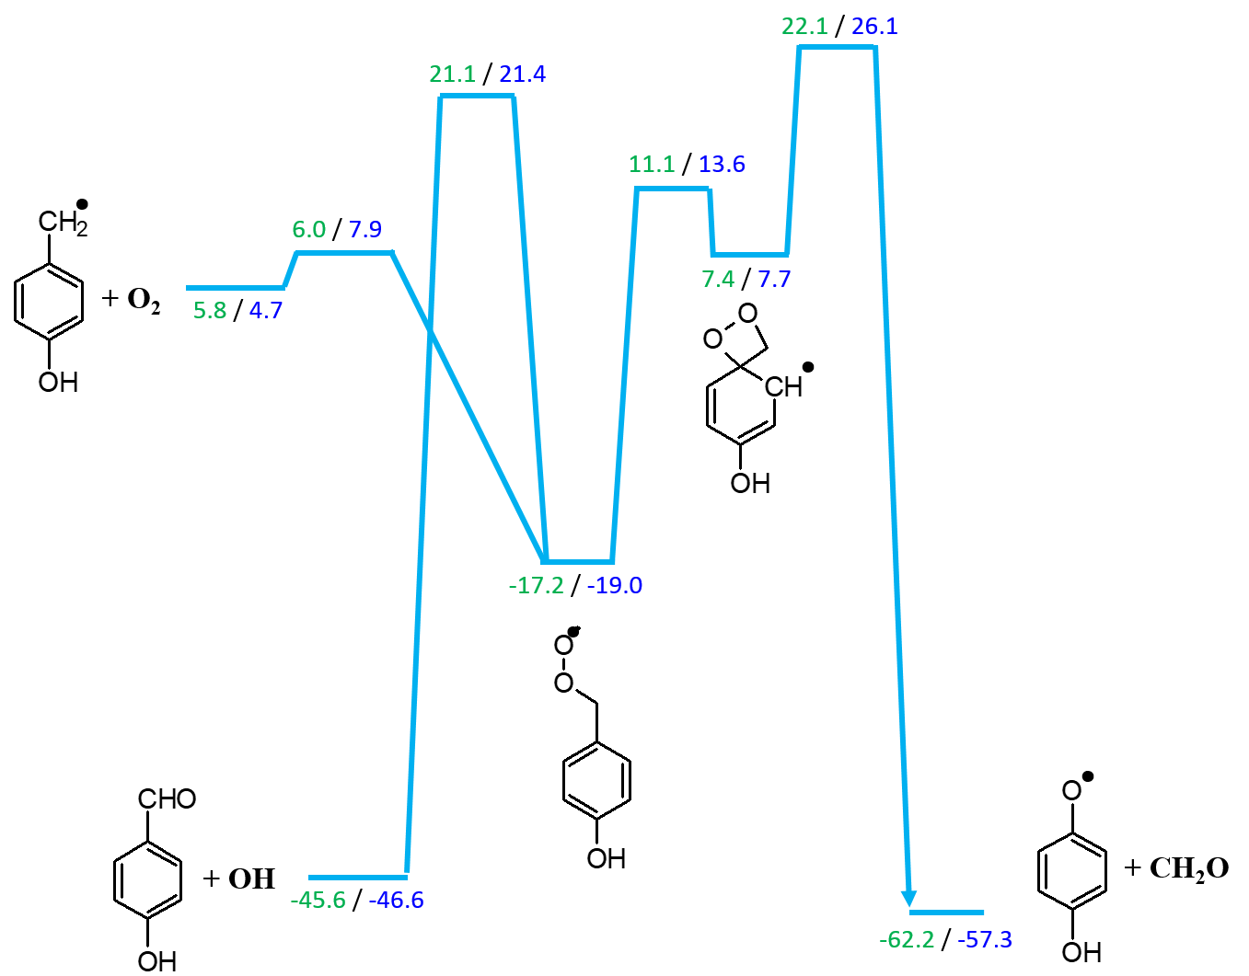
Figure SII-2n Simplified PES for O₂ addition pathways to p-hydroxybenzyl radical. Enthalpies at 298 K in kcal/mol are calculated at the CBS-QB3 (green) and G4 (blue) level of theory. The scheme is scaled according to the G4 data.

Even though the peroxy species from O₂ addition to p-hydroxybenzyl radical is moderately stable, all product channels have barriers higher than the entrance channel. Therefore, these pathways should not be important. Nevertheless, all channels are included in the sub-mechanism, since the products are anyway part of Colibri.

D3. O₂ addition to m´-methyl,o-hydroxyphenyl radical
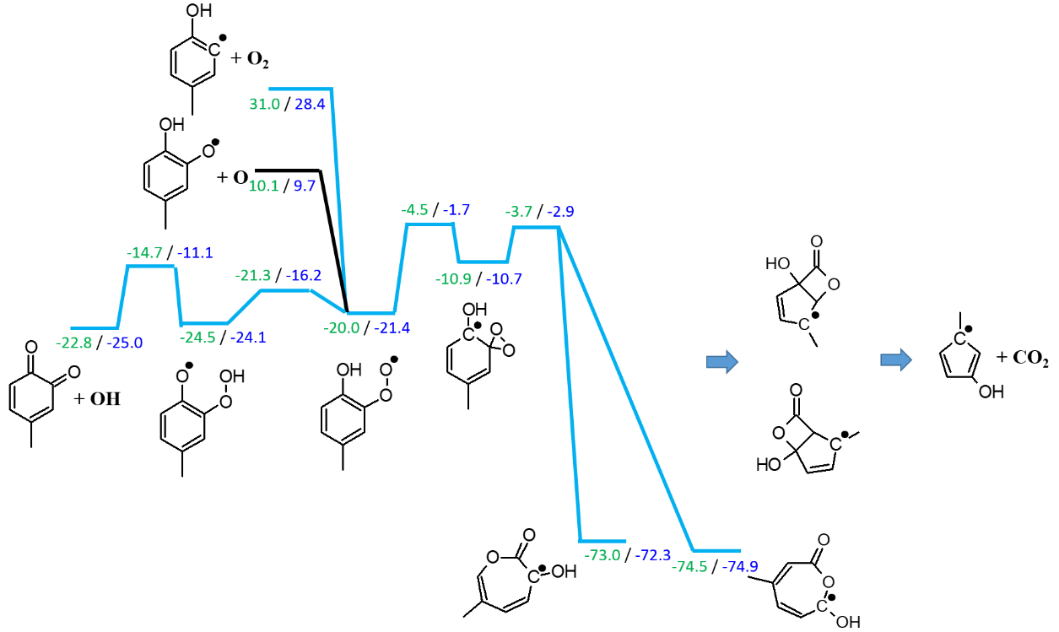
Figure SII-2o Simplified PES for O₂ addition pathways to m´-methyl,o-hydroxyphenyl radical. Enthalpies at 298 K in kcal/mol are calculated at the CBS-QB3 (green) and G4 (blue) level of theory. The scheme is scaled according to the G4 data.

The proximity of the peroxy group next to the hydroxyl moiety enables an intramolecular low-barrier H abstraction reaction which is followed by OH elimination to produce the methyl substituted quinone shown in the PES at the left. The overall barrier for the channel is lower than that of the CO₂ formation pathway. Both pathways in blue are included in the cresol sub-mechanism.

D4. O₂ addition to m´-hydroxy,o-methylphenyl radical
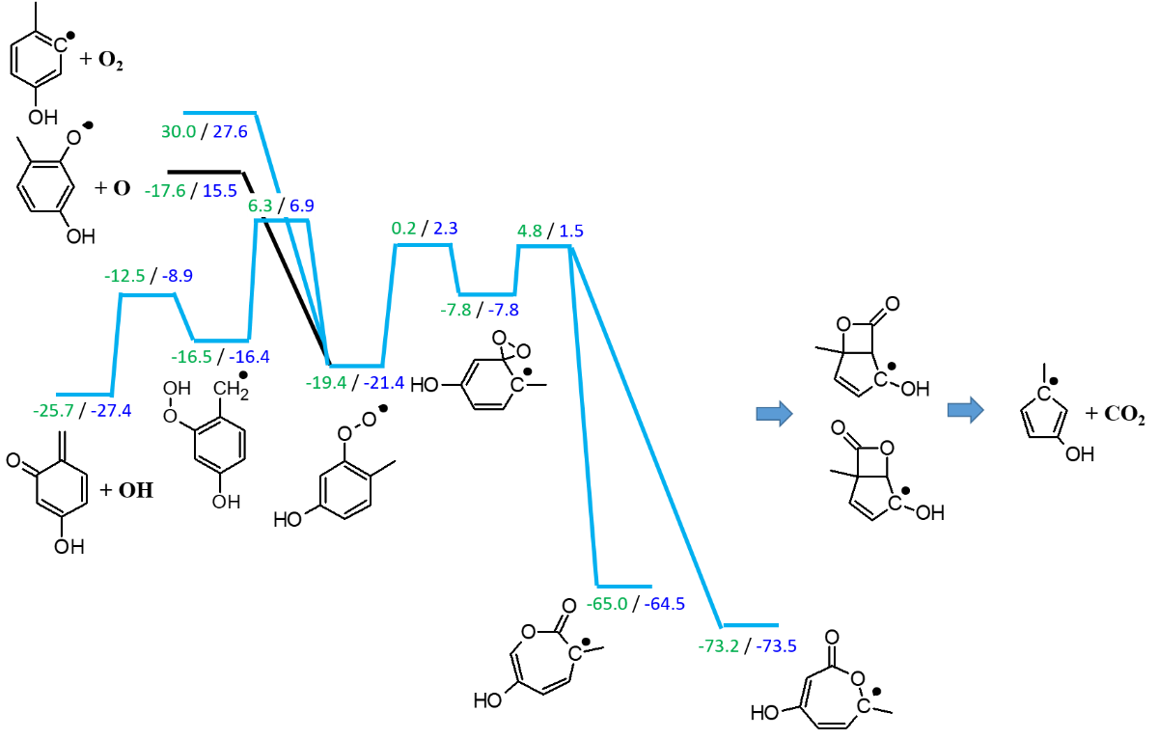
Figure SII-2p Simplified PES for O₂ addition pathways to m´-hydroxy,o-methylphenyl radical. Enthalpies at 298 K in kcal/mol are calculated at the CBS-QB3 (green) and G4 (blue) level of theory. The scheme is scaled according to the G4 data.

This PES is similar to the previous one but since intramolecular H abstraction from the methyl group requires more energy than from the phenolic moiety, the overall barrier for the OH formation pathway is higher than that of the CO₂ producing channel. Both (marked blue) are included in the cresol sub-mechanism.

3. Comparison between CBS-QB3 and G4 energies and T1 values
Calculations have been done at both, the CBS-QB3 and G4 levels of theory. Figure SII-3a shows that the deviations are not Gaussian distributed but resemble a bimodal structure. This indicates systematic differences between both methods. But in general, the energies for the stable points on the C₇H₇O₃ PES agree within 2 kcal/mol, which allows to reliably identify the most stable species on the surfaces. Only for five species, deviations of more than 3 kcal/mol are observed, of which – interestingly – three indicate a substantially higher G4 energy than calculated at the CBS-QB3 level while for two species the opposite is found. This emphasizes again the bimodal behavior.
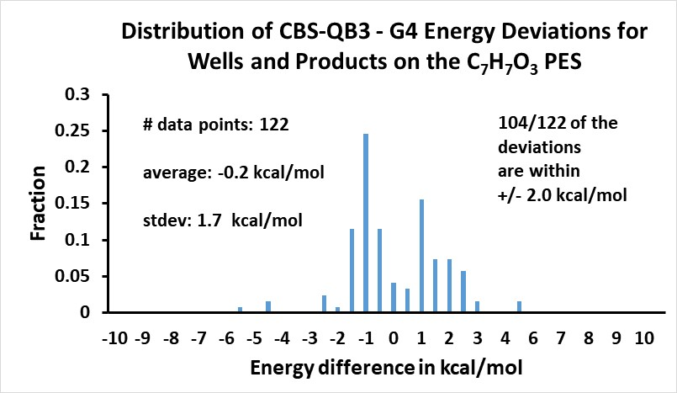
Figure SII-3a Δ_{f}H298 (CBS-QB3) - Δ_{f}H298 (G4) results calculated largely from the calculations shown in the PES plots in section 2. Identical product channels are only considered once.

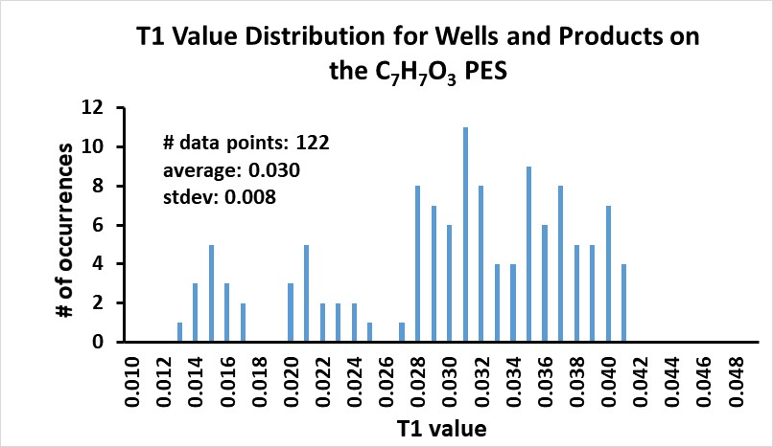
Figure SII-3b T1-diagnostic results for all species considered in Figure SII-3a. The T1 calculations were performed at the CCSD(T1Diag)/GTBas3 level using the G4 optimized geometries.

The T1 diagnostic may serve as a measure for possible multi-reference character of the wavefunction. According to Lee and Taylor [2], “a large T1 (i.e., >0.02) probably indicates the need for a multireference electron correlation procedure.” Although this criterion is not strict and larger values are often accepted, the large number of occurrences of values above 0.03 in Figure SII-3b and the fact that transition state structures have in part even higher T1 values and thus more multireference character indicate that CBS-QB3 and G4 calculations should be improved in future studies to better characterize the important cresol reactions. Given the large number of reactions studied in this work, such demanding calculations were beyond the computational capacity available to us.

4. Structures of new species included in the cresol sub-mechanism
The following table provides information for species used in the Colibri mechanism. This includes thermodynamic properties (enthalpy and entropy), which are calculated from the entries in the thermodynamic database. The comments point to the PES surfaces provided above, in which the species play a role.

Table SII.2: Names and structures of species relevant to the cresol sub-mechanism

Name  in mechanism | Structure | InChI | Δ_{f}H²⁹⁸  kcal∙mol⁻¹ | S²⁹⁸  cal∙mol⁻¹K⁻¹ | Comment
O-HOA1CH3 |  | InChI=1S/C7H8O/c1-6-4-2-3-5-7(6)8/h2-5,8H,1H3 | -30.5 | 84.5 | ortho-cresol
O-HOA1CH2 |  | InChI=1S/C7H7O/c1-6-4-2-3-5-7(6)8/h2-5,8H,1H2 | 7.3 | 83.4 | ortho-hydroxybenzyl  Figure SII-1  Figure SII-2b
O-OA1CH3 |  | InChI=1S/C7H7O/c1-6-4-2-3-5-7(6)8/h2-5H,1H3 | 3.0 | 83.9 | ortho-methylphenoxy  Figure SII-1  Figure SII-2a
O-MeA1OH-Ja |  | InChI=1S/C7H7O/c1-6-4-2-3-5-7(6)8/h2-3,5,8H,1H3  InChI=1S/C7H7O/c1-6-4-2-3-5-7(6)8/h2-4,8H,1H3 | 30.5 | 86.7 | Two different radicals are lumped together:  m-hydroxy,o-methylphenyl  Figure SII-2c  m-methyl,o-hydroxyphenyl  Figure SII-2f
O-MeA1OH-Jb |  | InChI=1S/C7H7O/c1-6-4-2-3-5-7(6)8/h3-5,8H,1H3  InChI=1S/C7H7O/c1-6-4-2-3-5-7(6)8/h2,4-5,8H,1H3 | 30.0 | 85.7 | Two different radicals are lumped together:  p-hydroxy,m-methylphenyl  Figure SII-2d  p-methyl,m-hydroxyphenyl  Figure SII-2e
C5H4CH3 |  | InChI=1S/C6H7/c1-6-4-2-3-5-6/h2-5H,1H3 | 51.5 | 69.0 | Figure SII-1
o-OC6H4CH2 |  | InChI=1S/C7H6O/c1-6-4-2-3-5-7(6)8/h2-5H,1H2 | 14.7 | 80.1 | Figure SII-2b
O-HOA1CH2OO |  | InChI=1S/C7H7O3/c8-7-4-2-1-3-6(7)5-10-9/h1-4,8H,5H2 | -19.8 | 93.5 | Figure SII-2b
O-HOA1CHO |  | InChI=1S/C7H6O2/c8-5-6-3-1-2-4-7(6)9/h1-5,9H | -57.4 | 82.5 | Figure SII-2b
O-OA1OH |  | InChI=1S/C6H5O2/c7-5-3-1-2-4-6(5)8/h1-4,7H | -38.0 | 78.1 | Figure SII-2b
O-MeA1(OH)OOJa |  | InChI=1S/C7H7O3/c1-5-6(8)3-2-4-7(5)10-9/h2-4,8H,1H3  InChI=1S/C7H7O3/c1-5-3-2-4-6(10-9)7(5)8/h2-4,8H,1H3 | -18.5 | 95.9 | Two different radicals are lumped together:  m-hydroxy,o-methylphenylperoxy  Figure SII-2c  m-methyl,o-hydroxyphenylperoxy  Figure SII-2f
HOC5H3CH3 |  | InChI=1S/C6H7O/c1-5-3-2-4-6(5)7/h2-4,7H,1H3 | 8.7 | 80.2 | Figure SII-2c  Figure SII-2d  Figure SII-2e  Figure SII-2f
OC6H3(O)CH3 |  | InChI=1S/C7H6O2/c1-5-3-2-4-6(8)7(5)9/h2-4H,1H3  InChI=1S/C7H6O2/c1-5-6(8)3-2-4-7(5)9/h2-4,8H,1H2  InChI=1S/C7H6O2/c1-5-4-6(8)2-3-7(5)9/h2-4,8H,1H2  InChI=1S/C7H6O2/c1-5-2-3-6(8)7(9)4-5/h2-4H,1H3  InChI=1S/C7H6O2/c1-5-2-3-6(8)4-7(5)9/h2-4,8H,1H2 | -28.6 | 87.6 | Five different products are lumped together:  Figure SII-2f  Figure SII-2i  Figure SII-2c  Figure SII-2j  Figure SII-2l  Figure SII-2o  Figure SII-2p
O-MeA1(OH)OOJb |  | InChI=1S/C7H7O3/c1-5-4-6(10-9)2-3-7(5)8/h2-4,8H,1H3  InChI=1S/C7H7O3/c1-5-2-3-6(10-9)4-7(5)8/h2-4,8H,1H3 | -5.2 | 94.9 | Two different radicals are lumped together:  p-hydroxy,m-methylphenylperoxy  Figure SII-2d  p-methyl,m-hydroxyphenylperoxy  Figure SII-2e
O-HOA1CH2O |  | InChI=1S/C7H7O2/c8-5-6-3-1-2-4-7(6)9/h1-4,9H,5H2 | -15.5 | 87.9
M-HOA1CH3 |  | InChI=1S/C7H8O/c1-6-3-2-4-7(8)5-6/h2-5,8H,1H3 | -30.3 | 85.1 | meta-cresol
M-HOA1CH2 |  | InChI=1S/C7H7O/c1-6-3-2-4-7(8)5-6/h2-5,8H,1H2 | 7.7 | 84.0 | meta-hydroxybenzyl  Figure SII-2h
M-OA1CH3 |  | InChI=1S/C7H7O/c1-6-3-2-4-7(8)5-6/h2-5H,1H3 | 4.7 | 84.2 | meta-methylphenoxy  Figure SII-2g
M-MeA1OH-Ja |  | InChI=1S/C7H7O/c1-6-3-2-4-7(8)5-6/h2-4,8H,1H3  InChI=1S/C7H7O/c1-6-3-2-4-7(8)5-6/h2,4-5,8H,1H3  InChI=1S/C7H7O/c1-6-3-2-4-7(8)5-6/h2-3,5,8H,1H3 | 30.6 | 85.5 | Three different radicals are lumped together:  o’-methyl,o-hydroxyphenyl  Figure SII-2i  p-hydroxy,o-methylphenyl  Figure SII-2j  p-methyl,o-hydroxyphenyl  Figure SII-2l
M-MeA1OH-Jb |  | InChI=1S/C7H7O/c1-6-3-2-4-7(8)5-6/h3-5,8H,1H3 | 29.6 | 86.3 | Figure SII-2k
M-HOA1CH2OO |  | InChI=1S/C7H7O3/c8-7-3-1-2-6(4-7)5-10-9/h1-4,8H,5H2 | -14.0 | 101.8 | Figure SII-2h
M-HOA1CHO |  | InChI=1S/C7H6O2/c8-5-6-2-1-3-7(9)4-6/h1-5,9H | -51.2 | 87.3 | Figure SII-2h
M-OA1OH |  | InChI=1S/C6H5O2/c7-5-2-1-3-6(8)4-5/h1-4,7H | -30.7 | 81.0 | Figure SII-2h
M-MeA1(OH)OOJa |  | InChI=1S/C7H7O3/c1-5-3-2-4-6(8)7(5)10-9/h2-4,8H,1H3  InChI=1S/C7H7O3/c1-5-4-6(8)2-3-7(5)10-9/h2-4,8H,1H3  InChI=1S/C7H7O3/c1-5-2-3-7(10-9)6(8)4-5/h2-4,8H,1H3 | -18.4 | 92.9 | Three different radicals are lumped together:  o’-methyl,o-hydroxyphenylperoxy  Figure SII-2i  p-hydroxy,o-methylphenylperoxy  Figure SII-2j  p-methyl,o-hydroxyphenylperoxy  Figure SII-2l
M-MeA1(OH)OOJb |  | InChI=1S/C7H7O3/c1-5-2-6(8)4-7(3-5)10-9/h2-4,8H,1H3 | -17.4 | 97.7 | Figure SII-2k
M-HOA1CH2O |  | InChI=1S/C7H7O2/c8-5-6-2-1-3-7(9)4-6/h1-4,9H,5H2 | -14.2 | 93.0
P-HOA1CH3 |  | InChI=1S/C7H8O/c1-6-2-4-7(8)5-3-6/h2-5,8H,1H3 | -29.7 | 83.9 | p-cresol
P-HOA1CH2 |  | InChI=1S/C7H7O/c1-6-2-4-7(8)5-3-6/h2-5,8H,1H2 | 7.7 | 82.5 | p-hydroxybenzyl  Figure SII-2n
P-OA1CH3 |  | InChI=1S/C7H7O/c1-6-2-4-7(8)5-3-6/h2-5H,1H3 | 3.8 | 82.9 | p-methylphenoxy  Figure SII-2m
P-MeA1OH-J |  | InChI=1S/C7H7O/c1-6-2-4-7(8)5-3-6/h2-4,8H,1H3  InChI=1S/C7H7O/c1-6-2-4-7(8)5-3-6/h2,4-5,8H,1H3 | 30.5 | 86.7 | Two different radicals are lumped together:  m’-methyl,o-hydroxyphenyl  Figure SII-2o  m’-hydroxy,o-methylphenyl  Figure SII-2p
p-OC6H4CH2 |  | InChI=1S/C7H6O/c1-6-2-4-7(8)5-3-6/h2-5H,1H2 | 11.4 | 78.5
P-HOA1CH2OO |  | InChI=1S/C7H7O3/c8-7-3-1-6(2-4-7)5-10-9/h1-4,8H,5H2 | -15.0 | 98.4 | Figure SII-2n
P-HOA1CHO |  | InChI=1S/C7H6O2/c8-5-6-1-3-7(9)4-2-6/h1-5,9H | -52.0 | 87.1 | Figure SII-2n
P-MeA1(OH)OOJ |  | InChI=1S/C7H7O3/c1-5-2-3-6(8)4-7(5)10-9/h2-4,8H,1H3  InChI=1S/C7H7O3/c1-5-2-3-6(8)7(4-5)10-9/h2-4,8H,1H3 | -17.2 | 96.4 | Two different radicals are lumped together:  m’-hydroxy,o-methylphenylperoxy  Figure SII-2o  m’-methyl,o-hydroxyphenylperoxy  Figure SII-2p
P-HOA1CH2O |  | InChI=1S/C7H7O2/c8-5-6-1-3-7(9)4-2-6/h1-4,9H,5H2 | -13.9 | 92.5

5. Reactions included in the cresol sub-mechanism

Table SII.3: Developed primary mechanism for o-cresol oxidation; units in cm³, mol, s, cal.
Reactions | A | n | Ea | Source/Comment
H-abstractions
O-HOA1CH3+H=O-HOA1CH2+H2 | $$4.4×{10}^{5}$$ | 2.48 | 8600 | Calculated with G4 method
O-HOA1CH3+H=O-OA1CH3+H2 | $$7.6×{10}^{7}$$ | 1.74 | 4800 | Calculated with G4 method
O-HOA1CH3+H=O-MeA1OH-Ja+H2 | $$7.3×{10}^{7}$$ | 1.84 | 13800 | Calculated with G4 method
DUP | $$1.3×{10}^{7}$$ | 2.07 | 14300 | Calculated with G4 method
O-HOA1CH3+H=O-MeA1OH-Jb+H2 | $$7.8×{10}^{7}$$ | 1.86 | 14800 | Calculated with G4 method
DUP | $$5.8×{10}^{7}$$ | 1.89 | 14200 | Calculated with G4 method
O-HOA1CH3+OH=O-HOA1CH2+H2O | $$3.5×{10}^{3}$$ | 2.84 | -2100 | Calculated with G4 method
O-HOA1CH3+OH=O-OA1CH3+H2O | $$2.0×{10}^{13}$$ | 0 | 0 | Estimated, barrierless
O-HOA1CH3+OH=O-MeA1OH-Ja+H2O | $$1.8×{10}^{4}$$ | 2.68 | 2400 | Calculated with G4 method
DUP | $$7.5$$ | 3.51 | 4400 | Calculated with G4 method
O-HOA1CH3+OH=O-MeA1OH-Jb+H2O | $$2.0×{10}^{4}$$ | 2.74 | 7700 | Calculated with G4 method
DUP | $$2.1×{10}^{4}$$ | 2.74 | 7300 | Calculated with G4 method
O-HOA1CH3+O=O-HOA1CH2+OH | $$2.2×{10}^{2}$$ | 3.19 | 1900 | Calculated with G4 method
O-HOA1CH3+O=O-OA1CH3+OH | $$3.3×{10}^{5}$$ | 2.14 | 2200 | Calculated with G4 method
O-HOA1CH3+O=O-MeA1OH-Ja+OH | $$1.3×{10}^{6}$$ | 2.33 | 9200 | Calculated with G4 method
DUP | $$4.7×{10}^{3}$$ | 2.9 | 7400 | Calculated with G4 method
O-HOA1CH3+O=O-MeA1OH-Jb+OH | $$1.8×{10}^{6}$$ | 2.4 | 9700 | Calculated with G4 method
DUP | $$1.5×{10}^{6}$$ | 2.42 | 9600 | Calculated with G4 method
O-HOA1CH3+CH3=O-HOA1CH2+CH4 | $$1.9×{10}^{1}$$ | 3.39 | 7100 | Calculated with G4 method
O-HOA1CH3+CH3=O-OA1CH3+CH4 | $$3.7×{10}^{3}$$ | 2.66 | 4400 | Calculated with G4 method
O-HOA1CH3+HO2=O-HOA1CH2+H2O2 | $$7.0×{10}^{−6}$$ | 5.13 | 10200 | Calculated with G4 method
O-HOA1CH3+HO2=O-OA1CH3+H2O2 | $$3.1×{10}^{2}$$ | 3.03 | 6800 | Calculated with G4 method
 | Bimolecular reactions with O₂
O-HOA1CH3+O2=O-HOA1CH2+HO2 | $$2.7×{10}^{−4}$$ | 4.49 | 36300 | Calculated with G4 method
O-HOA1CH3+O2=O-OA1CH3+HO2 | $$1.2×{10}^{3}$$ | 2.84 | 28200 | Calculated with G4 method
Decompositions of hydroxybenzyl and methylphenoxy radicals
O-OA1CH3 = C5H4CH3+CO | $$2.5×{10}^{12}$$ | 0.48 | 54400 | Calculated with G4 method
DUP | $$1.1×{10}^{12}$$ | 0.61 | 53300 | Calculated with G4 method
O-OA1CH3 = O-HOA1CH2 | $$9.8×{10}^{6}$$ | 1.69 | 31200 | Calculated with G4 method
O-HOA1CH2 = O-OC6H4CH2+H | $$1.2×{10}^{11}$$ | 0.95 | 57100 | Calculated with G4 method
O-HOA1CH2+O2 = O-HOA1CH2OO | $$4.4×{10}^{5}$$ | 1.98 | -2900 | Calculated with CBS-QB3 method
O-HOA1CH2OO = O-HOA1CHO+OH | $$3.9×{10}^{13}$$ | -0.22 | 36400 | Calculated with CBS-QB3 method
O-HOA1CH2OO = CH2O+O-OA1OH | $$6.3×{10}^{15}$$ | -1.13 | 32900 | Calculated with CBS-QB3 method
O-HOA1CH2OO = O-OC6H4CH2+HO2 | $$1.7×{10}^{18}$$ | -1.04 | 36700 | Calculated with CBS-QB3 method
Decompositions of methylhydroxyphenyl radicals
O-MeA1OH-Ja+O2 = O-MeA1(OH)OOJa | $$2.0×{10}^{13}$$ | 0 | 0 | Estimated, barrierless
DUP | $$2.0×{10}^{13}$$ | 0 | 0 | Estimated, barrierless
O-MeA1(OH)OOJa = HOC5H3CH3+CO2 | $$1.3×{10}^{13}$$ | 0 | 16700 | Calculated with CBS-QB3 method
DUP | $$1.0×{10}^{13}$$ | 0.09 | 28500 | Calculated with CBS-QB3 method
O-MeA1(OH)OOJa = OC6H3(O)CH3+OH | $$6.1×{10}^{13}$$ | 0.09 | 6300 | Calculated with CBS-QB3 method
DUP | $$1.6×{10}^{7}$$ | 1.65 | 23000 | Calculated with CBS-QB3 method
O-MeA1OH-Jb+O2 = O-MeA1(OH)OOJb | $$2.0×{10}^{13}$$ | 0 | 0 | Estimated, barrierless
DUP | $$2.0×{10}^{13}$$ | 0 | 0 | Estimated, barrierless
O-MeA1(OH)OOJb = HOC5H3CH3+CO2 | $$1.1×{10}^{11}$$ | 0.7 | 29400 | Calculated with CBS-QB3 method
DUP | $$6.1×{10}^{10}$$ | 0.7 | 20800 | Calculated with CBS-QB3 method
Others
H+O-OA1CH3=>O-HOA1CH3 | $$2.16×{10}^{33}$$ | -5.65 | 7614 | Estimated as A1O+H=A1OH
O-HOA1CH2+O=O-HOA1CH2O | $$2.28×{10}^{14}$$ | 0 | 0 | Estimated as A1CH2+O=A1CH2O

Table SII.4: Developed primary mechanism for m-cresol oxidation; units in cm³, mol, s, cal.

Reactions | A | n | Ea | Source/Comment
H-abstractions
M-HOA1CH3+H=M-HOA1CH2+H2 | $$1.0×{10}^{6}$$ | 2.39 | 4400 | Calculated with G4 method
M-HOA1CH3+H=M-OA1CH3+H2 | $$1.2×{10}^{8}$$ | 1.69 | 5900 | Calculated with G4 method
M-HOA1CH3+H=M-MeA1OH-Ja+H2 | $$2.8×{10}^{7}$$ | 1.98 | 14500 | Calculated with G4 method
DUP | $$2.5×{10}^{7}$$ | 2 | 14800 | Calculated with G4 method
DUP | $$8.7×{10}^{7}$$ | 1.84 | 14600 | Calculated with G4 method
M-HOA1CH3+H=M-MeA1OH-Jb+H2 | $$5.5×{10}^{7}$$ | 1.89 | 13700 | Calculated with G4 method
M-HOA1CH3+OH=M-HOA1CH2+H2O | $$1.5×{10}^{6}$$ | 2.33 | -900 | Calculated with G4 method
M-HOA1CH3+OH=M-OA1CH3+H2O | $$2.0×{10}^{13}$$ | 0 | 0 | Estimated, barrierless
M-HOA1CH3+OH=M-MeA1OH-Ja+H2O | $$5.6$$ | 3.54 | -1400 | Calculated with G4 method
DUP | $$1.7×{10}^{1}$$ | 3.41 | -200 | Calculated with G4 method
DUP | $$1.6×{10}^{4}$$ | 2.68 | 6900 | Calculated with G4 method
M-HOA1CH3+OH=M-MeA1OH-Jb+H2O | $$6.1×{10}^{4}$$ | 2.61 | 2200 | Calculated with G4 method
M-HOA1CH3+O=M-HOA1CH2+OH | $$5.2×{10}^{4}$$ | 2.75 | 3100 | Calculated with G4 method
M-HOA1CH3+O=M-OA1CH3+OH | $$7.3×{10}^{7}$$ | 1.68 | 3600 | Calculated with G4 method
M-HOA1CH3+O=M-MeA1OH-Ja+OH | $$4.0×{10}^{3}$$ | 2.92 | 7300 | Calculated with G4 method
DUP | $$3.8×{10}^{3}$$ | 2.93 | 7800 | Calculated with G4 method
DUP | $$1.4×{10}^{6}$$ | 2.36 | 9600 | Calculated with G4 method
M-HOA1CH3+O=M-MeA1OH-Jb+OH | $$1.6×{10}^{6}$$ | 2.41 | 9200 | Calculated with G4 method
M-HOA1CH3+CH3=M-HOA1CH2+CH4 | $$1.7×{10}^{1}$$ | 3.42 | 7100 | Calculated with G4 method
M-HOA1CH3+CH3=M-OA1CH3+CH4 | $$4.1×{10}^{3}$$ | 2.65 | 5100 | Calculated with G4 method
M-HOA1CH3+HO2=M-HOA1CH2+H2O2 | $$1.0×{10}^{−1}$$ | 4.17 | 11700 | Calculated with G4 method
M-HOA1CH3+HO2=M-OA1CH3+H2O2 | $$2.8×{10}^{1}$$ | 3.28 | 9000 | Calculated with G4 method
 | Bimolecular reactions with O₂
M-HOA1CH3+O2=M-HOA1CH2+HO2 | $$3.1×{10}^{2}$$ | 3.28 | 38900 | Calculated with G4 method
M-HOA1CH3+O2=M-OA1CH3+HO2 | $$9.0×{10}^{2}$$ | 2.87 | 29200 | Calculated with G4 method
Decomposition of hydroxybenzyl and methylphenoxy radicals
M-OA1CH3 = C5H4CH3+CO | $$2.2×{10}^{12}$$ | 0.49 | 53100 | Calculated with G4 method
DUP | $$3.8×{10}^{12}$$ | 0.43 | 53500 | Calculated with G4 method
M-HOA1CH2+O2 = M-HOA1CH2OO | $$6.7×{10}^{5}$$ | 2.01 | -1800 | Calculated with CBS-QB3 method
M-HOA1CH2OO = M-HOA1CHO+OH | $$3.1×{10}^{4}$$ | 2.44 | 34100 | Calculated with CBS-QB3 method
M-HOA1CH2OO = CH2O+M-OA1OH | $$1.5×{10}^{7}$$ | 1.5 | 37100 | Calculated with CBS-QB3 method
Decomposition of methylhydroxyphenyl radicals
M-MeA1OH-Ja+O2 = M-MeA1(OH)OOJa | $$2.0×{10}^{13}$$ | 0 | 0 | Estimated, barrierless
DUP | $$2.0×{10}^{13}$$ | 0 | 0 | Estimated, barrierless
DUP | $$2.0×{10}^{13}$$ | 0 | 0 | Estimated, barrierless
M-MeA1(OH)OOJa = HOC5H3CH3+CO2 | $$5.9×{10}^{13}$$ | 0.07 | 14900 | Calculated with CBS-QB3 method
DUP | $$4.0×{10}^{13}$$ | 0.09 | 15500 | Calculated with CBS-QB3 method
DUP | $$3.9×{10}^{12}$$ | 0.15 | 17200 | Calculated with CBS-QB3 method
M-MeA1(OH)OOJa = OC6H3(O)CH3+OH | $$2.4×{10}^{14}$$ | 0.15 | 6700 | Calculated with CBS-QB3 method
DUP | $$4.6×{10}^{13}$$ | 0.23 | 6900 | Calculated with CBS-QB3 method
DUP | $$4.5×{10}^{7}$$ | 1.52 | 24400 | Calculated with CBS-QB3 method
M-MeA1OH-Jb+O2 = M-MeA1(OH)OOJb | $$2.0×{10}^{13}$$ | 0 | 0 | Estimated, barrierless
M-MeA1(OH)OOJb = HOC5H3CH3+CO2 | $$4.7×{10}^{11}$$ | 0.62 | 33800 | Calculated with CBS-QB3 method
Others
H+M-OA1CH3=>M-HOA1CH3 | $$2.16×{10}^{33}$$ | -5.65 | 7614 | Estimated as A1O+H=A1OH
M-HOA1CH2+O=M-HOA1CH2O | $$2.28×{10}^{14}$$ | 0 | 0 | Estimated as A1CH2+O=A1CH2O

Table SII.5: Developed primary mechanism for p-cresol oxidation; units in cm³, mol, s, cal.
Reactions | A | n | Ea | Source/Comment
H-abstractions
P-HOA1CH3+H=P-HOA1CH2+H2 | $$8.0×{10}^{5}$$ | 2.42 | 5000 | Calculated with G4 method
P-HOA1CH3+H=P-OA1CH3+H2 | $$9.6×{10}^{7}$$ | 1.7 | 5000 | Calculated with G4 method
P-HOA1CH3+H=P-MeA1OH-J+H2 | $$1.1×{10}^{8}$$ | 1.88 | 13900 | Calculated with G4 method
DUP | $$4.3×{10}^{7}$$ | 2.01 | 14700 | Calculated with G4 method
P-HOA1CH3+OH=P-HOA1CH2+H2O | $$3.0×{10}^{6}$$ | 2.3 | -1700 | Calculated with G4 method
P-HOA1CH3+OH=P-OA1CH3+H2O | $$2.0×{10}^{13}$$ | 0 | 0 | Estimated, barrierless
P-HOA1CH3+OH=P-MeA1OH-J+H2O | $$9.3×{10}^{4}$$ | 2.57 | 2000 | Calculated with G4 method
DUP | $$3.4×{10}^{1}$$ | 3.41 | -100 | Calculated with G4 method
P-HOA1CH3+O=P-HOA1CH2+OH | $$4.7×{10}^{4}$$ | 2.72 | 0 | Calculated with G4 method
P-HOA1CH3+O=P-OA1CH3+OH | $$1.2×{10}^{8}$$ | 1.6 | 6500 | Calculated with G4 method
P-HOA1CH3+O=P-MeA1OH-J+OH | $$2.1×{10}^{6}$$ | 2.36 | 9500 | Calculated with G4 method
DUP | $$6.9×{10}^{3}$$ | 2.94 | 8000 | Calculated with G4 method
P-HOA1CH3+CH3=P-HOA1CH2+CH4 | 8.0 | 3.53 | 10700 | Calculated with G4 method
P-HOA1CH3+CH3=P-OA1CH3+CH4 | $$3.3×{10}^{3}$$ | 2.69 | 4300 | Calculated with G4 method
P-HOA1CH3+HO2=P-HOA1CH2+H2O2 | $$1.8×{10}^{−1}$$ | 4.15 | 11000 | Calculated with G4 method
P-HOA1CH3+HO2=P-OA1CH3+H2O2 | $$4.4×{10}^{1}$$ | 3.34 | 7800 | Calculated with G4 method
 | Bimolecular reactions with O₂
P-HOA1CH3+O2=P-HOA1CH2+HO2 | $$1.5×{10}^{2}$$ | 3.36 | 37400 | Calculated with G4 method
P-HOA1CH3+O2=P-OA1CH3+HO2 | $$1.7×{10}^{3}$$ | 2.85 | 27900 | Calculated with G4 method
Decomposition of hydroxybenzyl and methylphenoxy radicals
P-OA1CH3 = C5H4CH3+CO | $$4.5×{10}^{12}$$ | 0.49 | 54200 | Calculated with CBS-QB3 method
P-OA1CH3 = P-OC6H4CH2+H | $$1.0×{10}^{14}$$ | 0 | 0 | Estimated, barrierless
P-HOA1CH2 = P-OC6H4CH2+H | $$9.7×{10}^{11}$$ | 0.67 | 58100 | Calculated with CBS-QB3 method
P-HOA1CH2+O2 = P-HOA1CH2OO | $$2.0×{10}^{13}$$ | 0 | 0 | Estimated, barrierless
P-HOA1CH2OO = P-HOA1CHO+OH | $$2.3×{10}^{5}$$ | 2.31 | 35000 | Calculated with CBS-QB3 method
Decomposition of methylhydroxyphenyl radicals
P-MeA1OH-J+O2 = P-MeA1(OH)OOJ | $$2.0×{10}^{13}$$ | 0 | 0 | Calculated with CBS-QB3 method
DUP | $$2.0×{10}^{13}$$ | 0 | 0 | Calculated with CBS-QB3 method
P-MeA1(OH)OOJ = OC6H3(O)CH3+OH | $$5.7×{10}^{7}$$ | 1.44 | 23100 | Calculated with CBS-QB3 method
DUP | $$1.6×{10}^{13}$$ | 0.45 | 5800 | Calculated with CBS-QB3 method
Others
H+P-OA1CH3=>P-HOA1CH3 | $$2.16×{10}^{33}$$ | -5.65 | 7614 | as A1O+H=A1OH
P-HOA1CH2+O=P-HOA1CH2O | $$2.28×{10}^{14}$$ | 0 | 0 | as A1CH2+O=A1CH2O

JSR results
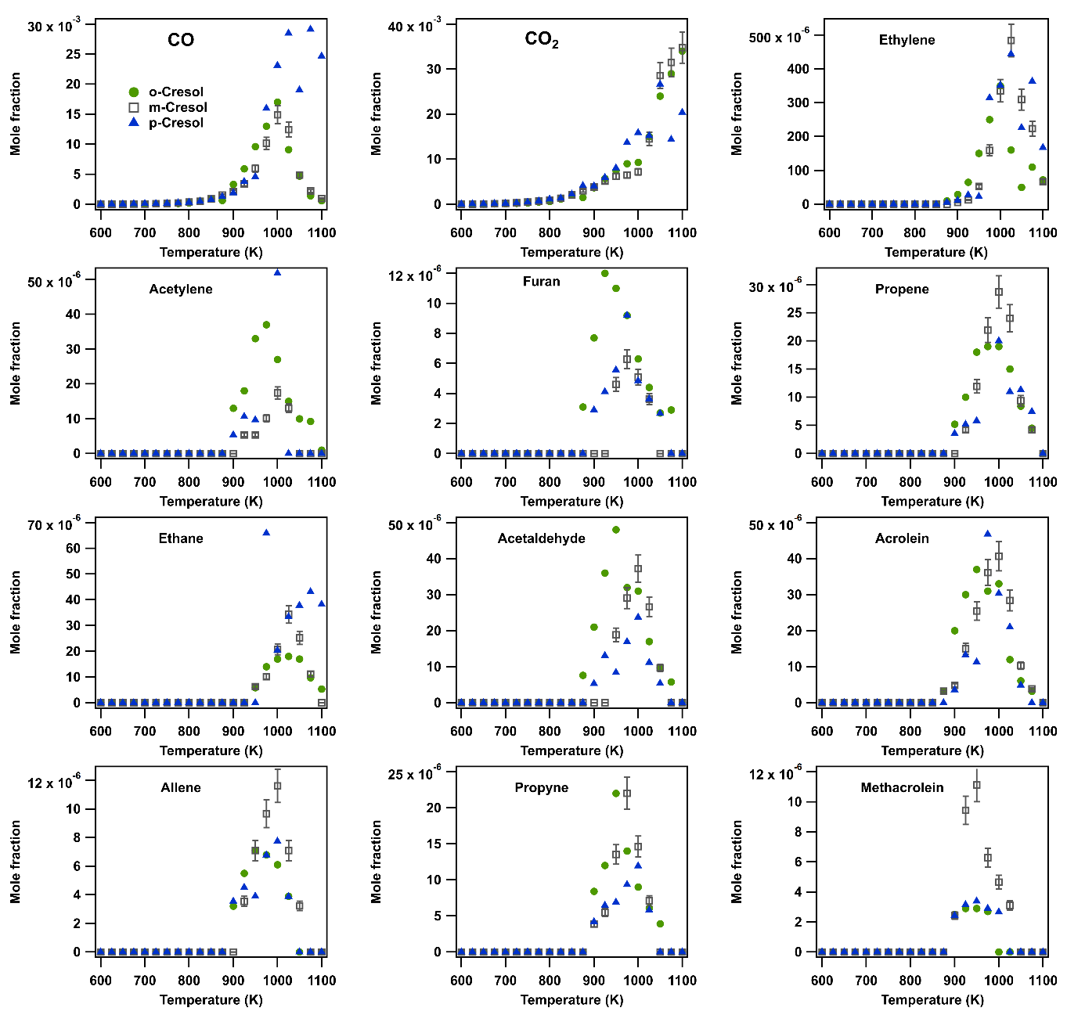
Figure SIII.1: Comparison between the experimental profiles of the common light products produced during the JSR oxidation of the three isomers of cresol (φ=1, τ=2 s, P=1.08 atm).

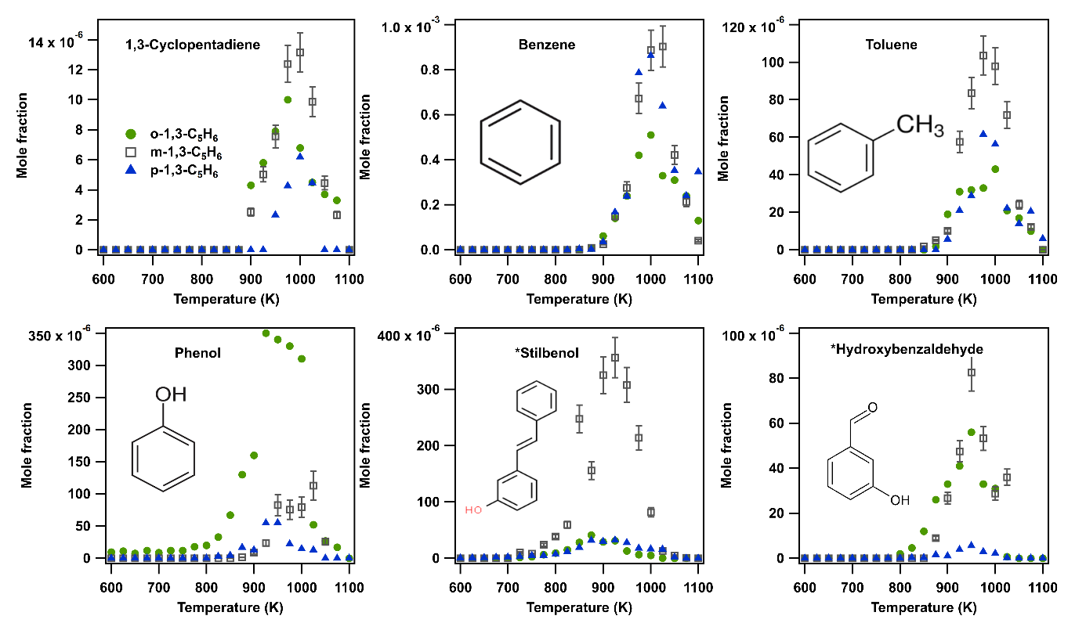Figure SIII.2: Comparison between the experimental profiles of the common heavy products produced during the JSR oxidation of the three isomers of cresol (φ=1, τ=2 s, P=1.08 atm), * the structure of the drawn structure corresponds to meta-xylene.

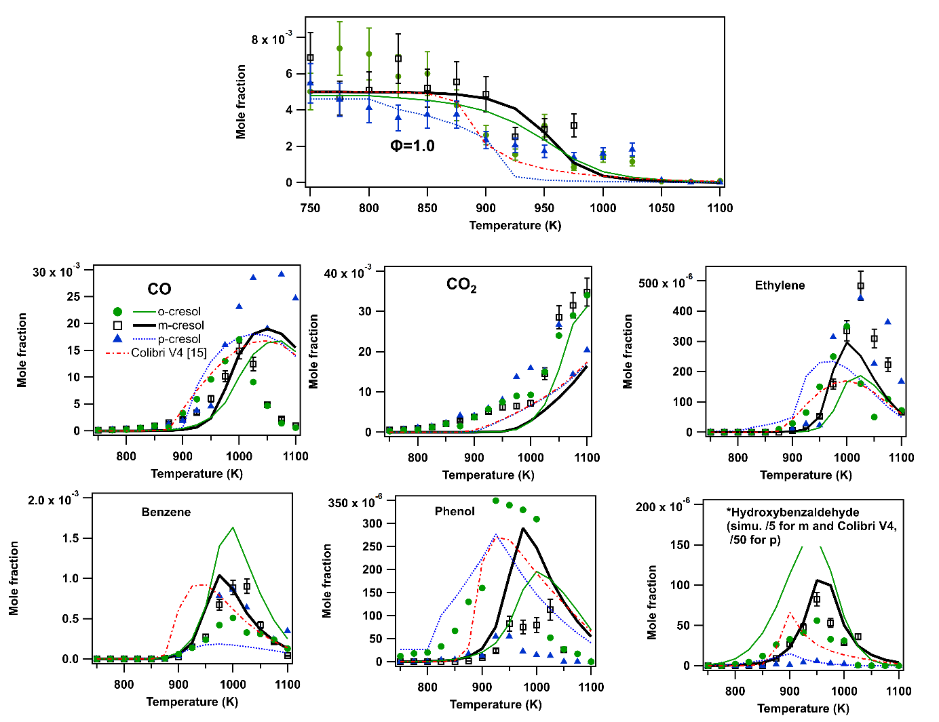
Figure SIII.3: Comparison between the experimental and simulated mole fractions of fuels and main common products during the JSR oxidation of the three isomers of cresol (symbols are experiments and lines modelling using COLIBRIv5 and COLIBRIv4 for lumped cresol isomers, φ=1, τ=2 s, P=1.08 atm).

Flow rate analyses for m- and p-cresol
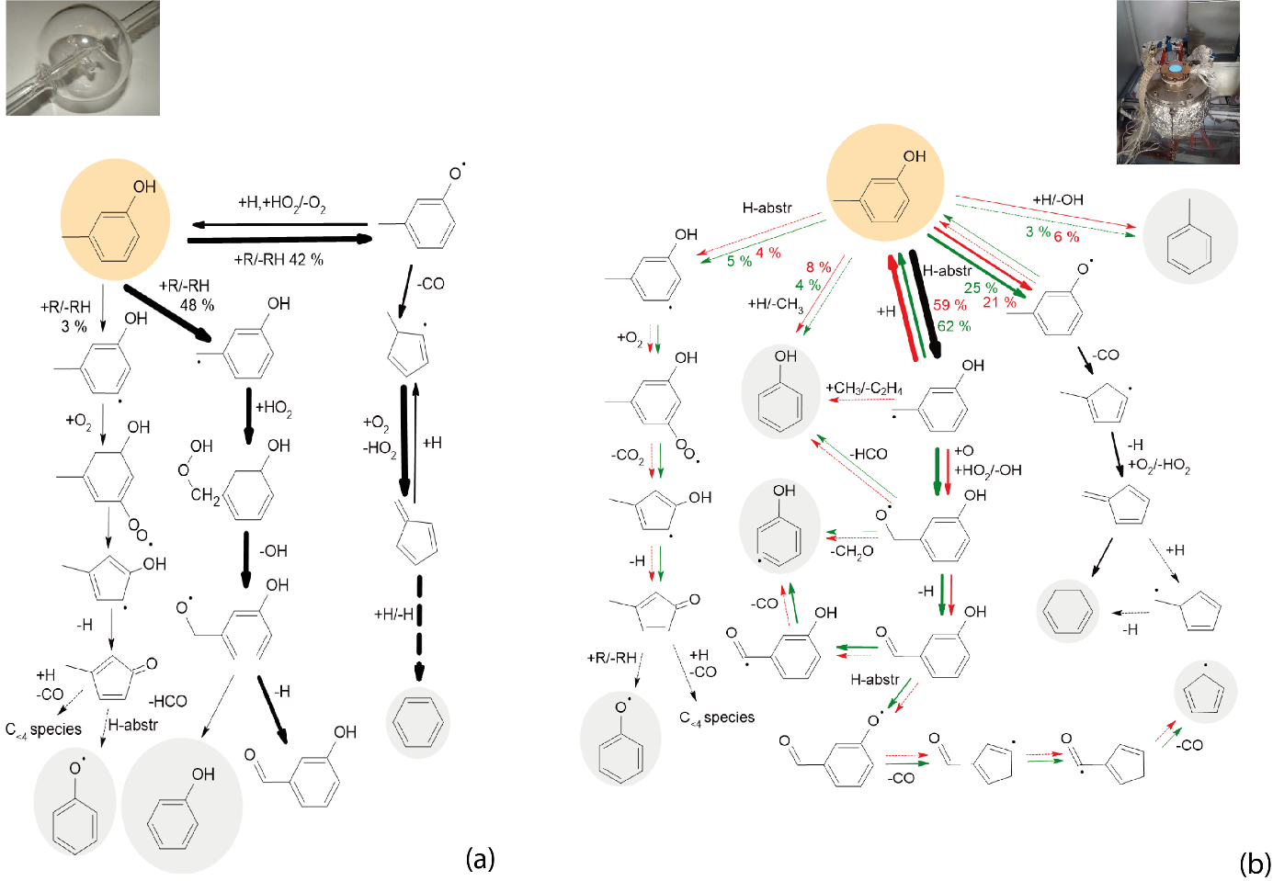Figure SIV.1: Flow rate analyses for m-cresol using COLIBRIv5: (a) in JSR at 1000 K at φ=1, (b) integrated analysis for fuel decomposition in m-cresol flames green arrows are for φ=0.8, and red ones for φ=1.3 (only flow rate above 2% are shown, grey backgrounds show species, the mechanism of which is already presented in analyses for toluene [3,4], the thickness of the arrows is proportional to their relative flow rates).

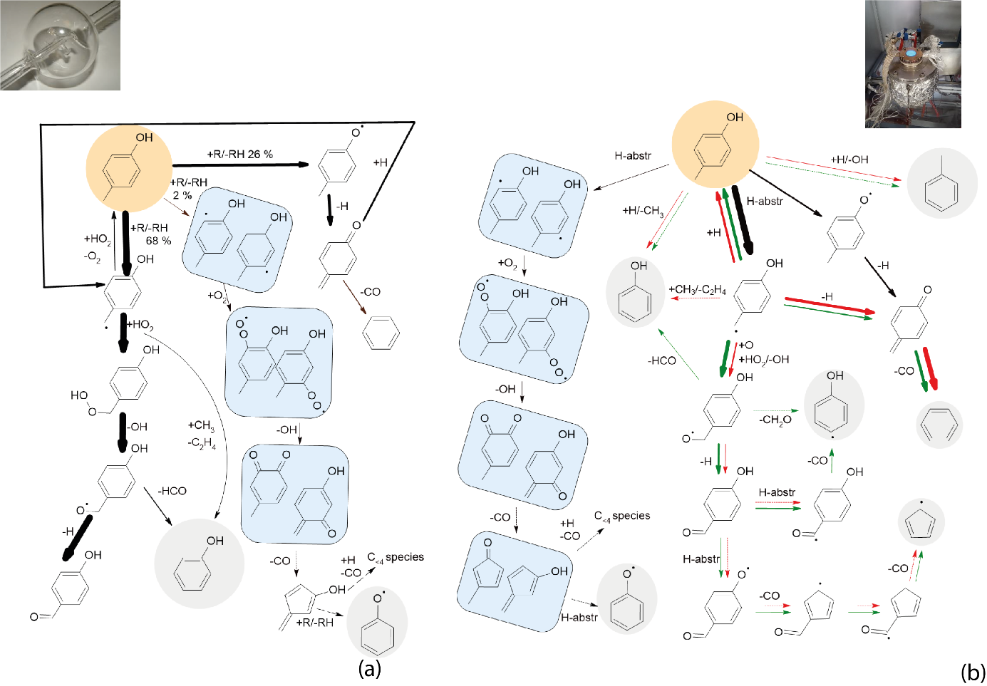
Figure SIV.2: Flow rate analyses for p-cresol using COLIBRIv5: (a) in JSR at 1000 K at φ=1, (b) integrated analysis for fuel decomposition in p-cresol flames green arrows are for φ=0.8, and red ones for φ=1.3 (only flow rate above 2% are shown, grey backgrounds show species, the mechanism of which is already presented in analyses for toluene [3,4], the thickness of the arrows is proportional to their relative flow rates).

LBV sensitivity analysis: 10 most sensitive reactions and C₃₊ reaction sensitivity analysis a φ = 1.2

V.1 o-Cresol
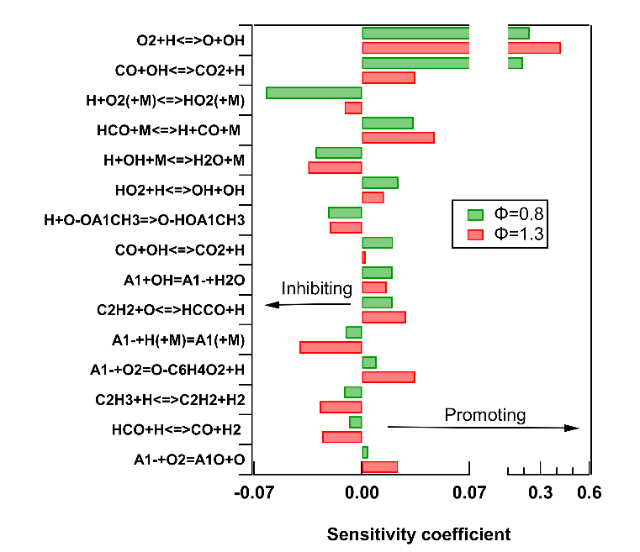
Figure SV.1: Sensitivity analysis on the LBV for o-cresol-air mixtures for fresh gases at 398 K: the 10 most sensitive reactions under both lean and rich conditions.

V.2 m-Cresol
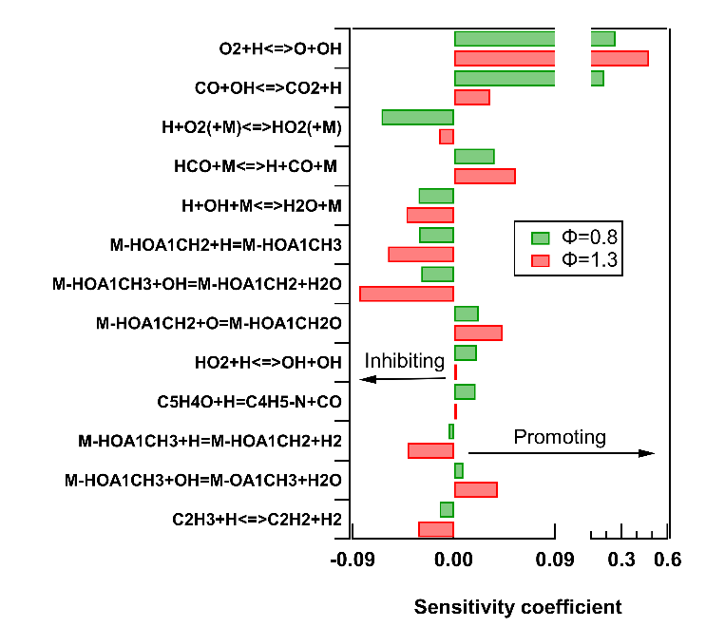
Figure SV.2: Sensitivity analysis on the LBV for m-cresol-air mixtures for fresh gases at 398 K: the 10 most sensitive reactions under both lean and rich conditions

V.3 p-Cresol

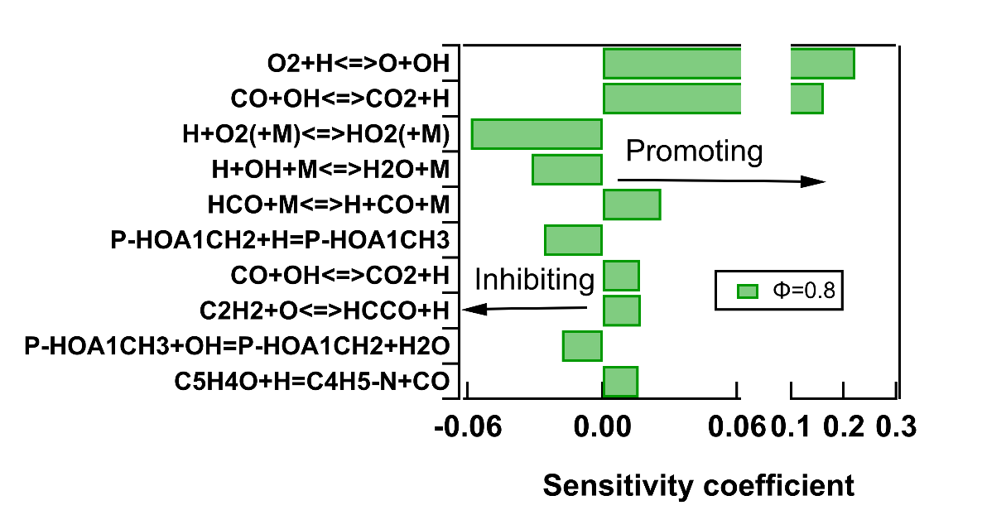
Figure SV.3: Sensitivity analysis on the LBV for p-cresol-air mixtures for fresh gases at 398 K: the 10 most sensitive reactions lean conditions.

V.4 C₃₊ reaction sensitivity analysis a φ = 1.2
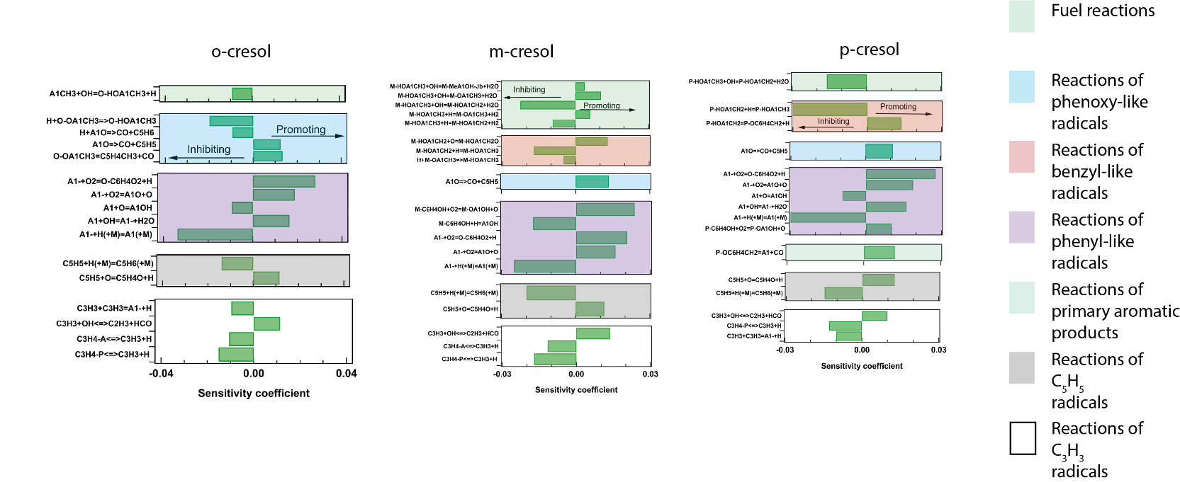
Figure SV.4: C3+ reaction sensitivity analysis on the LBV for fresh gases at 398 K at φ = 1.2.

Additonnal comparsions for m-cresol literature data [3]

Figure SVI.1: Comparison of mole fractions of m-cresol recorded during m-xylene oxidation in a JSR [3] and mole fractions predicted using COLIBRI-V5 model.

References
[1] I.V. Tokmakov, G.-S. Kim, V.V. Kislov, A.M. Mebel, M.C. Lin, The Reaction of Phenyl Radical with Molecular Oxygen: A G2M Study of the Potential Energy Surface, J. Phys. Chem. A 109 (2005) 6114–6127. https://doi.org/10.1021/jp051712k.
[2] T.J. Lee, P.R. Taylor, A diagnostic for determining the quality of single-reference electron correlation methods, Int. J. Quantum Chem. 36 (2009) 199–207. https://doi.org/10.1002/qua.560360824.
[3] I. Meziane, N. Delort, O. Herbinet, R. Bounaceur, F. Battin-Leclerc, A comparative study of the oxidation of toluene and the three isomers of xylene, Combust. Flame 257 (2023) 113046. https://doi.org/10.1016/j.combustflame.2023.113046.
[4] N. Delort, O. Herbinet, R. Bounaceur, F. Battin-Leclerc, Experimental and modeling study of the laminar burning velocity of C7-C9 aromatic hydrocarbons and C7-C8 aromatic oxygenates, Combustion and Flame 273 (2025) 113915.
https://doi.org/10.1016/j.combustflame.2024.113915.

