Supplementary Information
A non-classical pathway for selective N-functionalization in water: kinetic and mechanistic evidence beyond Schotten–Baumann reaction
Geun Ho Kimª and Jung Woon Yang^{a,b}*
ª Department of Energy Science, Sungkyunkwan University, Suwon 16419, Republic of Korea
^{b} Department of Energy, Sungkyunkwan University, Suwon 16419, Republic of Korea
E-mail: jwyang@skku.edu (J. W. Yang)

Contents
General Remarks, Materials and Chemicals, and Experimental Procedures S2
Kinetic Analysis of the Time-Course Data S4
Experimental Evidence for Alkali-Metal Cation Participation in Carbonate-Mediated
Acyl Transfer S7
Characterization Data for the Products S8
Computational Details S13
References S22
¹H NMR and ¹³C NMR Spectra of the Products S23
General Remarks
Commercial grade reagents and solvents were used without further purification. Thin-layer chromatography (TLC) was performed on Merck Kieselgel silica gel 60 F254. Flash chromatography was carried out using Merck silica gel (60 Å, 230−400 mesh, particle size 0.040−0.063 mm). ¹H, ¹³C and ¹⁹F nuclear magnetic resonance (NMR) spectra were recorded on a Bruker Ascend™ 500 spectrometer in a suitable deuterated solvent at 298 K. Chemical shift values are reported in ppm from tetramethylsilane as the internal standard with two or one digits after the comma. The yields of the products of general procedure were determined by ¹H NMR spectroscopy using ethylene carbonate as an internal standard. ¹H NMR spectral measurements were performed at 500 MHz in CDCl₃ (δ 7.26 ppm), CD₃OD (δ 3.31 ppm) or DMSO-d₆ (δ 2.50 ppm). ¹³C NMR spectral measurements were performed at 126 MHz using CDCl₃ (δ 77.16 ppm), CD₃OD (δ 49.00 ppm) or DMSO-d₆ (δ 39.52 ppm). ¹⁹F NMR spectral measurements were performed at 471 MHz using CDCl₃, CD₃OD or DMSO-d₆. The terms m, s, d, t, and q, quint., and sept. represent multiplet, singlet, doublet, triplet, quadruplet, quintuplet, septet, respectively, and the term br means a broad signal. High Resolution Mass Spectrometer (HRMS) was performed by electron impact (EI). Mass data acquired on a Supercritical Fluid Chromatograph combined with Xevo G2-XS QTOF Mass Spectrometer (Waters, Milford, MA, USA) at the Chiral Material Core Facility Center of Sungkyunkwan University. Optical rotations were measured using a Jasco P-2000 polarimeter.
Materials and Chemicals
All commercially available reagents were used as received unless otherwise specified. Acyl chlorides used for the synthesis of the corresponding acyl fluorides, benzoyl fluoride (>98.0%, GC), and amines (>99.0%, GC) were purchased from Tokyo Chemical Industry Co., Ltd. (TCI). Anhydrous potassium fluoride (99%) was purchased from Thermo Scientific Chemicals, and anhydrous potassium carbonate (99.5%) was purchased from Daejung Chemicals & Metals Co., Ltd. Deionized water was used as the reaction solvent for all aqueous amidation reactions.
Experimental Procedures
General procedure A for the synthesis of acyl fluoride 1
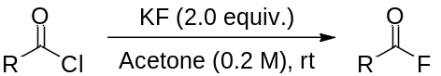
Potassium fluoride (1.0 mmol, 2.0 equiv.) was added to a stirred solution of the corresponding acyl chloride (0.5 mmol) in anhydrous acetone (2.5 mL, 0.2 M). The reaction mixture was stirred at room temperature for the specified time. After completion of the reaction, the resulting inorganic salts were removed by filtration, and the filtrate was purified according to the previously reported procedure to afford the corresponding acyl fluoride 1^{[1]}.

General procedure B for the synthesis of 3
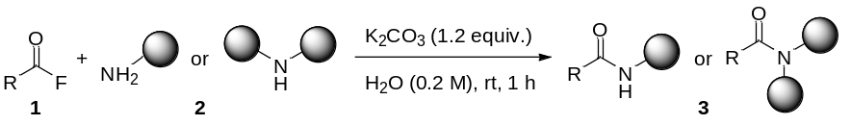
To a stirred solution of amine 2 (1.0 mmol) in deionized water (5 mL, 0.2 M) were added potassium carbonate (K₂CO₃, 1.2 mmol, 1.2 equiv.) and acyl fluoride 1 (1.0 mmol, 1.0 equiv.). The mixture was stirred at room temperature for 1 h. Upon completion of the reaction, the reaction mixture was acidified with 1 N HCl, resulting in precipitation of the corresponding amide. The resulting solid was isolated by vacuum filtration, washed thoroughly with water, and dried under reduced pressure to afford the corresponding amide 3.

Kinetic Analysis of the Time-Course Data
Determination of apparent decay constants
To provide a quantitative comparison of the reaction-progress profiles shown in Fig. 3, the early-time consumption of benzoyl fluoride 1a under K₂CO₃- and KOH-mediated conditions was analyzed by nonlinear least-squares regression. For both reaction conditions, the data collected over the initial 0–15 min period were fitted to a single-exponential decay function:
$$\frac{{\left[\text{1a}\right]}_{\text{t}}}{{\left[\text{1a}\right]}_{\text{0}}}\text{= }{\text{e}}^{\text{-}{\text{k}}_{\text{app}}\text{t}}$$
where [1a]_{t}/[1a]₀ represents the normalized amount of benzoyl fluoride 1a remaining at time t, and k_{app} is the apparent decay constant.
The same fitting window (0–15 min) was used for both reaction conditions to allow direct comparison of the early substrate-consumption profiles and to avoid assigning exact amounts to later time points at which the residual benzoyl fluoride approached the experimental detection limit. Because benzoyl fluoride, benzylamine, and the base were employed in stoichiometric quantities rather than under strict pseudo-first-order conditions, the single-exponential function was used to compare the early substrate-decay profiles and was not interpreted as an elementary kinetic rate law. The fitted parameters are therefore reported as apparent decay constants (k_{app}) rather than elementary reaction rate constants.
The apparent half-life (t_{1/2}) was calculated according to
$${\text{t}}_{\text{1/2}}\text{= }\frac{\text{ln2}}{{\text{k}}_{\text{app}}}$$
Table S1 Early-time benzoyl fluoride consumption data used for nonlinear kinetic fitting.
Time (min) | 1a remaining, K₂CO₃ (%) | [1a]_{t}/[1a]₀, K₂CO₃ | 1a remaining, KOH | [1a]_{t}/[1a]₀, KOH
0 | 100.0 | 1.000 | 100.0 | 1.000
1 | 80.0 | 0.800 | 85.0 | 0.850
3 | 42.5 | 0.425 | 50.0 | 0.500
5 | 27.5 | 0.275 | 25.0 | 0.250
7 | 25.0 | 0.250 | 15.0 | 0.150
9 | 20.0 | 0.200 | 12.5 | 0.125
15 | 10.0 | 0.100 | 12.5 | 0.125
Nonlinear fitting gave k_{app} = 0.229 min⁻¹ for the K₂CO₃-mediated reaction and k_{app} = 0.241 min⁻¹ for the KOH-mediated reaction. The corresponding apparent half-lives (t_{1/2}) were 3.03 and 2.88 min, respectively. The 95% confidence intervals for the fitted k_{app} values overlapped (0.181–0.276 min⁻¹ for K₂CO₃ and 0.193–0.288 min⁻¹ for KOH), indicating that the early-time rates of benzoyl fluoride disappearance are comparable under the two conditions.

Table S2 Apparent kinetic parameters obtained from nonlinear fitting of the early-time benzoyl fluoride consumption profiles.
Condition | k_{app} (min⁻¹) | 95% Cl for k_{app} (min⁻¹) | t_{1/2} (min) | R²
K₂CO₃ | 0.229 | 0.181–0.276 | 3.03 | 0.970
KOH | 0.241 | 0.193–0.288 | 2.88 | 0.978
Despite the comparable apparent substrate-decay constants, the product-formation profiles differed markedly. At 15 min, 90% of benzoyl fluoride 1a had been consumed under the K₂CO₃-mediated conditions, affording 90% amide 3a with no detectable benzoic acid 4a. Under KOH-mediated conditions, 87.5% of benzoyl fluoride 1a had been consumed, affording 72.5% 3a together with 15% 4a. Thus, the major kinetic difference between the two systems lies in the partitioning of consumed acyl fluoride between productive amidation and competing hydrolysis rather than in the overall rate of substrate disappearance. Under K₂CO₃-mediated conditions, substrate consumption is directed predominantly toward amide formation, whereas the KOH-mediated reaction exhibits a significant competing hydrolysis pathway.
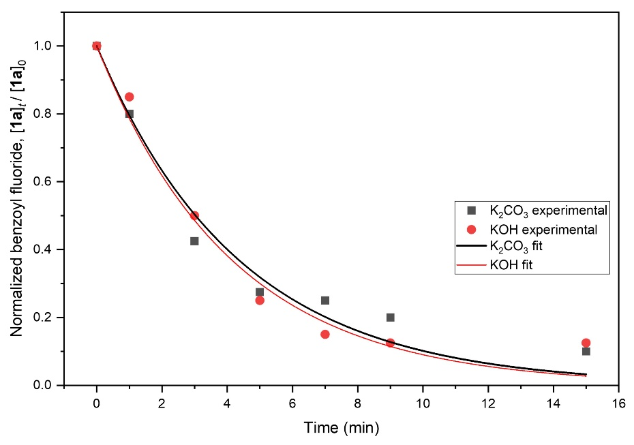
Fig. S1 Nonlinear fitting of the early-time benzoyl fluoride consumption profiles under K₂CO₃- and KOH-mediated conditions. Experimental data collected over 0–15 min were fitted to a single-exponential decay function.
Experimental early-time benzoyl fluoride consumption data (0–15 min) were fitted to the single-exponential decay function, ${\left[\text{1a}\right]}_{\text{t}}\text{/}{\left[\text{1a}\right]}_{\text{0}}\text{ = }{\text{e}}^{{\text{-}\text{k}}_{\text{app}}\text{t}}$, where [1a]_{t}/[1a]₀ represents the normalized amount of benzoyl fluoride 1a remaining at time t. The K₂CO₃-mediated reaction gave k_{app} = 0.229 min⁻¹, t_{1/2} = 3.03 min, and R² = 0.970, whereas the KOH-mediated reaction gave k_{app} = 0.241 min⁻¹, t_{1/2} = 2.88 min, and R² = 0.978. Experimental data are shown as individual points, and the corresponding nonlinear regression fits are shown as solid curves.
The similar k_{app} values indicate comparable early-time rates of benzoyl fluoride disappearance under the two conditions. Because the reactions were not conducted under strict pseudo-first-order conditions, the fitting was used for quantitative comparison of the early substrate-decay profiles and was not interpreted as an elementary kinetic rate law.
Experimental Evidence for Alkali-Metal Cation Participation in Carbonate-Mediated Acyl Transfer
Countercation control experiments were conducted to provide experimental support for the involvement of alkali-metal cations in carbonate-mediated aqueous amidation. To examine the effect of the countercation, carbonate was maintained as the common anion, while Li⁺, Na⁺, K⁺, and Cs⁺ were compared under otherwise identical reaction conditions.
Effect of the alkali-metal countercation on carbonate-mediated amidation
Benzoyl fluoride 1a was reacted with benzylamine 2a in water in the presence of Li₂CO₃, Na₂CO₃, K₂CO₃, or Cs₂CO₃ (1.2 equiv.). As summarized in Table S3, the reaction outcome varied with the identity of the alkali-metal countercation. Li₂CO₃ afforded amide 3a in 91% yield with a 3a:4a ratio of 97:3, whereas Na₂CO₃ and K₂CO₃ afforded 3a in 96% and >99% yield, respectively, with no detectable hydrolysis product 4a. In contrast, Cs₂CO₃ afforded 3a in 71% yield with a 3a:4a ratio of 96:4.
The variation in amidation efficiency and hydrolysis selectivity among the alkali-metal carbonates indicates a clear countercation effect on the carbonate-mediated acyl-transfer process. K₂CO₃ gave the highest amide yield with no detectable hydrolysis. This cation effect is in agreement with previous reports describing alkali-metal coordination to carbonic mixed anhydride-type species and supports the participation of K⁺ in the acyl-transfer process. DFT calculations suggest stabilization of the carbonic mixed anhydride through K⁺ coordination under aqueous conditions.
Table S3 Effect of the alkali-metal countercation on the carbonate-mediated aqueous amidation of benzoyl fluoride 1a with benzylamine 2a.ª
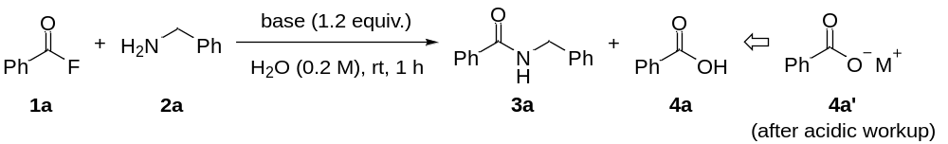
Entry | Base | Solvent | Ratio of 3a:4a | Yield of 3a (%)^{b}
1 | Li₂CO₃ | H₂O | 97:3 | 91
2 | Na₂CO₃ | H₂O | >99:n.d. | 96
3 | K₂CO₃ | H₂O | >99:n.d. | >99
4 | Cs₂CO₃ | H₂O | 96:4 | 71
ª General conditions: benzoyl fluoride 1a (1.0 equiv.), benzylamine 2a (1.0 mmol), alkali-metal carbonate (1.2 equiv.), H₂O (0.2 M), rt, 1 h. ^{b} Yields and product ratios were determined by ¹H NMR spectroscopy analysis using 1,3,5-trimethoxybenzene as an internal standard.
Characterization Data for the Products
N-Benzylbenzamide (3a)
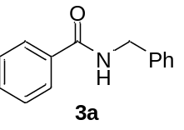 The title compound was synthesized according to general procedure B. Reaction time: 1 h, Yield: >99%, White powder. ¹H NMR (500 MHz, CDCl₃) δ 7.79 (dd, J = 8.4, 1.4 Hz, 2H), 7.54 – 7.46 (m, 1H), 7.43 (t, J = 7.5 Hz, 2H), 7.36 (d, J = 4.4 Hz, 4H), 7.33 – 7.28 (m, 1H), 6.45 (s, 1H), 4.65 (d, J = 5.8 Hz, 2H) ppm; ¹³C NMR (126 MHz, CDCl₃) δ 167.47, 138.32, 134.54, 131.69, 128.93, 128.74, 128.07, 127.78, 127.09, 44.29 ppm. These data were consistent with those reported in the literature^{[2]}.
N-Benzyl-4-bromobenzamide (3b)
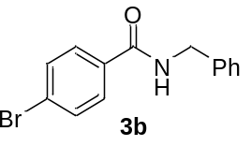 The title compound was synthesized according to general procedure B. Reaction time: 1 h, Yield: 95%, White powder. ¹H NMR (500 MHz, CDCl₃) δ 7.69 – 7.62 (m, 2H), 7.59 – 7.53 (m, 2H), 7.40 – 7.27 (m, 5H), 6.37 (s, 1H), 4.63 (d, J = 5.6 Hz, 2H) ppm; ¹³C NMR (126 MHz, CDCl₃) δ 166.48, 138.03, 133.34, 131.99, 129.01, 128.72, 128.12, 127.92, 126.40, 44.41 ppm. These data were consistent with those reported in the literature^{[3]}.
N-Benzyl-4-cyanobenzamide (3c)
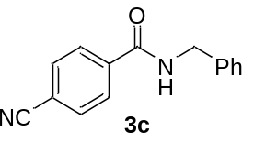 The title compound was synthesized according to general procedure B. Reaction time: 1 h, Yield: 97%, White powder. ¹H NMR (500 MHz, CDCl₃) δ 7.90 – 7.85 (m, 2H), 7.73 – 7.67 (m, 2H), 7.40 – 7.28 (m, 5H), 6.62 (s, 1H), 4.63 (d, J = 5.8 Hz, 2H) ppm; ¹³C NMR (126 MHz, CDCl₃) δ 165.69, 138.38, 137.65, 132.57, 129.03, 128.07, 128.02, 127.84, 118.09, 115.26, 44.50 ppm. HRMS (ESI, m/z): Calcd. for C₁₅H₁₃N₂O [M+H]⁺ 237.1028; found 237.1026.
N-Benzyl-4-nitrobenzamide (3d)
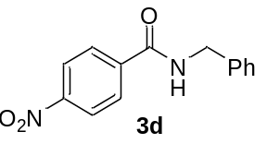 The title compound was synthesized according to general procedure B. Reaction time: 1 h, Yield: 95%, White powder. ¹H NMR (500 MHz, CDCl₃) δ 8.30 – 8.24 (m, 2H), 7.98 – 7.91 (m, 2H), 7.41 – 7.29 (m, 5H), 6.52 (s, 1H), 4.66 (d, J = 5.8 Hz, 2H) ppm; ¹³C NMR (126 MHz, CDCl₃) δ 165.43, 149.79, 140.06, 137.56, 129.10, 128.32, 128.16, 128.12, 124.00, 44.64 ppm. These data were consistent with those reported in the literature^{[3]}.
N-Benzyl-4-methoxybenzamide (3e)
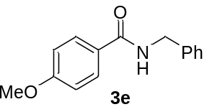 The title compound was synthesized according to general procedure B. Reaction time: 1 h, Yield: 87%, White powder. ¹H NMR (500 MHz, CDCl₃) δ 7.76 (d, J = 8.9, 2H), 7.35 (d, J = 4.4 Hz, 4H), 7.30 (dt, J = 8.2, 4.0 Hz, 1H), 6.91 (d, J = 9.0 Hz, 2H), 6.36 (s, 1H), 4.63 (d, J = 5.6 Hz, 2H), 3.84 (s, 3H) ppm; ¹³C NMR (126 MHz, CDCl₃) δ 166.98, 162.37, 138.54, 128.90, 128.06, 127.70, 126.80, 113.91, 55.55, 44.23 ppm. These data were consistent with those reported in the literature^{[4]}.
N-Methylbenzamide (3f)
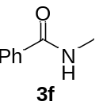 The title compound was synthesized according to general procedure B. Reaction time: 1 h, Yield: 99%, White powder. ¹H NMR (500 MHz, CDCl₃) δ 7.75 (dd, J = 8.3, 1.4 Hz, 2H), 7.44 (t, J = 7.4 Hz, 1H), 7.36 (t, J = 7.6 Hz, 2H), 6.71 (s, 1H), 2.95 (d, J = 4.9 Hz, 3H) ppm; ¹³C NMR (126 MHz, CDCl₃) δ 168.51, 134.65, 131.36, 128.54, 126.97, 26.87 ppm. These data were consistent with those reported in the literature^{[5]}.
(S)-N-(1-Phenylethyl)benzamide (3g)
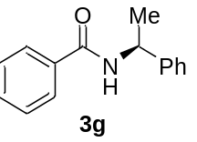 The title compound was synthesized according to general procedure B. Reaction time: 1 h, Yield: 99%, White powder. ${[α]}_{D}^{20}$ -20.9 (c 1.0, CHCl₃). ¹H NMR (500 MHz, CDCl₃) δ 7.77 (dd, J = 8.4, 1.4 Hz, 2H), 7.49 (t, J = 7.4 Hz, 1H), 7.45 – 7.33 (m, 6H), 7.28 (t, J = 7.1 Hz, 1H), 6.39 (br, 1H), 5.34 (p, J = 7.0 Hz, 1H), 1.61 (d, J = 6.9 Hz, 3H) ppm; ¹³C NMR (126 MHz, CDCl₃) δ 166.69, 143.27, 134.74, 131.59, 128.88, 128.68, 127.59, 127.06, 126.40, 49.35, 21.85 ppm. These data were consistent with those reported in the literature^{[6]}.
(S)-N-(1-(4-Methoxyphenyl)ethyl)benzamide (3h)
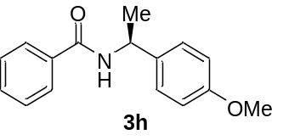 The title compound was synthesized according to general procedure B. Reaction time: 1 h, Yield: 99%, White powder. ${[α]}_{D}^{20}$ -30.4 (c 1.0, CHCl₃). ¹H NMR (500 MHz, CDCl₃) δ 7.76 (d, J = 7.0 Hz, 2H), 7.48 (t, J = 7.3 Hz, 1H), 7.41 (t, J = 7.5 Hz, 2H), 7.32 (d, J = 8.7 Hz, 2H), 6.89 (d, J = 8.7 Hz, 2H), 6.28 (d, J = 7.6 Hz, 1H), 5.30 (p, J = 7.0 Hz, 1H), 3.80 (s, 3H), 1.59 (d, J = 6.9 Hz, 3H) ppm; ¹³C NMR (126 MHz, CDCl₃) δ 166.61, 159.07, 135.37, 134.81, 131.56, 128.68, 127.63, 127.03, 114.24, 55.46, 48.79, 21.73 ppm. HRMS (ESI, m/z): Calcd. for C₁₆H₁₈NO₂ [M+H]⁺ 256.1338; found 256.1334.
(R)-N-(1-(Naphthalen-2-yl)ethyl)benzamide (3i)
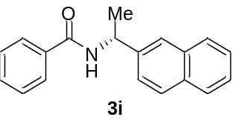 The title compound was synthesized according to general procedure B. Reaction time: 1 h, Yield: 99%, White powder. ${[α]}_{D}^{20}$ -19.5 (c 1.0, CHCl₃). ¹H NMR (500 MHz, CDCl₃) δ 8.17 (d, J = 8.5 Hz, 1H), 7.88 (dd, J = 7.7, 2.1 Hz, 1H), 7.82 (d, J = 8.2 Hz, 1H), 7.73 (dd, J = 8.2, 1.4 Hz, 2H), 7.59 (d, J = 7.2 Hz, 1H), 7.57 – 7.42 (m, 4H), 7.36 (t, J = 7.6 Hz, 2H), 6.46 (d, J = 8.1 Hz, 1H), 6.12 (p, J = 6.9 Hz, 1H), 1.77 (d, J = 6.9 Hz, 3H) ppm; ¹³C NMR (126 MHz, CDCl₃) δ 166.53, 138.32, 134.58, 134.10, 131.55, 131.34, 128.90, 128.62, 128.60, 127.06, 126.77, 126.02, 125.32, 123.56, 122.81, 45.34, 20.79 ppm. These data were consistent with those reported in the literature^{[7]}.
(R)-N-(1-Cyclohexylethyl)benzamide (3j)
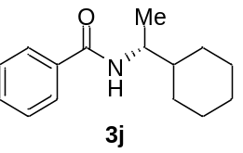 The title compound was synthesized according to general procedure B. Reaction time: 1 h, Yield: 99%, White powder. ${[α]}_{D}^{20}$ -15.3 (c 1.0, CHCl₃). ¹H NMR (500 MHz, CDCl₃) δ 7.75 (d, J = 7.2 Hz, 2H), 7.48 (t, J = 7.3 Hz, 1H), 7.42 (t, J = 7.4 Hz, 2H), 5.97 (d, J = 8.9 Hz, 1H), 4.08 (dt, J = 9.2, 6.6 Hz, 1H), 1.85 – 1.71 (m, 4H), 1.66 (d, J = 13.9 Hz, 1H), 1.43 (tdt, J = 12.1, 6.4, 3.2 Hz, 1H), 1.24 (tdt, J = 12.7, 6.4, 3.4 Hz, 2H), 1.19 (d, J = 6.7 Hz, 3H), 1.16 – 0.97 (m, 3H) ppm; ¹³C NMR (126 MHz, CDCl₃) δ 166.95, 135.31, 131.36, 128.65, 126.93, 49.98, 43.42, 29.28, 26.54, 26.33, 26.31, 18.15 ppm. HRMS (ESI, m/z): Calcd. for C₁₅H₂₂NO [M+H]⁺ 232.1701; found 232.1699.
tert-Butyl (S)-3-benzamidopyrrolidine-1-carboxylate (3k)
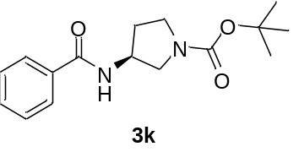 The title compound was synthesized according to general procedure B. Reaction time: 1 h, Yield: 98%, White powder. ${[α]}_{D}^{20}$ 32.3 (c 1.0, CHCl₃). ¹H NMR (500 MHz, CDCl₃) δ 7.75 (d, J = 7.8 Hz, 2H), 7.45 (t, J = 7.4 Hz, 1H), 7.37 (t, J = 7.6 Hz, 2H), 6.74 (d, J = 24.7 Hz, 1H), 4.59 (d, J = 6.1 Hz, 1H), 3.83 – 3.05 (m, 4H), 2.17 (dq, J = 14.0, 7.4 Hz, 1H), 1.93 (t, J = 19.4 Hz, 1H), 1.43 (s, 9H) ppm; ¹³C NMR (126 MHz, CDCl₃) δ 167.68, 154.70, 134.23, 133.05, 131.65, 130.01, 128.56, 128.34, 127.14, 79.74, 51.77, 50.93, 50.02, 49.46, 44.25, 43.89, 38.40, 32.05, 30.96, 28.54 ppm. HRMS (ESI, m/z): Calcd. for C₁₆H₂₂N₂O₃Na [M+Na]⁺ 313.1528; found 313.1527.
N,N-Dmethylbenzamide (3l)
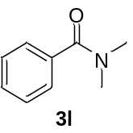 The title compound was synthesized according to general procedure B. Reaction time: 6 h, Yield: 99%, Colorless oil. ¹H NMR (500 MHz, CDCl₃) δ 7.31 (dq, J = 5.3, 3.0 Hz, 2H), 3.02 (s, 1H), 2.88 (s, 1H) ppm; ¹³C NMR (126 MHz, CDCl₃) δ 171.44, 136.23, 129.34, 128.18, 126.87, 39.40, 35.15 ppm. These data were consistent with those reported in the literature^{[8]}.
N,N-Diisopropylbenzamide (3m)
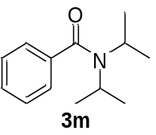 The title compound was synthesized according to general procedure B. Reaction time: 6 h, Yield: 99%, White powder. ¹H NMR (500 MHz, CDCl₃) δ 8.02 (d, J = 6.9 Hz, 2H), 7.67 (t, J = 7.6 Hz, 1H), 7.50 (t, J = 7.2 Hz, 2H), 2.88 (hept, J = 6.3 Hz, 2H), 1.02 (d, J = 6.3 Hz, 12H) ppm; ¹³C NMR (126 MHz, CDCl₃) δ 158.82, 156.08, 135.36, 131.51, 131.48, 129.13, 125.29, 124.81, 45.29, 23.37 ppm. These data were consistent with those reported in the literature^{[9]}.
N,N-Diphenylbenzamide (3n)
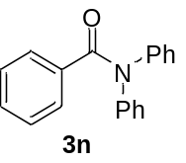 The title compound was synthesized according to general procedure B. Reaction time: 6 h, Yield: 99%, White powder. ¹H NMR (500 MHz, CDCl₃) δ 8.07 (d, J = 6.9 Hz, 2H), 7.72 (t, J = 7.5 Hz, 1H), 7.54 (t, J = 7.9 Hz, 2H), 7.31 – 7.26 (m, 4H), 7.09 (d, J = 7.2 Hz, 4H), 6.95 (t, J = 7.3 Hz, 2H) ppm; ¹³C NMR (126 MHz, CDCl₃) δ 158.92, 156.18, 143.23, 135.42, 131.59, 131.56, 129.47, 129.18, 125.34, 124.86, 121.15, 117.96 ppm. These data were consistent with those reported in the literature^{[9]}.
N,N-Dibenzylbenzamide (3o)
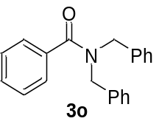 The title compound was synthesized according to general procedure B. Reaction time: 6 h, Yield: 98%, White powder. ¹H NMR (500 MHz, CDCl₃) δ 8.01 (d, J = 6.9 Hz, 2H), 7.66 (t, J = 7.6 Hz, 1H), 7.48 (t, J = 7.2 Hz, 2H), 7.36 – 7.27 (m, 8H), 7.24 – 7.19 (m, 2H), 3.76 (s, 4H) ppm; ¹³C NMR (126 MHz, CDCl₃) δ 158.88, 156.14, 136.29, 135.40, 131.57, 131.54, 129.77, 129.17, 128.63, 127.48, 126.84, 125.33, 124.84, 52.45 ppm. These data were consistent with those reported in the literature^{[9]}.
Computational Details
DFT calculations
All density functional theory (DFT) calculations were performed using the ORCA 6.1.1 program package^{[10]}. Geometry optimizations and transition-state searches were carried out using the B3LYP functional with Grimme’s D3BJ dispersion correction and the def2-SVP basis set. Solvation effects were treated using the conductor-like polarizable continuum model (CPCM) with water as the solvent. Harmonic vibrational frequency calculations were performed at the same level of theory to characterize the stationary points and to obtain Gibbs free-energy corrections. All local minima were confirmed to have no imaginary frequencies, whereas each transition state was characterized by exactly one imaginary frequency corresponding to the reaction coordinate.
Three explicit water molecules were included in the carbonate- and potassium-associated structures to represent the local aqueous coordination environment. Relative Gibbs free energies were obtained at the B3LYP-D3BJ/def2-SVP/CPCM(water) level and are reported relative to the corresponding reactant complex within each mechanistic section. The calculated energy profiles were used to compare relative energetic trends and structural features along the proposed reaction pathway rather than to determine method-independent absolute activation barriers. Range-separated hybrid functionals may provide additional information regarding long-range exchange effects in ionic or partially charge-separated structures but were not used to construct the reported energy profiles. The 3D structures were visualized using CYLview^{[11]}.
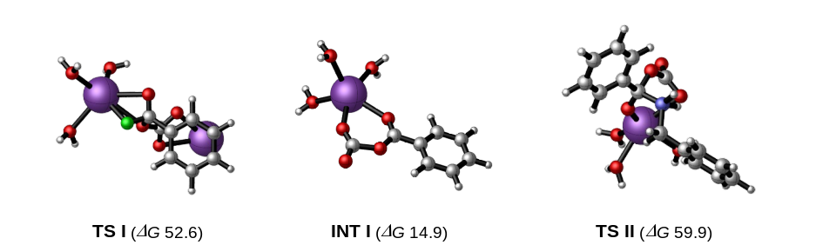
Fig. S2 Optimized geometries of TS I, INT I and TS II obtained from DFT calculations.
Water
H -1.33671368238415 1.09745152593143 -0.14366442094539
O -0.29162055602330 2.36379955718978 -0.12053716540168
H -0.60759576159255 1.58032891687878 0.26420158634708

Benzoyl fluoride
C 0.38375799191636 0.61734171188241 -0.35233061792575
C 1.38492267129535 1.46497269592753 -1.00728703180207
O 1.37423798807352 2.64469593707430 -1.16900013257880
F 2.45344793656078 0.75294148353917 -1.47649444189913
C 0.54681584184160 -0.76763796750381 -0.24809823932409
C -0.42862802065532 -1.52784805187672 0.38064507403837
C -1.56231017553494 -0.91272684627250 0.90454794154031
C -1.72605647545901 0.46727269695158 0.80152354857123
C -0.75688614433077 1.23349238978899 0.17471798862811
H 1.42777476833397 -1.24162177668760 -0.65577731151901
H -0.30558973358183 -2.59967241963082 0.46265933967386
H -2.32093961093976 -1.50986733777121 1.39438887038458
H -2.60834862616468 0.94209558373847 1.20994892518043
H -0.87139841135528 2.30526190084019 0.08755608703194

Benzyl amine
C 0.50856106148080 0.31310882959653 0.17936377634033
C 1.81372944113773 1.07885001634487 0.28790113348157
N 1.65486174237350 2.51004279080341 0.04638093914899
C -0.72978571902722 0.94637165730951 0.36213954830312
C -1.92275035927843 0.21784863506759 0.29574002790099
C -1.89598688710587 -1.15833392996579 0.04701319664986
C -0.66549753754745 -1.79961245651713 -0.14035359221668
C 0.52371975014767 -1.06763589784129 -0.07859908587087
H 2.20387014086158 0.95207438559359 1.31516027554452
H 2.55717927542227 0.58735189144239 -0.37312599786166
H 2.54540371042963 2.98131470549816 0.20978896430855
H 1.43777171900807 2.66665463101612 -0.94036748624590
H -0.74399881295291 2.02121958801905 0.55198881531208
H -2.87895221138903 0.72924421852860 0.43846957710026
H -2.82776945622823 -1.72774261186656 -0.00633154941627
H -0.63261172837863 -2.87383912724304 -0.34231584804977
H 1.48155587104652 -1.57351732578603 -0.23515269442910

Potassium
K 0.00000000000000 0.00000000000000 0.00000000000000

Carbonate
C -0.00041351124316 0.00000000260052 -0.00000001325326
O 1.29636225601617 0.00000001318151 0.00000000443302
O -0.64797436015082 1.12217513889886 0.00000000441012
O -0.64797438462219 -1.12217515468089 0.00000000441011

Potassium fluoride
F -4.09290976657462 1.26696044002179 0.00000000000000
K -1.87806023342537 1.30874955997821 0.00000000000000

Potassium hydroxide
H -0.28752556749294 1.58049241605150 -0.00066973696043
O -1.24544357493739 1.44818248751455 0.00018350756948
K -3.49073085756966 1.18080509643394 0.00048622939095

Carbon dioxide
O -0.99153197212360 -0.55518882145590 0.18861838147573
C 0.00323539283077 0.00644562711251 -0.01059647453444
O 0.99839657929283 0.56724319434339 -0.21022190694128

TS I
O 3.24763036553349 1.03725274746647 3.34289153789251
C -0.93806459784820 -1.13017272359743 -0.19903908150597
C 0.37844640696899 -0.51130587290135 0.27609424712599
F 1.34084791291948 -0.80675999599318 -0.89574297695344
O 0.43379708630051 0.69156755617195 0.59581570643561
C -2.12954280527024 -0.41686904846879 -0.02771017540441
C -3.36208277418086 -1.00054366597458 -0.34435999293106
C -3.41130010834399 -2.30811933618432 -0.84831987523253
C -2.21823294976279 -3.02073373927951 -1.04480583955084
C -0.98849353264534 -2.43279596420908 -0.72154410900953
K 3.16675197316032 0.21927731374024 0.78758880586316
O 5.01411862894686 -1.68940510509147 0.40148894315445
O 4.41842647144274 2.20647575125101 -0.49683281916438
H 3.67675210845754 0.54326446288970 4.05811826587131
H 2.35300375890482 1.19312463527898 3.68320145461925
H -2.07208593922402 0.59189610575909 0.38567039487237
H -4.28768405203678 -0.43833905338150 -0.19382662113198
H -4.37244505678479 -2.76771642687936 -1.09380361410942
H -2.24771973176590 -4.03679823813701 -1.44844079557289
H -0.05988822563485 -2.98991960303555 -0.85667624545431
H 5.34641866790918 -1.83997577637910 -0.49682366252236
H 4.84339187567350 -2.58551921879016 0.72959140854331
H 5.09553220384212 2.75312221555528 -0.06967526179815
H 3.93409546481932 2.83837355188354 -1.04993923676183
C 0.19690188649749 -2.00230797355810 2.22246253998896
O 0.38190754311065 -3.21554722214398 2.48238432917704
O 1.00751056573902 -1.48569158295733 1.22525649178357
O -0.67246703648429 -1.25735885756491 2.73443129903898
K -2.29434611024407 -3.27320493546938 2.49395488273657

INT I
O 0.36335157212363 3.11892949803324 0.71527651630307
C -0.57479716705422 2.50910465460335 0.23220870138680
O -0.19279674863424 1.05363666916816 0.08588166365747
O -1.70292698277345 2.81474049654652 -0.13975948595746
C -0.93048520971723 0.06572140688569 -0.39170915722236
O -2.07105338021144 0.14228538917301 -0.81043917097578
C -0.19047408260399 -1.24783535310892 -0.37136634357012
C -0.85144697337517 -2.39223038953022 -0.83680806805757
C -0.20241421783043 -3.62691942312528 -0.83455702071211
C 1.11199473192841 -3.72292406804202 -0.36716888645700
C 1.77519637436274 -2.58344755943537 0.09763382898001
C 1.12673944468580 -1.34743358917280 0.09658783599731
H -4.98801383081109 3.94116202967068 -3.56594320799235
H -1.87822674528836 -2.29961513712563 -1.19876283775049
H -0.72218927012501 -4.51787668762716 -1.19829899994754
H 1.62201913597444 -4.69087145907038 -0.36516189864222
H 2.80338237574497 -2.65830866440293 0.46306905753200
H 1.63668070258896 -0.45231967455014 0.45784402999398
K -3.91721414357809 1.99896918279356 -1.18948234204084
O -5.69491659527076 0.21168405353026 -2.10663069617343
O -5.71342586834322 3.19772673648433 0.37326463944357
O -4.11963856705502 3.60317365701971 -3.30694586075701
H -5.47135601105400 3.96503334382233 0.91011462022855
H -6.58191254106120 3.43542999929761 0.02017555972316
H -5.48001215862131 -0.32345907093797 -2.88324947016761
H -6.09892152143959 -0.42604046998749 -1.50189414570796
H -3.54076232256100 4.37191442908783 -3.40411886111404

TS II
C -0.99203982441310 3.09098120506367 0.53973621264132
C 0.36473448743367 2.88424372642045 -0.12706578899900
O 1.36961273331791 3.28522562738538 0.81590761177833
O 0.52022062902346 3.25633173360405 -1.32449976865500
C 2.71299776119620 3.19662211203907 0.37949674614737
O 3.39937764174863 4.19997271407290 0.58004966114750
O 3.05052498679760 2.11052200006136 -0.16696225317122
C -1.18491781540334 2.91447758863181 1.91792572501215
C -2.45274309711469 3.08765438051399 2.48042428463631
C -3.53950561529446 3.43931218344702 1.67016057519142
C -3.35058450730742 3.61888795438832 0.29573629745624
C -2.08055702156304 3.44601743288251 -0.26440746157477
C 0.51863213845232 -0.91803218785891 -1.42075177237937
C 1.67084968446817 -1.03514566151280 -2.21467053805150
C 2.27484527554430 -2.27933441646691 -2.41494082366381
C 1.73017036669604 -3.42532781415675 -1.82347622631293
C 0.58069402705609 -3.31928106015421 -1.03304381846006
C -0.01943229980716 -2.07187348027728 -0.83222996141439
N 0.57936039809935 1.14991092668956 -0.06931971374422
C -0.09207146853992 0.43885709685176 -1.16773962209484
H -1.16100222579943 0.35496925324922 -0.92515714805724
H 1.62194837920153 1.14678075546364 -0.15852664232448
H -0.33515752218232 2.64823213672358 2.55017796668561
H -2.59399090090610 2.95052707011628 3.55593073925271
H -4.53082709066715 3.57448899036645 2.11087289004285
H -4.19455907330819 3.89645371454901 -0.34159279447110
H -1.90955824905791 3.58767289958925 -1.33316651803467
H 2.09597190118652 -0.14297434323207 -2.68418260951714
H 3.16999917320645 -2.35593298312494 -3.03768156236518
H 2.19973145535594 -4.39975354907971 -1.98120764591990
H 0.14896250452263 -4.21122798546348 -0.57132857907296
H -0.91744815012994 -1.98948366547234 -0.21313177308343
H 0.33279182699040 0.77014105628028 0.84793843242805
H 0.01168080999732 1.08843880168337 -2.04916904734320
K 2.86076725979541 3.43532605105349 -2.56233050190369
O 3.43207423106487 5.49229249674257 -4.33268534043002
O 1.92109460087997 3.33688010832465 -5.21082282364573
O 4.97427905585078 2.36700702186504 -3.73516785567735
H 5.78099197204567 1.98982532900457 -3.35388520664829
H 5.15731135119950 2.39404015629843 -4.68637252159913
H 3.05060985306060 6.37818357242511 -4.43964994392396
H 4.32272341830211 5.56981099640453 -4.71077916745419
H 2.44887822710574 4.16313263898335 -5.18359674644730
H 2.43533871189449 2.74995741562374 -5.78458496597907

N-Benzylbenzamide
C -1.95525220999726 -0.24807991896293 -0.53527756315235
C -1.02773935486642 0.70497768067667 -1.26479140804841
N -0.91327977567077 1.99609849140126 -0.59517933819787
C -3.09716494869937 -0.76172241312575 -1.16349695682336
C -3.94716250501122 -1.64613832670997 -0.48797764165788
C -3.66311979032778 -2.02232465062553 0.82782767591409
C -2.52447450333516 -1.51149489912040 1.46494679152487
C -1.67824563859609 -0.63076144546280 0.78793036627433
C 0.06710351526192 2.42861887927191 0.24461839066050
C 1.41632281920332 1.76905646770117 0.16488575755881
O -0.12545989232565 3.35380850069714 1.03360795436101
C 2.06331159685504 1.43264874416359 1.36403758975505
C 3.34226904573035 0.87224674306480 1.34124070064750
C 3.99731783727195 0.67007118833762 0.12054089634123
C 3.36804272086745 1.02851850836252 -1.07640985577595
C 2.07966682505402 1.57098648009060 -1.05631976356526
H -0.02749722555930 0.26042527736666 -1.33777924406059
H -1.38822512550691 0.86206382182870 -2.29300081018193
H -1.78837671891972 2.50332583986184 -0.47455507716292
H -3.32303838344810 -0.46635600581539 -2.19227260819813
H -4.83494994142929 -2.03803804425291 -0.99145181163453
H -4.32613075314397 -2.71097763100028 1.35811177012751
H -2.29550251507714 -1.80359424729405 2.49332760315777
H -0.79051623739981 -0.23674492845652 1.29089295015742
H 1.55246723397134 1.60927212242445 2.31327380219978
H 3.83278237656659 0.59730777770494 2.27846098702193
H 5.00130416390507 0.23828249653485 0.10281306934491
H 3.88222334366342 0.88749416401407 -2.03044342756260
H 1.59572404096349 1.85812932732373 -1.99276079902493
References
- Kim GH, Kim DH, Lee Y, Yang JW. 2025. Sustainable synthesis of acyl fluoride via 1,3-chelation-assisted transhalogenation and its application in the valorization of biomass-derived alcohol in aqueous system. Advanced Synthesis & Catalysis 367: e202500103 https://doi.org/10.1002/adsc.202500103
- Kajihara K, Arisawa M, Shuto S. 2008. A method for cleaving an allyl protecting group at the amide nitrogen of peptides by one-pot olefin isomerization−oxidation. The Journal of Organic Chemistry 73: 9494−9496 https://doi.org/10.1021/jo801915c
- Kokare ND, Nagawade RR, Rane VP, Shinde DB. 2007. Organophosphorus esters of 1-hydroxy-2-phenylbenzimidazole: Synthesis and utilization as novel peptide coupling reagents. Synthesis 2007: 766−772 https://doi.org/10.1055/s-2007-965918
- Krause T, Baader S, Erb B, Gooßen LJ. 2016. Atom-economic catalytic amide synthesis from amines and carboxylic acids activated in situ with acetylenes. Nature Communications 7: 11732 https://doi.org/10.1038/ncomms11732
- Shuai Q, Deng G, Chua Z, Bohle DS, Li C-J. 2010. Copper-catalyzed highly regioselective oxidative C−H bond amidation of 2-arylpyridine derivatives and 1-methylindoles. Advanced Synthesis & Catalysis 352: 632−636 https://doi.org/10.1002/adsc.200900775
- Wang Z, Zhang Y, Fu H, Jiang Y, Zhao Y. 2008. Efficient intermolecular iron-catalyzed amidation of C−H bonds in the presence of N-bromosuccinimide. Organic Letters 10: 1863−1866 https://doi.org/10.1021/ol800593p
- Noji M, Ohno T, Fuji K, Futaba N, Tajima H, et al. 2003. Secondary benzylation using benzyl alcohols catalyzed by lanthanoid, scandium, and hafnium triflate. The Journal of Organic Chemistry 68: 9340−9347 https://doi.org/10.1021/jo034255h
- Mane RS, Bhanage BM. 2017. Carbonylative tertiary amide synthesis from aryl iodides and tertiary amines via oxidant-free C−N bond cleavage catalyzed by palladium(II) chloride in polyethylene glycol/water. Advanced Synthesis & Catalysis 359: 2621−2629 https://doi.org/10.1002/adsc.201700317
- Barbe G, Charette AB. 2007. Highly chemoselective metal-free reduction of tertiary amides. Journal of the American Chemical Society 130: 18−19 https://doi.org/10.1021/ja077463q
- Neese F. 2025. Software update: The ORCA program system—Version 6.0. WIREs Computational Molecular Science 15: e70019 https://doi.org/10.1002/wcms.70019
- Legault C. CYLview, 1.0 b; Université de Sherbrooke: Sherbrooke, QC, Canada, 2009. http://www.cylview.org
¹H NMR and ¹³C NMR Spectra of the Products
N-Benzylbenzamide (3a)
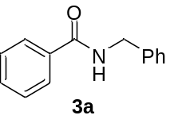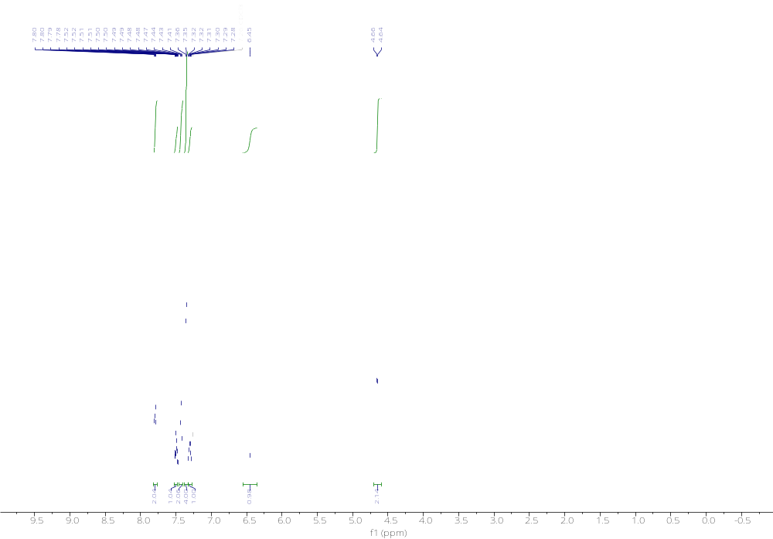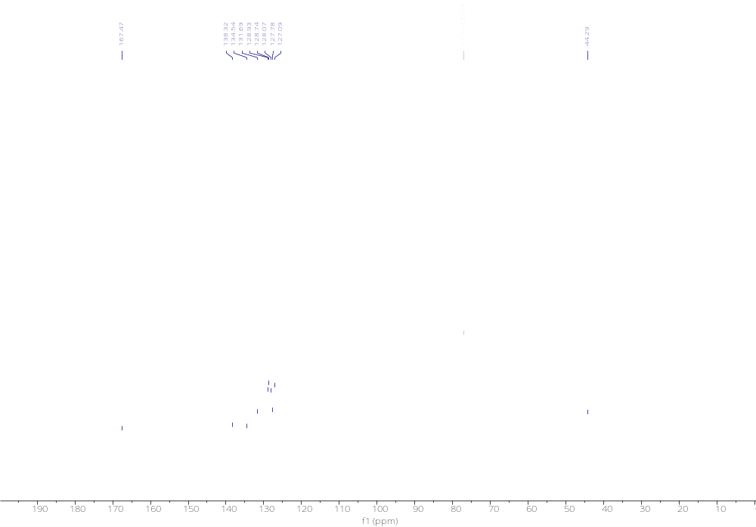
N-Benzyl-4-bromobenzamide (3b)
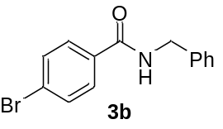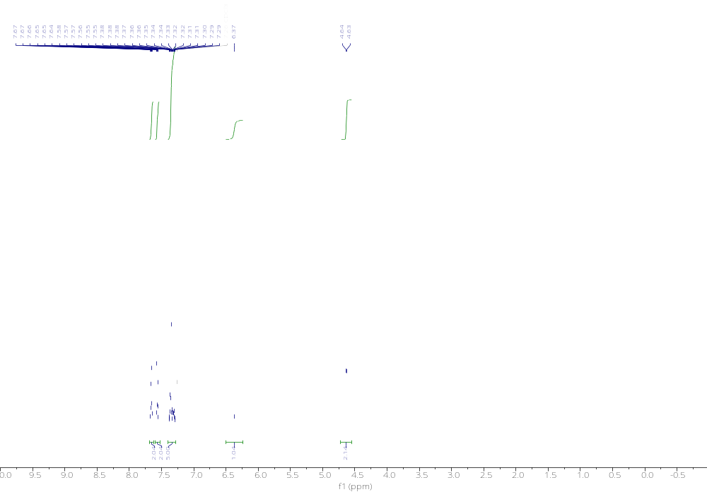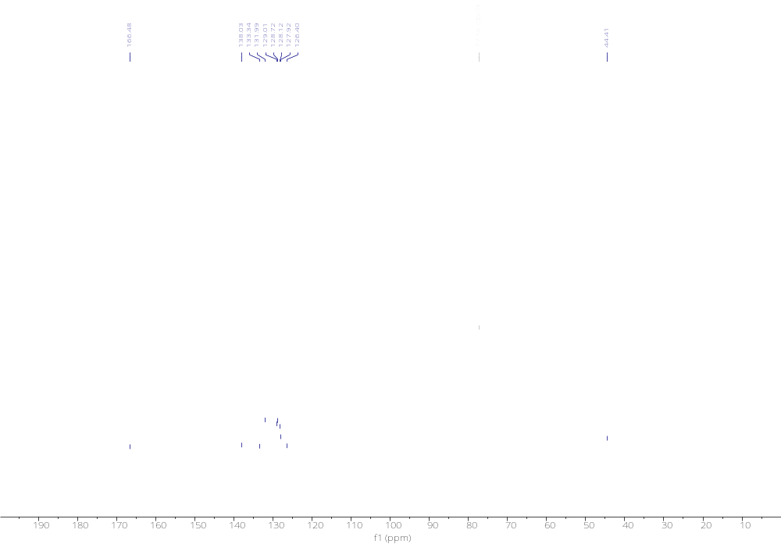

N-Benzyl-4-cyanobenzamide (3c)
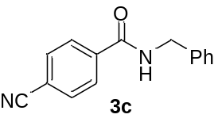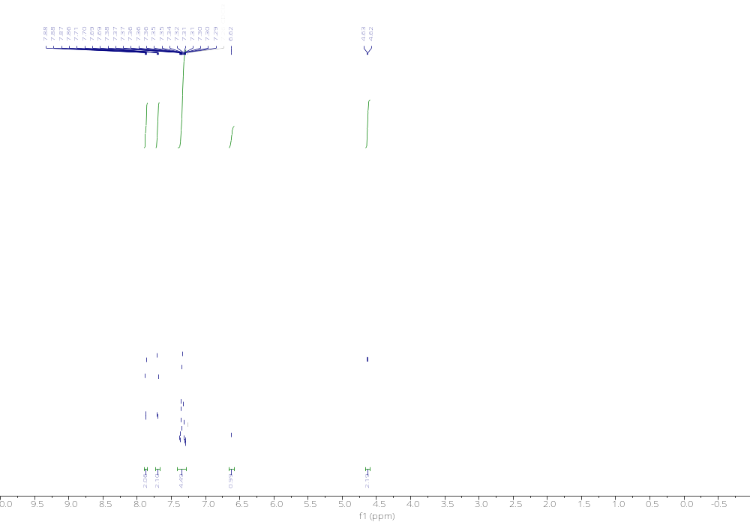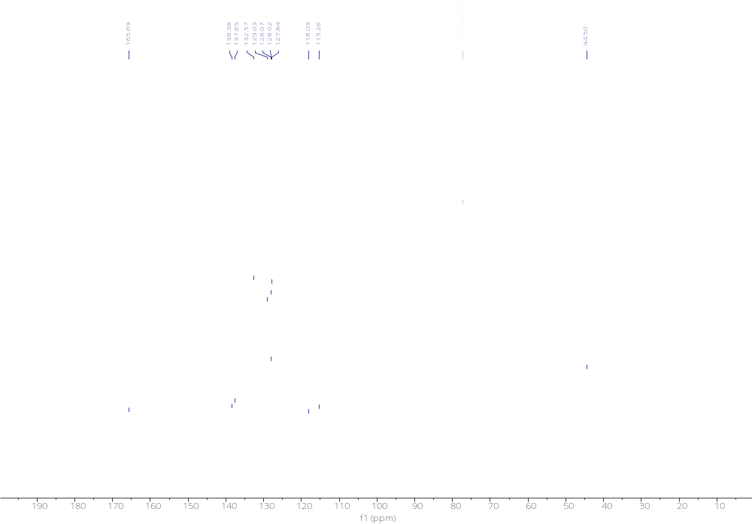

N-Benzyl-4-nitrobenzamide (3d)
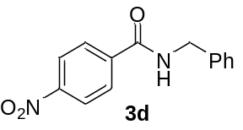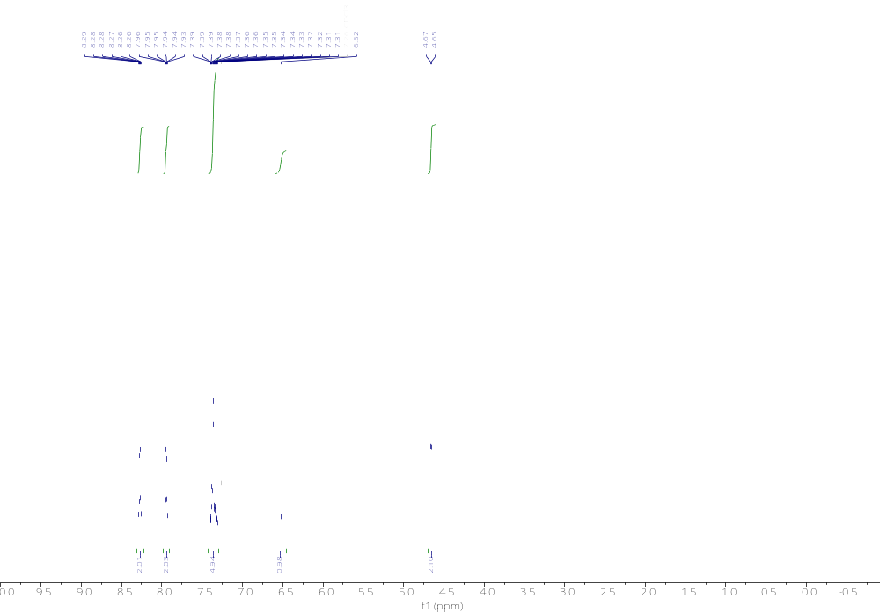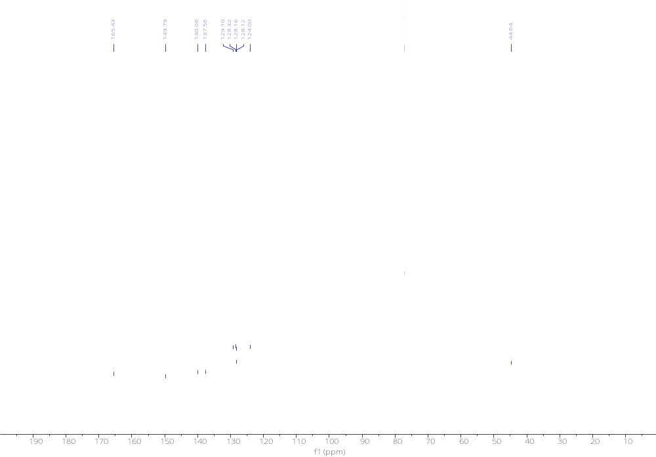

N-Benzyl-4-methoxybenzamide (3e)
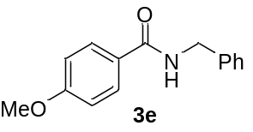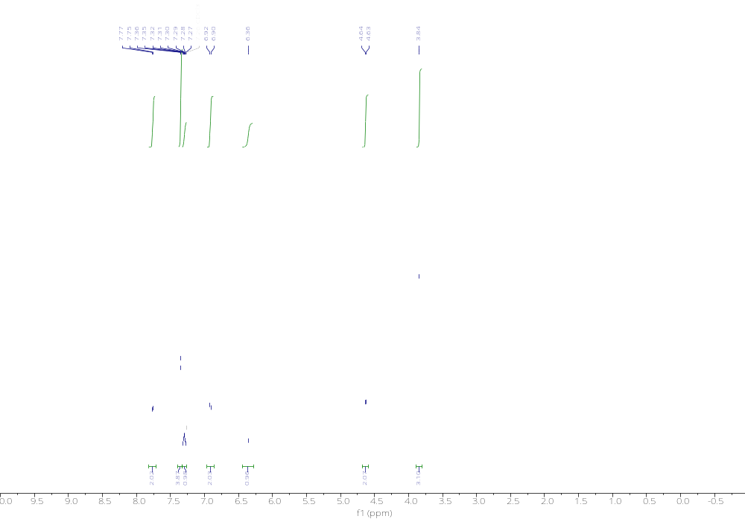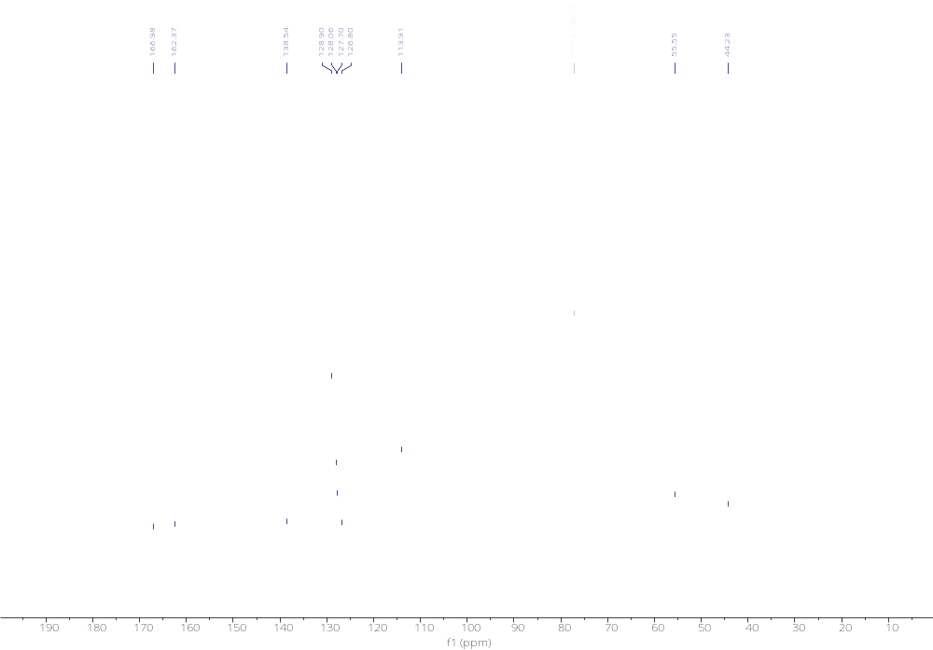

N-Methylbenzamide (3f)
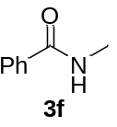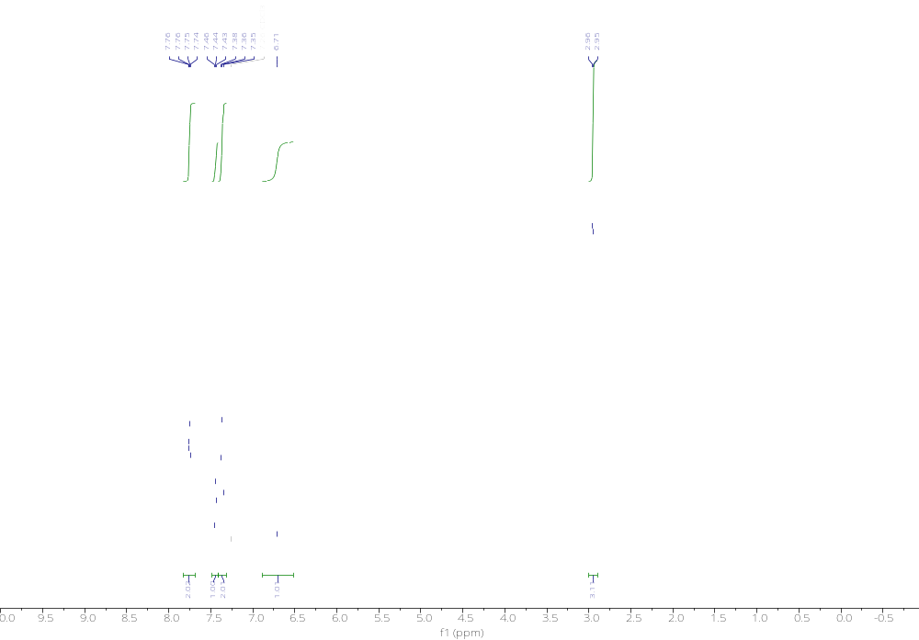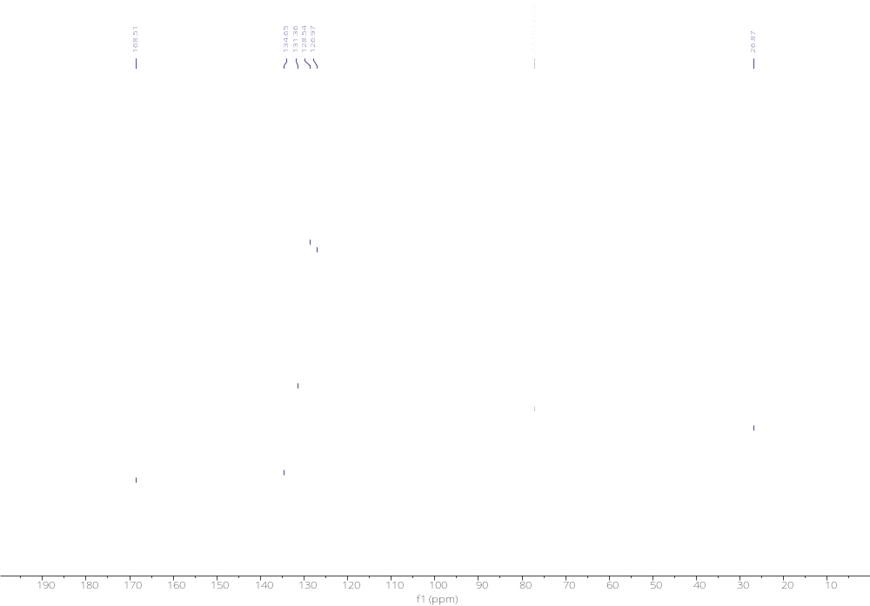

(S)-N-(1-Phenylethyl)benzamide (3g)
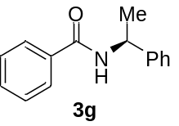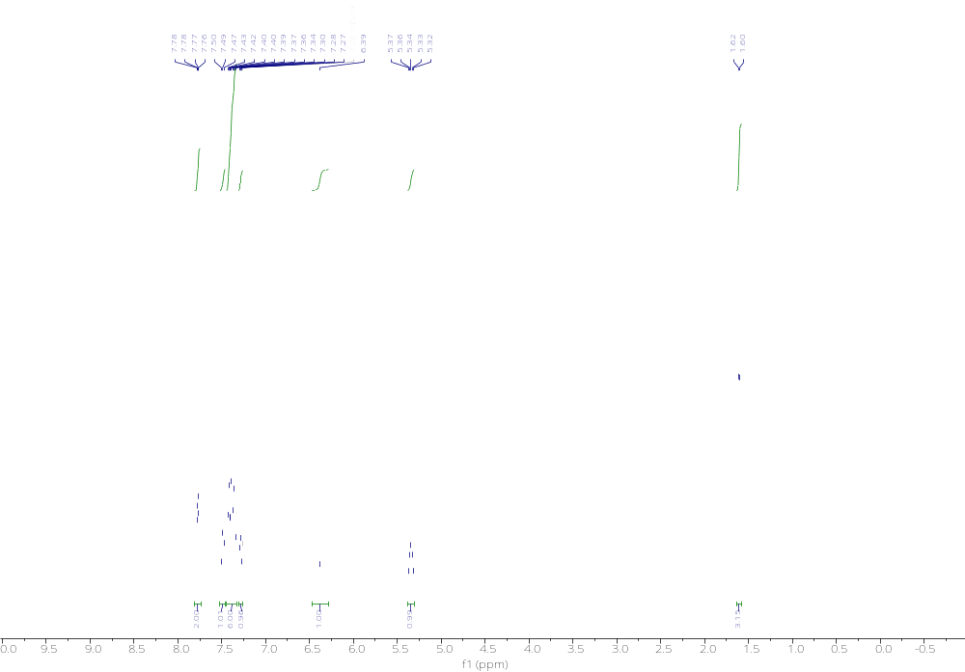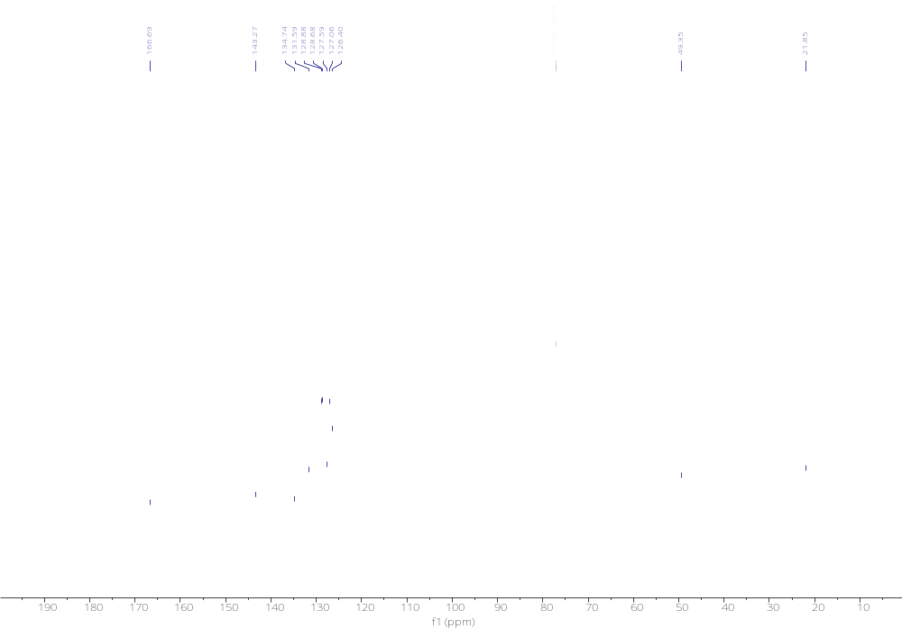

(S)-N-(1-(4-Methoxyphenyl)ethyl)benzamide (3h)
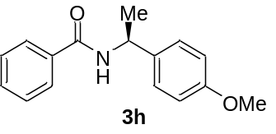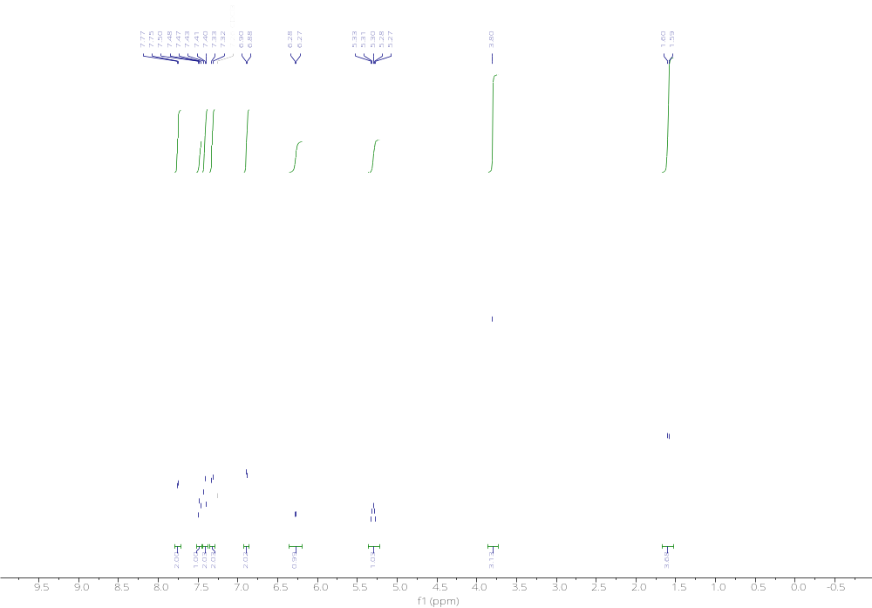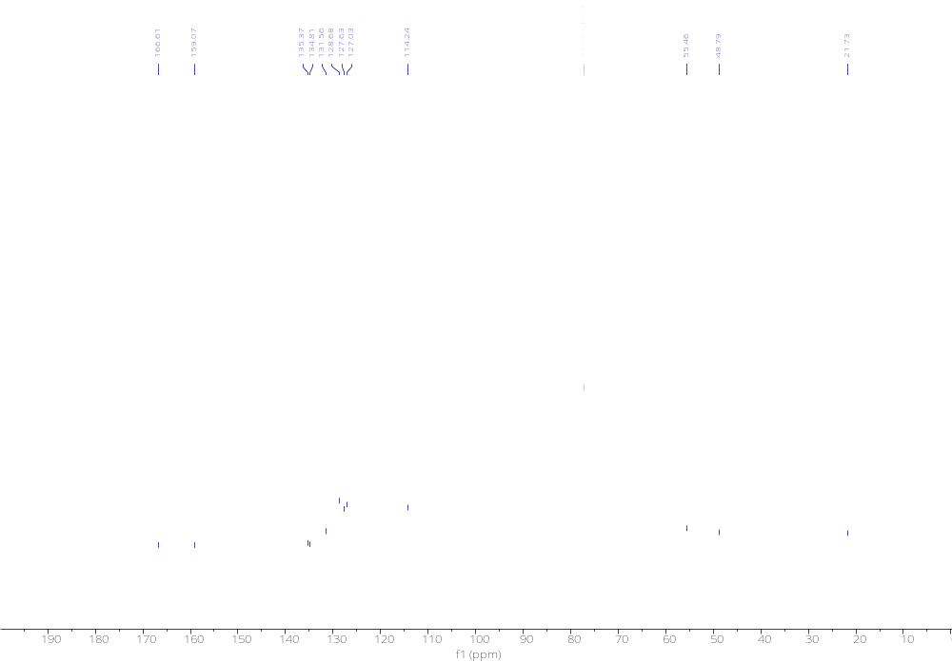

(R)-N-(1-(Naphthalen-2-yl)ethyl)benzamide (3i)
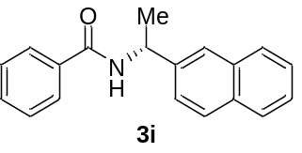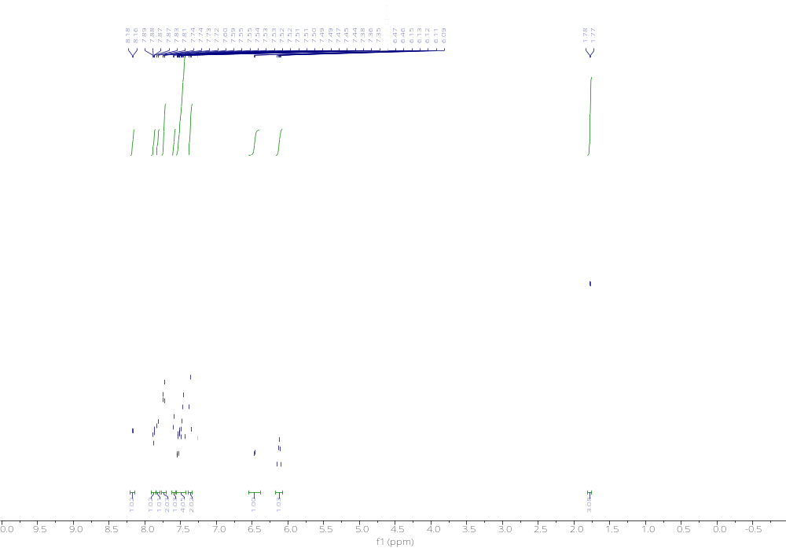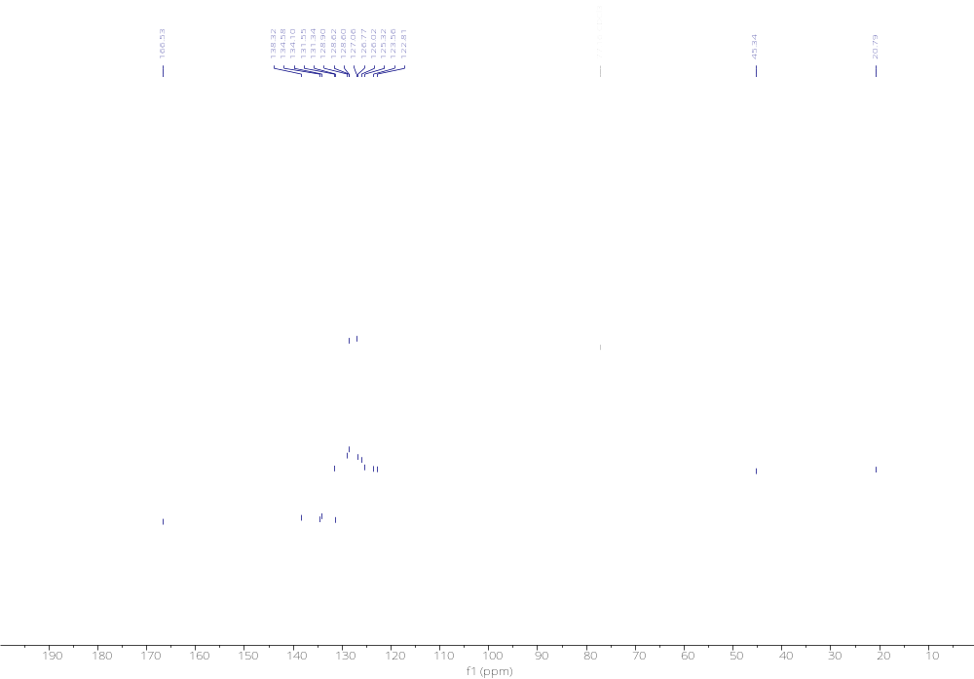

(R)-N-(1-Cyclohexylethyl)benzamide (3j)
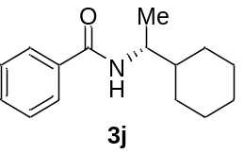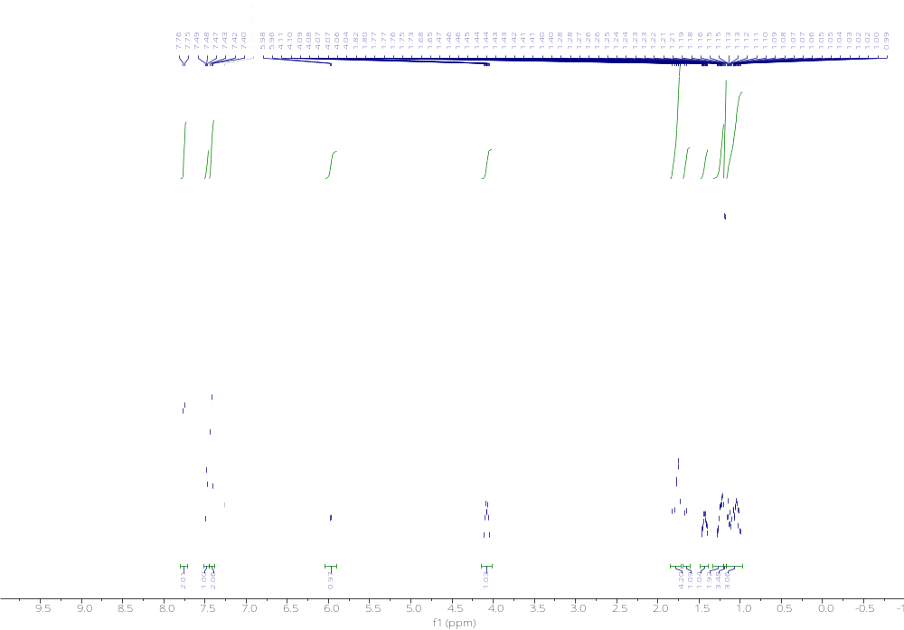 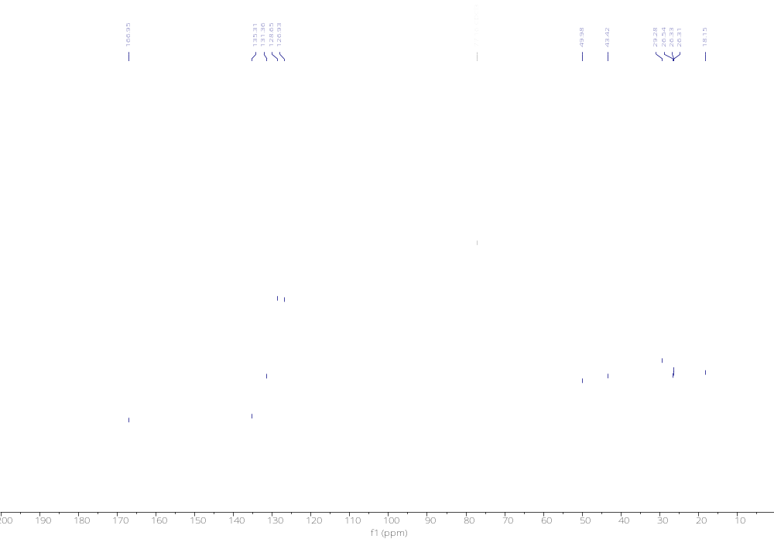'
tert-Butyl (S)-3-benzamidopyrrolidine-1-carboxylate (3k)
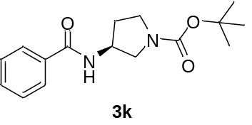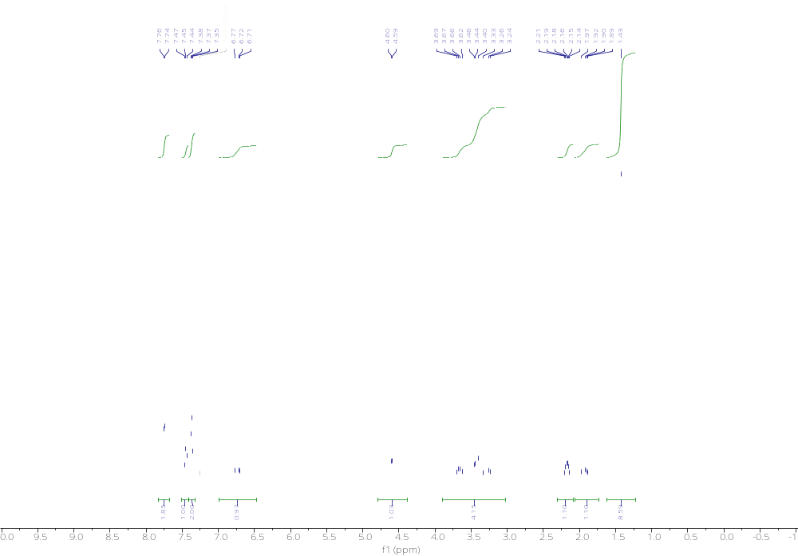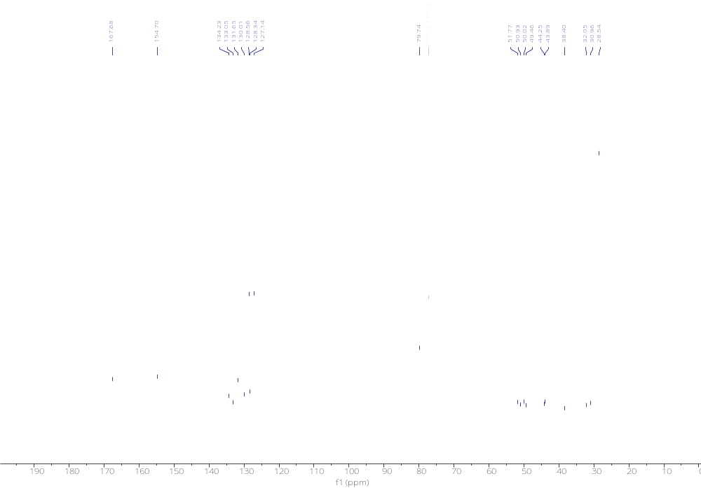

N,N-Dmethylbenzamide (3l)
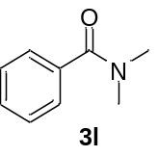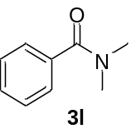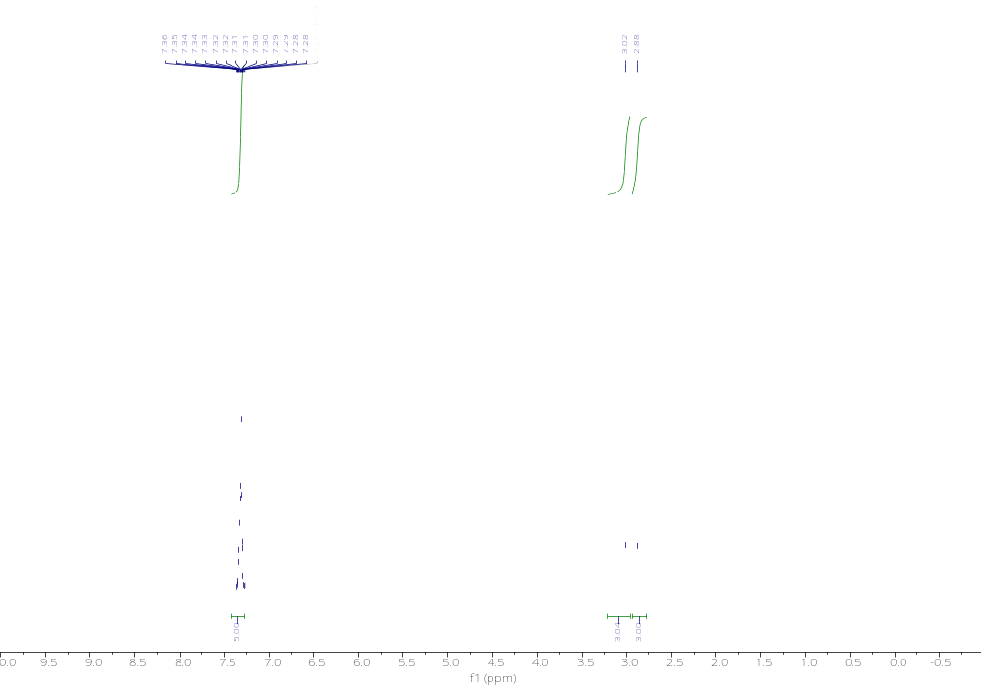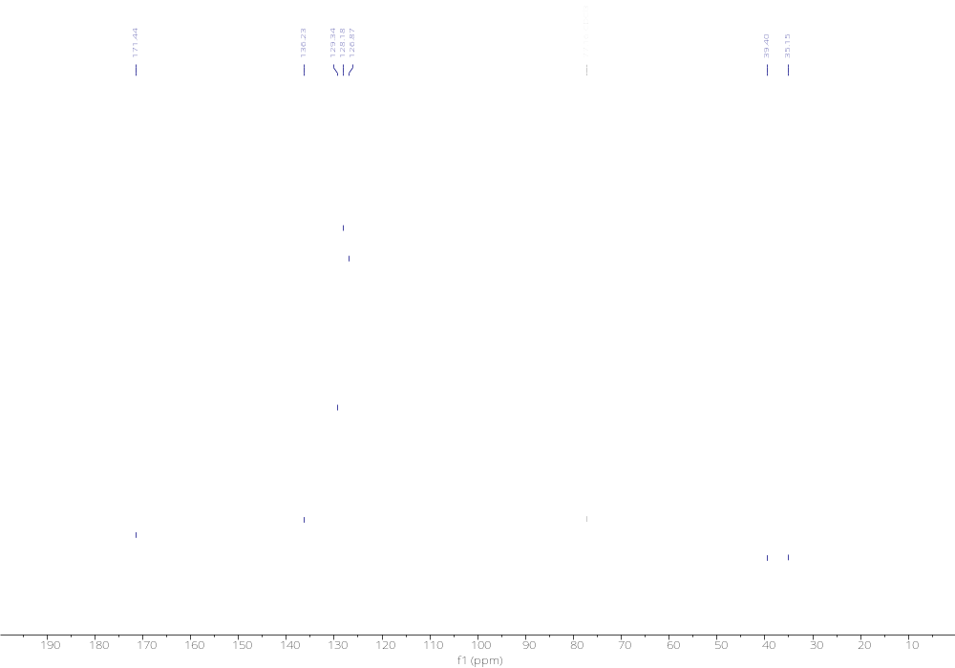

N,N-Diisopropylbenzamide (3m)
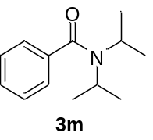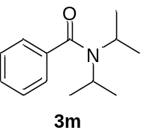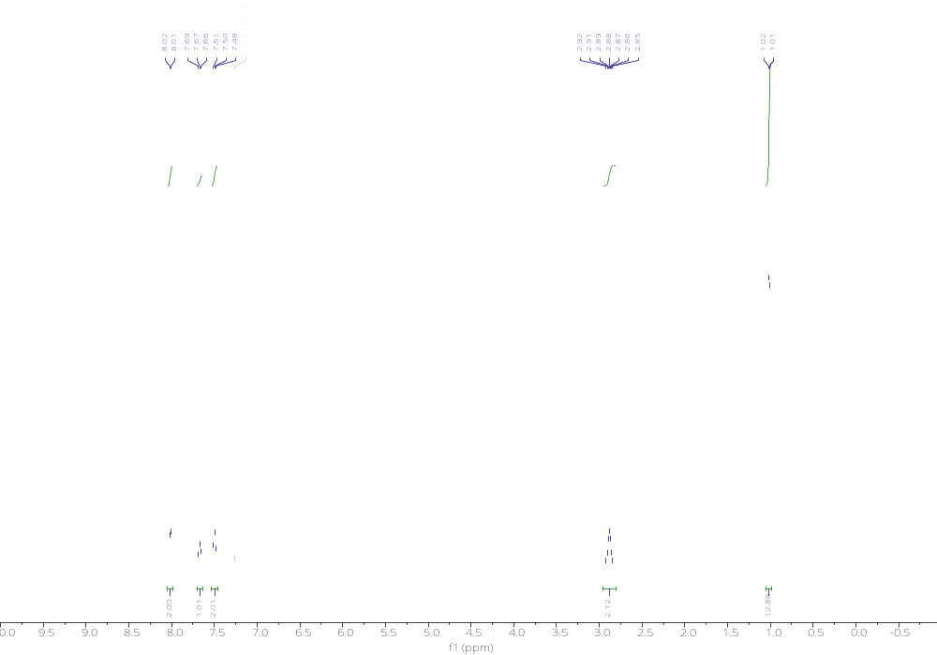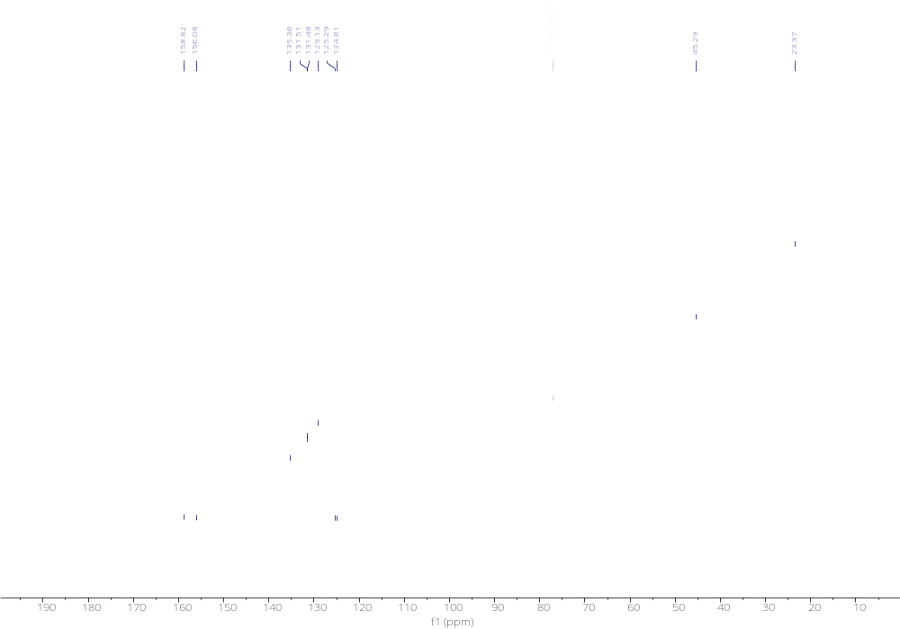
N,N-Diphenylbenzamide (3n)
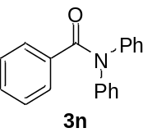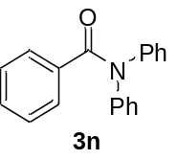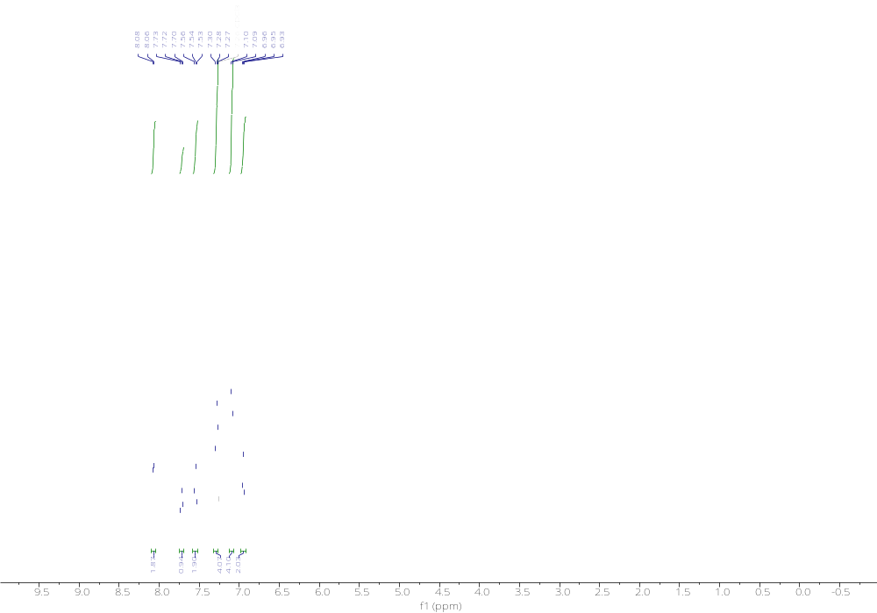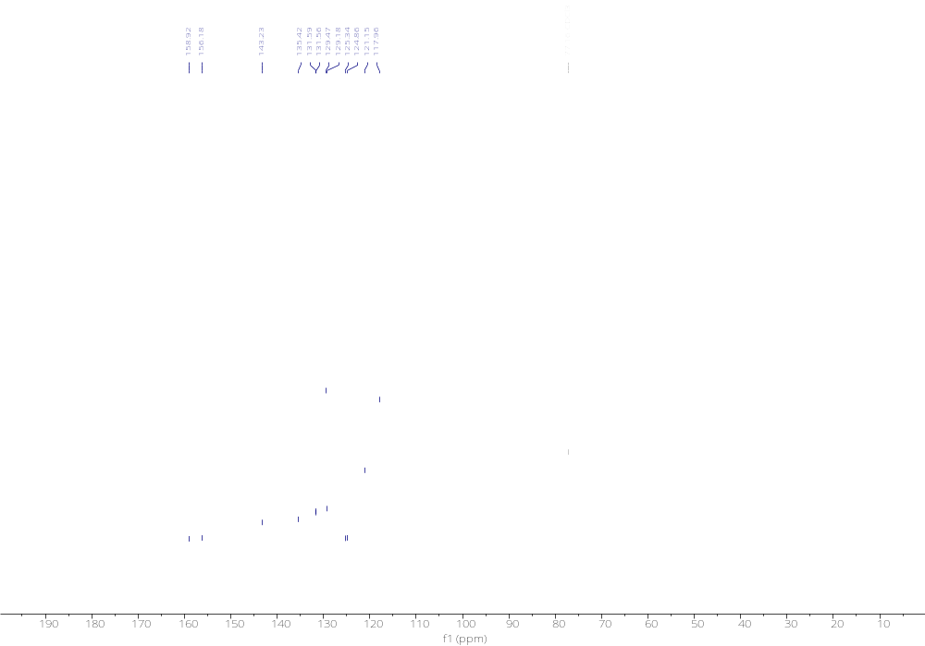
N,N-Dibenzylbenzamide (3o)
