Supplementary File 4: Predicted versus observed CGM values for challenging patients #357, #393 and #498 for the 30-minute prediction horizon
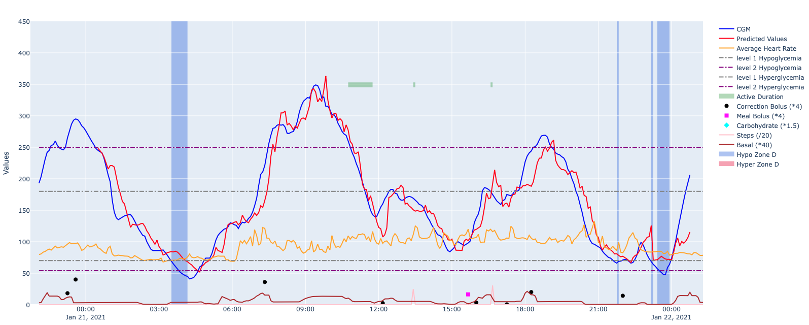
Figure S1: Predicted versus observed CGM values for patient 357 on the first test day for 30-minute prediction horizon
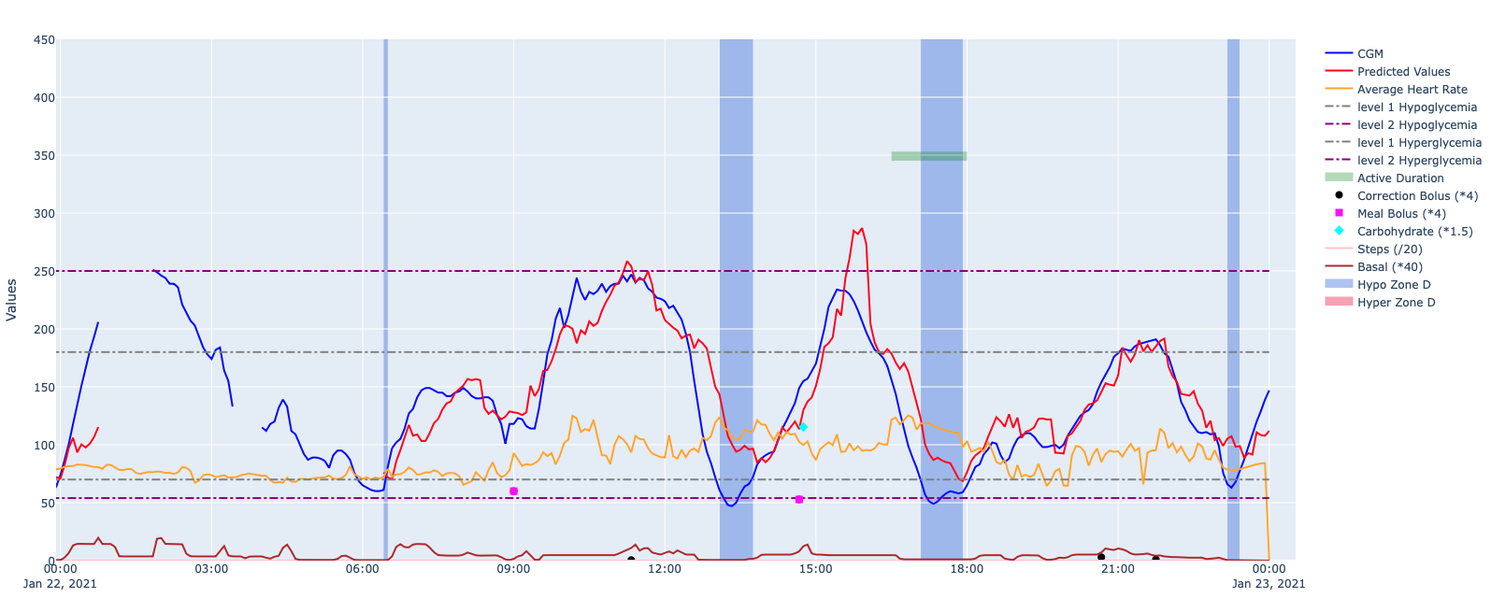
Figure S3: Predicted versus observed CGM values for patient #357 on the second test day for a 30-minute prediction horizon

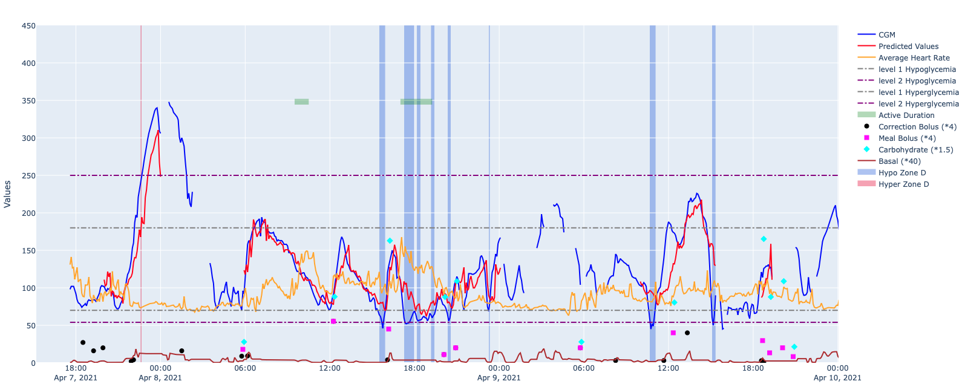
Figure S4: Predicted versus observed CGM values for patient #393 on the first test day for a 30-minute prediction horizon
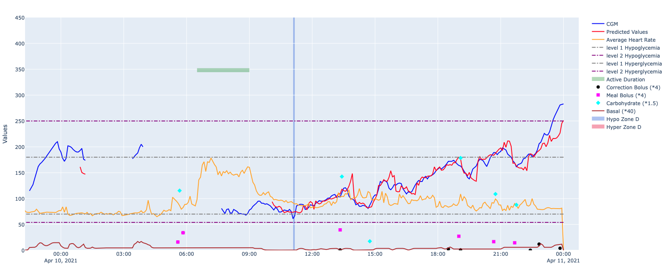
Figure S5: Predicted versus observed CGM values for patient #393 on the second test day for a 30-minute prediction horizon
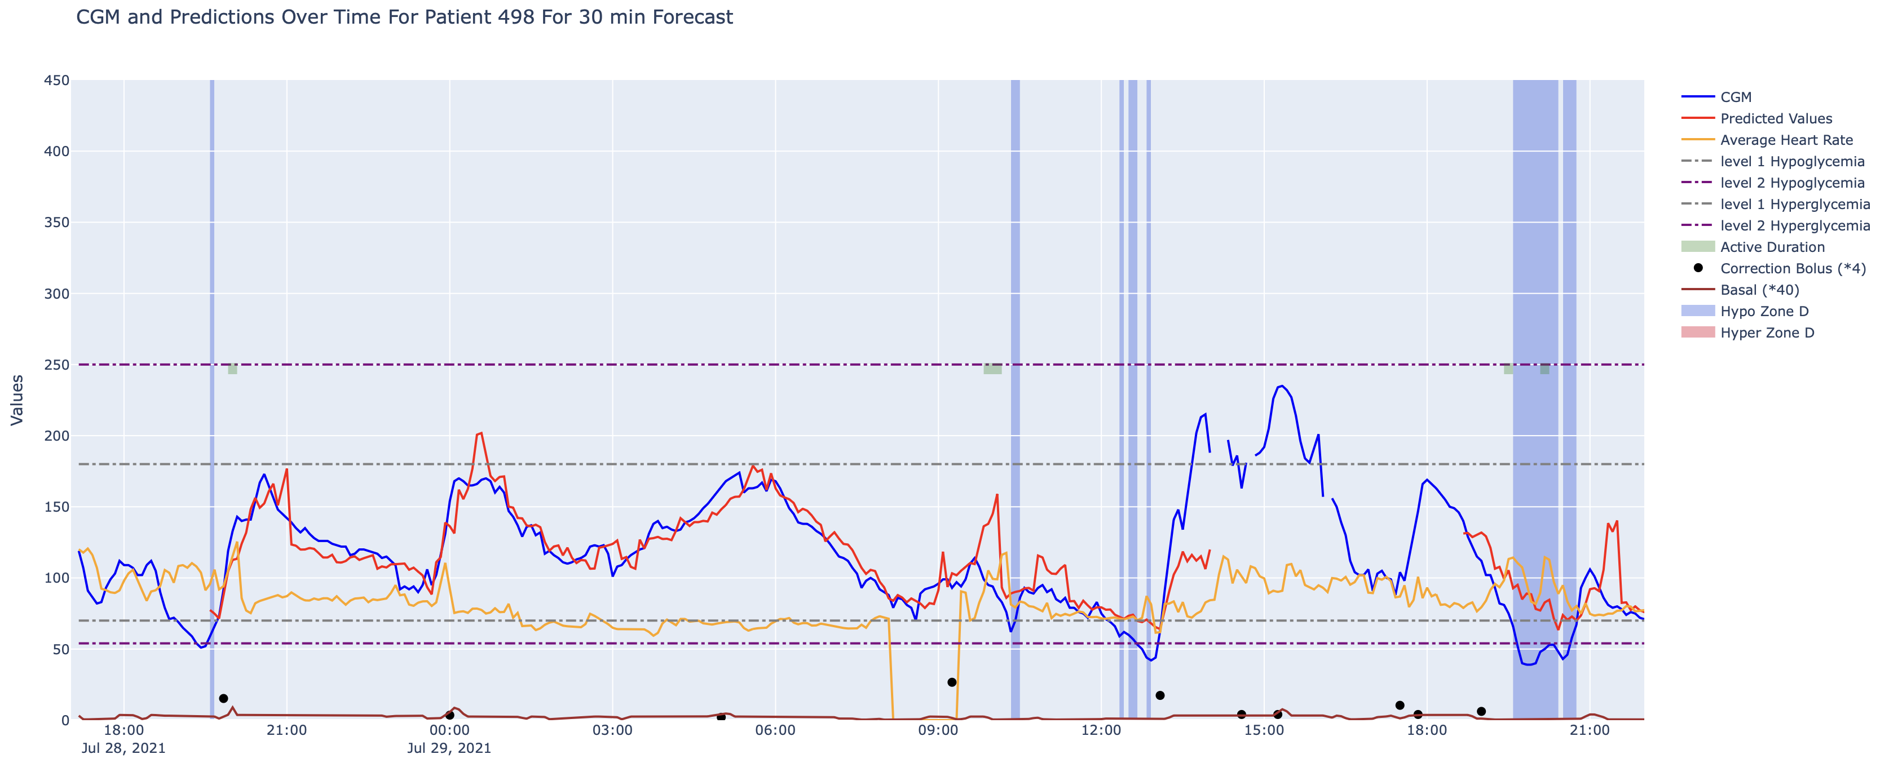
Figure S6: Predicted versus observed CGM values for patient #498 on the first test day for a 30-minute prediction horizon
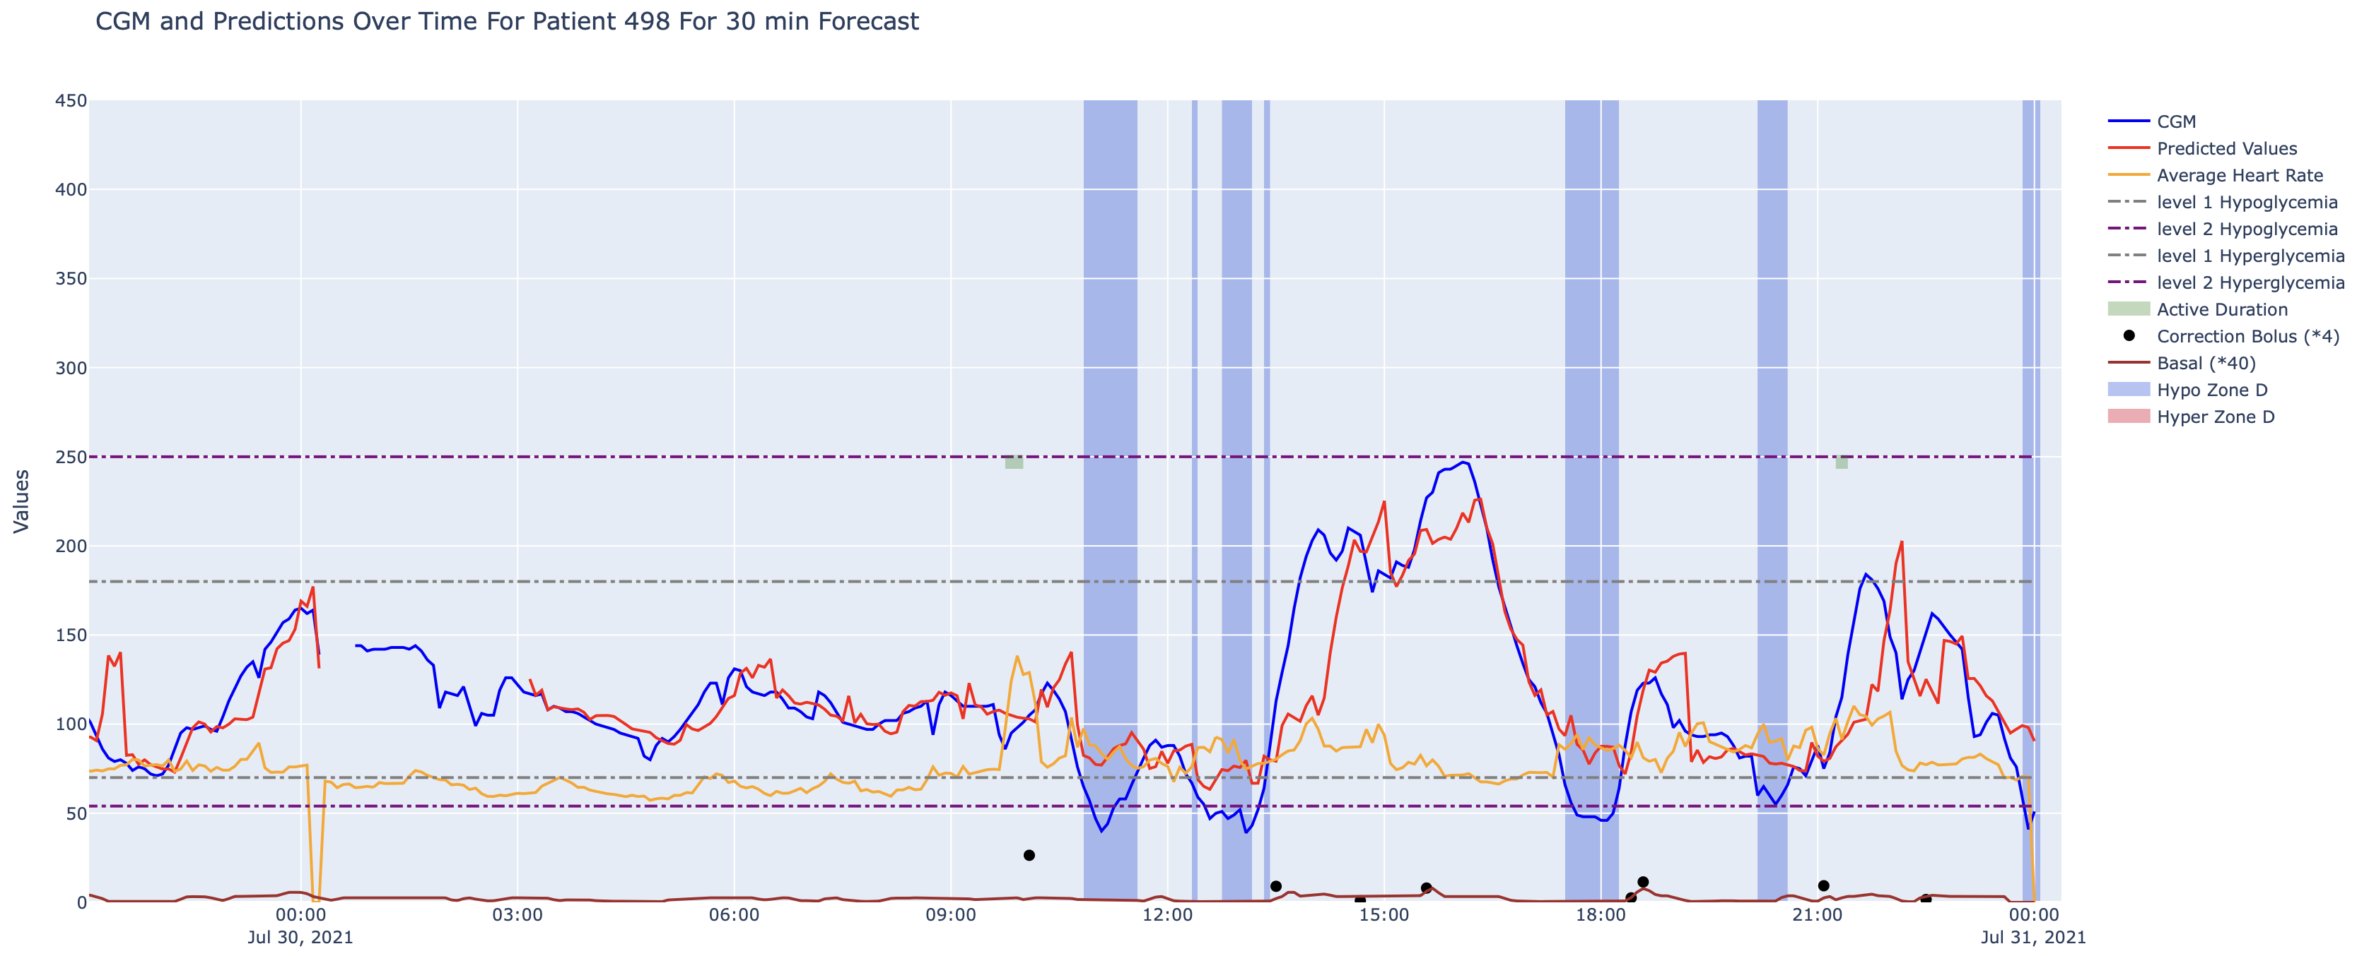
Figure S7: Predicted versus observed CGM values for patient #498 on the second test day for a 30-minute prediction horizon

